Signal Integrity
--
Board Design
&
Simulation Techniques
Roy Leventhal
7/28/26

Contents

* Denotes a section yet to be written or completed.

Process & Methodology 5
Top-Down & Iterative 5
Signal Integrity Engineering Skills 6
Getting Started 6
Reducing Risk & Trusting the Simulation 6
Caveat Emptor 7
The Iterative Process 15
*Robust Design: Plan for DOE of: 16
Introduction 16
Designing the Experiment 16
Set Up and Run the Simulations: 17
Analyze the Results: 17
Optimization and Conclusions: 18
Resources: 18
3Com IBIS Model Standard 19
Variables for Simulation 19
IBIS Variables 19
Symbolic Representation of an IBIS Device – Input Side 20
Symbolic Representation of an IBIS Model – Output Side 21
Composite simulator variables: “Slow-Typ-Fast” 22
SPICE Variables 22
Environmental Variables 23
Board Variables 24
Topology & Termination Variables 25
Receiver Input Impedance and Matching 25
Driver Output Impedance and Matching 26
Performance Factors and Virtual Measurements 28
Switching Delay Times 28
Buffer Delay 28
Propagation Delay 28
First Switch Delay 28
Final Settle Delay 28
Rise Delay/Fall Delay 29
Comments on buffer delay: 29
Crosstalk 29
Ground-Power Bounce/SSN 29
Effect of Reflections on Crosstalk and Ground Bounce 30
Comprehensive Noise Simulation 31
Overshoot/Undershoot 31
Noise Margins 31
Monotonicity Requirements 33
Parasitics 33
Current Requirements/Power Dissipation 33
EMI 34
Signal Integrity 101 35
Tutorial - Courtesy of Cadence Design Systems 35
Signal Integrity Simulation Tools 35
EMI Control 37
EMI Technical Discussion 37
Introduction 37
Sources and Receivers 37
Noise Signal Paths 38
Near and Far Fields: Coupling Vs Radiation 39
Conducted Paths: 40
Coupled Paths: 40
Radiated Paths: 41
Differential and Common Mode Signals 41
Quieting Source and Receiver: EMI Suppression Components 43
Conduction: Working From the Ground Up: Placement 43
Conduction: Working From the Ground Up: Multi-Point Grounding & Multiple Power Busses 44
Conduction: Working From the Ground Up: Single-Point Grounding 44
Decoupling with Shielding: Layer Stackup 44
Decoupling with Shielding: Fences, Cans, and Guard Traces 45
Decoupling with Distance: Trace Separation 46
Radiation: Faraday Shielding: Fences, Cans, Seams, Etc. 46
Grounding of Shields 47
Radiation: Antennas, Apertures, Seams, Slots, Traces/Corners and Waveguides 47
EMP 47
Absorption, Attenuation and Reflection 48
RF Layout Rules 49
Introduction 49
1. Separate and shield analog and digital signals and ground returns from each other. 49
2. Separate and shield signal grounds and power ground returns from each other. 50
3. Separate and shield input and output stages from each other 50
4. Minimize power line coupling stage-to-stage with bypass capacitors or power line filters or on-board voltage regulators. 50
5. Treat stage-to-stage coupling capacitors and bypass capacitors as resonant elements, particularly for leaded components. 51
6. Fan out ground and power traces rather than employing continuous copper if skin effect (ground loop) begins to be a problem. 52
7. Avoid sharp corners on traces or at trace ends. 52
8. Run controlled impedance, short, match terminated signal traces. 53
9. Replace your discrete circuit with a surface mount ASIC if you don't need the power, voltage standoff, etc. 53
10. Trust nothing to behave ideally. 53
EMI Design Rules 56
Three General Rules: 56
Three Technical Fundamentals: 56
Four Design Techniques: 57
Design Rule Driven EM Control Checking 57
Placement Rules 57
Associated Placement Rules 58
Bypass Rules 59
Power and Ground Plane Rules 59
DC Routing Rules 60
Signal Routing Rules 60
Signal Quality Rules 61
EMI Simulation Tools 62
Interpreting the Results 64
Introduction 64
Waveforms 64
Examples and Value Judgements 64
Lab 1 64
Lab 2 70
Lab 3 73
Lab 4 77
Waveforms at the Die vs. Waveforms at the Pins 79
Measurement Reports 79
Decisions and Implementing Them: Topology Templates and Constraint Management 81
Death by Analysis 81
Decisions 81
Topology Templates 82
Electrical Constraints 82
Physical Constraints 82
How Simulators Behave 84
Introduction 84
Transmission Lines, Reflection/Bounce Diagrams 84
Newton-Raphson 85
Timing Driven Simulations 85
How to Tell if the Effect of C_comp is being Double-Counted 86
Algorithms Vs. Field Solvers 86
Data Sheets and Verification 87
Relation to High Frequency RF Analysis 89
EMI 89
Data Monotonicity and Convergence 89
Test Measurements and Verification 90
Modeling Oscilloscope Probes for Simulation Results 90
Model Accuracy, Precision and Verification 96
Definitions and Technical Notes 97
Ramp Data: Slew Rate 97
Switching speed: 97
Rise/Fall Definitions: 97
Rise and Fall Times, Slew Rates, V-T Curves and Verification 98
Noise Margin 98
Verifying Your Simulator and IBIS Model 100
Time and Frequency 101
Time, Distance and Frequency: Lumped and Distributed Circuits: Transmission Lines 101
Transmission Line Equations 104
RLGC Matrices 104
Resources & References 105
Web Sites: 105
Signal Integrity Textbooks: 109
[END] 110

Process & Methodology

Top-Down & Iterative

Designing for signal integrity in high speed digital circuits should be done using a
Top-Down methodology.

It is extremely difficult to fix complex, high density, high speed board designs if need be. When you build prototypes it's no time to be adding unplanned terminations. You'll have to re-spin your board if you haven’t already gained considerable insight in what to do and haven’t already designed out as many problems as possible. Modern designs are too complex and design cycles are too short to fly by the seat-of-your-pants and wait until you get copper before you worry much about the design. So, you might as well take good advantage of the Top-Down high speed digital signal integrity simulation methodology. A brief review is in order:

An ideal sequence of processes that the Signal Integrity Engineer works through is:

- Start with the System Designer / Logic Designer having done a schematic capture design and having produced a schematic, netlist, bill-of-materials and timing analysis.
- Explore different process technology parts such as CMOS, LVTTL, GTLP, etc. Simulate reflections, along with what-ifs, of the nets/netlist topologies in a suitable simulator. Explore different topologies and their terminations. Produce topology templates with electrical and physical constraints to pass to the Board Designer.
- Place critical parts and rooms of parts and pre-route critical nets in a floorplanning layout tool. Investigate EMI issues with a placement-driven EM control rules checker. Do what-if simulations of timing, crosstalk and EMI with tools that can run from placement and possible routing scenarios. Provide for bypass capacitors, faraday shields, etc., in the design as appropriate. Simulate possible thermal issues. Update the electrical and physical constraints to pass to the Board Designer.
- Design a preliminary board stackup and extract critical pre-routed net into the signal integrity simulator. Verify performance for timing, reflections, ground bounce and possibly crosstalk and EMI.
- After the Board Designer returns a routed board and stackup database verify its signal integrity performance as required. Detailed placement, routing and plane design will have been done. Verify timing, reflections, crosstalk, simultaneous switching noise and EMI as appropriate.

Signal Integrity Engineering Skills

The Signal Integrity Engineer will apply design skills in ground/power plane design and bypassing, shielding and crosstalk, transmission line reflections and termination, topology and device loading and timing design, device selection and noise margins, and EMI radiation issues at a minimum. Refer to the section below: Signal Integrity.

Getting Started

Start by simulating with anything to see if your topology/design will work at all. Start with its topology if you don’t have a routed board with a defined stackup. Start with the simulation software’s default generic driver/receiver model. Progress to a generic model of the process technology you intend to use ASAP.

Reducing Risk & Trusting the Simulation

So, what is the right model for each design phase and design challenge? A model that is accurate enough. To quote:

“The accuracy of an experiment is a measure of how close the result of the experiment comes to the true value.” An engineer might amend his definition as follows: “The accuracy of a simulation is a measure of how close the result of the simulation comes to the true value.” In the case of behavioral modeling of high-speed digital circuits, the true value is what one accurately measures in the lab, and the behavioral simulation is a theoretical prediction. A highly accurate behavioral simulation is one in which the difference between simulation and lab data is small.

From the book, “Data Reduction and Error Analysis for the Physical Sciences,” author Philip Bevington.

This author wishes he knew what hard and fast advice to give for all situations. But, the truth is that the particulars vary too much from case to case to do that. It is very much a matter of inference unless a previously used model and simulation are very similar to your new design problem.

Of course, if you can do some design reuse, you can save yourself a lot of work, provided: that the original design, parts, models, databases, etc., have been thoroughly simulated, verified and documented. And, the original parts/processes are still purchasable.

Caveat Emptor

A word of warning:

Top-down robust design, using modeling and simulation, assumes that the model is basically correct, if maybe a little inaccurate. In parallel with refining the design and making it less sensitive to parameter variation you may discover a need to refine the model and make it more accurate in critical areas.
But, what happens when the model you are using is very different from the actual part behavior, unbeknownst to you?

This question recently was re-emphasized for me, as the following example will show:

A multidrop TDM backplane bus with variable loading was studied to come up with recommendations for the design engineers.

Some of the givens were:

- Clock frequency: 8 MHz
- Backplane: 957 mils pitch between connectors, Zo = 63 ohms, 80 mils separation to closest aggressor nets on same layer.
- Nets: 56 TDM lines with 2 to 18 boards (variable) teed into each net at the connector in daisy chain fashion. But, removing or inserting a board did not interrupt the backplane bus continuity.
- Daughter cards: Each daughter card was a bi-directional I/O, that is each could be driver or receiver as determined by switching logic.
- Termination: Termination at the ends of the backplane bus would be OK, termination on each daughter card was less desirable.
- To Be Designed: Termination details, stub lengths and technology choices.

Some Results were:

- Stub lengths were optimized at 1000 mils.
- Technology choice was open-drain GTLP I/Os.
- Termination was one 33 ohm pullup resistor at each end of the nearly 18 inch long backplane bus.

One of the most interesting results was the completely different conclusion I came to about the GTLP technology choice as opposed to my first impressions of it. In between I spent considerable time optimizing BTLP technology (which was the most recommended at the time) and investigating several others. What happened to change my mind?

Well, the first time I simulated the GTLP model it was an IBIS 1.1 version that did not contain V-T curves. I removed the V-T curve data and keywords from the IBIS file in order to return to that level of model. The file still had the [Ramp] keyword and data in it.

Below is what the simulation results showed in the final optimized topology using only the [ Ramp ] data:

Figure 1: TDM Bus Envelope of Responses: 18 Boards

Figure 2: TDM Bus Switching Parameters: 18 Boards

################################################################################
# Report: Standard Reflection Summary Sorted By Worst Settle Delay
# Mon Jan 25 16:14:12 1999
################################################################################

CASE 1: 1000 mil stubs, 63 ohm system, no RC termination,
8 MHz, 33 ohm pullups, open_drain IO, 18 boards
load11.top

************************************************************************************************************
Delays (ns), Distortion (mV), (Typical FTSMode)
************************************************************************************************************
XNet Drvr Rcvr NMHigh NMLow OShootHigh OShootLow SwitchRise SwitchFall SettleRise SettleFall Monotonic
------- ----------- ---------- ------ ----- ---------- --------- ---------- ---------- ---------- ---------- ---------
1 A MD7 A IOP-73 31 A IOP-90 1 272.4 336.1 1697 443.6 11.09 9.129 12.02 9.861 PASS
1 A MD7 A IOP-73 31 A IOP-89 1 265.6 344.7 1692 441.3 10.78 8.717 11.67 9.458 PASS
1 A MD7 A IOP-73 31 A IOP-88 1 288.8 353.3 1669 441.3 10.44 8.236 11.3 9.023 PASS
1 A MD7 A IOP-73 31 A IOP-87 1 298.4 327.8 1664 433.2 10.11 7.849 10.94 8.557 PASS
1 A MD7 A IOP-73 31 A IOP-85 1 299.5 335.8 1642 435.8 9.636 7.422 10.47 8.358 PASS
1 A MD7 A IOP-73 31 A IOP-86 1 267.4 304.8 1632 388.1 9.286 6.797 10.04 7.97 PASS
1 A MD7 A IOP-73 31 A IOP-84 1 273.9 295.1 1627 441.9 8.844 6.626 9.694 7.479 PASS
1 A MD7 A IOP-73 31 A IOP-74 1 58.14 110.5 1753 455.2 5.063 2.26 9.571 2.846 FAIL
1 A MD7 A IOP-73 31 A IOP-83 1 231.3 233 1654 419.5 8.376 6.412 9.266 7.224 PASS
1 A MD7 A IOP-73 31 A IOP-82 1 245.1 269.9 1630 449 8.063 5.868 8.903 6.647 PASS
1 A MD7 A IOP-73 31 A IOP-81 1 227.3 236.6 1649 459.7 7.643 5.418 8.525 6.101 PASS
1 A MD7 A IOP-73 31 A IOP-80 1 227.3 252.7 1636 420 7.358 4.917 8.083 5.704 PASS
1 A MD7 A IOP-73 31 A IOP-79 1 221.8 232.6 1621 462 6.825 4.57 7.653 5.34 PASS
1 A MD7 A IOP-73 31 A IOP-78 1 175.2 218.2 1645 454.5 6.442 4.145 7.227 4.92 PASS
1 A MD7 A IOP-73 31 A IOP-77 1 207.8 175.8 1646 477.8 6.201 3.651 6.936 4.297 PASS
1 A MD7 A IOP-73 31 A IOP-76 1 169.1 174.5 1673 452.7 5.762 3.227 6.54 3.859 PASS
1 A MD7 A IOP-73 31 A IOP-75 1 198.2 335 1653 467 5.319 2.582 6.052 3.746 PASS
---------------------------------------------------------------------------------------------------------------------------------

*********************************************************************
Simulation Preferences
---------------------------------------------------------------------
Variable Value
------------------------ ---------------
Pulse Clock Frequency 8MHz
Pulse Duty Cycle 0.5
Pulse Step Offset 0ns
Pulse Cycle Count 2

But, this part has an active feedback (Gunning Transistor Logic) controlled ramp rate and soft turnon/turnoff.

Now, look at the following properly modeled V-T curves from the IBIS 2.1 model:

Figure 3: Rise Waveform V-T Curves for 16612a.ibs

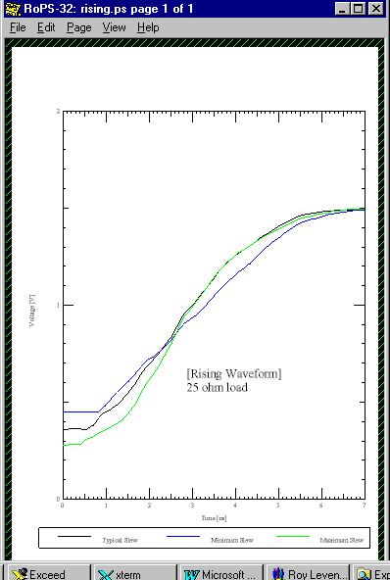

Figure 4: Fall Waveform V-T Curves for 16612a.ibs

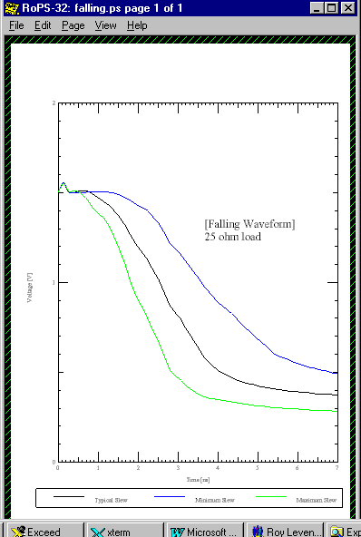

And, here are the results of using the correct model in the simulation:
Figure 5: TDM Bus Envelope of 166612a.ibs Responses: 18 Boards
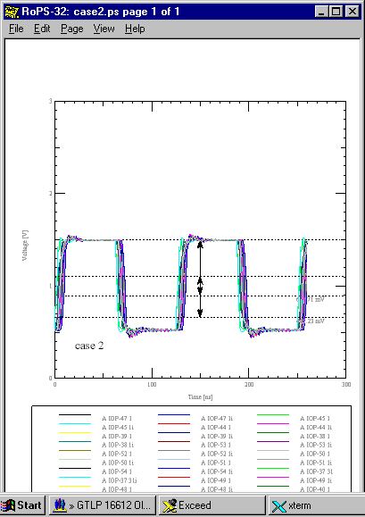

Figure 6: TDM Bus Switching Parameters for 16612a.ibs: 18 Boards

################################################################################
# DF/SigNoise 13.0
# (c) Copyright 1997 Cadence Design Systems, Inc.
#
# Report: Standard Reflection Summary Sorted By Worst Settle Delay
# Mon Jan 25 16:18:16 1999
################################################################################

CASE 2: 1000 mil stubs, 63 ohm system, no RC termination,
8 MHz, 33 ohm pullups, 18 boards
load5.top

************************************************************************************************************
Delays (ns), Distortion (mV), (Typical FTSMode)
************************************************************************************************************
XNet Drvr Rcvr NMHigh NMLow OShootHigh OShootLow SwitchRise SwitchFall SettleRise SettleFall Monotonic
------- ----------- ---------- ------ ----- ---------- --------- ---------- ---------- ---------- ---------- ---------
1 A MD7 A IOP-37 31 A IOP-54 1 373.7 344.9 1542 452.5 10.12 10.06 10.98 10.82 PASS
1 A MD7 A IOP-37 31 A IOP-53 1 376.4 347.9 1543 453.2 9.757 9.708 10.61 10.46 PASS
1 A MD7 A IOP-37 31 A IOP-52 1 382.6 357.3 1539 466.7 9.358 9.311 10.24 10.08 PASS
1 A MD7 A IOP-37 31 A IOP-51 1 372.3 343.6 1543 458.4 8.975 8.928 9.846 9.687 PASS
1 A MD7 A IOP-37 31 A IOP-50 1 381.5 354.5 1548 455.8 8.552 8.501 9.481 9.289 PASS
1 A MD7 A IOP-37 31 A IOP-49 1 382 336.4 1560 439 8.12 8.088 9.06 8.863 PASS
1 A MD7 A IOP-37 31 A IOP-48 1 385 323.1 1544 451.8 7.748 7.685 8.646 8.449 PASS
1 A MD7 A IOP-37 31 A IOP-47 1 385.3 303.9 1540 459.6 7.367 7.293 8.267 8.045 PASS
1 A MD7 A IOP-37 31 A IOP-46 1 381.4 305.5 1547 456 6.915 6.861 7.818 7.6 PASS
1 A MD7 A IOP-37 31 A IOP-45 1 387.3 294.8 1545 447.1 6.534 6.456 7.368 7.162 PASS
1 A MD7 A IOP-37 31 A IOP-44 1 369.2 288.3 1547 450 6.106 6.023 6.972 6.735 PASS
1 A MD7 A IOP-37 31 A IOP-43 1 369.3 350.8 1526 475.5 5.642 5.567 6.537 6.295 PASS
1 A MD7 A IOP-37 31 A IOP-42 1 356.4 268.3 1538 458.4 5.241 5.165 6.066 5.84 PASS
1 A MD7 A IOP-37 31 A IOP-41 1 358.4 344.3 1531 472.6 4.825 4.741 5.695 5.431 PASS
1 A MD7 A IOP-37 31 A IOP-40 1 356.3 331.6 1521 478.7 4.396 4.321 5.254 4.987 PASS
1 A MD7 A IOP-37 31 A IOP-39 1 356.4 336.8 1518 488.5 3.952 3.826 4.823 4.53 PASS
1 A MD7 A IOP-37 31 A IOP-38 1 349.7 327.2 1515 490.8 3.51 3.39 4.383 3.992 PASS
---------------------------------------------------------------------------------------------------------------------------------

*********************************************************************
Simulation Preferences
---------------------------------------------------------------------
Variable Value
------------------------ ---------------
Pulse Clock Frequency 8MHz
Pulse Duty Cycle 0.5
Pulse Step Offset 0ns
Pulse Cycle Count 2

So, with a more badly behaved topology a more sophisticated and correct model of the V-T behavior makes all the difference. All the T-junctions where the daughter boards tap into the bus, the stub lengths and the distributed lumped - loaded, heavily loaded effects on the line cause noise. Eliminating as much high frequency content, especially edge rate and hard turnon/turnoff from the part as possible and properly modeling it makes all the difference. This has the effect of making the clock more trapezoidal - even sinusoidal - and (we would already have guessed) much easier to tame.

The Iterative Process

The process outlined next is a sequence of simulation activities that overlaps with the sequence of design phases (net design - placement - topology design - routing - design verification).

Beyond my warnings in caveat emptor, here is the iterative process I recommend:

- Start simulating with a generic part/model in the process technology (LVTTL, CMOS, GTLP, ECL, etc.) speed and drive range you think you will need.

- Modify (do “what-ifs,” worst-case, etc.,) the (remember to save yourself an original “virgin” copy of the IBIS model) speed, drive, pin parasitics, etc., parameters that you think your design will be sensitive to. Gain a quantification of how sensitive the design signal integrity performance is to model properties.

- Try to de-sensitize your design to the most sensitive parameters. Good routing, shielding, termination and heat sinking are a few obvious techniques. Devices with more/less speed and output drive capabilities and inherent noise margins are others.

- Simulate your design with an IBIS model of the actual part that you will be using as soon as the model becomes available.

- Push on the provider of the IBIS model for a verification of its accuracy (or a better or more complete model) if you are close to violating certain design specifications, e.g., noise margin. In parallel, add requirements to the specification requirements for the IBIS model as outlined below. Such add-ons necessitated by the need for greater accuracy are things such as V-T curves, individual pin parasitics, and MIN-MAX data on parameters and lab measurement verification data. Use some judgement. For instance, it’s one thing to come close to violating a un-guardbanded Vih threshold. It’s a different matter if you’ve specified a conservative, guardbanded noise margin. Be prepared, worst case, to do your own lab verification measurements yourself and adjust your design if necessary.

*Robust Design: Plan for DOE of:

The outline below is lacking an actual design example. As well, alternate approaches to statistical design, i.e., Monte-Carlo, Response Surface optimization could be discussed.

Introduction

The following is a plan for a Taguchi style robust design-of-experiment (DOE) simulation of a point-point transmission line design. This “virtual experiment” makes use of the results of simulation to generate the measurements instead of a set of prototype boards.

A robust design is one that continues to perform well despite variations in components and manufacturing tolerances. A designed virtual experiment is used to extract the best target settings for controllable design parameters in order to achieve this result. Both good design centering and desensitization are choices that the results can help achieve.

Designing the Experiment

Choose the performance factors to measure. These might include:

- Noise Margin
- First Switch
- Final Settle
- Crosstalk
- Ground Bounce
- EMI

Choose the component and board properties (factors) to vary. These might include:

- Driver strength and speed (V-I, V-T variables)
- Etch width and dielectric constant (Zo)
- Load impedance and capacitance
- Temperature
- Voltage
- Clock speed
- Termination choices

And, the choice of which factors are control factors and which are noise factors.

Choose the levels at which to set the control factors. These might include:

- Process corners
- Slow-Typical-Fast
- Etch lengths

Set up the DOE experimental array and identify factor interactions:

- ?
- ?

Set Up and Run the Simulations:

- Board setup
- Model property variations
- Board property variations
- Plan each simulation run
- Running simulations
- Reports and data collection

Analyze the Results:

- Response table
- DOE software
- ANOVA, etc.
- Main factors and factor strength
- Interactions
- Best settings
- Confirmation runs

Optimization and Conclusions:

- Topology, termination and other design choices
- Centering and de-sensitization
- Design performance margins
- Cost factors
- Time-to-market

Resources:

“Engineering Methods for Robust Product Design”
W. Y. Fowlkes & C. M. Creveling
C1995 Addison-Wesley
ISBN 0-201-63367-1

3Com IBIS Model Standard

We have developed a minimum (Standard) IBIS Model Specification Requirement for 3Com Carrier R&D. It is covered in detail in our “3Com IBIS Model Standard. " As well, there are many other properties than the minimum specification that are available in IBIS. These are added, or not, to the minimum specification at the discretion of the Hardware Engineer as his or her design decision. These 3Com add-on IBIS property options are also discussed in the above standard.

This document (guideline) outlines the methods by which the decision of what to include is arrived at.

Variables for Simulation

IBIS Variables

IBIS properties that can be varied in a simulation and the effects you are likely to see are thoroughly discussed in:

- Creating an IBIS Model
- IBIS Model Requirements and Verification
- How to Use the IBIS Model

The main IBIS properties that can be varied on buffer devices are merely listed here as a convenience:

- Min-Typ-Max data can be applied to most properties
- V-I curves for pullup, pulldown, power clamp and ground clamp as present in the device
- Threshold voltages - Vinl, Vinh, Vol & Voh
- Ramp dV/dt_r and dV/dt_f slew rates
- V-T rising and falling waveform curves
- Pin/Package R-L-C parasitics
- Internal hookups of buffer cells to power and ground busses

Symbolic Representation of an IBIS Device – Input Side

Symbolic Representation of an IBIS Model – Output Side

Composite simulator variables: “Slow-Typ-Fast”

Many board simulators offer the choice of composite variables under the labels “Slow-Typical-Fast” simulation modes. These are a combination of IBIS variable settings. A typical example follows:

IBIS Property | Mode |  |  | Notes
IBIS Property | Fast | Typical | Slow | Notes
C_comp | Min | Typ | Max
Ramp | Fast | Typ | Slow
Pullup Voltage | Max | Typ | Min
Pulldown Voltage | Min | Typ | Max
PWR Clamp Voltage | Max | Typ | Min
GND Clamp Voltage | Min | Typ | Max
Pullup Current | Max | Typ | Min
Pulldown Current | Max | Typ | Min
PWR Clamp Current | Max | Typ | Min
GND Clamp Current | Max | Typ | Min
R_pin | Min | Typ | Max
C_pin | Min | Typ | Max
L_pin | Min | Typ | Max
Launch Delay | Typ | Typ | Typ

An example IBIS model file, g612mtd.ibs, is attached (with the permission of Fairchild Semiconductor, Inc.) at the end.

SPICE Variables

IBIS only applies to active digital IC input/output buffer devices and certain termination devices. A real network will consist of these and resistors, capacitors, inductors, diodes, connectors, cables and PCB etch – that is, transmission lines. Most simulation engines are actually based on SPICE. They are set up to handle these SPICE model elements and subcircuits consisting of them. However, I have not yet seen IBIS simulators that handle transistors, transformers, crystals and other possible SPICE elements. The usual properties that are varied for those SPICE and SPICE-like elements that are included can also be varied in IBIS.

Environmental Variables

Voltages, Temperatures, and Population Spreads

Power supply voltage and ambient temperature are not independent, accessible variables with regard to the IBIS model. However, when running a simulation on an open pullup part you can connect a resistor to a pullup voltage and vary the voltage. As well, you can place various termination networks in your topology and vary power supply voltage and other variables as valid modifications.

Another place that you will see voltage, temperature, etc., is in the IBIS model properties such as Vol, Voh, Vil, Vih, the V-I curves, slew rates, etc. It is important to recognize that in most instances these parameters represent statistical data of the population distribution run at a combination of variables that will result in worst case results.

The Min and Max V-I curves, for instance, are supposed to incorporate the corners of the process population distribution as well as the effects of temperature and voltage. That is, the effects of temperature and voltage over the range of the [ Temperature Range ] and [ Voltage Range ] Keyword variables of the IBIS model.

While min and max data may appear and may have been taken with worst case population units plus temperature conditions plus supply voltage, etc., there is no direct connection between setting those parameters in the simulator and the results predicted. All such effects are subsumed under the min-typ-max (sometimes called fast-typical-slow by the simulator software) data given in the model as typical behavior and worst case behavior. Whatever conditions of high-voltage, low-temperature, process-corner result in those worst case responses – they are subsumed under the min-typ-max data. There is no way to “de-embed” the effect, say, of the temperature variable and extend the range or precision of its predictions.

Can the Effects of Environmental Variables be Simulated?

In a word – no. The Min-Typ-Max values on the V-I and V-T curves, parasitics and other parameters already have embedded in them worst case conditions including variations in voltage, temperature, process, etc. The voltage, temperature and other variables are not directly accessible and variable, per se. Some simulators may add features an “wrappers” that make their capabilities look different. But, remember that IBIS is not a “physical” model like SPICE where temperature, voltage, etc., are directly variable.

IBIS is a behavioral model. Vcc can be varied by +/- 5% if the data is in the model. But, not by much more. You cannot, for instance, simulate a 5 V model of a part at 3.3 V and get meaningful results. The V-I curves and other data will default back to the 5 V values. To simulate at 3.3 V you have to generate a 3.3 V model.

Board Variables

There are many choices of targeted property values and design implementation that can be made in the actual physical realization of a board design. Some of these choices are easier to realize and control than other choices. A good PCB designer is a godsend to the electrical designer in what is achievable. This is also where practical considerations such as cost, time-to-market, designing for manufacturability and ease of assembly come into play.

Top-down design can really be made to pay off with so many variables that can be modeled and choose targets for. The payoff of all this modeling and simulation effort is when the PCB designer can implement your design targets. This exerts tremendous positive potential for cost, time-to-market, design performance, reliability and other success goals. Communicating your design intent in a timely and accurate manner to the CAD department, as they begin their activity, can be the difference between success and failure. Many simulator companies include features in their tools for constraint management.

The many physical and electrical choices to be made fall into the areas of placement, stackup, characteristic impedance, topology, termination, routing, component characteristics, and package characteristics. In this section we will merely list a number of the more important ones:

Placement

Room outline, room assignment of components, density of components and heat dissipation, targeted etch length

Stackup

Layer thickness, layer count/type/sequence; shield planes and shapes, dielectric constant, copper thickness and conductivity

Characteristic Impedance

Targeted Zo, etch width, tolerance on Zo

Topology

Fan-out, pin order, placement of T-points, choice of far-end Vs near-end star, etc

Termination

Number, type and placement of terminators

Routing

Trace separation and final realized length; clearance to pins, vias; type of corner (rectangular, chamfered, round), number and types of vias; padstack design (including thermal reliefs), pin escape design, glossing (tapering) at etch discontinuities; max parallel length, max exposed length; choice of layer to rout on, main direction (x, y, diagonal) of etch on a given layer; keepins/keepouts

Component Characteristics

Electrical characteristics: particularly current drive, speed, buffer delay, capacitive loading, power dissipation; use of filter elements such as bypass capacitors, ferrite beads, etc., heat sink usage, power supply requirements

Package Characteristics

Size, pinout, thermal characteristics

Topology & Termination Variables

Receiver Input Impedance and Matching

Almost all receivers have a very high input impedance. If they have clamping diodes and you turn on those clamping diodes by an overshoot or undershoot reflection this impedance changes. Once the clamping diodes turn on they ideally present a short circuit to the clamping rail, be it Vcc or ground

Within the active range the input impedance, Zin, consists primarily of the loading capacitance that the device presents to the circuit as a first approximation. This capacitance usually consists C_comp from input pin to ground. Pin and package parasitics can add a couple of pF to C_comp.

Matching the receiver input impedance to the transmission line impedance, Zo, will most often consist of putting a shunt termination in parallel with the receiver such that:

Zo = Zload = (Ztermination)(Zin)/( Ztermination + Zin)

Where Zload represents the total adjusted input impedance.

The degree to which the input impedance (with or without matching termination) does not satisfy this equation is the degree to which energy from the incident switching wave will be reflected back towards the source. More specifically, we can analyze the effect mathematically by looking at reflection coefficient, ρ:

ρ = (Zload – Zo)/(Zload + Zo)

ρ can vary from +1 to –1, or +100% to –100%. The + sign means that the reflected wave will be of the same polarity as the incident wave and the – sign means that the reflected wave will be of opposite polarity than the incident wave.

The next level of sophistication in looking at input impedance is to add in the effects of pin parasitics. An even more detailed look at input impedance would replace the single line pin parasitic model consisting of C_pin, R_pin and L_pin above with an N-by-N RLGC matrix set that would include the effects of mutual coupling and conduction between pins and between pin and package.

Driver Output Impedance and Matching

The output impedance of a driver is significant in two ways. First, it is of interest in terms of how it matches the Zo of the transmission line it is connected to. Second, it is of interest when understanding what the magnitude of the wave it launches down the transmission line will be.

IBIS does not include any parameters for driver (or receiver) impedance directly. But, such information is implicit in a device’s V-I curves. Think of the Zout of the driver chip itself as the slope of those curves:

Zout = ΔV/ΔI

The V/I curves can be quite non-linear. But, in the active, unclamped midrange they can usually be approximated by a straight line calculation of:

Zout = |(V2 – V1)/(I2 – I1)|

With the absolute value signs, |… |, indicating that Zout will be real, non-regenerative, for most any situation encountered in signal integrity analysis.

Zout is usually quite low and less than the Zo of the transmission line. Thus, it’s quite common to see a series terminating resistor matching a driver to a transmission line where the object is to have:

Zo = Ztermination + Zout

When a driver sees the reflected energy wave returning from a receiver (or impedance discontinuity) it can be in an on or off state. If on, its Zout is given by the above. If off, it goes to a high impedance state. You would be more likely to parallel terminate if the round trip reflection propagation time delay is large enough (greater than the pulse width) for the driver to have turned off. The effects on matching Zo of C_comp and pin parasitics (C_pin, R_pin and L_pin) are added in the same manner as discussed under Receivers above.

Refer to figure 2 above for how this topology is connected.

As mentioned above, Zout is also of interest when analyzing its effects related to a low impedance and/or heavily loaded line. So far in our discussion, we have been assuming that our driver is a constant voltage generator. A constant voltage generator assumes a zero or insignificant internal generator impedance, Zg.

The condition that Zg be insignificant (especially in relation to Zo, loaded Zo and parallel terminated (at the driver) Zo) is not always met. Since Zg = Zout we can look to see if it is insignificant. The fraction of the driver output voltage swing launched down the line will be given by:

Vout’ = (Vout)(Zo’)/(Zo’ + Zout’)

Where Zout’ = driver impedance plus internal parasitics, and Zo’ = net transmission line impedance presented to the driver including the effects of lumped distributed loads and parallel termination at the driver. Likewise, the voltage sent out of a series terminator at a driver would be reduced because the terminator will act like an added internal generator resistor.

Performance Factors and Virtual Measurements

Performance factors include the electrical performance specifications you are trying to meet. Virtual measurements are the results of the simulations you run on your design as reported in terms of those specifications. Time domain waveforms depicting the results of your modeling and simulation efforts are equally as useful a way of judging those results. But, waveform interpretation will be covered in more depth under "Interpreting the Results."

Some of the more standard measures of Signal Integrity performance include:

Switching Delay Times

Three popular switching delay measurements for determining if a physical implementation will meet its logic timing constrains are buffer delay, propagation delay, first switch delay and final settle delay.

Buffer Delay

Buffer delay is the time for a driver to turn on or off, otherwise known as rise and fall times. The IBIS spec contains dV/dt or equivalent data that inherently gives buffer delay. See comments below about buffer delay.

Propagation Delay

Transmission line wire delay. The time required for a wave to propagate from driver to receiver. Taking the absolute value of first switch delay and compensating for buffer delay usually arrives at propagation delay. “Compensating for” means subtracting from.

First Switch Delay

First switch delay is found by measuring the delay when an input rising (falling) wave first crosses the Vil (Vih) threshold. This is when a few members of the receiver population will first be able to switch high (low) at their output. First switch measurements reported by the simulator may be compensated or uncompensated (absolute).

Final Settle Delay

Final settle delay is found by measuring the delay to when an input rising (falling) wave last crosses the Vih (Vil) threshold. This is when the last few members of the receiver population will finally be able to switch high (low) at their output and stay there without switching jitter. Final settle switch measurements reported by the simulator may be compensated or uncompensated This measurement is especially sensitive to ringing that causes the input waveform to cross and re-cross the Vih (Vil) threshold.

Rise Delay/Fall Delay

The pullup/pulldown behavior of buffers is not usually perfectly symmetric. Therefore, the above First Switch and Final Settle delays are usually given for both rising and falling edge switching This also applies to Overshoot and Noise Margin switching high and switching low.

Comments on buffer delay:

The rise/fall time of a buffer will vary according to the definition of how it is being measured. Is it being measured per the traditional 10% - 90% rule, the IBIS 20% - 80% guideline, a manufacture’s “transition time” definition of 30% - 70%, or what?

Secondly, the actual rise/fall of a buffer will vary according to the loading placed on it. IBIS provides for supplying rise/fall test fixture data which the simulator can use to adjust buffer delay to correlate with the loading conditions you are actually simulating Vs the test fixture the rise/fall data was taken (simulated) in.

Crosstalk

Crosstalk is noise on the digital signal (added to the noise caused by reflections) due to signal pickup from neighboring traces. There are several methods of analyzing and measuring crosstalk, each with advantages and disadvantages for going about how to reduce its harm to signal integrity. First, crosstalk can be measured in rms., or in peak voltage. Second, crosstalk can be characterized as forward/backward, or, far end/near end, or even mode/odd mode crosstalk.

Ground-Power Bounce/SSN

Ground bounce and power bounce is noise on the digital signal (added to the noise caused by reflections) due to voltages induced by switching currents on the power supply and ground pins. Voltages will be induced when the power supply and ground supply impedances seen at those connection points are not ideally close to zero. That is usually the case in most practical circuits.

Further, when the ground and power connection returns are shared with other circuits those circuits can induce noise on the victim circuit. This is usually referred to as simultaneous switching noise (SSN).

Effect of Reflections on Crosstalk and Ground Bounce

Up until now we have discussed, primarily, reflections. We will now briefly consider crosstalk and ground bounce.

Crosstalk is the EM energy that can get coupled between neighboring transmission lines. In digital circuits it is unwanted because it is an additional source of noise on the digital signal of the victim line. The coupling impedances, the frequency and amplitude of the aggressor signal and the characteristic impedances of the coupled lines primarily control crosstalk. The board geometry and stackup primarily set up the coupling and characteristic impedances. Switching sequences and logic states affect the final results with groups of mutually coupled nets affecting each other. As such, it would seem for crosstalk to not involve the IBIS model that much.

But, remember that the IBIS model sets up the starting conditions of the pulse waveform: its amplitude and frequency content. As well, reflections and clamping are simulated per the IBIS model. Reflections are a second order effect that can be important at times. Reflections represent high frequency energy that is bouncing around in the circuit, not being efficiently absorbed in the load, and presenting additional interference with the victim line.

Ground (power) bounce represents the additional source of noise interference that can come from ground not remaining at zero volts and Vcc not remaining at its voltage. Which I/O cells which bouncing voltages affect depends on the bus structure and connections inside the IBIS package. As well, switching sequences and logic states affect the results.

As switching speed and power goes up, voltages begin to be induced on points that are ideally supposed to have zero impedance and zero parasitic effect. So, if the path to true ground contains sufficient R, L, and C in series we get:

V_bounce = R(i) + L(di/dt) + 1/C(i∗dt)

In this equation consider the switching current to be the forcing function and V_bounce to be the response.

Of course, the exact form of the V_bounce equation will depend on what parasitics are present in the ground (power) return path and how they are connected. The portion of and V_bounce that is due to the etch to the power and ground planes and the parasitics of those planes themselves is outside the scope of IBIS. The V_bounce due to the POWER and GND pin parasitics of the IBIS model are accounted for if that data is present.

Comprehensive Noise Simulation

Noise due to reflections, crosstalk and power bounce is additive (algebraically). A designer naturally needs to know what the total noise is on a signal in addition to looking at the individual contributions from these noise sources. Board level simulators sometimes label this a "comprehensive" signal integrity simulation.

Overshoot/Undershoot

The terms overshoot and undershoot have had different meanings over the history of signal integrity analysis. This has led to considerable confusion although, now the industry is converging towards the common meaning given next:

Overshoot on pullup is the measure of (the peak amount) by how much a pulse voltage swings above its quiescent high voltage. On pulldown it is the measure of (the peak amount) by how much a pulse voltage swings below its quiescent low (most often ground) voltage. Further, on the assumption (in some simulations) that output high and output low may not settle to a quiescent high or low, the measurement on pullup is given as maximum voltage with reference to ground. On pulldown it is given as the minimum voltage reached, again with reference to ground.

Overshoot is of concern in addition to its signal noise impact. It also represents additional power dissipation and potential for overstressing a part.

Undershoot on pullup is the measure of (the peak amount) by how much a pulse voltage swings below its quiescent high voltage. On pulldown it is the measure of (the peak amount) by how much a pulse voltage swings above its quiescent low (most often ground) voltage.

See pages 12 and 13 for an example set of simulation waveforms and their associated overshoot measurements.

Noise Margins

Noise margin is more often looked at than undershoot to see if false switching is going to occur because of noise on a signal. Noise margin is a measure of how close to falling below Vih the input pullup voltage drops once it passes Vih. On pulldown, it is a measure of how close to rising above Vil the input pullup voltage rises to once it passes Vil.

See the following illustration:

Figure 7: Noise Margin Definitions
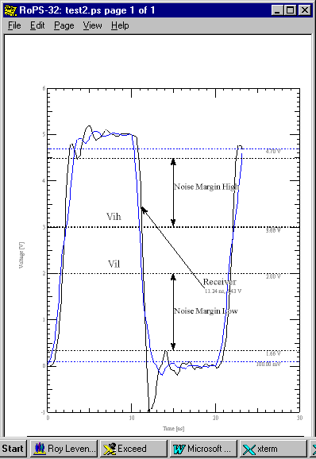

Monotonicity Requirements

A monotonic series of numbers is one that only increases or decreases - thus mono (one) tonic (direction). A rising or falling pulse edge is one that only rises or falls. There are no little reversals of direction during the transition from low to high or high to low.

Simulators generally have a problem with non-monotonic edges. Some are more robust than others. The IBIS spec spells out requirements for monotonicity. It will help your understanding of the degree of monotonicity required by referring to it:

Monotonicity Requirements:
|
| To be monotonic, the V/I table data must meet any one of the
| following 8 criteria:
| 1- The CURRENT axis either increases or remains constant as
| the voltage axis is increased.
| 2- The CURRENT axis either increases or remains constant as
| the voltage axis is decreased.
| 3- The CURRENT axis either decreases or remains constant as
the voltage axis is increased.
| 4- The CURRENT axis either decreases or remains constant as
| the voltage axis is decreased.
| 5- The VOLTAGE axis either increases or remains constant as
| the current axis is increased.
| 6- The VOLTAGE axis either increases or remains constant as
| the current axis is decreased.
| 7- The VOLTAGE axis either decreases or remains constant as
| the current axis is increased.
| 8- The VOLTAGE axis either decreases or remains constant as
| the current axis is decreased.
|

Parasitics

Parasitic capacitance, resistance, inductance and time delay on a net are often extracted using a board signal integrity simulator. These parasitics, associated with the routed etch and the I/Os hung on the net are often managed (through design choices) by the engineer and board designer to achieve desired signal integrity and timing goals.

Current Requirements/Power Dissipation

Some signal integrity simulators, particularly those based on SPICE I/O models will calculate and extract power supply current requirements and on-board power dissipation as a function of switching activity.

However, I have a problem with signal integrity simulators based on SPICE I/O models. SPICE is primarily a linearized small signal model. I believe it gives misleading results (particularly on heavily loaded busses) for digital switching which is basically large signal and non-linear.

EMI

IBIS does not currently address EMI issues and data. The FCC (Federal Communications Commission), ISO 9000 and other agencies address EMI/EMC issues.

Signal Integrity 101

Tutorial - Courtesy of Cadence Design Systems

Cadence Design Systems has shared with me their Power-Point presentation of a "classical" transmission line tutorial to which I have added material of my own. This presentation can be seen in the separate document "Signal Integrity 101." It was too large to include here.

Signal Integrity Simulation Tools

As of today (5/1999) our mainline CAD and high speed digital circuit simulation tools are Allegro® and SpecctraQuest®, Version 13.5, by Cadence Design Systems, Inc. Although, a wide variety of tools such as those from HyperLynx are also in use.

What I have avoided is too close an identification with, and endorsement of, any vendor's CAE tools. Obviously, the particular tool you use and your skill in it will markedly affect your success in dealing with SI issues and even what you view as SI issues. But, that is a changeable affair and what I've tried to do is present the theory, art and practice of SI which is pretty much a known body of knowledge.

The explanation of how to use these CAE tools belongs to a separate publication. This subject is one that is better handled in detail by the tool vendors themselves. I do, however, intend to write up some specific instructions (getting started, 3Com-centric issues, etc.) in the future.

For now, the reader should be aware that Cadence has provide all of its help and tutorial documentation on-line or through Cadence courses. There is no set of printed or CD instruction manuals or tutorial separate from their courses or the purchase of their software.

If a license is available, you can go to context-sensitive Help or the

Help → Table of Contents → SPECCTRAQuest Tutorial

pulldown menu once inside the tool. Follow the directions once there although I don't consider the way they're written to be very intuitive. Once you get into the online tutorial a little ways it will get better.

What you will need from a NT machine is to X-Window into a server where the software is (I currently use jbond007).

From a UNIX machine I telnet to jbond007 after first setting > xhost + . Note: This only needs to be done once unless you logoff or reboot. Then, once logged on you:

> setenv DISPLAY your_ip_address:0.0

And, you will need a UNIX account with a .cshrc that contains:

alias spc 'specctraquest &'

setenv LM_LICENSE_FILE 5280@jbond007:/apps/licenses/data/folder.lic/license.dat:5281@149.112.102.15
(on one line)

set INSTDIR = /apps/tools/cadence/pe13.5
set TOOLSDIR = $INSTDIR/tools
set ALGROPATH = $TOOLSDIR/pcb/bin
set FETPATH = $TOOLSDIR/fet/bin
set VIEWERPATH = $TOOLSDIR/infotools/helpViewer/bin

setenv SKILLPATH $TOOLSDIR/dfII/bin
setenv CDBERR $INSTDIR/share/pcb/text/cbds_err.msg

set path = ( \
$TOOLSDIR/bin \
$ALGROPATH \
$FETPATH \
$SKILLPATH \
$VIEWERPATH \
$path )

Then, from the command line you can invoke specctraquest with 'spc.' I run it in background mode, so:

> spc &

EMI Control

EMI Technical Discussion

Introduction

EMI - electromagnetic interference - is a source of noise to other electronic equipment and outside sources can interfere with the proper operation of your equipment. It is a good general observation that equipment that is a source of unwanted problems is usually highly susceptible to outside interference. This is because EMI requires a source, a path, and a receiver. This completes an unwanted circuit, just as any desired circuit is completed. Any such complete circuit path is usually completely or highly bidirectional. Part of understanding this is realizing that the source, path, and receiver are all operating in each other's frequency range (or bandwidth).

EMI should be looked at as an unintended signal due to an unintended circuit. Common terms include sneak circuit and ghost circuit. A ghost circuit might be one that depends on a variable distance to a source of noise. An example is driving within a couple of blocks of a radio transmitting tower and having your automobile radio go bananas. The problem isn't caused by RF interference. It's due to electromagnetic induction directly from heavy currents circulating in the lower frequency sections of the radio station. A few blocks further away and the problem disappears because near-field electromagnetic strength drops exponentially with distance - not true for radiated signals.

The usual techniques for reducing EMI are to quiet the source and/or receiver and to interrupt the unintended paths.

We should also consider the different electrical systems intermixed in a piece of electrical equipment as well as sectioning the problem into source, receiver and path. There is the power supply and ground return system, the signal line and ground return system, the control signal line and ground return system, and in most equipment, an analog and a digital system each with their ground systems that should usually be kept separate.

Sources and Receivers

Quieting an EMI source most often means paying attention to the frequency spectrum of the signals it produces and the signal power produced at those frequencies. Not exciting higher frequency modes, spectrum shaping and reducing power levels are common techniques.

In high speed digital circuits this can mean reducing switching currents and voltages, clock speeds and edge rates unless they are truly needed. Reduced ringing has the same effect because it means that high frequency energy is being absorbed and not continuing to reflect and re-reflect in the source.

Quieting an EMI receiver most often means to reduce its bandwidth and noise sensitivity. Reducing bandwidth means it will not be as sensitive to as wide a frequency spectrum of signals. A slower switching part may not react to narrow, high frequency pulses (glitches). Input filtering can reduce such glitches at the receiver. Reducing noise sensitivity can mean choosing a receiver with a higher inherent noise margin, providing lower impedance ground returns, etc.

Noise Signal Paths

Noise in a circuit may be self-generated such as thermal (Johnson) noise, transmission line reflection noise or ground bounce generated at the driver. Or, the noise may be injected into the victim circuit by a "nearby" aggressor circuit.

There are three modes of injecting noise into a circuit. Conducted noise, coupled noise and radiated noise. They are three different physical phenomena having some characteristics in common and some unique characteristics.

An individual noise path element, for purposes of analysis, would consist of one type of element: conducted, coupled or radiated. Each existing path can be considered a branch of a larger, interconnected network of various noise paths. Each branch could potentially contain an EMI driver and/or receiver in it. Thus, you could have a noise network of a number of branches, nodes and loops using one or all three modes of injection. And, there is nothing that says that the elements would have to be connected as a simple ladder network.

Thus, the potentially very complex nature of noise analysis stands revealed. A given path from a particular EMI noise generator to a particular receiver can consist of a combination of conducted, coupled and radiated elements in various series and parallel combinations.

To solve, in a deterministic way, for the results of any one EMI problem corrective action may require extracting and solving the entire network. Discussions of the right action to take in eliminating noise often take on the flavor of the four blind men describing an elephant. This is because analyzing and extracting an entire noise topology before engaging in such discussions can be a very complex undertaking. This can make EMI reduction seem like a black art to nearly everyone. But, it is not. Everything that happens can be exactly predicted by known theory if you have the time and energy to do the job in a detailed manner.

What happens instead of a deterministic solution of the complete noise network is that various experts put forth various sets of rules that appear to me to often conflict and have conflicted with my own practical experience. I currently "subscribe" to the E-mail discussion group/exploder called SI-LIST. It includes some 800 engineers and scientists who are really into signal integrity issues. Some of the most respected names in the field participate. Often, the discussions about how to deal with a particular SI issue can be endless and occur over and over again. But, some common sense principles can be applied with a high degree of success. Just be prepared for occasional surprises.

Skilled Regulatory Engineering practitioners are pretty much of the opinion that following a few simple rules avoids 80%+ of the problems they see. Then, if you "breadboard and debug" (test for EMI and eliminate the residual problems) you are taking a practical approach to EMI noise reduction.

What, therefore, follows is a presentation of these simple rules. Even using these as a guide can be a complex task in a complex piece of equipment. So, I recommend the use of computer aided rule checking and computer aided analysis and simulation. This is not a substitute for thinking, but an aid for managing complexity.

Near and Far Fields: Coupling Vs Radiation

Close to a source the electric (E) field attenuates at a rate of (1/distance)³ and the magnetic (H) field attenuates at a rate of (1/distance)². The near field properties are determined primarily by the characteristics of the source.

At a distance of λ/2π (λ=wavelength) the field transitions from "near" to far with wave impedance, E/H, transitioning to its free space value of 377 ohms and wave shape transitioning to a launched plane wave.

Far from the source the field properties are determined primarily by the medium it is propagating through.

Conducted and coupled circuits follow Ohm's Law / Kirchoff's Rules, etc., out to very high frequencies. That is, they are usually looked at as lumped elements and circuits and the following applies:

Parasitic resistance: v = iR conducted or leakage
Parasitic capacitance: i = C(dv/dt) conducted or coupled
Parasitic inductance: v = L(di/dt) conducted or coupled

Where "parasitic" = unintended.

Radiated paths are first approached from the standpoint of a transmitting and receiving antenna.

Conducted Paths:

An illustration of a typical conducted path is that which gives rise to ground bounce. The impedance from the point you are calling ground (i.e. the buffer ground pin) to true (i.e. always zero volts) ground may be high enough to cause a voltage to appear when a switching current is injected in it. The conductive path does not behave in an ideal manner. Further, another buffer connected to the same ground pin will see any ground bounce voltage generated at the pin. The ground voltage thus generated is easily conducted to other parts of the design through the low impedance ground connecting nearly everything.

Because noise voltage on ground is common to all of your circuitry it is referred to as "common mode voltage."

A good, or clean, ground system is analogous to a good sewer system where all signals flow down the drain (return to source) without backing up.

Typical methods of dealing with conducted noise paths include interrupting them or separating them by providing separate return paths for noise current or lowering their impedance so that a given current doesn't generate a noise voltage.

Coupled Paths:

An illustration of a typical coupled path is that which gives rise to crosstalk. Crosstalk comes about when coupling due to mutual parasitic stray inductance and capacitance exist between two otherwise separate circuits.

Coupling occurs between two circuits that are close physically. Thinking about wavelength and radiation launched between one circuit and another would be misleading.
Thinking about electric and magnetic field lines linking the two circuits is closer to the physical reality. The coupled return current must flow in something.

There are two direct ways of dealing with coupled noise paths: separation (as discussed above concerning near fields) and providing a shunt (i.e. short circuit) for protecting one circuit from the other. This shunt usually takes the form of a shield completely surrounding the source or receiver of the noise. In PWBs this is usually not practical. Instead crosstalk is usually prevented by following max parallelism rules, minimum separation rules, running etch orthogonally on adjacent layers and placing interfering etch on layers separated by a shield plane.

A transformer is an example of where mutual coupling is put to beneficial use.

Radiated Paths:

An illustration of a typical radiated path is what happens when a distant TV transmitter interferes with your circuit. This occurs when part of your circuit acts like an antenna to pick up the broadcasted TV signal thus injecting noise.

A radiated signal has already been launched from an interfering source. You can either try preventing that or you can try preventing its effects. The usual way of interrupting the noise path is to try and interpose a (usually a high electrical conductivity, often highly optically reflective) shield plane between the source and receiver of the noise. This plane is supposed to act like a mirror and often does not need to completely surround the victim circuit. The higher the frequency of interference the more it needs to look like a smooth mirror with no gaps or holes.

Differential and Common Mode Signals

Consider first a pair of wires. The first wire connects the output of a driver (source) with the input of a receiver (sink). The second wire connects the "return" of the receiver with the "return" of the driver. Thus, we have a complete current loop (as we know we must have) out from the driver, through the receiver and returning to the driver. Further, we know that exactly as much signal current as flows out of the driver, no more and no less, must return to it since we cannot create or destroy charge.

The voltage at the driver drives the current down the signal line. The voltage difference induced on the circuit must be equal and "opposite" to the voltage difference on the circuit. That is, as we go from low to high (or vice versa) at the driver we go from high to low at the receiver, assuming low loss lines. Or:

*Figure 8: A Simple Transmission Line

This is our desired circuit operation. The loop of current produces a desired difference mode of voltage at the input terminals of the receiver.

What if the low and high side receiver terminals moved up and down in voltage together (with respect to some absolute zero/earth potential) exactly in sync and in magnitude? They would be moving in a common mode and produce no useful input signal. The voltage difference across the receiver would always be zero. No current would flow. No power would be transferred from the driver to the receiver.

However, whenever a transient voltage or current is impressed between power and ground there is always a possibility of setting up unwanted noise signals because of:

- Non-ideal (non-zero) ground and power circuit impedances
- Different path lengths and delays
- Coupling, especially unequal, to other circuits, especially "earth" ground
- Radiation from the power or ground system
- Etc.

Neglecting leakage current, a conductive mechanism usually insignificant in PWBs, two common mechanisms exist for forming this additional circuit: coupling and radiation. Indeed, they always exist. Capacitive and inductive coupling are powered by the electromagnetic fields set up by a current flow. Radiation can occur from a section of the circuit acting as a dipole antenna or by the differential circuit acting as a loop antenna.

Far from a well balanced differential circuit the electromagnetic fields tend to cancel because the current flow is equal and opposite. However, electromagnetic coupling from common mode currents are additive since they flow in the same direction.

Some "tricks of the trade" to avoid EMI include:

- The use of shields (image planes, guard traces, cable jackets, etc.) to cut down on radiated and coupled emission.
- The use of twisted pair cables to break up a large loops into smaller (higher frequency) self-canceling loops.
- The chassis grounding of a cable shield at only one end so as to interrupt any common mode continuous current loops that might be set up on the shield.
This is usually only done at lower frequencies. Here you want to complete the coupled path to a common system (clean) ground without including the receiver in that loop. This path then acts as a shunt. This is the idea of ground acting as a sewer to drain away unwanted EMI without running through your circuit.
At higher frequencies you want to induce a complete current loop on, and confined to, the shield. You ground both ends of the shield, so that the receiver is enclosed by the shield. Here, the current induced on the shield is an image current and the shield acts as a reflector of EMI.

Quieting Source and Receiver: EMI Suppression Components

High frequencies present in the spectrum of a signal are usually more of an EMI problem. Etch begins to act more like radiating antennas and there is more coupling signal passed due to parasitics. Therefor, it's common practice to filter out the troublesome high frequencies with EMI suppression components.

When this is done directly on signal lines you take a direct trade-off hit on circuit switching speed. This may be OK or not OK. When EMI suppression is done in the power supply it is for preventing high frequency signals from being conducted through the DC supply paths in the form of simultaneous switching noise or ground/power bounce.

There is usually a very good correlation between actions taken to prevent a driver from becoming a source of EMI and preventing it from being susceptible to EMI when viewed as a potential receiver. A high speed, high frequency driver is a potential source of high frequency noise = unwanted signals. It is also more sensitive to high frequency noise than a slower part.

However, not all design actions undertaken are totally "bidirectional" with regard to aggressor/victim of EMI. Power supply filters may not suppress equally well in both directions depending on how they are designed.

Conduction: Working From the Ground Up: Placement

The first weapon in a line of defense against EMI is placement. Critical nets are usually placed first. This affords the greatest opportunity for keeping etch length short, routing to avoid coupling, etc.

Placement also affords an opportunity for keeping incompatible circuitry such as a high speed, noisy digital circuit away from a sensitive analog circuit. Good placement can set up conditions where you can easily separate analog and digital ground systems.

Conduction: Working From the Ground Up: Multi-Point Grounding & Multiple Power Busses

Multi-point grounding is usually done on the theory that ground is at zero potential and low impedance throughout. This is often, but not always, true. It gives you the opportunity to keep your ground leads short, your ground impedances small and your ground bounce at a minimum at the I/O buffer.

Likewise, splitting up power supplies lowers the current demands on any given connection path inducing smaller voltages drops and less chance for coupling unwanted power bounce between circuits.

Often you see these ideas implemented at the large package IC level with several hundred and more I/Os. Such packages are set up with multiple power and ground busses.

Conduction: Working From the Ground Up: Single-Point Grounding

Single point grounding at a system level is where an "absolute" ground reference between power, digital, analog and RF subsystems (nets) is established. It is an admission that ground returns are rarely zero impedance and thus cannot maintain zero reference voltage throughout a system. Thus, unwanted coupling paths between nets that shouldn't share signals (noise) get set up.

A way around this problem is to set up separate ground returns to each subsystem in the form of rays emanating from a central point. Thus, complete ground loops connecting together the separate subsystems are eliminated along with the unwanted sharing of noise signals on ground.

Decoupling with Shielding: Layer Stackup

We have already discussed the shielding (image current pathways) effect that ground and power planes have. When the top / bottom layers on a board stackup are shields they contain EMI from all layers within them as well as shielding everything inside the stackup from outside interference. The shield planes are extended beyond the signal planes to prevent radiation and coupling out of the edge (fringing effect) of the stackup. The rule of thumb is to extend the shield 20 times the separation between the planes beyond the outermost signal runs.

In a multilayer stackup shield planes shield signals on separate layers from each other. On large, complex boards with several thousands of nets and cost tradeoffs to consider the stackup scheme can get equally complex and arcane. As well, achievable characteristic impedances, running nets perpendicular on alternate layers to avoid inductive coupling, maintaining a controlled (constant) impedance, routing, etc., all enter into the picture.

In addition, a closely spaced power-plane and ground-plane pair in the middle of the stackup is often done to provide a distributed bulk (buried) capacitance that is effective to very high frequencies.

Decoupling with Shielding: Fences, Cans, and Guard Traces

Guard traces (etch connected to ground) are most effective shielding between long parallel runs of etch on the same or adjacent layers. Multiple grounding of guard traces is recommended. Some people call such multiple grounded guard traces fences.

I refer to a copper wall connected to ground and extending up/below the board as a "fence". Such fences would normally go completely around the components comprising a portion of circuitry such as a high speed clock oscillator. They are intended to prevent direct package to package coupling on the surface of a board.

A shield room, or "can" takes the fence idea and puts a "roof" over the circuitry thus completely surrounding it with ground plane.

Shield wall materials are most often a highly conductive metal such as copper or tin plated steel, which is effective for higher frequencies. Such materials are effective for shielding electric fields. High permittivity metals such as steel are better for shielding against magnetic fields. So, you need to understand the nature of near field coupling, is it E or H, to make a good choice of shield materials.

The thickness and continuity of the shield affects all shielding capability.

When shield thickness drops below a few skin depths and/or source power increases the shield can begin to "saturate." This means that it will not attenuate the signal sufficiently. This is a rare problem in low power high speed digital circuits. But, can be encountered in RF transmitters where the shielding materials employed are often heavier.

Holes, seams, sharp corners and discontinuities also have a tendency to "leak" electromagnetic energy. In fact, coaxial cables with flexible braided sheaths can leak significant interference depending on their length, how they are bent, and how well the shield is connected to the board. Each opening can act as a small slot antenna radiating EM power just as any ground plane gap can. Perforated shields in the form of RF screen rooms have long been used as a lighter weight - "good enough" - alternative to solid shield rooms. They just don't attenuate as effectively as the solid rooms.

All of this can be brought down to a simple illustration for the digital PWB electronics design engineer:

There is a company that provides shield cans for incorporation into a surface mount board for reducing EMI radiated from the board. The can is five sided (bottom side open) with tabs that insert into the board and make contact with the ground plane. The top (in particular) is perforated with small round holes to provide visual inspection capabilities after solder reflow. The tooling costs for a custom-sized can are on the order of $10k - $20K and the per-unit manufacturing cost are in pennies. So, for a production run of a few thousand or more, the per unit added cost is still pennies. A "micro" shield room can thus be built around some critical piece of circuitry such as a high speed clock oscillator or noise-sensitive analog circuitry.

Typically, the shield cans provide 20db to 30db of isolation. In combination with traditional signal integrity techniques they can provide the margin necessary for meeting regulatory requirements.

Decoupling with Distance: Trace Separation

Near H-field drops off as 1/r³. Near E-field drops off as 1/r². So, if your EMI on your board is due to near field coupling, as in crosstalk, a little added trace separation is usually quite dramatic in reducing it.

Radiation: Faraday Shielding: Fences, Cans, Seams, Etc.

Most antennas radiate in all 3 dimensions. Electromagnetic coupling (near field) is also 3 dimensional. Depending on E-field (capacitive) or H-field (inductive) and mode excited radiation, or coupling, in all 3 space directions is not equally efficient by any means.

The effectiveness of a shield room is measured in the amount of signal attenuation in db it provides. Per the formula:

Attenuation = 10log(Pout/Psource)

An attenuation of 20 db reduces power radiated by a source to 1/10th of its strength. Typically, regulatory agencies issue specifications that call for radiated power spectrums
to be something like 50db below 1 watt across the signal spectrum.

This is a rare problem in low power high speed digital circuits. But, can be encountered in RF transmitters where the shielding materials employed are often heavier.

Grounding of Shields

A coaxial cable's return circuit is its shield or sheath. It must be continuous between driver and receiver or there must be some other ground return. In the case of a shielded pair (or shielded multiconductor cable, or board, or - - -) the shield may act strictly as a ground reference.

We already know from our previous discussion that single point (star) grounding can be very effective at frequencies low compared with the size of the structure in question. Likewise, grounding of a shield (be it Faraday room or cable sheath or ground plane) at one end or point is often done. At higher frequencies where the effect of ground impedance goes up both ends of a cable sheath should be grounded.

Again, the assumption is that the ground point supplied to the shield is low impedance and quiet. Otherwise, the shield structure can act as an antenna.

Radiation: Antennas, Apertures, Seams, Slots, Traces/Corners and Waveguides

Radiation of (and absorption of) electrical energy can occur more easily at nearly any kind of electrical discontinuity or structure. Part of the reason for this is the higher field intensities (concentration of field lines) at corners. Part of the reason is the presence of standing EM waves on structures approaching in size a significant fraction of the wavelength of the energy being transmitted. Signal reflections on the transmitting structure increase the amount of energy available for radiation.

Traces can act as antennas. Ground slots and apertures can act as antennas. The open dielectric around the edges between shield planes can act like the open end of a (horn) antenna waveguide, etc.

EMP

EMP is the acronym for Electromagnetic Pulse. EMP refers to the fact that if the power of a detected source of noise radiation is high enough it can completely disrupt, even destroy, the victim electronic circuit. The US military now routinely employs weapons that produce such high powered broadband noise.

Protecting against EMP can be very difficult. The model discussed for EMI indicates employing a heavy shield of alternating thick layers of copper and mu-metal (high permittivity). Such a shield would be in the form of a smooth sphere with as few, small apertures as possible.

Absorption, Attenuation and Reflection

Understanding how a plane EM wave passes from one material to another can be enhanced by picturing how light passes from air into water. Or, about how a pulse gets received at a receiver. Part of the energy gets reflected and the rest is absorbed (transmitted into) the receiving material. Some of the energy may be dissipated (attenuated) in the pin parasitics before reaching the intended device. Usually the attenuation is quite small.

In the case of light passed into water, some is reflected depending on the angle of incidence, the index of refraction, etc. The remaining fraction will be absorbed at the top layer of the water. At sufficient depth (and turbidity) all of the light will have been attenuated (meanwhile warming the water) and none will penetrate to the bottom. Because of the different propagation speeds of light in the two mediums, a post stuck into the water at an angle will appear to be bent at the surface and of larger dimensions underwater.

For an EM wave analogous effects based on material properties, mismatch at the material boundary and wavelength can be observed.

RF Layout Rules

Introduction

The following applies to "low frequency" RF circuits. These are signals perhaps up to 1 GHz in frequency content and edge rates. In the range of 1 GHz the transition from a lumped constant view of circuit behavior to a traveling wave distributed circuit view becomes inevitable. Circuit physical size and component characteristics influence this transition point.

If you are much above this frequency range, you must treat circuits as pulsed or continuous microwave. You will require knowledge of transmission line and microstrip, structures, waveguides, stub and quarter wave matching, etc.

The following guidelines are offered for laying out RF circuits up to a GHz or so.

1. Separate and shield analog and digital signals and ground returns from each other.

Separating two signal traces with ground traces is one technique. The ground trace shorts out coupled noise.

Depending on your requirements, you may need to separate shield digital and analog grounds from each other until you can tie them to a single reference ground for your system or subsystem. Care must be taken when separating grounds to include the capacitive effects between the different ground structures. Failure to include this effect may negate the ground separation.

A second method of blocking circulating currents is to use a common ground plane for both digital and analog circuitry and separate the power planes. Care must be taken to include physical distance isolation of sensitive analog signal traces and components from digital traces and components when using a common ground plane.

Other techniques include running signal lines of any length in twisted pair, shielded twisted pair, mini coax or coax.

One of the criteria used for going to shielded lines is when trace/lead lengths become an appreciable fraction of a quarter of a wavelength long at the highest frequencies present. At that point leads and traces begin to look like radiating and receiving antennae.

Another criteria are proximity. Closely spaced signal paths can be inductively and/or capacitively coupled. Capacitive coupling increases as separation decreases. Inductive coupling increases as the length of a parallel running of lines increases.

2. Separate and shield signal grounds and power ground returns from each other.

You're correct if you understand this to imply multiple ground, power and signal planes. Voltage and current noise, "glitches / ground bounce / power supply bounce," begin to really mess up your ground (power) planes because of finite ground and power supply impedances.

Part of this deterioration of impedance is "skin effect," the increased tendency for signals to not penetrate into a conductor. This rapidly raises the apparent resistance / impedance. At microwave, of course, electric and magnetic waves propagate almost entirely in the space surrounding the conductor.

Another way of thinking about what is happening at high frequency is to remember:

v = L(di/dt), i = C(dv/dt)

Therefore, at a given frequency (a given dt) as you raise power levels (the magnitude of dv or di), you induce more and more noise coupling due to parasitic inductance and capacitance.

3. Separate and shield input and output stages from each other

Particularly if there is any appreciable gain and phase shift (time delay) between input and output. Else, you may complete the loop on a feedback oscillator.

"Oldie - Time" RF construction techniques often employed continuous copper sheet ground planes, and, all enclosing copper walled cubicles for individual stages or subsystems in high gain, high frequency circuits. Signals were passed from stage to stage through feed-through filters/capacitors in partition walls. Such construction is still employed at true microwave frequencies today. But, it is expensive and expensive of real estate. Use it only when all other shielding techniques fail.

Today, using highly miniaturized components, where possible, avoids a lot of the need for this. Surface mount components in lower power circuits are a real plus. They help you avoid high parasitic R, L and C due to size, high phase shift due to time delay, and radiating antenna-like leads.

4. Minimize power line coupling stage-to-stage with bypass capacitors or power line filters or on-board voltage regulators.

Switching transients, "bounce," and amplified RF signals have an annoying tendency of appearing on your power supply lines as frequency content as signal levels increase. Once on your power supply, they will look like noise and ringing on your signal lines. They will then be amplified in any succeeding gain stages including digital logic. In analog circuits feedback oscillation can occur because of power line coupling

The common practice is to bypass power lines where switching and signal glitches are apt to appear. It is good practice to put these bypass elements (they can themselves radiate) on the power supply side of the board with their associated ground plane between them and the signal side of the board.

Additional techniques are to employ a Pi-section low pass filter with an input and output capacitor and series inductor on the power line. Employing a voltage regulator as an on-board, low impedance surrogate local power supply is another technique for quieting your power supply glitches.

Use of isolated power lands with low pass filters can further reduce circulating high frequency currents and power supply bounce. The land pad must be physically larger than the associated chip to which it is supplying power. Provide a low pass Pi-section filter by using input and output capacitors from power land to power plane to ground and a series inductor consisting of wire and ferrite bead. The ground plane must remain unbroken in the area of the isolated power land.

5. Treat stage-to-stage coupling capacitors and bypass capacitors as resonant elements, particularly for leaded components.

Recognize that capacitors have their own internal stray inductance and resistance. The bigger they are, the more parasitics they usually have. Certain types of construction, aluminum electrolytics, etc., are also worse for this. Thus, at some frequency they will become series self-resonant and begin looking like inductors. As you go still higher in frequency, most any lumped element will look like a complex network, which in fact it has now become, with many poles and zeros.

However, at series self-resonance a bypass element will have the lowest possible series impedance between its two leads. The technique is to then "tune" it to the frequency you are coupling or bypassing (coupling to ground). This is inherently a narrow band technique. It can be made more wideband by employing the largest capacitance with the shortest leads and highest Q available.

To increase the bandwidth of the coupling element, bypassing (paralleling) the main (center frequency) capacitor with a smaller (higher frequency) capacitor and a larger (lower frequency) capacitor was common in the past. This is one area where surface mount components can give a real advantage with their very low self-inductance.

Care must be taken when designing bypass circuits with multiple capacitor values to include parasitic resonances of circuit elements on the lumped effect of capacitors. Physical separation of capacitors and associated trace inductance must be included in the design simulation tp attain, true multi-frequency response from bypass elements.

Years ago (vacuum tube era), designers would use grid-dip meters in this tuning process. They would form a loop of wire with the capacitor's leads twisting them together at the point of contact. This would form a parallel-resonant circuit that could be tuned to the desired frequency by varying the wire loop size. When the loop is cut and spread at the point of contact the capacitor is then series resonant with its leads. The signal end of the resonated element is connected to the point where the noise energy is to be bypassed. The ground end of the bypass element is attached to a 'solid ground" not the end of a long board trace. The grid-dip meter served as signal source/antenna/loading detector for tuning.

6. Fan out ground and power traces rather than employing continuous copper if skin effect (ground loop) begins to be a problem.

A star, or asterisk (*) pattern, with the center as reference (system) ground point, serves to interrupt ground loops between its rays. The wide separation at the end of the rays is particularly effective for interrupting the loops. Circuits that must be decoupled from each other, except for amplification directly through signal lines, can be placed along different or opposite rays.

Here ground loop coupling can be minimized over employing a solid sheet ground plane. You may want to employ this once you reach frequencies where skin-effect begins generating ground loop coupling. Of course ground plane shielding between two signal or power supply layers will not be as effective.

7. Avoid sharp corners on traces or at trace ends.

Sharp bends, corners, junctions and square trace ends radiate more strongly. They act as high field points more prone to breakdown and they cause higher parasitic coupling. They also cause impedance mismatches and signal reflections. Round off everything you can on your layout.

Trace impedance at 90 degree bends in trace decreases by 50% over the equivalent impedance of a straight trace. Using two 45° bends separated by a minimum of two trace widths decreases the trace impedance by 20%. The best method of maintaining trace impedance at a comer is to use a bend with arc radius of 5 times trace width. This will increase trace impedance by less than 1%. Also, minimize via transfers between board layers for high speed signals. Via impedance mismatch is equivalent to a 90° bend in a trace.

8. Run controlled impedance, short, match terminated signal traces.

This should be obvious. Care should always be taken to run the shortest possible trace length. The exception to running matched terminated signal lines is when common mode induced cable radiation must be minimized.

To use this technique, the trace length must be a very small fractional portion of a wavelength (1/10th) or less. Or, care must be taken to minimize standing wave reflections at the source and load. Best results are obtained when the receiving load impedance is:

Z_{load} > 10X(trace + series source + ground)impedance

9. Replace your discrete circuit with a surface mount ASIC if you don't need the power, voltage standoff, etc.

If your circuit size gets down below the shortest quarter wavelength you have to deal with, you can stop worrying about a lot of this stuff. Providing all functions "on-chip" also lessens the impedance mismatch problems of package-to-pin-to-lead transitions. Another benefit of ASIC is to use high clock rates on-chip only for data manipulation data combining, etc. Slower clock rates can sometimes be used for data transfer on/off chip. This lowers the requirements for short, impedance matched traces.

10. Trust nothing to behave ideally.

Some examples will serve to make the point here:

# 1

A differential input video amplifier for a CRT had two delay equalizing delay lines on its input. Two coils of mini-coax formed these lines. For eight years the circuit behaved marginally. It had insufficient gain or oscillated. Yield on the video amplifier, when it worked at all, ran around 15%. Production was spotty.

The problem was cured when someone with practical RF experience noticed that the delay line coils had been placed around the neck of the CRT. Through this neck ran the video modulated beam current. This coil placement was handy from a mechanical layout point of view. But, the coax cable acted as a pickup antenna to form a feedback amplifier.

Coax cable outer shields are not ideal. They will have some small fringing field penetration of the sheath, especially when bent in a loop, into the space around the cable.

A second, often overlooked, physical constraint of coaxial cable braid is the weaving. Braid strands travel both inside and outside the shield ") plane" (actually a cylindrical surface) as the wire is woven around the core. Current induced on the strands can be induced into or out of the shield plane. This is a physical limitation of braided shielding and is not correlated to shield saturation. Therefore, at higher frequencies foiled mylar or semi-rigid coax is a better shield. Care with termination at the cable closure points must be taken. ⁽¹⁾

Yields on the video amplifier went to 80% after relocation of the delay line coils.

# 2

More isn't necessarily better. It's common for transistor manufacturers to spec beta ranges wide. If your circuit works fine with the low end of the distribution, it may not if you start receiving high end product. Gain will go up, but so will f_{t} (gain bandwidth). Excess phase shift and gain at the higher frequencies in the rest of your circuit may make it unstable.

# 3

Two different semiconductor makers may claim they make the same high speed digital part. But, ground bounce on one, usually due to lead frame and bounding wire differences, may be much worse. You cannot "get at" the internal package inductances and thus compensate them. You may have to sole source your digital part. This can turn out to be a source of future grief

An example of this problem was the use of 7F214 driver chips for an I/0 circuit. The Motorola chip used during product design, debug and certification worked fine. When a TI chip was substituted the board started causing failures of the FET receiver - transmitter switches on a daily basis. Testing finally found that the TI chip was self-oscillating at approximately 40OMHz. Other digital chips were amplifying the oscillation during transition times. The 500 milliwatt FET switches were actually being subject to over 5 watts of power at 400MHz.

# 4

A PIN diode antenna switch was being used to protect a sensitive, ultra low noise RF preamplifier input to a receiver. During a transmit sequence on a nearby transmitter, more than enough signal was picked up to back avalanche the base-emitter junction on the preamplifier. Over time this degrades the low current beta and noise figure of a BJT assuming the part isn't destroyed outright. The antenna switch was there to protect the front end.

However, the detected RF transmit pulse was being used to switch the antenna switch PIN diodes. It was an "iffy" proposition regarding whether the switch would switch before the preamplifier base would begin to avalanche.

Deriving a switching command and driving signal off the command logic that told the transmitter to turn on was a more reliable approach.

# 5

Lastly, consider the difficulty of protecting your circuitry against damage from xray tube arcs. You may seem to be shielded from such damage. But, a consideration of RF characteristics illustrates the challenge. Suppose the stored energy in the tube gets discharged through an arc.

First, the tube capacitance can be a couple of hundred pf charged to a couple of hundred kilovolts. Risetime on the discharge pulse can easily be on the order of 500 picoseconds or less. This is an edge rate of two GHz or more. Energy will be radiated and coupled as the arc finds its way to ground and circuit completion.

Now suppose we are linked to this discharge through a stray capacitance of 0.1 pf.

Then, i = C(dv/dt) = .1pf(100kV/.5ns)

The numbers say 20 amps of current will be induced through this parasitic capacitance.

The stored energy available is:

E = 1/2(CV²) = 1/2(150pf)(IOOkV)²

Or, 0.75 joules.

This energy source is capable of producing up to an instantaneous transmit pulse of 1500 megawatts for a very short period of time given the switching speed of .5 nanosecond. This depends on radiating structures, discharge impedances, etc., and assumes that all the energy is radiated rather than dissipated in other ways. This analysis also indicates why the internal burrs that are the usual cause of arc-over are usually vaporized by the arc.

If the total time of discharge on the tube is around 1/2second, the average power available for radiation is 1.5 watt. Again, how much is radiated or coupled depends on many factors.

This coupled energy source will look instantaneously almost like a constant current source. It will capable of inducing many volts of pulse energy across even small discharge impedances stuck in the pick-up path. These impedances will tend to be high because of the RF nature of the coupled pulse.

Note that the sheer magnitude of the switched voltage source and the speed of arc over produce results that make you disbelieve theory. That is, until real life shows you what kind of damage can be generated in an equipment rack from tube arcs, any low voltage circuitry in the vicinity of a tube arc, not thoroughly protected, will be cooked. An understanding of RF phenomenon is necessary if you're going to solve the problems involved in arc protection.

Note that the very first RF communications transmitters from Marconi's time, before DeForest invented the vacuum tube, were spark gap transmitters. High voltage units were discharged into a resonant "tank" circuit for generating a high power radiated pulse at the desired frequency.

EMI Design Rules

Three General Rules:

I. Design-in EMC performance, don't add it on later - As time-to-market and overall
development and manufacturing costs become more important, the small extra effort to design-in EMC performance will pay off in the long run with less re-work and faster compliance testing.

II. Do pre-compliance testing early and often - In order to incorporate robust EMC techniques, the problem areas must be identified (test early), and the evolution of a design must not subvert previously implemented protection techniques (test often).

III. Use the slowest logic you can live with - Fast edge rates are a characteristic of high-speed logic, containing lots of energy at frequencies determined by repetition rate, pulse width and on /off transition times. Don't increase your EMC problems by using super-fast logic for mundane low-speed functions!

Three Technical Fundamentals:

IV. Ground is rarely at zero potential - Ground planes on circuit boards and the
surfaces of enclosures cannot be considered as infinite "current sinks." They have circulating currents anywhere that ground is a return path. These currents, like all currents, generate fields that add to the total radiation.

V. Common-mode currents radiate through antennas - Common-mode currents use
cables as antennas. Keeping them inside a shielded enclosure controls them. All cables should be filtered and/or shielded at the point where they exit an enclosure. Terminating cables inside (at the board edge, for example) may allow currents to couple into them before they exit.

VI. Differential-mode currents radiate through loops - The self-shielding properties of
twisted pairs, coaxial cables' or circuit board transmission lines are diminished when open loops are formed. Radiation from a loop is proportional to its area, so keep it small. Best example: don't put V+ and V- on opposite edges of a p.c. board; the loop they create encloses a huge area! Route them side-by side.

Four Design Techniques:

VIL Separate radiating circuits from inputs and outputs - Don't make it easy for them to couple into cables that may act as antennas. Remember that power density diminishes as the square of distance: doubling the distance cuts the power by a factor of four, tripling the distance cuts it by nine.

VIII. Maintain shielding integrity - Slots and holes are obvious places to watch, but seams, welds and joints must be done right, too! (Note: paint and mechanical joints are the most common culprits.)

IX. Use filters properly - A simple ferrite bead is nearly useless in a high-impedance circuit, just as a bypass capacitor doesn't accomplish much in a low-impedance circuit. With an L-network EMI filter, be sure to put the shunt capacitor across the highest impedance side, and the inductance in series with the lowest impedance.

- Don't run currents across a slot - Don't forget that an open slot is equivalent to a wire dipole the same length as the slot; it's an efficient antenna. Signal currents that flow across the slot apply power to the antenna feedpoint, guaranteed to increase radiation. Find another route for those

Design Rule Driven EM Control Checking

Normally, the following rule checking is implemented with software:

Placement Rules

- Clock generators should be placed at the center of the region formed by the components they drive.
– Information.
- Connectors, and the components they are connected to, should not be closer than a specified minimum distance from other components not connected to the connector.
– Warning.
- Connectors, and the components they are connected to, should not be further than a specified maximum distance to the components they are connected to. This excludes passive and discrete components.
– Warning.

- Connectors should be placed in the lowest frequency regions available on the board. Critical high frequency components should not be placed in those regions.
– Error.
- Ground screws should exist between clock generators and connectors.
– Error.
- The components of each clock generator circuit (and other high speed high current switching circuits) should all be placed in their own floorplanned room. This will allow them to be physically isolated and shielded from the rest of the board.
– Warning.
- The boundaries of regions having different critical EMI properties should be fenced off with Faraday shields. The fences should be placed at specified sensitive distances to the boundary and have a required ratio of overlap with the boundary segments.
– Warning.

Associated Placement Rules

- Filter elements (capacitors, resistors, ferrite beads, feed-through filters, etc.) associated with particular elements (oscillators, connectors, power pins, etc.) will be placed immediately adjacent to the output or input pin of the element they are intended to filter as designated by the engineer. Thus, maintaining the shortest length of etch possible between the filter components and the element they are filtering.
- High frequency oscillators (clocks) are the worst source of EMI on a board. Their placement and the nets to the elements they supply are usually the most critical nets. These clocks and their critical output nets are usually placed first. One objective is to have the shortest length of interconnect etch possible. Another objective is often to have nearly equal etch length to all elements supplied with clock signal. This minimizes skew between clock signals.
- Large format chips (DSPs, ASICs, microprocessors, etc.) with their associated EMI critical signal nets are usually the next most critical elements to place. Such chips with very fast edge rate switching are the next worse source of EMI. They are often also the most susceptible to received EMI. As well, they are often high heat dissipaters.
- A common EMI shielding technique is to place a ground shape (sometimes a heat sink) on the component layer under a large chip in direct contact with its body. It is possible for such a copper area to act as both an EMI shield and a heat spreader. One consideration is to place such components near the edge of the PCB card where the copper area can come in contact with metal card edge guide rails. When thinking about employing this technique it's best to consult with the design engineer and Regulatory Engineering because the design choices can be technically complex.

Bypass Rules

- Bypass capacitors should be of specified types.
– Warning.
- High current, high speed ICs and switching transistors should have a specified minimum number of bypass capacitors per I/Os. These bypass capacitors should be of specified types.
– Error.

- I/Os and switching transistors should have their bypass capacitors a certain specified distance from their power pins.
– Error.
- Critical high speed, high current I/Os and switching transistors should use the arrangement of “3-parallel” bypass capacitors, discussed above, for bypassing.
– Error.
- Critical high speed, high current I/Os and switching transistors should not have the loop area of their power-ground paths greater than a specified amount.
– Error.
- The boundary between adjacent EMC regions having different frequency classifications requires a specified minimum number of bypass capacitors per unit length. . These bypass capacitors should be of specified types.
– Information.

Power and Ground Plane Rules

- Components shall be placed so as to cause the fewest number and size of voids, holes, slots and other discontinuities in the power and ground planes.
- The power and ground planes will cover the maximum usable (not counting edge keepouts, etc.) PCB surface area.
- Symmetrical ground shapes are to be placed under each clock generator. The overlap ratio between the ground shape and the package geometry areas at least .5 and there must be at least one ground shape under each quadrant of the package geometry. The ground shape must be associated with TOP or BOTTOM depending on where the clock generator is placed, TOP or BOTTOM.
– Warning.
- Z-axis separation between power and ground planes should not be less than a specified amount nor more than a specified (different) amount.
– Error.

DC Routing Rules

- Power trace segments longer than specified amounts are to be bypassed to ground. Longer power trace segments require a specified number of (equally spaced) bypass capacitors per unit length.
– Warning.
- Connector filters are to be connected to separate ground shapes separated by a moat and having only connector or filter elements connected to them.
–Error.
- The trace parasitic resistance between the voltage source pin (or power plane via) and the supply pin of an IC or switching transistor shall not exceed a maximum permissible value. Likewise for the ground pin.
– Error.
- The power and ground trace widths must be greater than a specified minimum amount.
– Error.

Signal Routing Rules

- Critical nets will be ranked by EMI and timing priority. They will be routed in order of those priorities.
- Critical nets are not to be routed within a specified minimum distance to a card edge. This distance may be different for buried (surrounded by shield layers) and exposed nets.
– Error.
- Critical net exposed lengths shall not exceed a specified amount.
– Error.
- Critical nets may not exceed their Manhattan length by a specified percentage.
– Error.
- Critical nets may not have more than a specified number of vias.
– Error.
- Critical net via to pin ratio may not exceed a specified amount.
– Error.
- All signals running to a connector must be filtered.
– Warning.
Critical net to connector net crosstalk cannot exceed a specified amount.
– Error.
- Nets routed over clean ground shapes must cross the moat at right angles and have a minimum etch path length within the clean ground shape.
– Error.
- Critical nets must not be routed through connector footprints.
– Error.
- Clock nets should be paralleled by grounded guard traces. Separation must not exceed a specified distance.
– Warning.

Signal Quality Rules

- Clock frequency spectral content may not exceed a specified spectral content envelope variable.
– Warning.
- Critical net overshoot and undershoot should not exceed a maximum percentage of the voltage swing.
– Error.
- Critical nets must be terminated when the driver rise/fall is less than twice the propagation delay.
– Error.

- Differential mode EMI for critical nets routed on external layers shall not exceed a specified amount.
– Error.
- Total differential mode EMI for a board shall not exceed a specified amount.
– Error.

EMI Simulation Tools

To invoke the Cadence SI tool (SpecctraQuest) see the Signal Integrity Simulation Tools subsection above at the end of the Signal Integrity section.

Cadence SpecctraQuest v13.5 now includes a single-net EMI emission simulator. It is invoked from the

Analyze → SI/EMI Sim → Probe pulldown menu

When the Probe dialog box comes up pick/enter a net to analyze and go to

Reports

When the SigNoise Report Generator dialog box comes up pick/click on the
Single Net EMI radio button.

This report computes differential mode peak radiated emissions from a single net throughout a design taking into account shield layers, Fast Fourier Transform spectra of the signal and its reflections, etc. You can select emission standards and generate reports showing compliance. The current (6/15/99) emission standards for individual PCBs that 3Com Carrier R&D is working to are:

FCC 15 Class B and EN 55022 Class B

The radiated specctra can be viewed from the Waveforms dialog box. Choose the EMI_Single tab, select the waveform_result_db.sim and view it. This will allow you to do an EMI qualification simulation on a virtual prototype board.

For ground/power bounce or SSN (Simultaneous Switching Noise) Cadence plans a "Power Plane Builder" and "EMWave Window" license/software. This software will extract non-ideal (real) models of power/ground plane impedances and it will simulate their electromagnetic behavior. This will allows you to (virtual) prototype your power distribution, bypassing and switching noise accurately. As of Cadence's v13.5 release you can observe shield plane EMI "hot spots" on a plot similar to a thermal profile. But, extraction of quantitative data is not yet ready.

Interpreting the Results

Introduction

EDA is an acronym for "Electronic Design Automation." Simulation of the behavior of a circuit produces results (data) that are examined to see if design goals will be met. If EDA was all that automatic, a computer could be programmed to produce the design. Once the programming was done we could sit back and let the machine turn out future designs at less cost, faster with fewer mistakes.

Not likely to happen in my lifetime. Although, I'm grateful for the aid that computers can provide and some tasks can be automated. But, what signal integrity analysis involves are some of the world's most complex technical issues.

In addition, close attention to unexpected results has to be exercised. Is the input data wrong? Is there some subtle, unexpected way in which the board was routed that gives puzzling results? Also, what constitutes a "good" waveform and a "bad" waveform? Is there a novel and effective way that I can solve a noise problem? And, so forth. A lot of the questions involve judgement calls and creativity.

A series of "lab exercises" will next help bring the judgement call issue into focus.

Waveforms

Examples and Value Judgements

Try to first answer the questions I pose - yourself - in the following examples, before referring to the answers I provide.

Lab 1

Suppose you get the following results from simulating reflections on a net (NET 4). First, the net will be simulated from the board layout (tutor.brd) database (test 1). Second, the net will be extracted into a schematic/physical viewer (net4.top) and simulated from there (test 2).

The first thing you notice is that the waveforms are not exactly the same even though the exact same IBIS models and the exact same simulation engine were used for the two tests.

Why?
Figure 9: Tutor.brd Layout
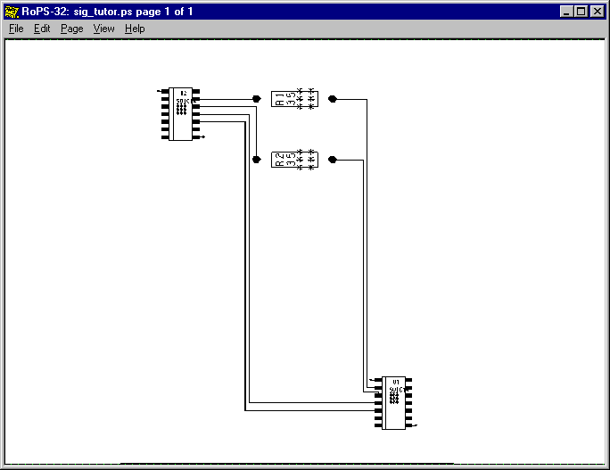

Figure 10: NET4.top Topology

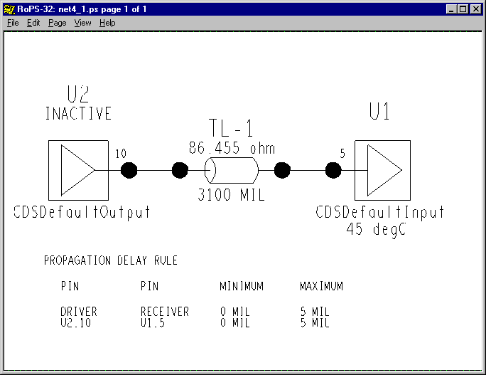

Figure 11: NET4.top Signal Reflections: test 1

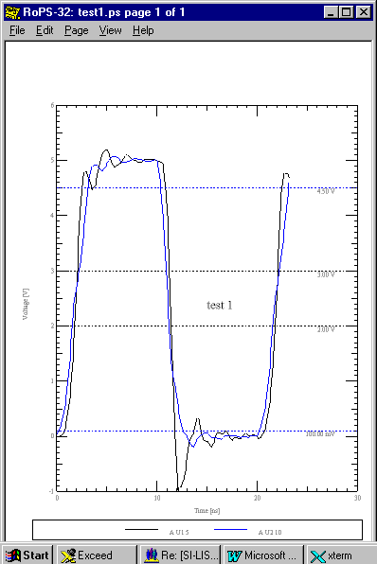

Figure 12: NET4.top Signal Reflections: test 2
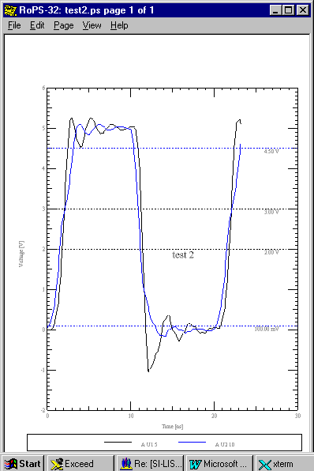

Answer:

We are dealing with a very simple board here. First, it has a simple stackup with only two signal routing layers. Both are targeted to about Zo = 86 ohms.

Net 4 is the first vertical etch line on the left of the board going from left to right. You might notice that it appears wider for the vertical portions than for the horizontal portions. That is, you might notice if you are a nit-picky engineer like all of us are supposed to be. Closer examination would confirm this suspicion. What does this matter? Well, it should start the suspicion that we are dealing with an "unexpected result."

Let us next extract the net into the schematic view tool with the routed etch option. What we get is:

Figure 13: NET4.top Topology with Extracted, Routed Etch
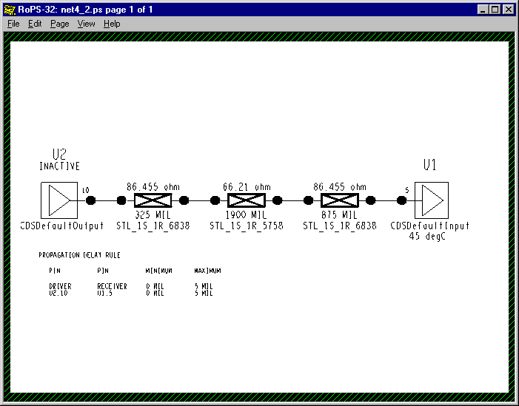

Now we see that we do not have uniform etch with a uniform Zo of 86.455 ohms. So we have some additional mismatch reflections in the actual vs. the pre-layout etch. Now we can confirm that we get the exact same reflection simulation results (test 3).

For unexpected results, expect the devil to be in the details.
Figure 14: NET4.top Signal Reflections with Routed Etch: test 3

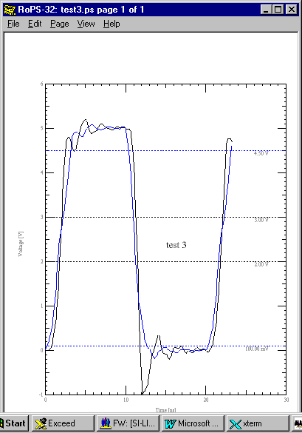

Lab 2

Next we will consider whether such a small difference is such a big deal. Consider what happens when we make Net 3 and Net 4 a differential pair.

In case 4 we have nets 3 and 4 hooked up as differential pair. These two nets are routed side-by-side together. That is how you would expect to route a differential pair.

But, net 4 still has that troublesome step down - step up in impedance due to the change in etch width. So, the two sides of the differential pair have dissimilar topologies due to changes in characteristic impedance.

You can see a considerable difference in the ringing when you drive high Vs when you drive low. Consequently, there will be a common mode voltage to reckon with and you have lost one of the chief advantages of using a differential pair net.

Now, in case 5 we have the same situation with the width of the vertical etch set to match (narrowed from 12 mils to 6 mils etch width) the rest of the etch run at 86.455 ohms Zo. You can see that the ringing is symmetric on both sides of the differential net.

Figure 15: NET3 & NET4 as a Differential Pair: Signal Reflections: Case 4

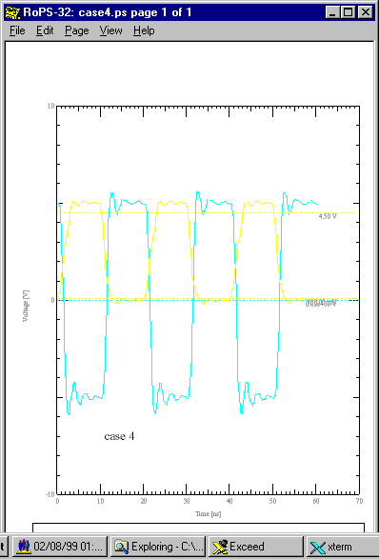

Figure 16: NET3 & NET4 as a Differential Pair with Balanced Etch:
Signal Reflections: Case 5
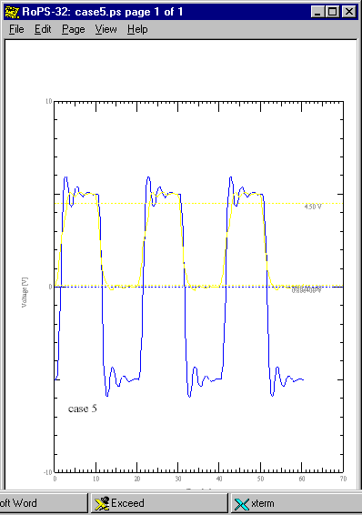

Lab 3

Next, we will look at two waveforms and discuss what we mean when we say one is "good" and one is "bad."

Obviously, Run 24 is good and Run 25 is bad. But, is that so in an absolute sense and why?

Figure 17: A "Good Waveform:" Run 24

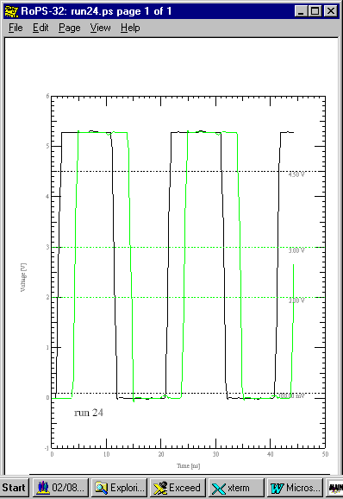
Figure 18: A "Bad Waveform:" Run 25

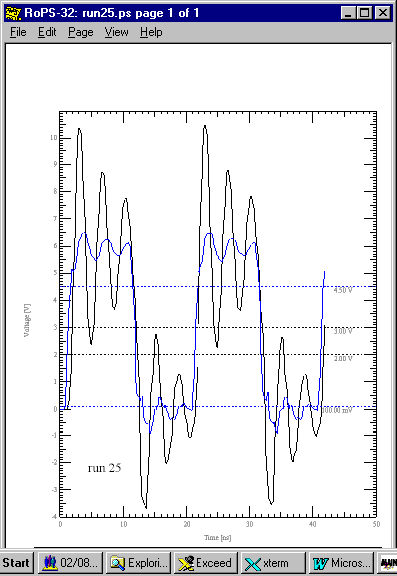
Answer:

The answers are that:

Yes, the first waveform is good in an absolute sense, because:

- There is no appreciable ringing of any consequence, hence a noise margin that is as large as the entire inherent noise margin available from the part is available on the net;
- There is no appreciable loss of drive pulse amplitude at the driver or the load because of insufficient driver capability, and;
- There is no loss of edge rate speed due to capacitive line loading.

How often is a designer likely to see such ideal performance? This ideal performance is not common. It represents what you get from an ideally terminated transmission line without lots of T-junctions/stubs, a driver with low output impedance compared to the line being driven and line lengths relatively short compared with the highest frequencies present in the driver pulse. Further, noise from crosstalk and ground bounce is apparently not a problem here.

Achieving such perfection in the switching waveform of a circuit is esthetically pleasing. But, is it realistic? Probably not. At least not in practical terms like schedule and cost.

And, the second waveform is bad in an absolute sense, because:

- Initial undershoot ringing on both rise and fall is large enough to cross Voh and Vol respectively, hence false switching is guaranteed to occur;
- Ringing is bad enough that a DC steady state is never achieved either on turn-on or turn-off, and;
- Overshoot ringing on both turn-on and turn-off is actually high enough (2Vcc to -Vcc) to actually damage the parts over time when run this way.
RF engineers see this kind of ringing as "high VSWR (Voltage Standing Wave Ratio)," a known cause of stress damage to drivers.

How realistic is the second waveform? Well, it's a bit extreme and I wouldn't expect to see it often in practice. The waveform shows what happens with a pure 6 pF capacitor as a receiver (no resistive loading and damping and no diode clamps) on a transmission line. Also, the line is short (0.5 nS) enough to look 1/4 wavelength resonant to some frequencies present in the driver pulse. Thus, an exposed run of etch is apt to be an efficient radiator of EMI.

Ignoring the signal integrity problems of such a waveform guarantees serious product problems.

Lab 4

Finally, we will talk about when a waveform is "good enough."

Obviously, you will want to make your noise margin and time delay design objectives with some cushion. If you do so, the fact that your waveform may show some ringing may be something you'll just have to live with. Also, Remember that undershoot, on both
turn-on and turn-off is likely to be more of a problem than overshoot. Undershoot is more likely to cause false turn-on and turn-off triggering. Clamping diodes are often present and will usually limit overshoot effectively.

Following is a waveform that isn't totally clean but is reasonable from a signal integrity point of view. Overshoot excursions are somewhat worse than undershoot excursions and there is plenty of noise margin at the receiver even if the result is a touch ugly:

Figure 19: Small Mismatches
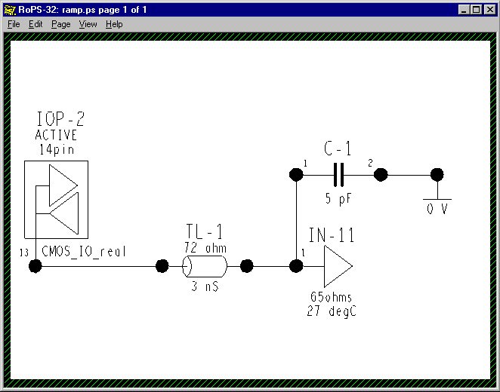

Figure 20: "Good Enough?"

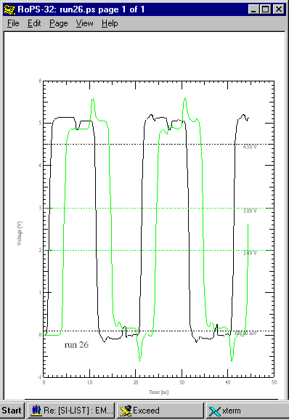

Waveforms at the Die vs. Waveforms at the Pins

So far, we have been discussing waveforms, reflections and matching as things appear on the etch trace connecting a driver package and a receiver package on a PWB. For understanding what waveforms appear at, or on, the die’s connection pads consider that:
The die bondwire, package pin, etc. are usually physically too small and too short electrically to act as transmission line structures.

The values of C_pin, R_pin, L_pin and C_comp can be large enough to act as a filter to waves entering or leaving a die as that wave propagates through that package filter structure.

Measurement Reports

Waveforms give you a big picture look at signal integrity performance. But, they are imprecise in normal circumstances. It is difficult to "eyeball" how much overshoot (say) you have, down to millivolts, in a given simulation you have just run compared to one just previous. Second, waveforms don't lend themselves to looking at many network points at once to compare, for example, first switch delay at all of them. For precision and further data analysis you want a measurement report.

Setting up cursors on the waveform graph is time consuming and still prone to larger errors than letting the simulator run the measurements for you in a report.

Following is an example report from an example signal integrity simulator:
Figure 21: Measurement Reports

#############################################################################
# Report: Standard Reflection Summary Sorted By Worst Settle Delay
# Mon Jan 25 16:14:12 1999
#############################################################################

CASE 1: 1000 mil stubs, 63 ohm system, no RC termination,
8 MHz, 33 ohm pullups, open_drain IO, 18 boards
load11.top

************************************************************************************************************ *******************
Delays (ns), Distortion (mV), (Typical FTSMode)
************************************************************************************************************ *******************
XNet Drvr Rcvr NM NM OShoot OShoot Switch Switch Settle Settle
High Low High Low Rise Fall Rise Fall Monotonic
------- ----------- ---------- ------ ----- ---------- --------- ---------- ---------- ---------- ---------- --------- --------- ---------- -------
1 A MD7 A IOP-73 31 A IOP-90 1 272.4 336.1 1697 443.6 11.09 9.129 12.02 9.861 PASS
1 A MD7 A IOP-73 31 A IOP-89 1 265.6 344.7 1692 441.3 10.78 8.717 11.67 9.458 PASS
1 A MD7 A IOP-73 31 A IOP-88 1 288.8 353.3 1669 441.3 10.44 8.236 11.3 9.023 PASS
1 A MD7 A IOP-73 31 A IOP-87 1 298.4 327.8 1664 433.2 10.11 7.849 10.94 8.557 PASS
1 A MD7 A IOP-73 31 A IOP-85 1 299.5 335.8 1642 435.8 9.636 7.422 10.47 8.358 PASS
1 A MD7 A IOP-73 31 A IOP-86 1 267.4 304.8 1632 388.1 9.286 6.797 10.04 7.97 PASS
1 A MD7 A IOP-73 31 A IOP-84 1 273.9 295.1 1627 441.9 8.844 6.626 9.694 7.479 PASS
1 A MD7 A IOP-73 31 A IOP-74 1 58.14 110.5 1753 455.2 5.063 2.26 9.571 2.846 FAIL
1 A MD7 A IOP-73 31 A IOP-83 1 231.3 233 1654 419.5 8.376 6.412 9.266 7.224 PASS
1 A MD7 A IOP-73 31 A IOP-82 1 245.1 269.9 1630 449 8.063 5.868 8.903 6.647 PASS
1 A MD7 A IOP-73 31 A IOP-81 1 227.3 236.6 1649 459.7 7.643 5.418 8.525 6.101 PASS
1 A MD7 A IOP-73 31 A IOP-80 1 227.3 252.7 1636 420 7.358 4.917 8.083 5.704 PASS
1 A MD7 A IOP-73 31 A IOP-79 1 221.8 232.6 1621 462 6.825 4.57 7.653 5.34 PASS
1 A MD7 A IOP-73 31 A IOP-78 1 175.2 218.2 1645 454.5 6.442 4.145 7.227 4.92 PASS
1 A MD7 A IOP-73 31 A IOP-77 1 207.8 175.8 1646 477.8 6.201 3.651 6.936 4.297 PASS
1 A MD7 A IOP-73 31 A IOP-76 1 169.1 174.5 1673 452.7 5.762 3.227 6.54 3.859 PASS
1 A MD7 A IOP-73 31 A IOP-75 1 198.2 335 1653 467 5.319 2.582 6.052 3.746 PASS
----------------------------------------------------------------------------------------------------------------------------------------------------------

*********************************************************************
Simulation Preferences
---------------------------------------------------------------------
Variable Value
------------------------ ---------------
Pulse Clock Frequency 8MHz
Pulse Duty Cycle 0.5
Pulse Step Offset 0ns
Pulse Cycle Count 2

I tend to use both measurement reports and waveform plots. They complement each other nicely.

Decisions and Implementing Them:
Topology Templates and Constraint Management

Death by Analysis

Death by analysis means overdoing it.

Understanding and accepting real world effects, rather than hoping one more simulation will make a problem magically disappear, is not smart. For instance, high frequency reflections at stubs are a reality that may require ramp controlled clocks and/or different bus architecture.

Another way to overdo analysis is, for instance, struggle to get a noise margin of 200mV Vs 190mV. The precision in the modeling and simulation process doesn't warrant such nit picking. You need to think clearly about the criticality of not meeting that goal. As well, you may need a strategy that makes your design robust and jumps you to a noise margin of 300mV rather than struggling over 10mV more at the margins.

Finally, is analysis necessary at all? Do you need to analyze a short, low frequency net (say 100 KHz) and you have followed good design rules?

Focus your analysis on the critical nets.

Decisions

This design guideline has led you up to the moment of truth - making a design decision. Unfortunately, I cannot offer you help for the mystic moment itself. Once you make that decision you have a "design intent." The next step will be trying to get it implemented. How do you communicate your design intent effectively down the process flow?

Simulation software from "full service" EDA vendors usually is fully integrated with their schematic capture, board layout and other tools. Thus, design constraints you want to communicate to your board designer can be included right in the design database where these issues can be flagged. These design constraints can be communicated in three main ways. Constraints on:

- Topology - the geometry and termination of the net.
- Electrical Properties - such as delay in nS, Zo, noise margin, etc.
- Physical Properties - such as etch width, minimum etch spacing, etc.

Topology Templates

Once a topology has been designed, say a far-end star, fan-out of three, with shunt termination and a Zo of 65 ohms, it can be assigned to a list of nets that should be routed and terminated in that fashion. Then, when the PC designer clicks information on the "ratsnest" etch connecting those pins, a form with that information pops up. He/she can then modify the design rule checking (DRC) that will be applied to those nets during routing.

Electrical Constraints

Some common electrical constraints that can be set are:

Impedance
Impedance tolerance
Max overshoot
Max crosstalk
Max peak crosstalk
Max simultaneous switching noise
Min noise margin
Delay rules (Actual (typical), min , max) in nS
Match delay
Net schedule and priority
Max stub length
Max via count
Max parallelism

These constraints can be set by net or globally.

Physical Constraints

Some common physical constraints that can be set are:

Spacing:

Line to line
Line to pad
Line to via
Line to shape
Line width
Pad to pad
Via to via
Via to pin
Shape to shape
Shape to shape
Shape to pin
Shape to via

Line width
Minimum B&B via gap

Differential Pair:

Length tolerance
Secondary length tolerance
Primary max separation
Secondary max separation

These constraints can be set by layer, pin type, or globally.

How Simulators Behave

Introduction

This entire section is written to provide greater insight into IBIS models and what should be included in a given IBIS model. This section does not address the IBIS model directly. But, the “end game” of using an IBIS model is to simulate signal integrity issues inherent in boards, connectors and cables.

To illustrate: If I assert that output pulse frequency content is a critical consideration for signal integrity, unless I have some understanding of transmission lines, reflection coefficients and capacitive loading, I will not have much understanding of the merits of the various elements of the IBIS model.

Transmission Lines, Reflection/Bounce Diagrams

The transmission lines are solved and simulated by closed form algorithms, or in the better simulators, a field solver. “2-1/2 D” field solvers are most common. These simulators solve and derive the RLGC matrices for a given section of interconnect where physical dimensions, etc. do not change. One of the “end products” of this geometrical field solution of a transmission line is its characteristic impedance, Zo. Other “end products” are coupling impedances to neighboring lines, propagation velocity, and propagation time.

The concept of a reflection diagram solution of the reflections and re-reflections at each end of a transmission line with linear terminating impedances, and the sum of these reflections on the line, is fairly straightforward and familiar to most people with an electrical engineering background. The Bergeron method adds the (pre-computer, pre- data-table-lookup and interpolate) capability of constructing such a diagram for non-linear terminating impedances on the line. The non-linear driver and receiver impedances are represented by their V-I characteristics. The transmission line impedance is represented as a load line on the V-I graph and the resultant voltage/current and reflected waves can be found. This load-line method
Of solution given non-linear device characteristics is also familiar to most people with an electrical engineering background.

A Mr. Bergeron gets the credit for developing this technique. He was a mechanical engineer who needed to analyze the water-hammer effect in steam lines well before the era of electronics. For an excellent explanation of the method applied to transmission lines, see:

Ch. 4: Non-Linear Sources and Loads
“Transmission Lines in Computer Engineering”
Sol Rosenstark
McGraw-Hill c1994
ISBN 0-07-053953-7

Newton-Raphson

Most digital computer simulators use a variation of a solution algorithm called Newton-Raphson. A feature of this method is that, in converging on a solution for the next point on a solution curve, a prediction (guess) is made of where that point is based on the rate of change at the current point.

This presents obvious difficulties at sharp, discontinuous jumps between a steady state high-low low-high as is commonly found in digital signals. Sometimes the problem is convergence to a solution. Sometimes the problem is lack of resolution (detail) at the discontinuity. Sometimes the problem is computer time if fine resolution appropriate at a discontinuity is continued for long period pulse trains.

The wonder is that simulator companies do so well in working with digital signal simulations on a digital computer.

Timing Driven Simulations

Timing information is not “officially” supported in IBIS. However, most simulators take the IBIS data and are able to simulate First Switch, Final Settle, Noise Margin, Buffer Delay, Propagation Delay and Clock Skew with it. The addition of clock-to-output, minimum setup and hold, clock period and jitter, clock skew (either from static timing or in verification thereof) and the prediction / constraint of propagation delay allows some signal integrity simulators to verify setup and hold margins.

Timing driven simulations references timing information from logic simulations to determine the sequence of how a set of drivers turns on and off. This information improves the simulation results for crosstalk and Simultaneous Switching Noise, SSN (ground bounce), rather than the simplistic assumption that all drivers turn on and off together. This will probably give an absolute worst case induced switching noise result. But, this approach can end in an overly conservative design.

We are beginning to consider Signal Integrity Methodology issues such as whole board simulations and timing driven simulations. This is because we have found our designs too complex to be able to reliably count on engineering judgement as to which nets simulate and which to ignore so as to avoid problems.

How to Tell if the Effect of C_comp is being Double-Counted

The simulation of an IBIS driver model is supposed to include the effect of C_comp in the slew rates and/or V-T curves as mentioned previously. Varying C_comp is supposed to have no effect on driver rise and fall as opposed to adding a variable capacitance across the output.

One way to test this is to reduce C_comp to zero and then raise it to a very large value, say 50 pF. C_comp may be getting “double counted” in a simulation if you see the buffer rise time change as it is varied. If you see such results, I suggest you simulate the rise and fall time of the IBIS test fixture with the correct values of C_comp entered in Min-Typ-Max to see if you reproduce the IBIS slew rate and/or V-T curves. Remember to use the IBIS values, as the data sheet values are usually “guard-banded.”

Algorithms Vs. Field Solvers

I use the term algorithms to loosely refer to results calculated from a formula as opposed to, in this instance, first solving for the electromagnetic field in a transmission line structure and then extracting the RLGC parameters of the field solutions on the way to finding Zo, etc.

Field solution results have been shown to correlate within a percent or two to measured results. Using algorithms often results in answers that are off by +/- 5% and sometimes as much as much as +/- 10% - depending on whose algorithm you use. Obviously, it’s better to use a simulator that uses only a field solver for extracting Zo, propagation velocity, coupling capacitance, etc.

The formulas that were developed to solve PCB transmission line structures stem mostly from empirical curve fitting research that started in the early 1950’s. This was before the availability of sufficient computing power to go the field solution route. The chief problem with their accuracy is that they only apply to situations that closely match those in which the curves were generated.

Most simulators use a “2-1/2 D(imension)” field solver to save on computing time and power. The field is solved in two dimensions in an x-y plane perpendicular to the etch in this approach. The velocity of propagation along the etch is then used in the z-direction. This limits the solver’s accuracy at etch transitions, corners, vias, split planes, etc. But, this is not of practical concern until you begin to switch at edge rates in the 100 pS range or less.

Data Sheets and Verification

Following is one example of verifying V-I type information. The circuit was simulated to verify a manufacture’s data sheet value of Vol Vs. results of using their IBIS model. A pullup current of 100 ma was set to match their data sheet conditions. The transmission line to the receiver was kept too short to enter into the result thus duplicating the discrete test fixture conditions. In arriving at the 11 ohm pullup resistor value to set up the 100 ma current the simulator was used to “empirically” arrive at the result. This is expected, since the output is not represented by a simple, linear saturation resistance.

A pulse is displayed below. It shows a Vol at 100ma Iol of approximately 1.0 volts vs. the data sheet specification of 1.15 volts Vol. This represents an increase of 47% in low state noise margin for the IBIS model over the data sheet. Calling the manufacturer revealed that the data sheet spec was guard banded by 200 mV.

Figure 22: A Simple Topology

Figure 23: Simulated Vol/Voh from an IBIS Model

Relation to High Frequency RF Analysis

Behavior that occurs from input to output of a device (such as amplification, etc.) is normally ignored. The focus and use of an IBIS model is what happens from Driver Output to Receiver Input across a transmission line. Behavior with frequency, gain amplification, phase, bandwidth, feedback, dispersion, etc., is inherently not a part of IBIS. The impedance matching and pulse shaping techniques available to RF engineers in the frequency domain are not readily available here. They require different models (primarily Scattering- (or, S-) Parameter), different simulators (Smith-Chart based for one) and different mathematics.

EMI

EMI – Electro-Magnetic Interference – is not addressed at all by IBIS. EMI concerns and signal integrity issues are unified in board simulations that take into account reflections, crosstalk, exposed etch length, radiation patterns, etc. IBIS contains no direct connection to EMI properties. IBIS also doesn’t contain package dimensions, lead dimensions and other information that would enter into an EMI simulation. The tacit assumption is made that the package is too small and the edge rates too slow to create EMI radiation.

Data Monotonicity and Convergence

Most simulators tend to choke when data is fed to them that is non-monotonic. While these simulators (often? usually?) produce signal integrity results that are non-monotonic due to ringing, noise and the like, they don’t like being fed IBIS models that are non-monotonic (often due to a SPICE simulation to produce the IBIS model). Some simulators will “filter” a non-monotonic model and smooth out or just eliminate the offending data points. Some simulators can tolerate small model non-monotonicities. But, in general they all have serious convergence problems with non-monotonicities.
The IBIS spec recognizes this and includes a serious write-up of what is allowable.

Test Measurements and Verification

Modeling Oscilloscope Probes for Simulation Results

The following topologies were simulated to illustrate the effect an oscilloscope probe might have on a circuit. The simulations were run to show rise time. Clock frequency was 50 MHz and the driver model used was the CMOS_IO_ideal model (presented before -contains V-T curves with sharp corners) under Fast simulation conditions:

Figure 24: A Simple Topology

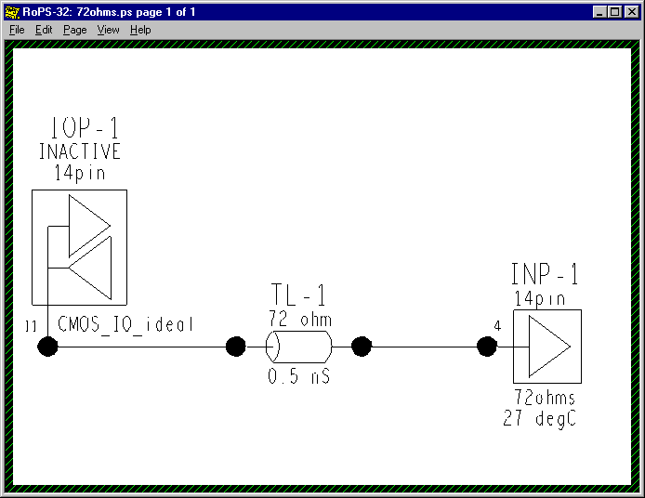

Figure 25: Reflections on a Simple Net

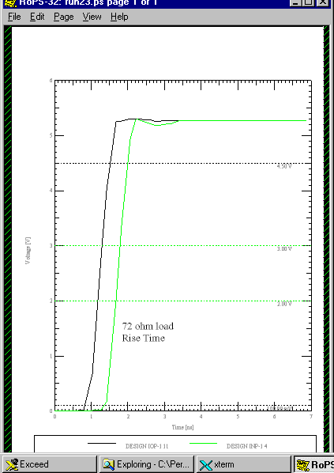

The first virtual oscilloscope modeled shows how a passive input probe of 2 pf input capacitance (7pf total loading capacitance) and a 10:1 divider ratio might look. Adding the extra receiver and its input circuit created this. Probe lead inductance for a 6 inch ground lead was modeled but, not the EMI noise pickup effects.

Figure 26: A Simple Net with Oscilloscope Probe
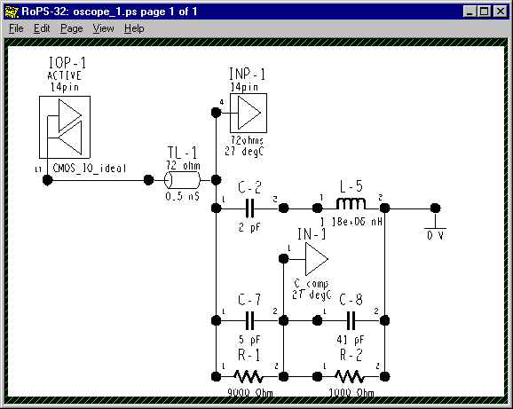

Recall:

Missmatch Introduced by Probe Capacitance

Frequency  (MHz) | |Xc| (ohms)
Frequency  (MHz) | 2.5 pF | 5 pF | 10 pF
625 | 101.92 | 50.96 | 25.48
1250 | 50.96 | 25.48 | 12.73

And, Reflection Coefficient, ρ, is given by:

ρ = (ZL – Zo)/(ZL + Zo)

And, on our 72 ohm line we get:

Frequency  (MHz) | ρ
Frequency  (MHz) | 2.5 pF | 5 pF | 10 pF
625 | .172 | -.171 | -.477
1250 | -.171 | -.477 | -.7

Figure 27: Reflections on a Simple Net with Oscilloscope Probe

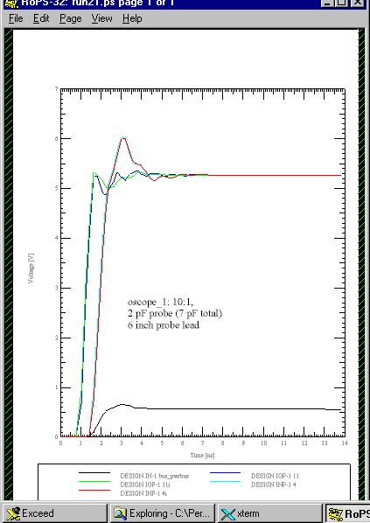

Pretty Amazing – What!

You can easily see the miss-matching of the line due to the probe and the rolloff of the scope.

The second virtual oscilloscope modeled looks more like how an active input probe of 1 pf total loading capacitance might look. A 2:1 divider ratio was used to give a better look at what the viewed waveform would look like. Probe lead inductance for a 1/2 inch ground lead and no EMI noise pickup effects was modeled.

Figure 28: A Simple Net with High Frequency Oscilloscope Probe

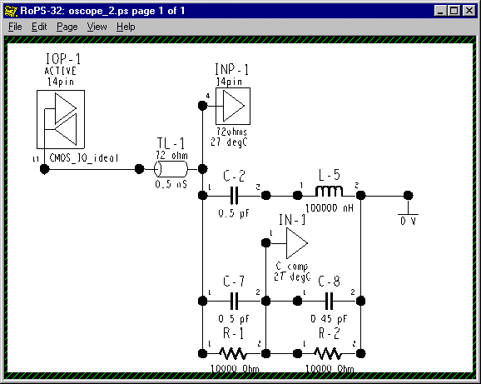

You may note that the probe may not be perfectly compensated. But, it’s pretty close.

Figure 29: Reflections on a Simple Net with High Frequency Oscilloscope Probe

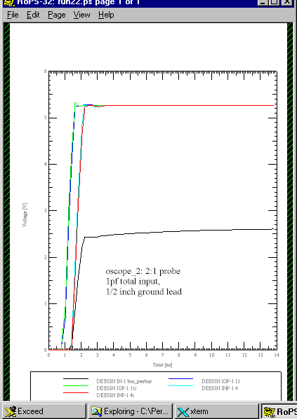

Model Accuracy, Precision and Verification

You can reproduce the V-T waveform tables, if provided, of your simulator to verify the accuracy of the simulator. That is, the waveform tables can also serve as “golden waveforms” to check the simulator with. Since the load conditions that produced the tables should be provided, the simulator should be able to reproduce those waveforms using the specified loads. The simulator can be said to be verified if the IBIS waveforms and the simulator waveforms agree.

A good verification study would have simulated and measured results agreeing within a few percent. To accomplish this you would need accurate model and measurement results within a few percent. You would also need to account for all primary, and at least secondary, effects at your switching speeds of interest.

This exercise does not verify the IBIS model, however. For that, the IBIS model should be checked for consistency with the databook/datasheet but, especially, verified with test measurements. The EIA IBIS Open Forum Committee has begun to address this issue by formulating an “IBIS Accuracy Specification.” As of this date, 1/8/99, it exists in Final Draft form and is in the process of being submitted for review and approval. We have copies and I have referenced it in “Creating an IBIS Model” and “IBIS Model
Requirements and Verification.”

Remember that high speed waveform measurement is a complex and precision science. It is easy for stray EMI pickup and other effects to mess up your measurements.

Plus, it is very difficult to ensure that the device you model is the device as built into the board you are measuring. For such reasons I advocate a statistical approach to verification studies. By that I mean you simulate an envelope of results using a population (model population) sample and see if the measured results fall within that envelope.

Definitions and Technical Notes

Ramp Data: Slew Rate

The various definitions and terms used to describe switching speed can be confused, because: 1) They have changed depending on usage (for example, the definition of Rise Time), and; 2) Minimum Rise Time corresponds to Maximum Rise Slew corresponds to Fast Switching and Minimum Fall Time - - - and so forth. Also, an IBIS file arranges its data columns Typ-Min-Max left-to-right instead of Min-Typ-Max which latter format most simulators and data books follow anyway. Formatting can get confused in the translation from databook to IBIS file to simulator file to simulator user interface.

The user has to understand the basic switching speed terms and definitions and remember to keep a few things straight:

Switching speed:

“Fast Rise Time” corresponds to minimum (Min) Rise Time (t_{r}) and
- maximum (Max) Slew Rate (dV/dt_r) and, for parts normally held low, minimum drive high/turn on time. Similar definitions hold for the fall time/turn off time. Note that holding a logic part low usually means that it is turned on and drawing current!

- “Typical Rise Time” corresponds to typical (Typ) Rise Time (t_{r}) and typical (Typ) Slew Rate (dV/dt_r) and, for parts normally held low, typical drive high/turn-on time. Similar definitions hold for the fall time/turn-off time.

- “Slow Rise Time” corresponds to maximum (Max) Rise Time (t_{r}) and minimum (Min) Slew Rate (dV/dt_r) and, for parts normally held low, typical drive-high/turn-on time. Similar definitions hold for the fall time/turn-off time.

Rise/Fall Definitions:

- Historical Definition of Rise Time (and similarly Slew Rate) was the time to go from 10% to 90% of the rail-to-rail (usually 0 to Vcc) swing at the output of a device. Similarly for Fall Time. This is still the convention followed by most of the electronics industry and data books in particular.

- IBIS Definition of Rise Time (and similarly Slew Rate) is the time to go from 20% to 80% of the rail-to-rail (usually 0 to Vcc) swing at the output of a device. Similarly for Fall Time.

Rise and Fall Times, Slew Rates, V-T Curves and Verification

The definition of Rise and Fall Times and Slew Rates and Switching Speed has already been covered in “Ramp Data: Slew Rate.”

Rise and Fall Times – IBIS - 20% - 80% of the full output Final Settle swing by definition.

Rise and Fall Times – Traditional - 10% - 90% of the full output Final Settle swing by definition.

Rise and Fall times for an IBIS model can be verified for an IBIS model by simulating the Data Sheet test fixture with the IBIS model and seeing that the measured rise and fall correspond to the data sheet. Sometimes you will want to have the simulator report the rise and fall time directly. At other times you will want to measure the rise and fall times off the simulator waveform curves. Many simulators have cursors that can be placed on the waveform to aid in this process.

What follows is the results of measuring the rise and fall off the waveforms.

When the model is simulated to yield the rise and fall times you usually have to make any “transmission line” to the receiver, i.e., “test instrument” so short as to not be a transmission line. That is so no reflections of any consequence would be set up as in a real test fixture.

Simulation  Model Mode | Simulated and Measured IBIS Model |  |  |  | Data Sheet
Simulation  Model Mode | 20%– 80% IBIS Definition |  | 10% - 90% Definition |  | 1.3 – 1.8 V - t_{t} Definition
Simulation  Model Mode | Rise (nS) | Fall (nS) | Rise (nS) | Fall (nS) | Rise (nS) | Fall (nS)
Slow | 3.72 | 3.58 | 5.99 | 5.84 | 1.99 | 1.69
Typical | 1.99 | 1.43 | 3.84 | 3.14 | 1.23 | .913
Fast | 1.6 | .886 | 3.0 | 1.23 | 1.16 | .627

Noise Margin

Noise margin is one of the most important considerations in signal integrity. It is a measure of the difference between an input switching threshold and the voltage on the input pin that may cause that input to switch again – unwantedly, due to noise on the waveform. There are two noise margins: Noise Margin High (logic state) corresponding to Vih, and Noise Margin Low (logic state) corresponding to Vil.

Figure 30: Reflections on a Simple Net

Verifying Your Simulator and IBIS Model

In addition to checking a simulator's results against a data sheet you may also want to know how accurate is the IBIS model - how accurate is the simulator? As in the former case, so in the latter case, verification can be a chicken-and-egg situation. Where are errors coming from if they exist?

The usual standard of accuracy is lab measurements on physical part/board samples. This can be a science in itself. Suffice to say, if you have a known accurate model it can be used to check simulator predictions against real measurements and vice-versa. Likewise, for an accurate simulator and measurements checking a model.

Another, far more common, thing to do is to verify the IBIS model simulations against a verified SPICE Model simulation.

An excellent white paper on model verification is the proposed IBIS Committee Accuracy Specification that can be found at:

http://ww.vhdl.org/pub/ibis/accuracy

Which leads to the object of any verification exercise: trust building. And, how do you know what part of a distribution your physical verification devices came from and their actual model parameters? Well, you can measure their IBIS parameters, simulate them and verify the simulations with measurements as well as carefully measuring the properties of the boards you built them on. All the while carefully tracking everything.

An alternative I tend to favor is to get a statistical sample of parts, predict and measure an envelope (sweep) of responses and look for a match between the predicted and measured envelopes.

Time and Frequency

An amplitude Vs time electromagnetic (EM) waveform can be observed when an observer with an oscilloscope probes a point on a circuit. As well, this EM wave propagates along the interconnects from its point of injection to other points in the system.

We do not experience the frequency domain, or dimension, as we do with space (distance) and time. But, to gain understanding about traveling EM waves, transmission lines, and how the IBIS model is applied, we often need to convert our thinking to the frequency domain. The mathematics that helps us make the transition back and forth between a time waveform and its frequency spectrum is called Fourier Analysis.

What we are aware of as electrical engineers is that any time waveform can be thought of as a particular combination of a set of discrete frequency sine/cosine time waveforms of various amplitudes and phases.
Once we make this transition we can start to answer how reactive impedance, characteristic impedance, skin effect, losses, dispersion, wavelength, reflections, electromagnetic radiation and interference and many other properties behave with frequency. And, having found these answers in the frequency domain, we can construct what is going on in the time domain.

Time, Distance and Frequency: Lumped and Distributed Circuits: Transmission Lines

We all recall that the velocity of an electromagnetic (EM) wave in air, or in free space is (denoted by):

C = 3 ∗ 10¹⁰ cm/sec = v_{p}

This wave may be partially reflected and partially absorbed (transmitted, received) when it reaches another medium or discontinuity, as in radar and microwaves.

If the time delay for the reflected wave to arrive back at the signal source is very short, the time element drops out except in terms of charging capacitors, establishing currents in inductors and turning devices on and off. Everything happens “instantaneously” around a given circuit and the mathematics for analyzing what is happening simplifies. Ohm’s law and Kirchoff’s Laws become the basis for thinking about what is happening. Such circuits are called “lumped” because their properties and behaviors can be modeled in terms of lumped elements (resistance (R), inductance (L), conductance (G), and capacitance (C)) with connections between them as ideal, property-less wires.

Propagation velocity and distance give the time, t_{p}, for an electromagnetic wave to travel from source to receiver:

t_{p} = Distance/ v_{p} = D/ v_{p}

For any reflected wave to arrive back at its source it takes twice t_{p} to make the round trip.

But, an electromagnetic wave will not normally propagate into a dielectric (non-conductive) medium. To do so, for starters, the source would have to begin acting like an antenna. This begins to occur when the dimensions of the source become 1/10 of a wavelength, λ , long or longer. The length of an electromagnetic wave, λ, in a propagating medium is:

λ = v_{p} /frequency = v_{p} /f

For lower frequencies electromagnetic propagation is pretty much confined to conducting wires and R, L, G, and C elements. At higher frequencies (radio, microwave, x-ray, etc.) wave propagation is chiefly by radiation of the wave. Losses in conducting elements become high at these higher frequencies and one is better off without such elements. Energy can propagate through dielectrics and / or be guided by dielectric structures very effectively until the x-ray frequencies.

In between the lumped element region and the pure radio/microwave region lies the region of chief interest to signal integrity engineers. In this region electromagnetic energy is normally guided along conductive paths but, is strongly affected by the properties of the surrounding dielectric medium. The connections that guide the energy become known as transmission lines. The energy penetrates only a short distance into (skin effect) the conductor and the electric and magnetic fields appear chiefly in the surrounding dielectric. The transmission lines can be modeled as lossless at the lower frequency end of this range and lossy at its higher end.

Propagation in a dielectric medium slows down. This fits intuitively because the electric property, per unit volume, of C is increased substantially over that of air. And, there is a time delay associated with energizing and de-energizing these elements. Expressing this, in a dielectric:

Velocity becomes lower

v_{p`} = C/(ε)^{1/2}

where ε = dielectric constant

ε = ε_{r`} = effective relative dielectric constant

where effective, ε_{r`} refers to whether the field lines are in dielectric (stripline) or partially in dielectric and partially in air (microstrip), and relative, ε_{r}, refers to relative to air

and, time delay increases

t_{p`} = D/ v_{p`} = (D/ v_{p}) ∗ (ε)^{1/2} = t_{p} ∗ (ε)^{1/2}

Working out the numbers:

t_{p`} = 85 ∗ (ε_{r`})^{1/2} picosecond per inch

and, wavelength becomes smaller

or, as we should really consider for our dielectric medium:

λ` = v_{p`} /f = v_{p} /(f ∗ (ε_{r`})^{1/2})

Our discussion of time, distance, frequency and wavelength leads to this question: what is the electrical length of a waveform feature that will start to interact according to transmission line behavior with the physical length of an interconnect? The electrical length of a feature, for example t_{r}, is given by:

L = t_{r} / t_{p`}

Systems small enough for all points to act in near unison to an EM wave traveling on them are lumped systems. Systems larger than that are transmission line systems. Reflections and re-reflections that travel back and forth on these systems can become a problem because they introduce noise on the waveform being transmitted.

The rule of thumb⁽²⁾ is that systems with:

D < (waveform feature electrical length)/6

Assuming a stripline with ε_{r} = 4.6 we get t_{p`} = 182.3 pS/inch.

With a t_{r} = 1 nS we get L = 5.5 inches.

A trace length of 915 mils is expected to begin behaving like a transmission line.

Note 2: My reference for this rule of thumb is found on page 7 of:

“High Speed Digital Design: A Handbook of Black Magic”
H. W. Johnson & M. Graham
Prentice-Hall c1993
ISBN 0-13-395724-1

Transmission Line Equations

Using the methods of differential calculus (the transmission line is divided into more and more, smaller and smaller sections until we can approximate its distributed behavior with cascaded lumped constant RLGC sections) we can derive:

Zo = [(R + X_{L})/(G – 1/X_{C})]^{1/2}

With X_{L} = j2πfL and X_{C} = 1/ j2πfC

For a lossless transmission line this simplifies to:

Zo = (L/C)^{1/2}

Where L and C are the per unit length (or, per unit volume in a 3-D sense) values of the transmission line inductance and capacitance.

Since we have already said that capacitance per unit volume in a dielectric medium increases it follows that microstrip Zo for a given structure is higher than for stripline. This is because only part of the EM wave travels through dielectric.

The reflection coefficient, ρ, expresses the fraction of the amplitude of an incident wave that gets reflected at a load or discontinuity. The load can be the intended receiver or the driver when a reflected wave reaches it. The load consists of the receiver (driver) – usually its C_comp - and any bias or terminating resistances. Discontinuities can be vias, corners, different Zo on different layers, stub T-points, etc.

ρ = (Z_{L} – Zo)/(Z_{L} + Zo)

RLGC Matrices

An RLGC matrix can easily represent the electrical model of any linear structure. This structure could as well be a transmission line, a connector, or the wire bond or other connections inside an IC package. Such a matrix can be a so called “single-line” model or one that includes the mutual coupling effects between package interconnects, or connector pins, or a group of etch lines on a board.

A full discussion of RLGC matrices only applies to the parasitics information included in an IBIS model under the [ Package Model ] keyword.

In general, you should know that in the [ Package Model ]:
- The matrix will be N x N where N = number of pins in the package.
- All the self-parasitic elements, a_{ii}, are on the main diagonal.
- All the mutual-parasitic elements, a_{ij} or a_{ji}, are off the main diagonal.
- In a large package with many pins Banded_matrix and Sparse_matrix are used to limit the complexity.
- The G matrix (leakage conductance) is usually zero or approximated to zero since its elements are usually extremely small.
- Most matrices will be symmetric and thus easier to mathematically manipulate.
- The R, L, G, and C matrices are combined into an impedance, Z, matrix by the simulator.
It is the impression of this author that the effects of most pin self-parasitics are inconsequential above 1 nS edge rate and most mutual pin-parasitics are inconsequential above 200 pS edge rate.

Resources & References

Web Sites:

Following is a brief list of web sites for Electronic Design Automation (EDA). For a more complete list see “Web Sites for EDA.”

3Com EDA Process Sites:

3Com Midwest EDA Page
http://pcbcad.rd.usr.com

3Com Midwest Component Data Base
http://149.112.202.10/3com_lib/

3Com Midwest ISO Documentum
wysiwig://14/http://3community/library

Signal Integrity Discussion Group:

Signal Integrity Mailing List
http://www.emclab.umr.edu/si-list.html

EDA Consultants & Publications:

High-Speed Digital Design (Howard Johnson)
http://www.sigcon.com

North East Systems Associates (Ed Sayre)
http://www.nesa.com

UltraCAD Design, Inc. (Doug Brooks)
http://www.ultracad.com

EDA Organizations and Links:

EDA Industry Working Groups
http://www.eda.org

EDA Consortium
http://www.edac.org/EDAC/edacFrameBody.htm

EMC Links
http://www.emclab.umr.edu/emclinks.html

EDA Software Companies:

Cadence Design Systems, Inc.
http://www.cadence.com/main.html

SourceLink (Cadence)
http://sourcelink.Cadence.COM/

HyperLynx
http://www.hyperlynx.com/header.html

ViewLogic
http://www.viewlogic.com

EDA Hardware Companies:

Boldt Metronics International (Faraday shields)
http://www.bmimetronics.com

California Micro Devices (termination devices & networks)
http://www.calmicro.com

Test & Measurement Companies:

HP
http://www.tmo.hp.com

TDA Systems, Inc. (instrument software drivers)
http://www.tdasystems.com

Tektronix
http://www.tek.com

IBIS Model Sources:

Aptos Semiconductor:
http://www.aptos.com/ibismain.htm

Fairchild Semiconductor:
http://www.fairchildsemi.com/models/ibis

IC Works Semiconductor:
http://www.icworks.com/IBIS

IDT Semiconductor:
http://www.idt.com/products/logic/logic_models.htm

Intel:
wysiwig://45/http://developer.intel.com/design/i960/SWSUP/INDEX.HTM

Mitsubishi Semiconductor:
http://www.mitsubishichips.com/data/files/download.cgi?ibis.htm

National Semiconductor:
http://www.nsc.com/models/ibis/

PMC Sierra Semiconductor:
http://www.pmc-sierra.com/Ibismodels/default.cfg

Quality Semiconductor:
http://www.qualitysemi.com/main/device.htm

TI Semiconductor - Logic:
http://www.ti.com/sc/docs/asl/models/ibis.htm

TI Semiconductor – Data Transmission:
http://www.ti.com/sc/docs/msp/datatran/ibis.htm

Zeelan Technologies/ICX:
http://www.mentorg.com/icx/icx_models

Search Engine:

MetaCrawler
http://www.go2net.com/search.html

Google
http://www.google.com

Signal Integrity Textbooks:

Following is a brief list of textbooks for Signal Integrity Engineering. For a more complete list, see: “Signal Integrity Engineering Textbooks.”

“High Speed Circuit Design – A Handbook of Black Magic”
H. W. Johnson & M. Graham
Prentice-Hall c1993
ISBN 0-13-395724-1
“Handbook of Digital System Design” 2nd Ed.
Wen C. Lin
CRC Press c1990
ISBN 0-8493-4272-4
“Digital Design Principles and Practices” 2nd Ed.
J. F. Wakerly
Prentice-Hall c1994
ISBN 0-13-211459-3
“Transmission Lines in Computer Engineering”
S. Rosenstark
McGraw-Hill c1994
ISBN 0-07-053953-7
“Signal and Power Integrity in Digital Systems: TTL, CMOS & BiCMOS”
J. E. Buchanan
McGraw-Hill c1996
ISBN 0-07-008734-2
Motorola Semiconductor c1988
“High Speed VLSI Interconnections –Modeling, Analysis & Simulation”
A. K. Goel
J. Wiley & Sons c1994
ISBN 0-471-57122-9
“Transmission Line Handbook”
B. C. Wadell
Artech House c1991
ISBN 0-89006-436-9
“Foundations for Microstrip Circuit Design” 2nd Ed.
T. Edwards
John Wiley & Sons c1992
ISBN 0-471-93062-8
“MECL System Design Handbook” 4rth Ed.
W.R. Blood

[END]

