Logic Family
Signal Integrity
Comparisons

Roy Leventhal
11/10/99

Contents

* Indicates an unfinished section

Signal Integrity (SI) Summary and Recommendations 4
Switching Standards 5
Capabilities 7
Test Circuit Examples 8
Logic Family Results 11
5 Volt Logic 11
ABT: Advanced BiCMOS Technology 12
ACT: Advanced CMOS Logic 26
ACTQ: Advanced CMOS Logic 28
AHC: Advanced High Speed CMOS Logic 30
AHCT: Advanced High Speed CMOS Logic 32
*ALS 34
*AS 35
CDS Default: Cadence Design Systems CMOS Default 36
HC: High Speed CMOS Logic 38
HCT: High Speed CMOS Logic 40
LS: Low Power Schottky Logic 42
*S: Schottky Logic 44
VHC: 46
3.3 Volt Logic 49
AHC/AHCT: Advanced High Speed CMOS Logic 50
ALVC: Advanced Low Voltage CMOS Technology 52
ALVCH: Advanced Low Voltage CMOS Technology 54
ALVT: Advanced Low Voltage CMOS Technology 60
HSTL: High Speed Transceiver Logic 64
LV/LVC: Low Voltage CMOS Logic 66
LVCH: Low Voltage CMOS Logic 72
LCX 74
LVT: Low Voltage BiCMOS Technology 76
LVX: 82
SSTL: Stub Series Terminated Logic 84
2.5 Volt Logic 86
ALB: Advanced Low Voltage BiCMOS Technology 87
F/FAST: F Logic 89
NC: 91
VCX 95
2.5/2.1 Volt Logic (Backplane Technology) 98
*BCT 99
BTL/FB: Futurebus+ Backplane Transceiver Logic 101
LVT: Backplane Behavior 105
*CBT 106
*CBTLV 108
GTL/GTLP/GTL+: Gunning Transceiver Logic 110
Differential Nets 118
CDS Default: Cadence Design Systems CMOS Default Differential Switch 119
*ECL: Emitter Coupled Logic 122
LVDS: Low Voltage Differential Switching 125

Signal Integrity (SI) Summary and Recommendations

Only some very general recommendations are made regarding the choice of a default IBIS model for different logic levels. The recommendation of a particular technology as "best" for a particular application is not made.

This catalog of SI response was originally put together to aid in choosing a default IBIS model for each of the major logic family classifications into voltage ranges. Cadence Design Systems, Inc., SI simulation tools are used here at 3Com and they come set up with a 5 volt default IBIS model, CDSDefault - - -. Similarity to that model is used to guide my choices in other voltage ranges. The semiconductor industry's major voltage ranges appear to be 5, 3.3, 2.5-2.1 and (possibly in the future) 1.8-1.5. These voltages refer to the Vcc supply voltage and do not consistently imply a set value for the switching threshold standards of Vol, Vil, Vt, Vih, and Vol once you choose the Vcc. Further, backplane and differential switching are really categories by themselves.

Default choices are merely a starting point for running SI simulations when you do not have an IBIS model for the part. They are set up because, for instance, 2.1 volt logic has switching threshold standards that are totally inconsistent with 5 volt logic parts. Thus, totally irrelevant reports on noise margin, indeed the ability to switch at all, will result by letting the simulator automatically fall through to CDSDefault in all cases.

5.0 volt choice: CDSDefault
3.3 volt choice: LVT
2.5 volt choice: ALB

2.1 (and below) volt choices: Not enough data as of this date: 9/22/99.

Backplanes: LVT
Differential nets: LVT

Defaults are only good for seeing if a net is functional at all. As topology becomes more complex and frequency (edge rate) goes up they become less relevant even as a first approximation.

This report will be updated as more IBIS models become available.

Switching Standards

Family | Vol | Vil | Vt | Vih | Voh | Vcc
ABT | .4 | .8 | 1.5 | 2.0 | 2.4 | 5
ABTE | .4 | 1.4 | 1.5 | 1.6 | 2.4 | 5
AC | .5 | 1.5 | 2.5 | 3.5 | 4.44 | 5
ACQ |  |  |  |  |  | 5
ACT | .4 | .8 | 1.5 | 2.0 | 2.4 | 5
ACTQ |  |  |  |  |  | 5
AHC | .5 | 1.5 | 2.5 | 3.5 | 4.44 | 5
AHCT | .4 | .8 | 1.5 | 2.0 | 2.4 | 5
AS |  |  |  |  |  | 5
ALS |  |  |  |  |  | 5
FAST |  |  |  |  |  | 5
HC | .5 | 1.5 | 2.5 | 3.5 | 4.44 | 5
HCT | .4 | .8 | 1.5 | 2.0 | 2.4 | 5
LS |  |  |  |  |  | 5
S |  |  |  |  |  | 5
TTL |  |  |  |  |  | 5
VHC |  |  |  |  |  | 5
VHCT |  |  |  |  |  | 5
AC |  |  |  |  |  | 3.3
ACQ |  |  |  |  |  | 3.3
ALVC | .4 | .8 | 1.5 | 2.0 | 2.4 | 3.3
ALVT | .4 | .8 | 1.5 | 2.0 | 2.4 | 3.3
HSTL | .4 | .65 | .75 | .85 | 1.1 | 3.3
LCX |  |  |  |  |  | 3.3
LV | .4 | .8 | 1.5 | 2.0 | 2.4 | 3.3
LVC | .4 | .8 | 1.5 | 2.0 | 2.4 | 3.3
LVQ |  |  |  |  |  | 3.3
LVT | .4 | .8 | 1.5 | 2.0 | 2.4 | 3.3
LVX |  |  |  |  |  | 3.3
SSTL | 1.1 | 1.3 | 1.5 | 1.7 | 1.9 | 3.3
VCX |  |  |  |  |  | 3.3
VHC |  |  |  |  |  | 3.3

Family | Vol | Vil | Vt | Vih | Voh | Vcc
ALB
ALVC | .2 | .7 | 1.2 | 1.7 | 2.3 | 2.5
ALVT | .2 | .7 | 1.2 | 1.7 | 2.3 | 2.5
F
FAST
HC
LCX
LVC | .2 | .7 | 1.2 | 1.7 | 2.3 | 2.5
VCX |  |  |  |  |  | 2.5
BTL
ECL
GTL
/GTL+
LVDS

Capabilities
Family | Drive  I_{ol}/I_{oh}  mA | t_{PD}  nS | t_{r}  nS | t_{f}  nS | Supply Current Icc
ABT | 64/-32 | 3.6 | 1.6 | 1.4 | 30 mA
AC | 24/-24 | 7.5 | 1.7 | 1.5 | 80 uA
ACQ | 24/-24 | 6.5 | 2.4 | 2.4 | 80 uA
ACT | 24/-24 | 10 | 1.7 | 1.5 | 80 uA
ACTQ | 24/-24 | 7 | 2.5 | 2.4 | 80 uA
AHC | 8/-8 4/-4 | 8.5/13.5
ALS | 24/-15 | 10 | 2.3 | 2.3 | 27 mA
ALVC | 24/-24 | 3
ALVT | 64/-32
AS | 64/-15 | 6.2 | 2.1 | 1.5 | 90 mA
FAST | 64/-15 | 6.5 | 2.3 | 2.3 | 90 mA
GTL/GTLP | 34/OD | 8.2-7.9 | 2.6 | 2.6 | 1.04 uA
HC | 6/-6 | 25 | 3.6 | 4.1 | 80 uA
HCT | 6/-6 | 25 | 4.6 | 3.9 | 80 uA
LCX | 24/-24 | 4.5 | 2.9 | 2.4 | 20 uA
LS | 24/-15 | 18 |  |  | 54 mA
LVC | 24/-24 | 6.5
LVQ | 12/-12 | 9.5 | 3.5 | 3.2 | 40 uA
LVT | 64/-32 | 4.1 | 2.4 | 2.2 | 9.5 mA
LVX | 4/-4 | 12 | 4.8 | 3.7 | 40 uA
S | 64/-15 | 9 |  |  | 120 mA
SSTL | 20/-20
TTL | 40/.25 | 30 |  |  | 41 mA
VCX | 24/-24 | 2.5/3.2 | 2.4 / 3.1 | 2.1/2.5 | 20 uA
VHC | 8/-8 | 8.5 | 4.1 | 3.2 | 40 uA
VHCT | 8/-8 | 9.5 |  |  | 40 uA

Test Circuit Examples

General Simulation Settings:

Most reflection simulations were done at 50 MHz and 1 cycle with the Typical IBIS model selected. The transmission line was set at Zo = 60 ohms and 1 nS delay.

Unterminated
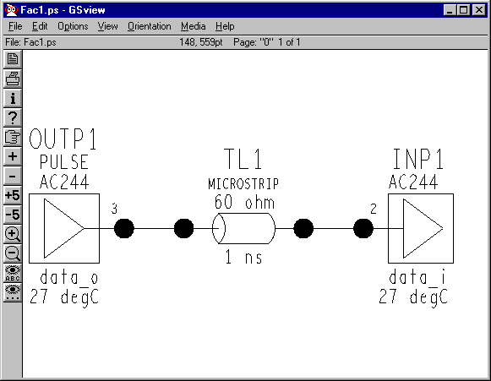

Terminated

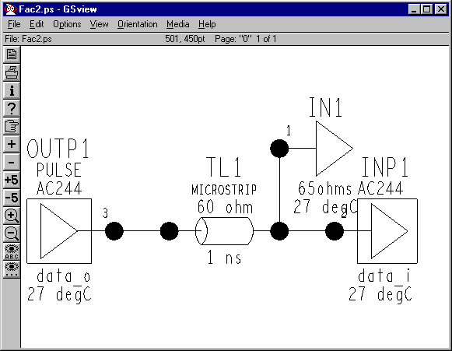

For terminations a V-I curve with Rin = R_{L} = 65 ohms was used. This provides a small, non-zero reflection at the receiver:

$$ρ=\frac{R_{L}−\text{Zo}}{R_{L}+\text{Zo}}$$

So, depending on input capacitance of the receiver and the frequency content of the driver, reflection coefficient ("matched") will be around 0.04.

18 Board Backplane
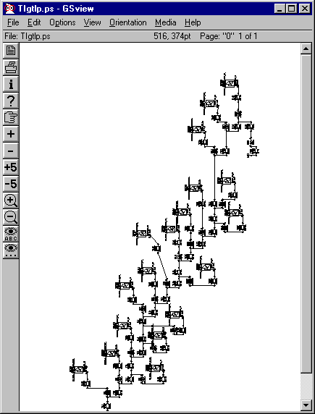

Pitch = 957 mils, Stubs = 1500 mils, f = 8.162 MHz, Driver = slot 9, Pullups = 30 Ohms, Zo = 63 ohms, V_pullup = 1.5 Volts

Logic Family Results

5 Volt Logic

CMOS: , CDS Default, AC, ACQ ACT, ACTQ, AHC, AHCT, HC, HCT, VHC, VHCT
BiCMOS: ABT, ABTE
TTL (BP): ALS, AS, F, LS, S, TTL

ABT: Advanced BiCMOS Technology
TI 0.8-μ

Un-Terminated

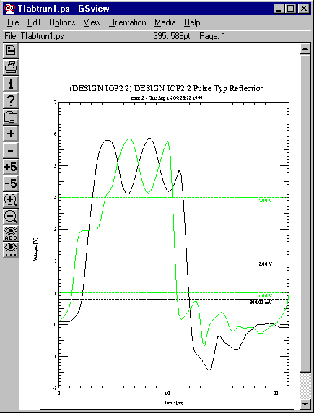

TI ABT: Driver = ABT16245a_IO, Receiver = ABT16245a_IO
Run1

Terminated

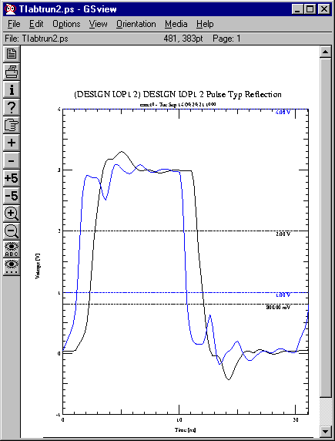

TI ABT: Driver = ABT16245a_IO, Receiver = ABT16245a_IO
Run2
Un-Terminated

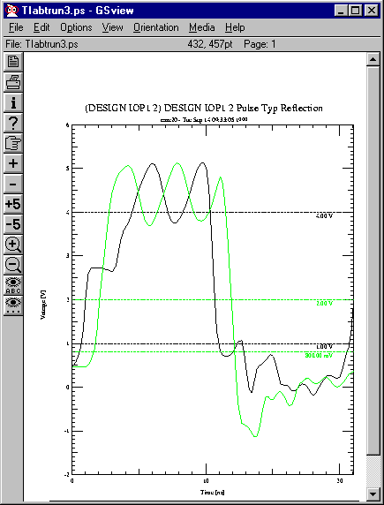

TI ABT: Driver = ABT245a_IO, Receiver = ABT245a_IO
Run3

Terminated

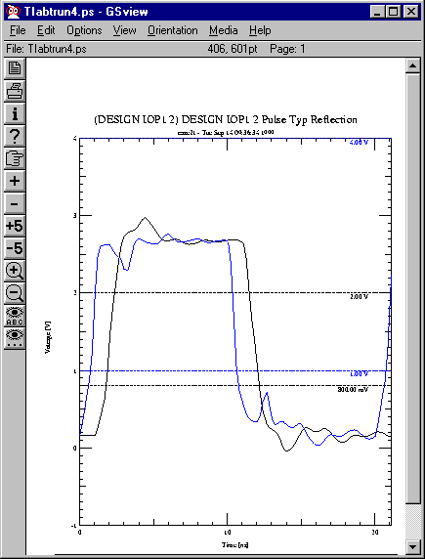

TI ABT: Driver = ABT245a_IO, Receiver = ABT245a_IO
Run4

Un-Terminated
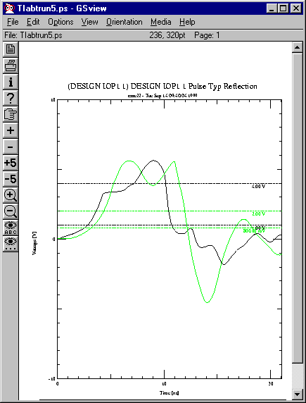

TI ABT: Driver = ABT25245_A_port (IO), Receiver = ABT25245_A_port (IO)
Run5

Terminated
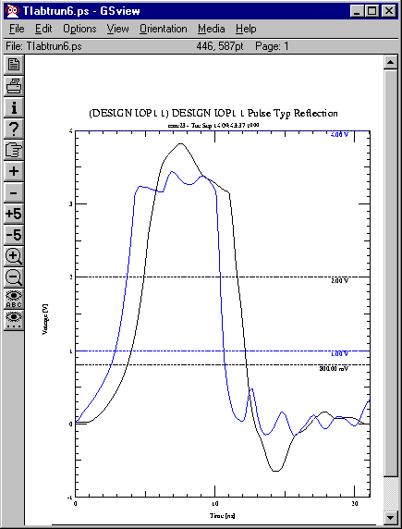

TI ABT: Driver = ABT25245_A_port (IO), Receiver = ABT25245_A_port (IO)
Run6

Un-Terminated

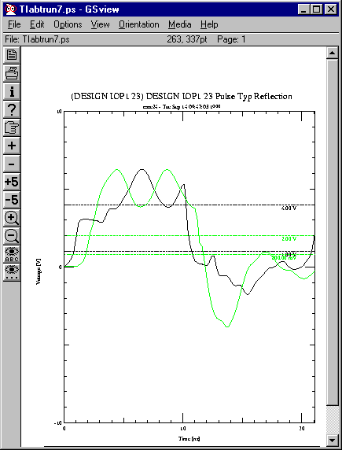

TI ABT: Driver = ABT25245_B_port (IO), Receiver = ABT25245_B_port (IO)
Run7
Terminated

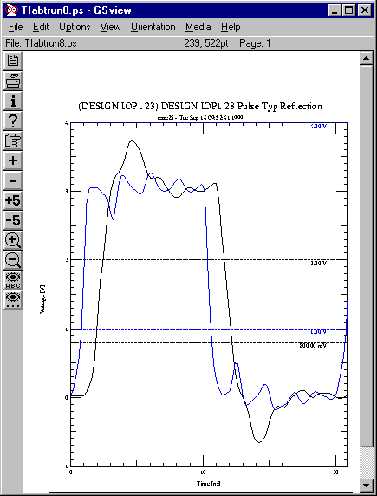

TI ABT: Driver = ABT25245_B_port (IO), Receiver = ABT25245_B_port (IO)
Run8

Un-Terminated
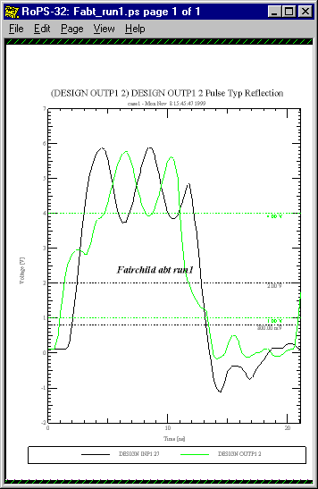

Fairchild ABT: Driver = ABT16244_data_o, Receiver = ABT16244_data_i
Run1
Terminated
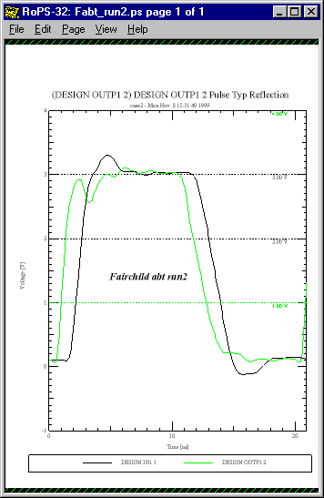

Fairchild ABT: Driver = ABT16244_data_o, Receiver = ABT16244_data_i
Run2

Un-Terminated
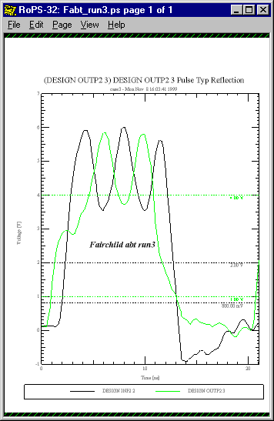

Fairchild ABT: Driver = ABT244_data_o, Receiver = ABT244_data_i
Run3
Terminated
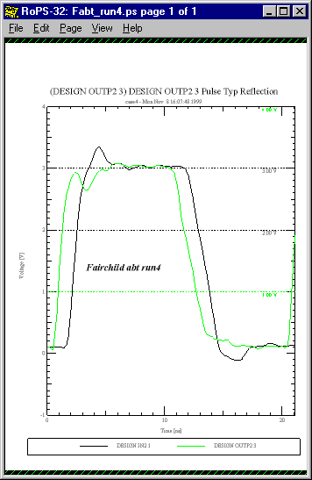

Fairchild ABT: Driver = ABT244_data_o, Receiver = ABT244_data_i
Run4
AC: Advanced CMOS Logic
TI, Fairchild

Un-Terminated
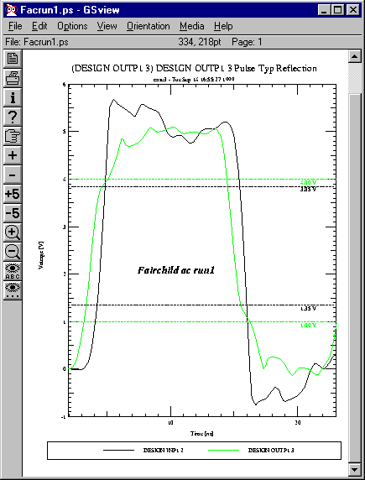

Fairchild AC: Driver = AC244 data_o, Receiver = AC244 data_i
Run1

Terminated
Terminated

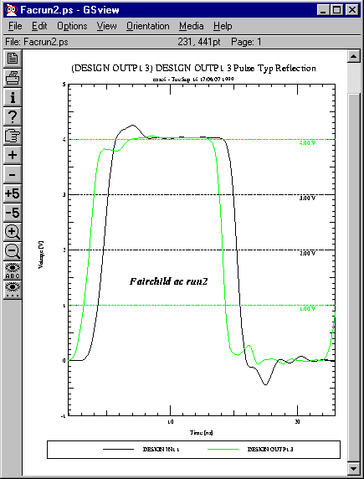

Fairchild AC: Driver = AC244 data_o, Receiver = AC244 data_i
Run2

ACT: Advanced CMOS Logic
Fairchild

Un-Terminated
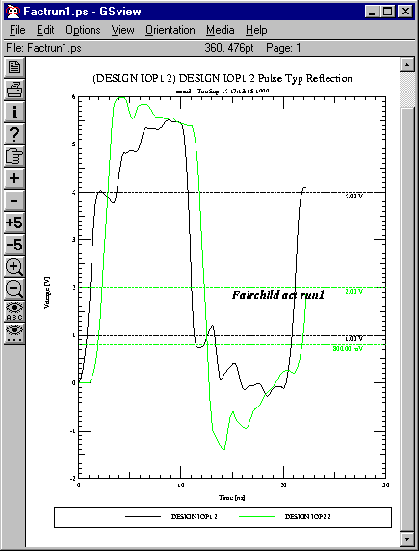

Fairchild ACTQ: Driver = 74ACT245SC data_io, Receiver = 74ACT245SC data_io
Run1

Terminated
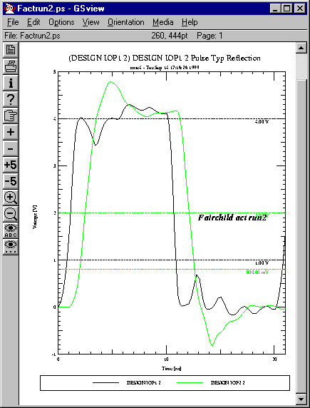

Fairchild ACT: Driver = 74ACTQ245SC data_io, Receiver = 74ACT245SC data_io
Run2

ACTQ: Advanced CMOS Logic
Fairchild

Un-Terminated
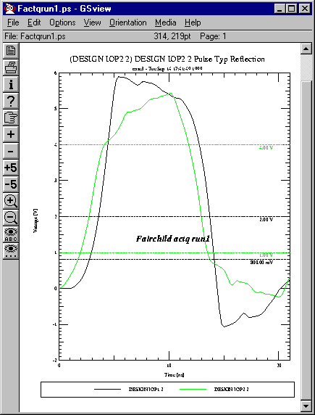

Fairchild ACTQ: Driver = 74ACTQ245SC data_io, Receiver = 74ACTQ245SC data_io
Run1

Terminated
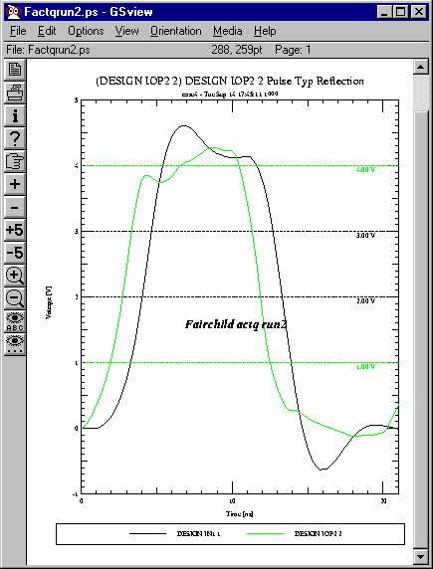

Fairchild ACTQ: Driver = 74ACTQ245SC data_io, Receiver = 74ACTQ245SC data_io
Run2

AHC: Advanced High Speed CMOS Logic
TI, Phillips

Un-Terminated
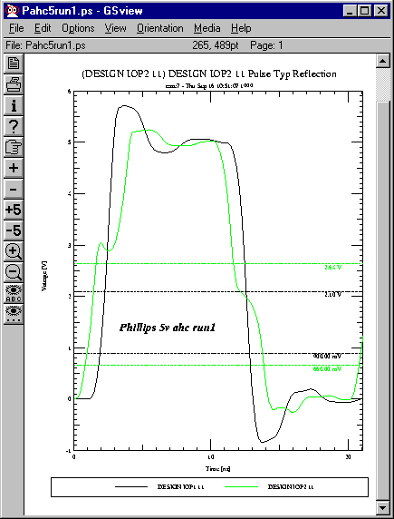

Phillips AHC: Driver = 74AHC245_IO_5V, Receiver = 74AHC245_IO_5V
Run1

Terminated
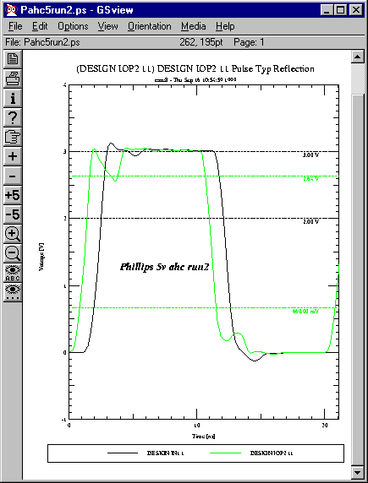

Phillips AHC: Driver = 74AHC245_IO_3V, Receiver = 74AHC245_IO_3V
Run2

AHCT: Advanced High Speed CMOS Logic
TI, Phillips

Un-Terminated
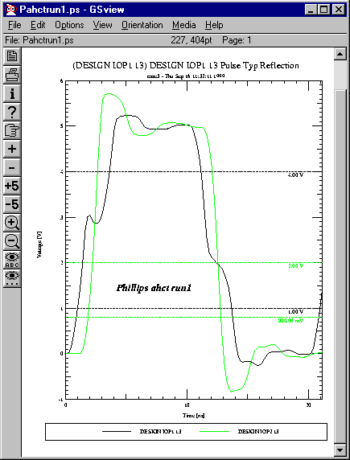

Phillips: Driver = 74AHCT245 IO_TTL, Receiver = 74AHCT245 IO_TTL
Run1

Terminated
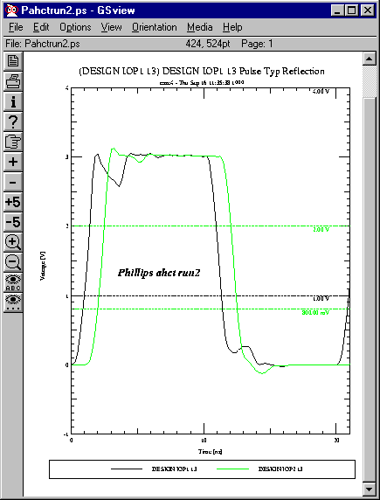

Phillips: Driver = 74AHCT245 IO_TTL, Receiver = 74AHCT245 IO_TTL
Run1

*ALS
Advanced Low Power Schottky Logic
TI

*AS
Advanced Schottky Logic
TI

CDS Default: Cadence Design Systems CMOS Default

Un-Terminated
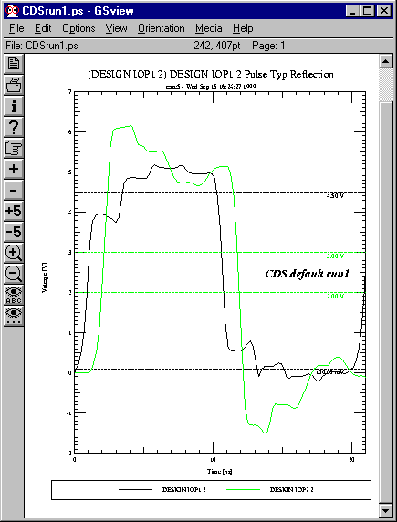

CDS Default: Driver = CDSDefaultIO, Receiver = CDSDefaultIO
Run1

Terminated
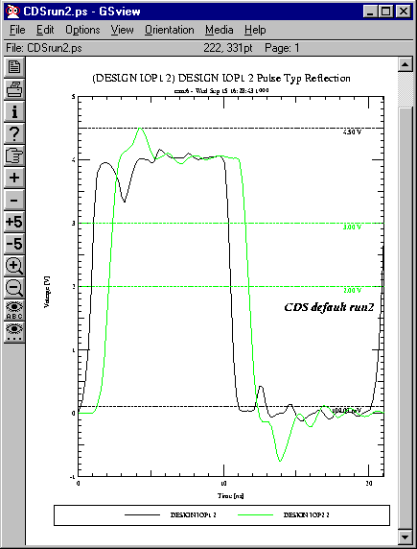

CDS Default: Driver = CDSDefaultIO, Receiver = CDSDefaultIO
Run1

HC: High Speed CMOS Logic
Fairchild

Un-Terminated
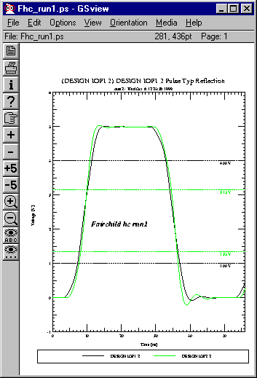

Fairchild HC: Driver = 74HC245SC data_io, Receiver = 74HC245SC data_io
Run1

Terminated
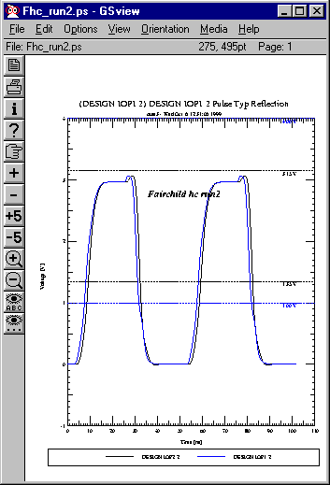

Fairchild HC: Driver = 74HC245SC data_io, Receiver = 74HC245SC data_io
Run2

HCT: High Speed CMOS Logic
Fairchild

Un-Terminated
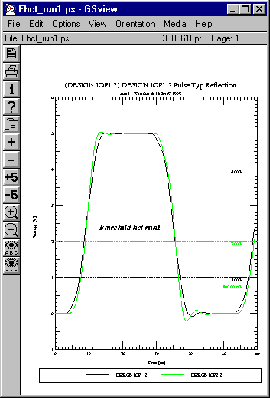

Fairchild HCT: Driver = 74HCT245SC data_io, Receiver = 74HCT245SC data_io
Run1
Terminated
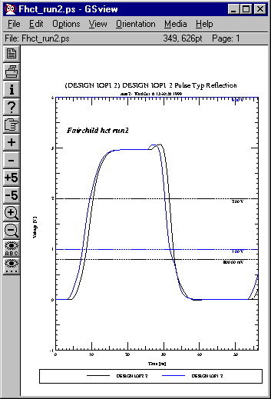

Fairchild HCT: Driver = 74HCT245SC data_io, Receiver = 74HCT245SC data_io
Run2

LS: Low Power Schottky Logic
TI, Fairchild

Un-Terminated
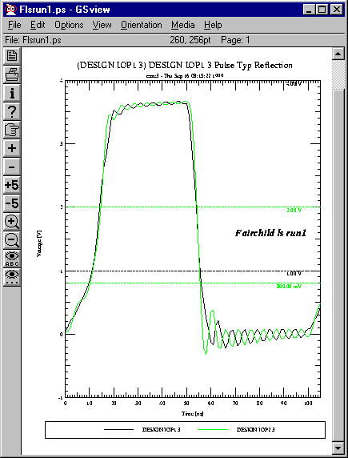

Fairchild LS: Driver = 74LS245SC data_io, Receiver = 74LS245SC data_io
Run1

Terminated
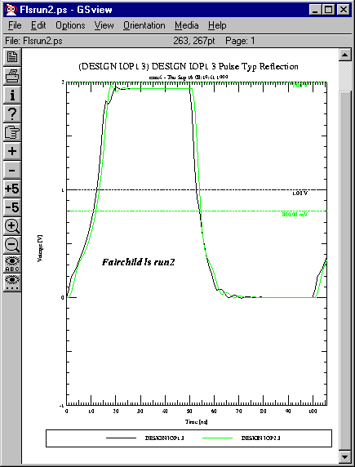

Fairchild LS: Driver = 74LS245SC data_io, Receiver = 74LS245SC data_io
Run2

*S: Schottky Logic
TI

Un-Terminated

Terminated

VHC:
Fairchild

Un-Terminated
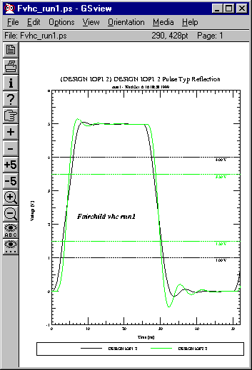

Fairchild VHC: Driver = 74VHC245SC data_io, Receiver = 74VHC245SC data_io
Run1

Terminated
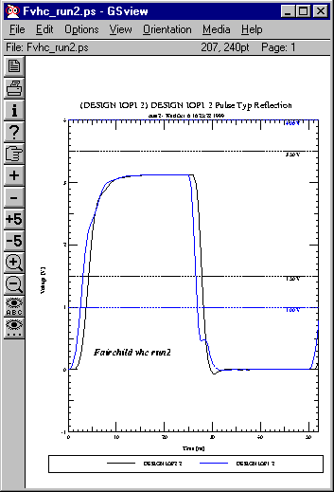

Fairchild VHC: Driver = 74VHC245SC data_io, Receiver = 74VHC245SC data_io
Run2

3.3 Volt Logic

CMOS: AC, ACQ, ALVC, LCX, LV, LVC, LVQ, LVX, VCX, VHC
BiCMOS: ALVT, LVT
TTL (BP):
GTL, GTL+, HSTL, CTT, SSTL

AHC/AHCT: Advanced High Speed CMOS Logic
TI, Phillips

Un-Terminated
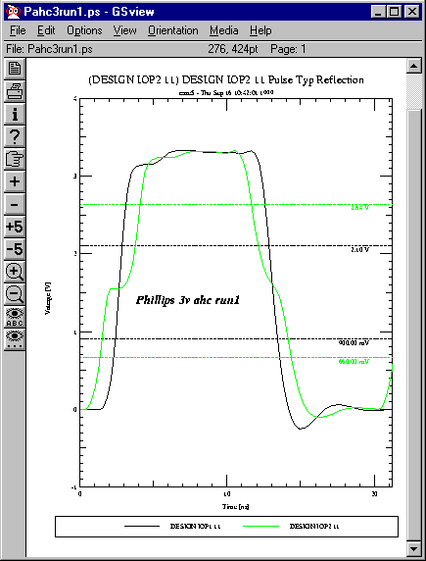

Phillips AHC: Driver = 74AHC245_IO_3V, Receiver = 74AHC245_IO_3V
Run1

Terminated
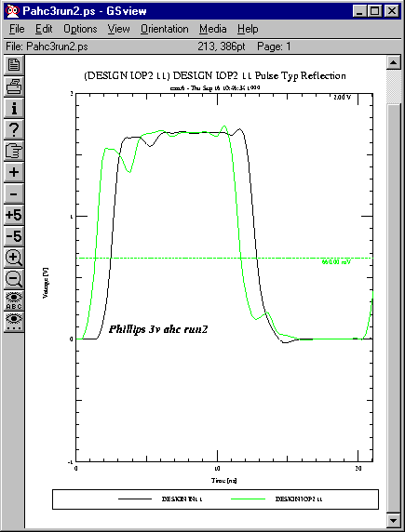

Phillips AHC: Driver = 74AHC245_IO_3V, Receiver = 74AHC245_IO_3V
Run2

ALVC: Advanced Low Voltage CMOS Technology
Phillips

Unterminated
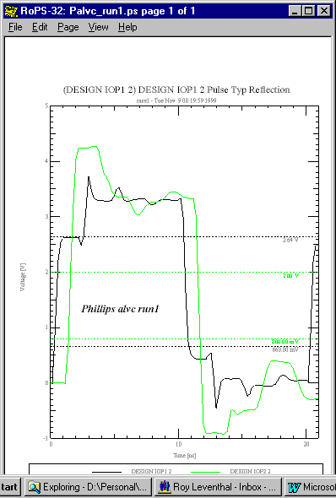

Phillips ALVC: Driver = 74ALVC16245_IO, Receiver = 74ALVC16245_IO
Run1
Terminated
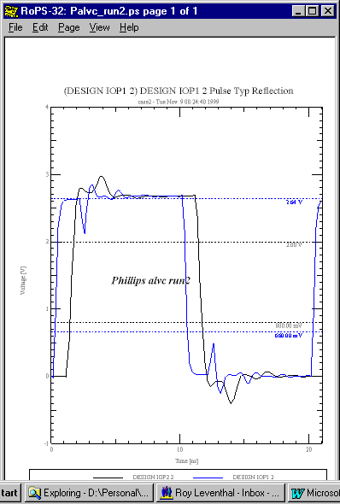

Phillips ALVC: Driver = 74ALVC16245_IO, Receiver = 74ALVC16245_IO
Run2

ALVCH: Advanced Low Voltage CMOS Technology
TI, Phillips

Un-Terminated
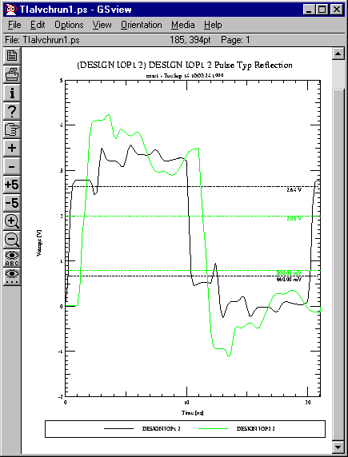

TI: Driver = ALVCH16245_IO, Receiver =ALVCH16245_IO
Run1

Terminated
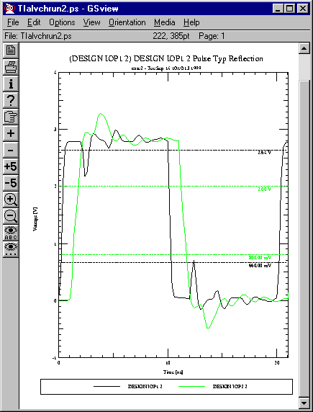

TI: Driver = ALVCH16245_IO, Receiver =ALVCH16245_IO
Run2

Un-Terminated
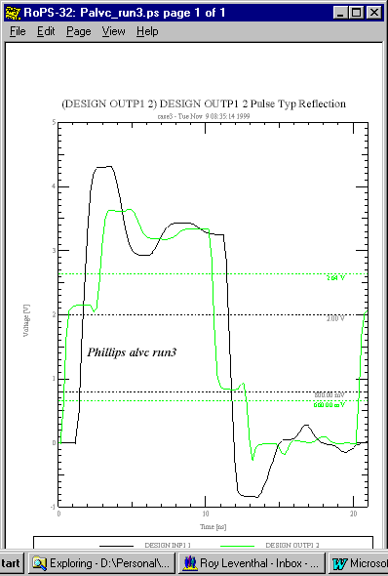

Phillips ALVCH: Driver = 74ALVCH162245_OUT, Receiver = 74ALVCH162245_IN
Run3

Terminated
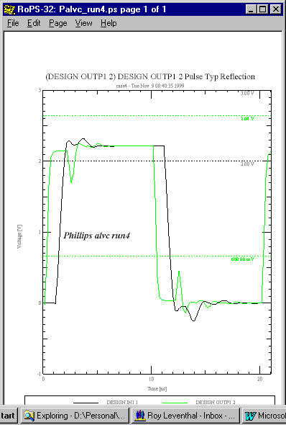

Phillips ALVCH: Driver = 74ALVCH162245_OUT, Receiver = 74ALVCH162245_IN
Run4
Un-Terminated

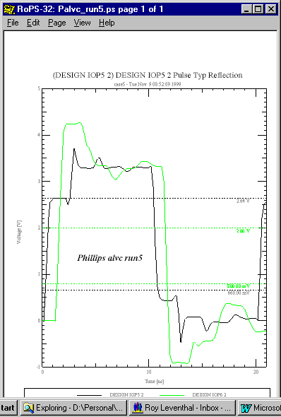

Phillips ALVCH: Driver = 74ALVCH16245_IO, Receiver = 74ALVCH16245_IO
Run5
Terminated
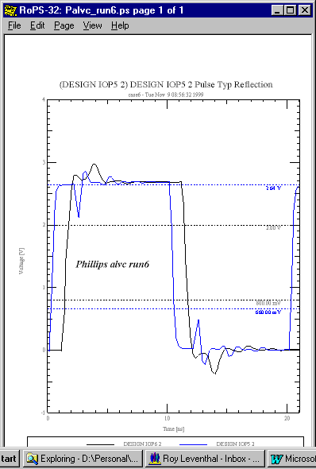

Phillips ALVCH: Driver = 74ALVCH16245_IO, Receiver = 74ALVCH16245_IO
Run6

ALVT: Advanced Low Voltage CMOS Technology
Phillips

Un-Terminated
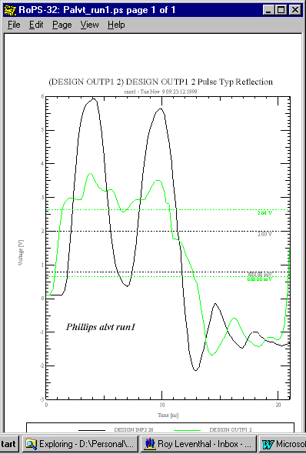

Phillips ALVT: Driver = 74ALVT162245_OUT, Receiver = 74ALVT162245_IN
Run1
Terminated

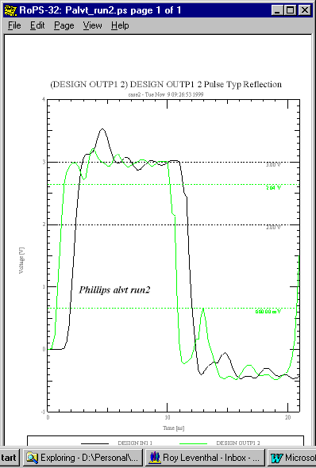

Phillips ALVT: Driver = 74ALVT162245_OUT, Receiver = 74ALVT162245_IN
Run2

Unterminated

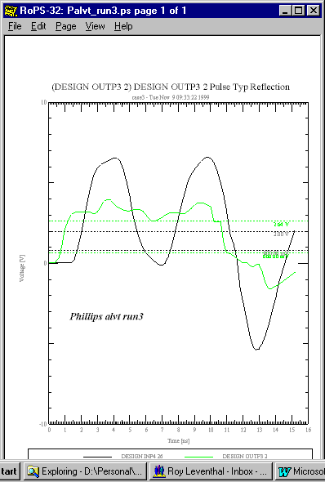

Phillips ALVT: Driver = 74ALVT16245_OUT, Receiver = 74ALVT16245_IN
Run3
Terminated
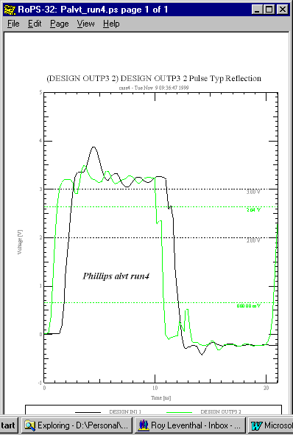

Phillips ALVT: Driver = 74ALVT162245_OUT, Receiver = 74ALVT162245_IN
Run2

HSTL: High Speed Transceiver Logic
TI

Un-Terminated
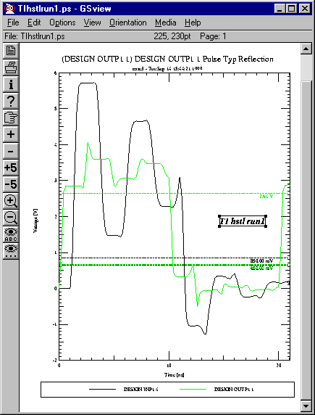

TI: Driver = HSTL16918_OUT, Receiver = HSTL16918_IN
Run1

Terminated
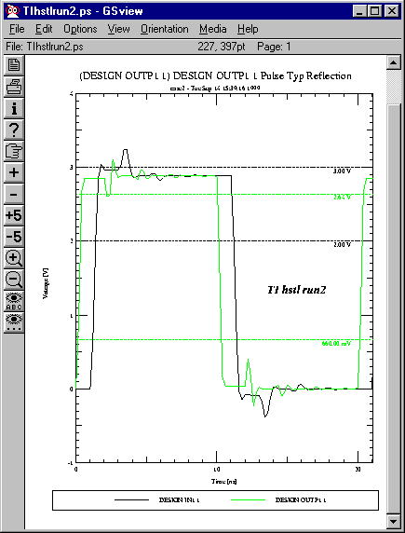

TI: Driver = HSTL16918_OUT, Receiver = HSTL16918_IN
Run2

LV/LVC: Low Voltage CMOS Logic
Fairchild, Phillips, TI

Un-Terminated
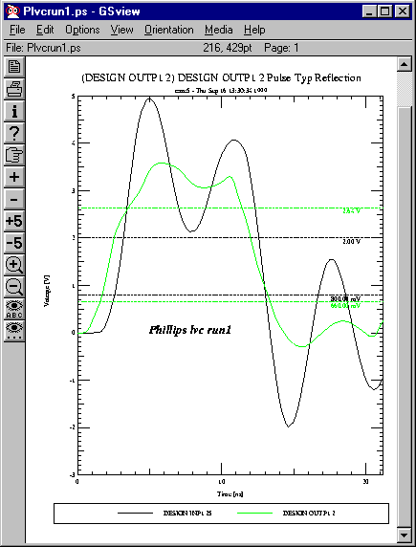

Phillips: Driver = 74LVC16245_OUT, Receiver = 74LVC16245_OUT
Run1

Terminated
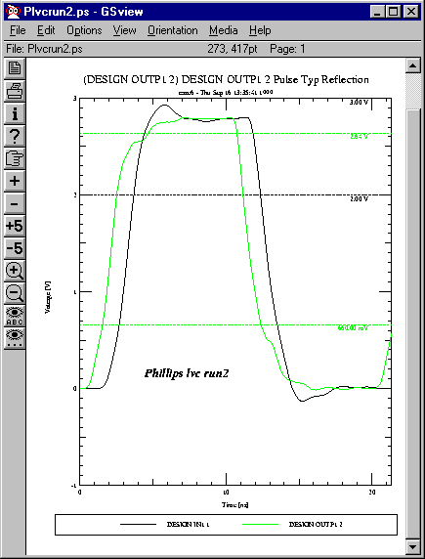

Phillips: Driver = 74LVC16245_OUT, Receiver = 74LVC16245_OUT
Run2

Un-Terminated
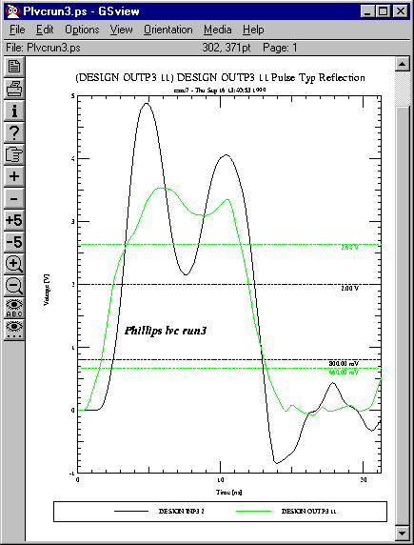

Phillips: Driver = 74LVC245_OUT, Receiver = 74LVC245_OUT
Run3

Terminated
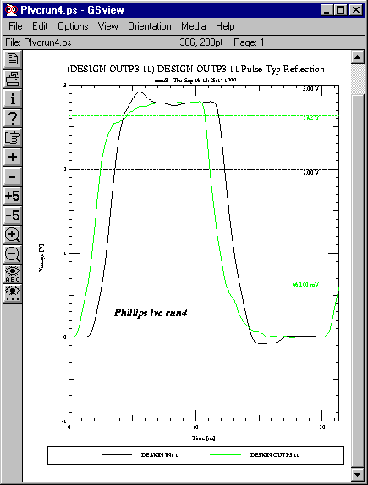

Phillips: Driver = 74LVC245_OUT, Receiver = 74LVC245_OUT
Run3

Un-Terminated
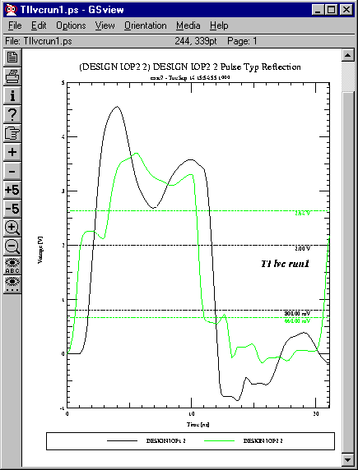

TI: Driver = LVC16245A_IO, Receiver = LVC16245A_IO
Run1

Terminated
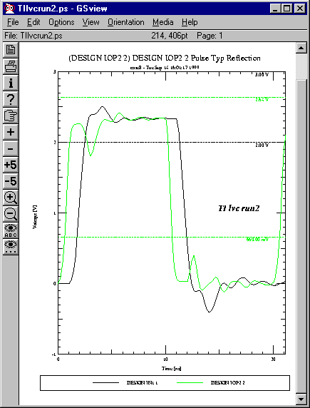

TI: Driver = LVC16245A_IO, Receiver = LVC16245A_IO
Run2

LVCH: Low Voltage CMOS Logic
Phillips

Un-Terminated
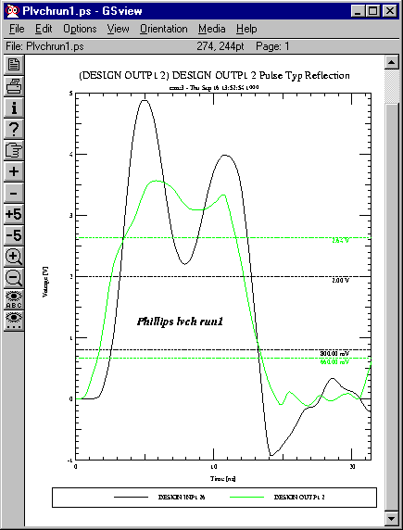

Phillips: Driver = 74LVCH16245_OUT, Receiver = 74LVCH16245_IN
Run1

Terminated
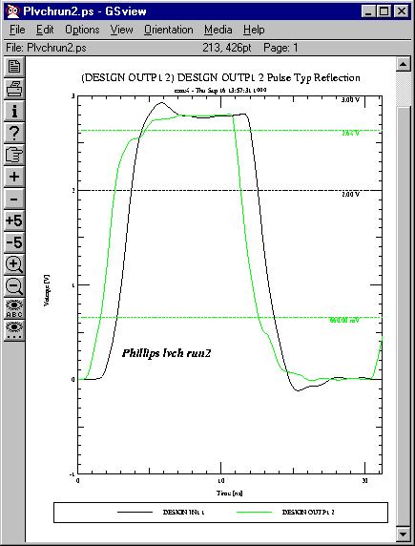

Phillips: Driver = 74LVCH16245_OUT, Receiver = 74LVCH16245_IN
Run2

LCX
Fairchild

Un-Terminated
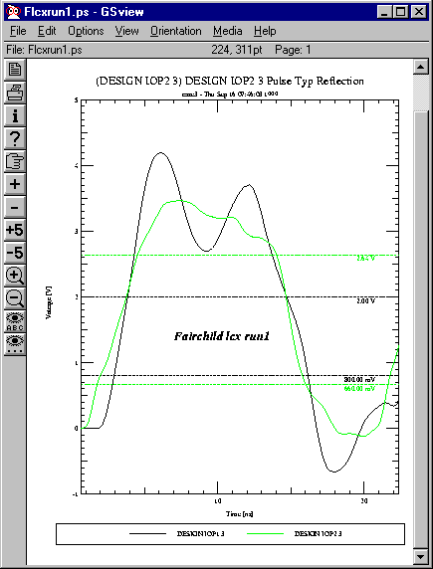

Fairchild: Driver = 74LCX245SC data_io, Receiver = 74LCX245SC data_io
Run1

Terminated
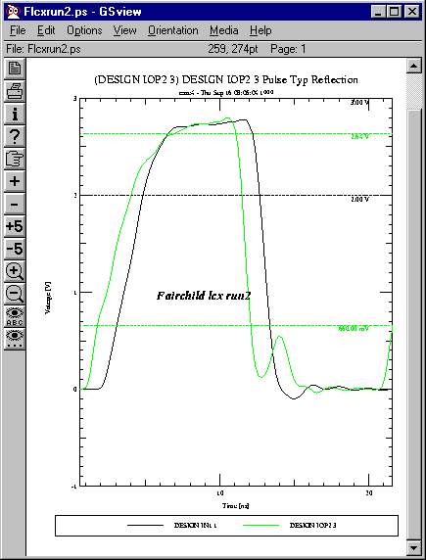

Fairchild: Driver = 74LCX245SC data_io, Receiver = 74LCX245SC data_io
Run1

LVT: Low Voltage BiCMOS Technology
TI, Fairchild, Phillips

Un-Terminated
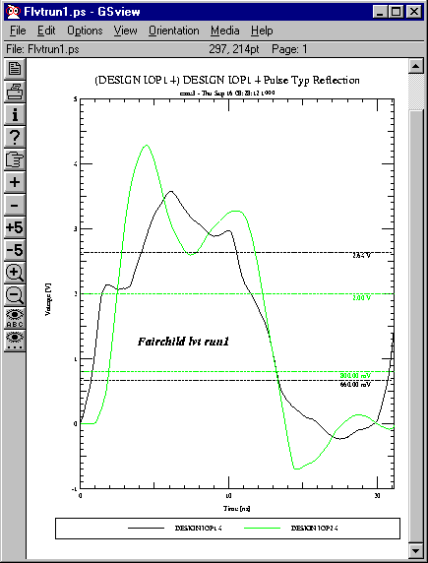

Fairchild: Driver = 74LVT245SC data_io, Receiver = 74LVT245SC data_io
Run1

Terminated
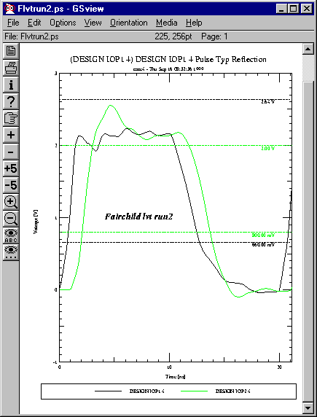

Fairchild: Driver = 74LVT245SC data_io, Receiver = 74LVT245SC data_io
Run2

Un-Terminated
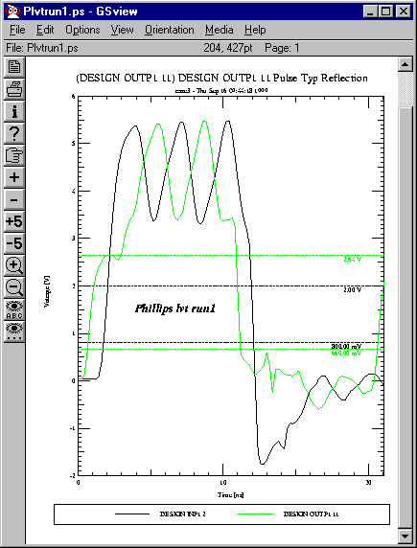

Phillips: Driver = 74LVT245_OUT, Receiver = 74LVT245_IN
Run1

Terminated
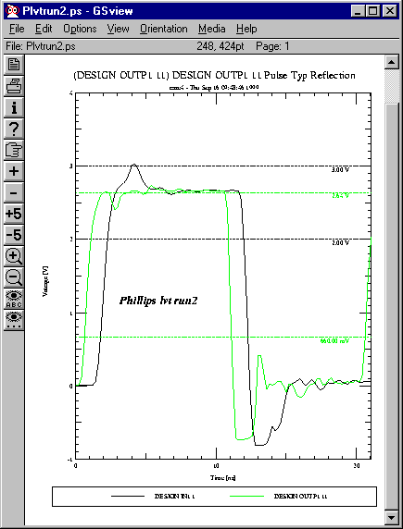

Phillips: Driver = 74LVT245_OUT, Receiver = 74LVT245_IN
Run2

Un-Terminated
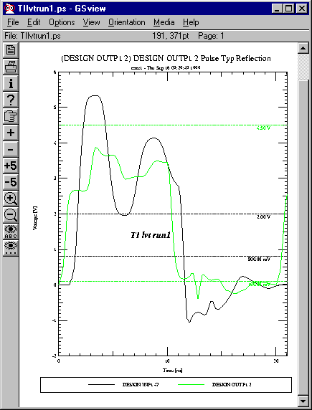

TI: Driver = LVT16244A_OUT, Receiver = LVT16244A_IN
Run1

Terminated
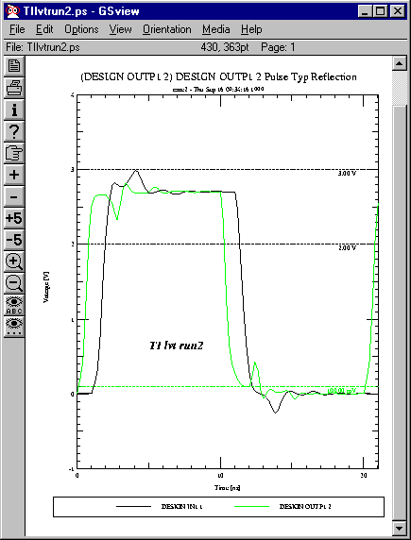

TI: Driver = LVT16244A_OUT, Receiver = LVT16244A_IN
Run2

LVX:
Fairchild

Un-Terminated
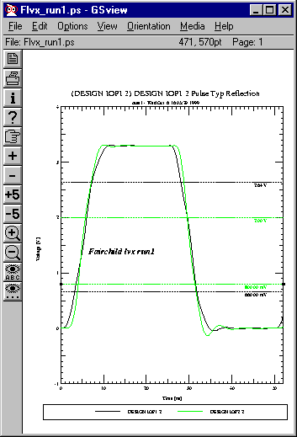

Fairchild: Driver = 74LVX245SC data_io, Receiver = 74LVX245SC data_io
Run1
Terminated
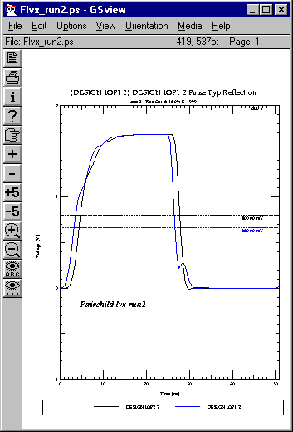

Fairchild: Driver = 74LVX245SC data_io, Receiver = 74LVX245SC data_io
Run2

SSTL: Stub Series Terminated Logic
TI

Un-Terminated
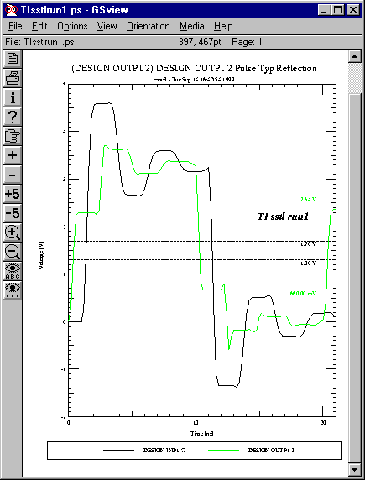

TI: Driver = SSTL16837_OUT, Receiver = SSTL16837_IN
Run1

Terminated
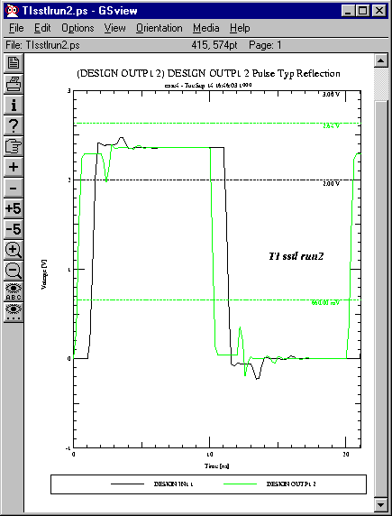

TI: Driver = SSTL16837_OUT, Receiver = SSTL16837_IN
Run1

2.5 Volt Logic

CMOS: ALVC, ALVT, LVC, VCX
BiCMOS: ALB, F/FAST

ALB: Advanced Low Voltage BiCMOS Technology
TI
Un-Terminated
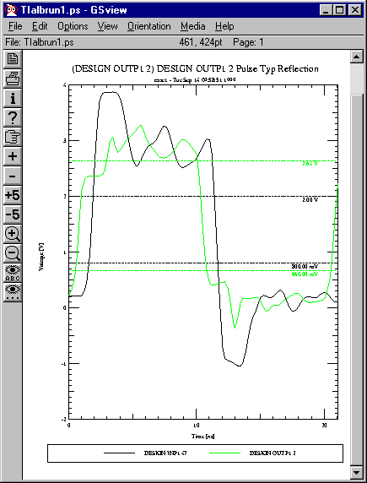

TI: Driver = ALB16244_OUT, Receiver = ALB16244_IN
Run1

Terminated
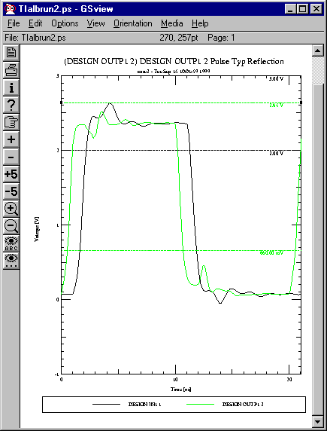

TI: Driver = ALB16244_OUT, Receiver = ALB16244_IN
Run2

F/FAST: F Logic
Fairchild, TI

Un-Terminated
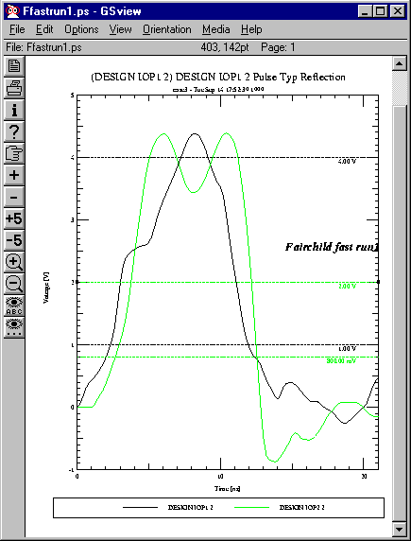

Fairchild: Driver = 74F245SC data_io, Receiver = 74F245SC data_io
Run1

Terminated
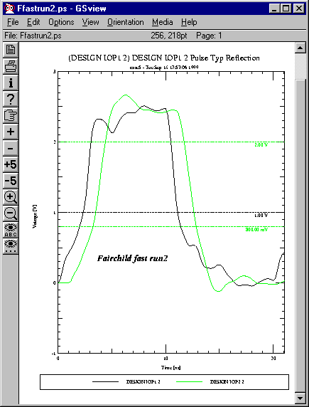

Fairchild: Driver = 74F245SC data_io, Receiver = 74F245SC data_io
Run1

NC:
Fairchild
Terminated
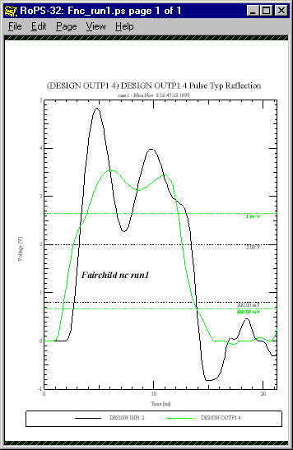

Fairchild NC: Driver = 74NC7SZ125_out, Receiver = 74NC7SZ125_in
Run1
Terminated
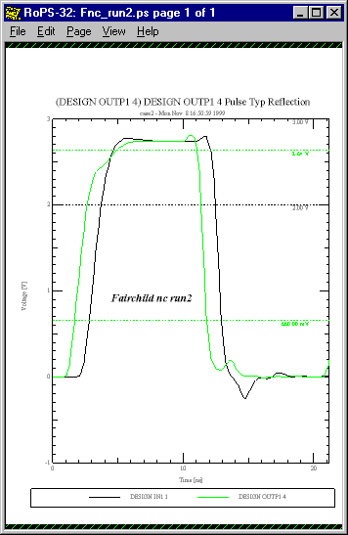

Fairchild NC: Driver = 74NC7SZ125_out, Receiver = 74NC7SZ125_in
Run2

Unterminated
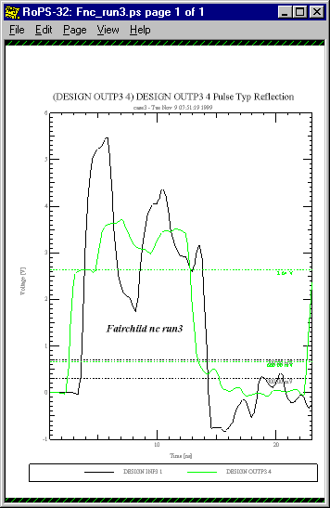

Fairchild NC: Driver = 74NC7WZ04_data_out, Receiver = 74NC7WZ04_data_in
Run3

Terminated
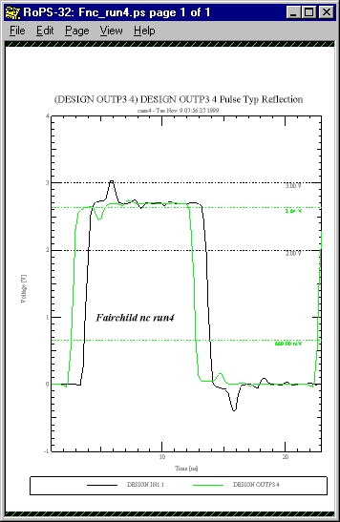

Fairchild NC: Driver = 74NC7WZ04_data_out, Receiver = 74NC7WZ04_data_in
Run4

VCX
Fairchild

Un-Terminated
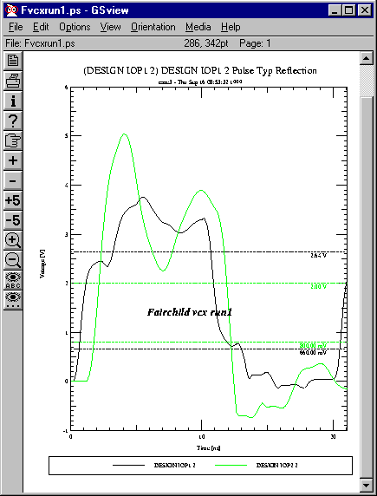

Fairchild: Driver = 74VCX16245MTD data_io, Receiver = 74VCX16245MTD data_io
Run1

Terminated

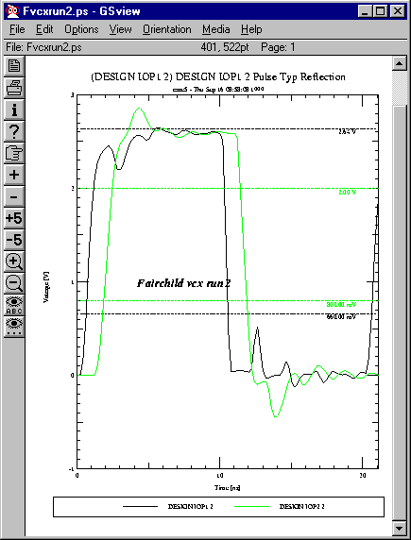

Fairchild: Driver = 74VCX16245MTD data_io, Receiver = 74VCX16245MTD data_io
Run2

2.5/2.1 Volt Logic (Backplane Technology)

BCT, BTL/ FB+, CBT, CBTLV, GTL/GTLP+

*BCT
BiCMOS Bus Interface Technology
TI

Un-Terminated

Terminated

BTL/FB: Futurebus+ Backplane Transceiver Logic
TI

Un-Terminated TTL
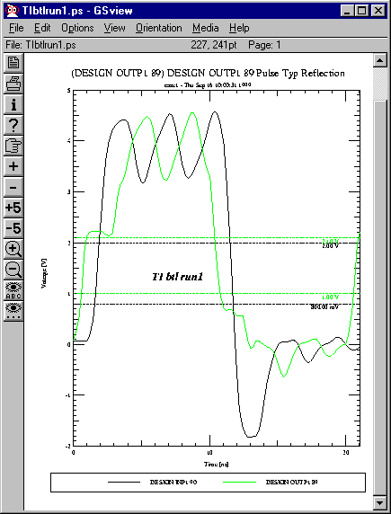

TI: Driver = FB1650_AOUT, Receiver = FB1650_AIN
Run1

Terminated TTL
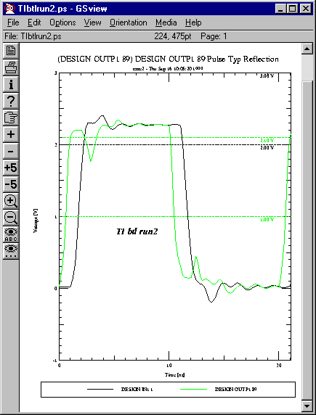

TI: Driver = FB1650_AOUT, Receiver = FB1650_AIN
Run2

BTL Point-Point
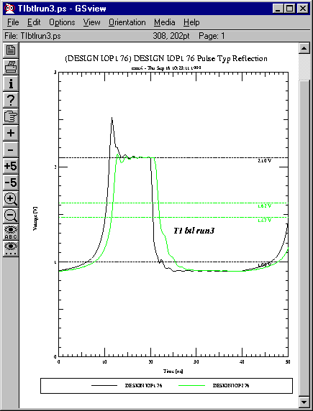

TI: Driver = FB1650_BIO, Receiver = FB1650_BIO
Run3

BTL Backplane behavior. Pullup resistor at each end of backplane bus is 33 ohms, V_pullup = 2.1 Volts.
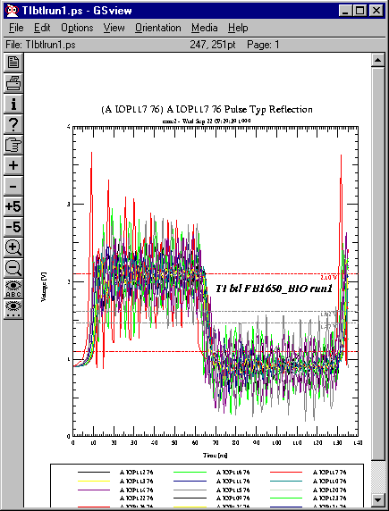

TI: Driver = FB1650_BIO, Receiver = FB1650_BIO
Run1

LVT: Backplane Behavior

Bias network at each end of backplane bus is resistor divider of 100/75 ohms from 5 volts to ground.
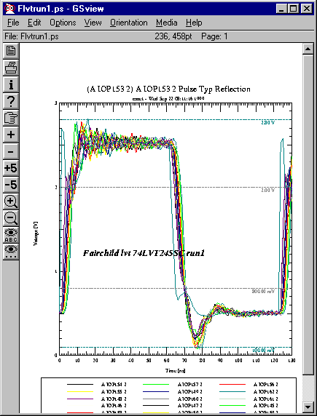

Fairchild: Driver = 74LVT245SC data_io, Receiver = 74LVT245SC data_io
Run1

*CBT
Crossbar Technology
TI

Un-Terminated

Terminated

*CBTLV
Low Voltage Crossbar Technology
TI

Un-Terminated

Terminated

GTL/GTLP/GTL+: Gunning Transceiver Logic
TI, Fairchild

Un-Terminated TTL
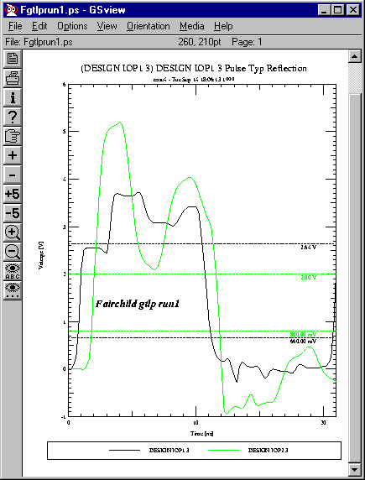

Fairchild: Driver = 74GTLP16616_TTL (IO), Receiver = 74GTLP16616_TTL (IO)
Run1

Terminated TTL
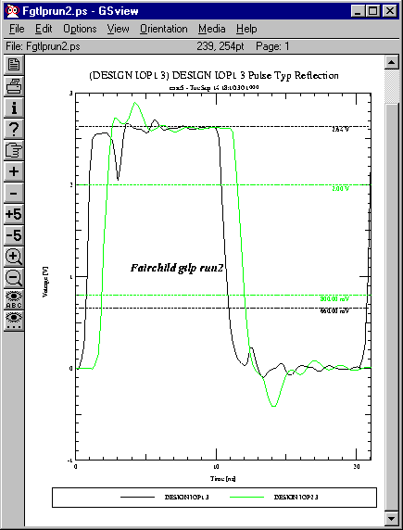

Fairchild: Driver = 74GTLP16616_TTL (IO), Receiver = 74GTLP16616_TTL (IO)
Run2

GTLP Point-Point
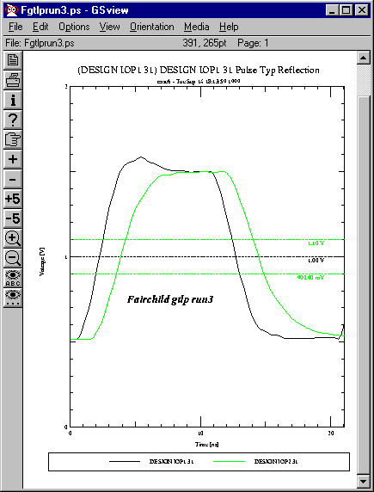

Fairchild: Driver = 74GTLP16616_GTL (IO), Receiver = 74GTLP16616_GTL (IO)
Run3

GTLP 18 Board Backplane

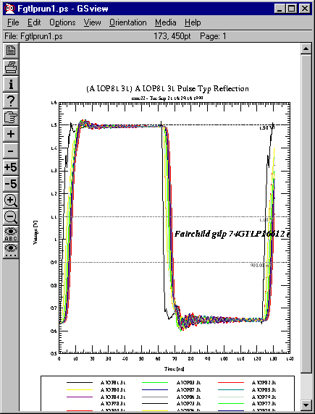

Fairchild: Driver = 74GTLP16616_GTL (IO), Receiver = 74GTLP16616_GTL (IO)
Run1

TI

TTL Un-Terminated
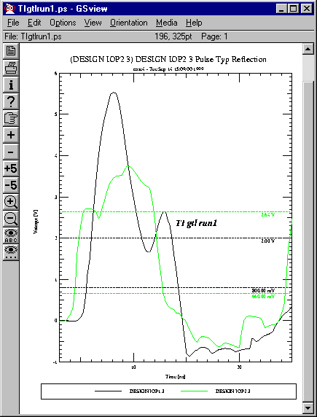

TI: Driver = 16612a_TTL_IO, Receiver = 16612a_TTL_IO
Run1

TTL Terminated
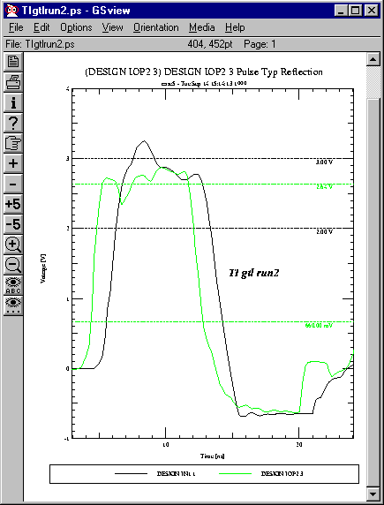

TI: Driver = 16612a_TTL_IO, Receiver = 16612a_TTL_IO
Run2

GTLP Point-Point
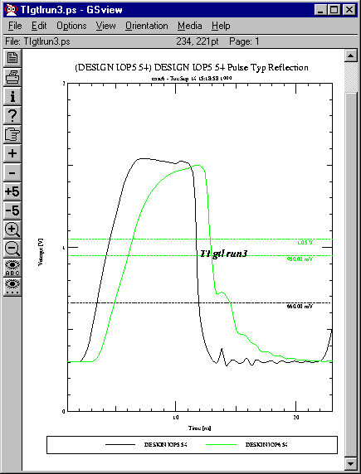

TI: Driver = 16612a_GTL_IO, Receiver = 16612a_GTL_IO
Run3

GTLP 18 Board Backplane
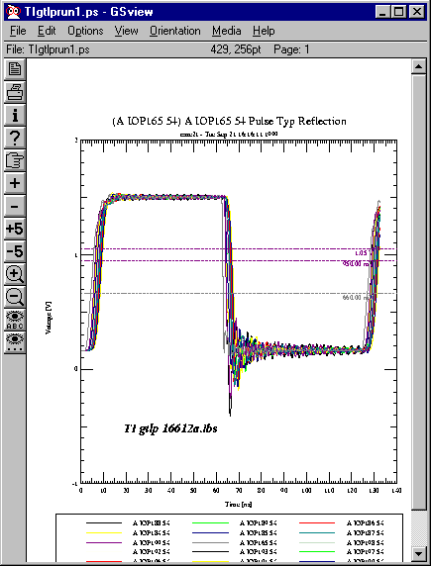

TI: Driver = 16612a_GTL_IO, Receiver = 16612a_GTL_IO
Run1

Differential Nets

CDSDefault (5 Volt), LVDS (2.5/2.1 Volt)

CDS Default: Cadence Design Systems CMOS Default Differential Switch

Un-Terminated
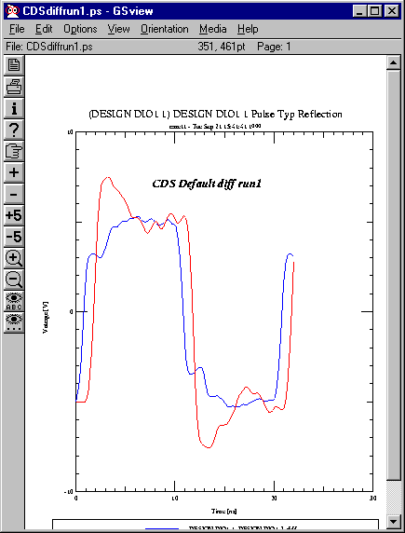

CDS Default: Driver = CDSDefaultIO (differential), Receiver = CDSDefaultIO (differential) Run1

Terminated Single-Ended (78 ohms)
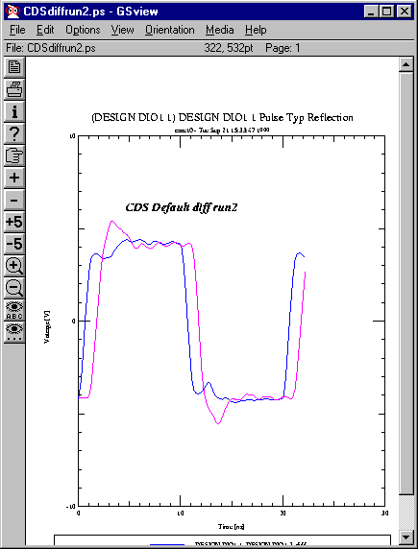

CDS Default: Driver = CDSDefaultIO (differential), Receiver = CDSDefaultIO (differential) Run2

Terminated Differentially (125 ohms)
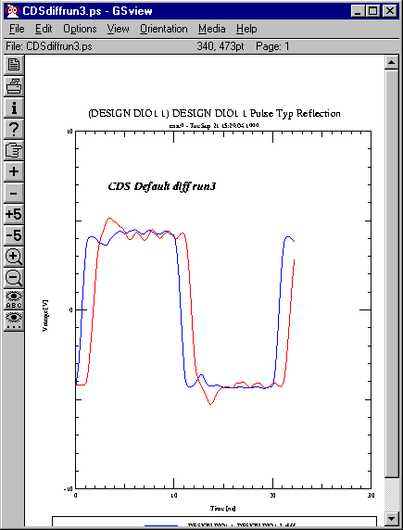

CDS Default: Driver = CDSDefaultIO (differential), Receiver = CDSDefaultIO (differential) Run3

*ECL: Emitter Coupled Logic
Fairchild

Unterminated

Fairchild ECL: Driver = , Receiver =
Run1

Terminated

Fairchild ECL: Driver = , Receiver =
Run2

Terminated

Fairchild ECL: Driver = , Receiver =
Run3

LVDS: Low Voltage Differential Switching
TI, NSC

Un-Terminated Single Ended
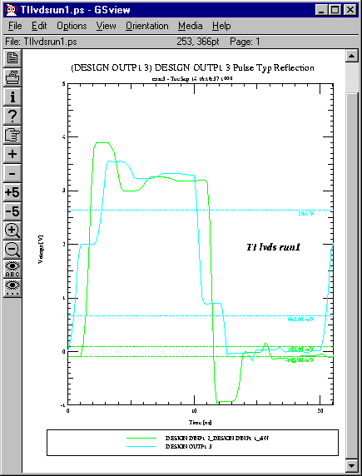

TI: Driver = SN65LVDS3486_ROUT, Receiver = SN65LVDS3486_RIN
Run1

Terminated Single Ended
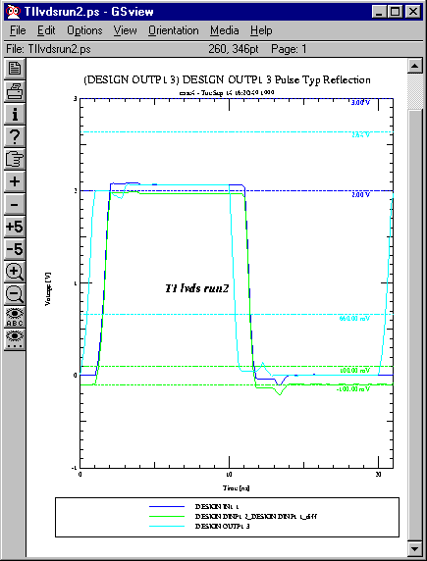

TI: Driver = SN65LVDS3486_ROUT, Receiver = SN65LVDS3486_RIN
Run2

LVT has reasonable capability to run on a bi-directional unterminated daisy-chain bus. GTLP actually performs much better than LVT, but is more expensive. For large, complex busses switch to GTLP.
By default, at this point in time.

