AGENDA - Asian IBIS Summit (Shanghai)
Friday, November 10, 2023

Parkyard Hotel
Shanghai, P.R. China

Room: Ballroom ABC
Sponsors: ANSYS
Cadence Design Systems
Empyrean
ZTE Corporation
(Order and times in CST subject to change)
09:00 SIGN IN
- Vendor Tables Open at 9:00
09:30 MEETING WELCOMES
WANG, Lance (Chair, IBIS Open Forum)
(Zuken, USA)
09:40 IBIS Chair’s Report
WANG, Lance (Zuken, USA)
10:00 AMI DLL Hook: A Novel Debug Method for IBIS-AMI Simulation
LI, Chuanyu (Intel Corp., PRC)
10:40 BREAK (20 minutes)
- Refreshments and Vendor Tables
- Reconvene at 11:00
11:00 Challenges and Solutions in Supporting USB4 Interface
KONG, Jianping (Cadence Design Systems, PRC)
11:30 Standard Compliant IBIS-AMI Model for System Sign-off with USB4 Gen2
as an Example
XU, Zhifei (Ningbo DeTooLIC Technology, PRC)
YANG, Zhiping (Missouri S&T EMC Lab and JAY Plus, USA)
[Presented by XU, Zhifei]
12:00 FREE LUNCH (90 minutes, hosted by sponsors)
- Reconvene at 13:30
- Vendor Tables
13:30 Performance Evaluation Approach for 112G Serdes
HUANG, Jian (ZTE Corporation, PRC)
ZHU, Daishan (ZTE Corporation, PRC)
YANG, Zhiwei (ZTE Corporation, PRC)
[Presented by HUANG, Jian]
13:55 Exploring the Requirements for 224 Gbps Channel
ZHENG, Ming (ZTE Corporation, PRC)
YIN, Changgang (ZTE Corporation, PRC)
WEI, Zhongmin (ZTE Corporation, PRC)
[Presented by ZHENG, Ming]
14:20 Matrix Parameters in Touchstone
ROSS, Bob (Teraspeed Labs, USA)
[Presented by WANG, Lance (Zuken, USA)]
14:40 Hardware and AI/ML: Applications of SIPI & IBIS
YANG, Zhiping (Missouri S&T EMC Lab and JAY Plus, USA)
15:05 Advanced SerDes & DDR AMI Modeling and Simulation
WU, Jiarui (Keysight Technologies, PRC)
LI, Chuanbao (Keysight Technologies, PRC)
JIANG, Xiuguo (Keysight Technologies, PRC)
[Presented by LI, Chuanbao]
15:35 CONCLUDING ITEMS
15:45 END OF IBIS SUMMIT MEETING
- Thank You for Your Participation
BREAK (5 minutes)
- Refreshments and Vendor Tables
15:50 VENDOR PRESENTATIONS, MODERATOR
WANG, Lance (Chair, IBIS Open Forum)
(Zuken, USA)
17:35 END OF VENDOR PRESENTATIONS
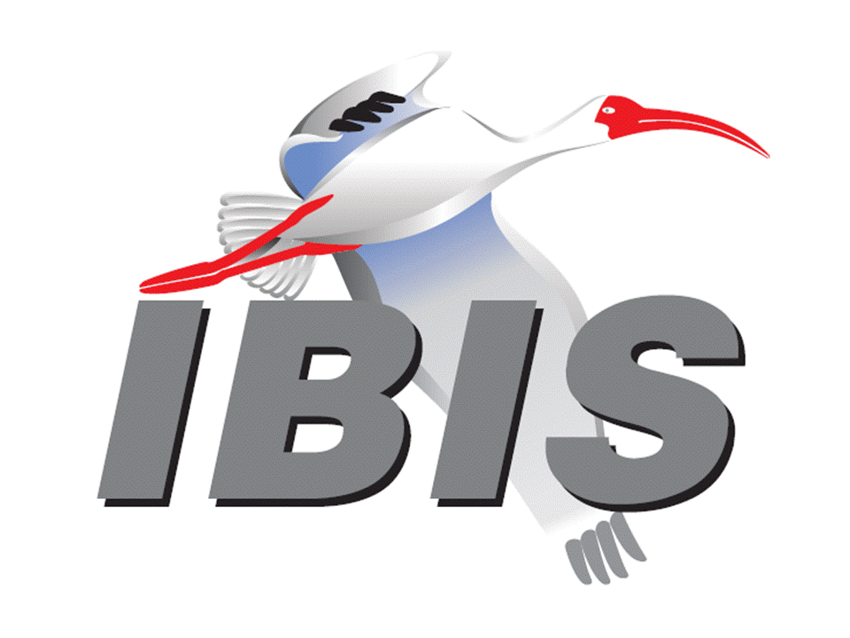
- Thank You to Our Sponsors

