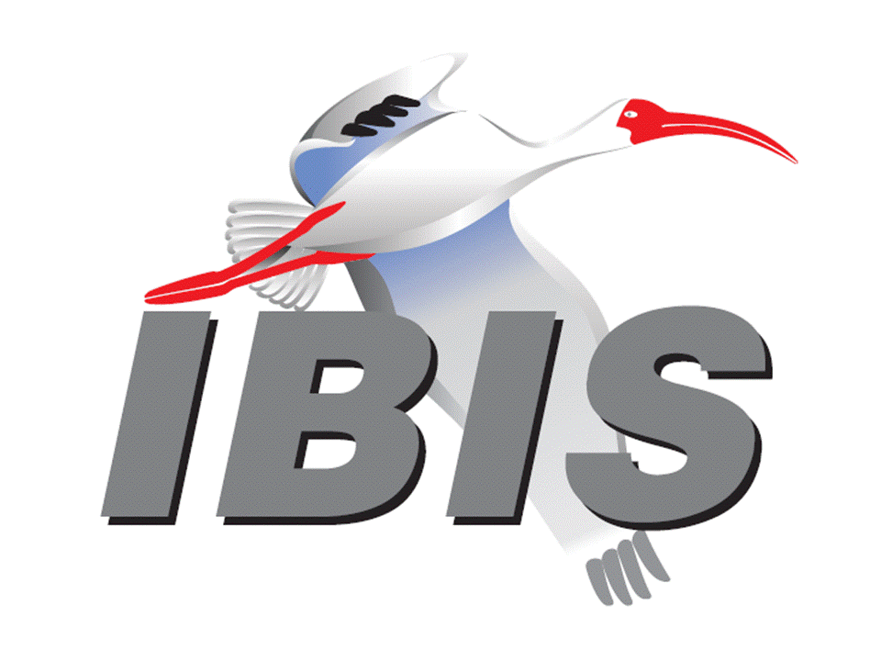

IBIS Open Forum Minutes

Meeting Date: May 4, 2018
Meeting Location: Teleconference

VOTING MEMBERS AND 2018 PARTICIPANTS
ANSYS Curtis Clark
Applied Simulation Technology (Fred Balistreri)
Broadcom (Yunong Gan)
Cadence Design Systems Brad Brim*, Ken Willis, Ambrish Varma
Cisco Systems Stephen Scearce, Cassie Yan, Baosh Xu
CST Stefan Paret
Ericsson Anders Ekholm, Zilwan Mahmod, Guohua Wang
GLOBALFOUNDRIES Steve Parker*
Huawei Technologies (Hang (Paul) Yan)
IBM Greg Edlund
Infineon Technologies AG (Christian Sporrer)
Intel Corporation Hsinho Wu*, Michael Mirmak*, Nilesh Dattani
Fernando Mendoza Hernandez, Varun Gupta
Subas Bastola, Hansel Dsilva
IO Methodology Lance Wang*
Keysight Technologies Radek Biernacki*, Ming Yan, Heidi Barnes
Pegah Alavi
Maxim Integrated Joe Engert, Yan Liang
Mentor, A Siemens Business Arpad Muranyi*, Weston Beal, Raj Raghuram
Carlo Bleu, Mikael Stahlberg, Yasushi Kondou
Vladimir Dmitriev-Zdorov
Micron Technology Randy Wolff*, Justin Butterfield
NXP (John Burnett)
Qualcomm Kevin Roselle, Tim Michalka
Raytheon Joseph Aday
SiSoft Mike LaBonte*, Walter Katz*, Todd Westerhoff
Synopsys Ted Mido, Adrien Auge*, Scott Wedge
Teraspeed Labs Bob Ross*
Xilinx Ravindra Gali
ZTE Corporation (Shunlin Zhu)
Zuken Michael Schaeder, Takayuki Shiratori

OTHER PARTICIPANTS IN 2018
Google Zhiping Yang
Haskware David Banas
John Baprawski, Inc. John Baprawski
KEI Systems Shinichi Maeda
Lattice Semiconductor Dinh Tran, Maryam Shahbazi
OmniVision Sirius Tsang
Ricoh Kazuki Murata
RITA Electronics Ltd. Kenichi Higashiura, Hiroyuki Motoki
SAE-ITC (Jose Godoy)
Signal Metrics Ron Olisar
Socionext Megumi Ono
SPISim Wei-hsing Huang
Stanford University Tom Lee
Toshiba Yasuki Torigoshi, Yoshinori Fukuba

In the list above, attendees at the meeting are indicated by *. Principal members or other active members who have not attended are in parentheses. Participants who no longer are in the organization are in square brackets.

UPCOMING MEETINGS
The bridge numbers for future IBIS teleconferences are as follows:

Date Meeting Number Meeting Password
May 18, 2018 624 227 121 IBISfriday11
May 25, 2018 IBIS Summit at SPI – no teleconference

For teleconference dial-in information, use the password at the following website:

http://tinyurl.com/y7yt7buz

All teleconference meetings are 8:00 a.m. to 9:55 a.m. US Pacific Time. Meeting agendas are typically distributed seven days before each Open Forum. Minutes are typically distributed within seven days of the corresponding meeting.

NOTE: "AR" = Action Required.

-------------------------------------------------------------------------------------------------------------------------------
INTRODUCTIONS AND MEETING QUORUM
Mike LaBonte declared that a quorum was reached and the meeting could begin.

CALL FOR PATENTS
Mike LaBonte called for declaration of any patents or pending patents related to the IBIS 3.2, IBIS 4.2, IBIS 5.1, IBIS 6.1, Touchstone 2.0, IBIS-ISS 1.0 or ICM 1.1 specifications. No patents were declared.

REVIEW OF MINUTES AND ARS
Mike LaBonte called for comments on the minutes of the April 13, 2018 IBIS Open Forum teleconference. Bob Ross moved to approve the minutes. Michael Mirmak seconded the motion. There were no objections.

There were no ARs from the previous meeting to review.

ANNOUNCEMENTS, CALL FOR ADDITIONAL AGENDA ITEMS
None.

MEMBERSHIP STATUS AND TREASURER'S REPORT
Bob Ross reported that we have 26 members. There have been 18 renewals for 2018 so far. There is $12,287 in the treasury. He is in contact with four companies intending to rejoin this month or later. If renewal payment is not received by May 31, an organization loses their vote.
However, if renewal payment is received by June 15, a vote for officers will be counted in the officer election. About three companies have not responded to membership renewal requests. He noted that we also made the SPI Summit payment.

WEBSITE ADMINISTRATION
Mike LaBonte reported that we have not had significant changes to our website. SAE-ITC has engaged more with us, and they are promoting the SPI Summit on their homepage on their top-level banner. They are also offering other promotions. It is possible we will have some new people clicking into our website. Mike has looked at our own website to see where we may want to make updates such as information about how to become a member.

MAILING LIST ADMINISTRATION
Mike LaBonte reported that there have been typical changes. Some Freescale addresses had to be converted to NXP addresses.

LIBRARY UPDATE
None.

INTERNATIONAL/EXTERNAL ACTIVITIES
- Conferences
SPI2018 – the 22nd IEEE Workshop on Signal and Power Integrity will be held in Brest, France on May 22-25, 2018. An IBIS Summit will be held after the event. More information is available at:

https://spi2018.sciencesconf.org/

- Press Update
Bob Ross reported on an online article from Eric Bogatin and others, “Validating IBIS Models with Measurements” in the Signal Integrity Journal. Bob noted the model used was based on a waveform extraction with 500 ohm loads, and this is not the recommended methodology. The measurement setup was based on PCB traces with impedances in the order of 50 ohms. Bob sent some comments to Eric Bogatin. He added that the Accuracy Handbook written by Greg Edlund does show some measurement methodology that is useful. Many vendors do measurement correlation with good results, better than that seen in the article. The article can be found at:

https://www.signalintegrityjournal.com/articles/799-validating-ibis-models-with-measurements

- Related standards
IEC 63055/IEEE 2401, JEITA “LPB”

Michael Mirmak reported the first meeting of the IEEE 2401 specification team will take place Wednesday, May 16, 2018. There are IEEE participation rules involved. Mike LaBonte added that this meeting came up as a topic at the recent DASC meeting he and Michael attended. Michael commented that DASC made many positive references to IBIS in the meeting. Michael noted that any organization can attend an IEEE meeting once before needing to join as a member. This group is reconvening to consider changes to the LPB standard. Mike noted he will contact Tanaka-san to inquire about attending.

SUMMIT PLANNING AND STATUS
- European IBIS Summit at SPI 2018
SPI 2018 will be held in Brest, France on May 22 through May 25, 2018. An IBIS Summit will be held the afternoon of Friday, May 25, 2018. One more announcement will go out today. The conference organizer has offered to conduct a short walking tour of historical sites after the Summit meeting. Mentor, a Siemens Business, SiSoft, Teraspeed Labs, and Zuken are sponsors.

Mike LaBonte noted some transit strikes in France that may create some travel difficulties. Walter Katz asked if someone will give a report on BIRD189. Walter noted Mike should make some remarks about BIRD189, since the SPI workshop relates to packaging. Mike responded he could expand his comments about upcoming changes to IBIS to include more detail of BIRD189. Bob Ross added he has penciled in 7 presentations so far.

- EPEPS/EDI CON Discussion
Bob noted that EPEPS and EDI CON occur in the same week, so we cannot host a Summit at both events. We’ll need to decide if we want to do a Summit in October at one of these events. Walter asked of the benefit to IBIS of attending one of these events. Bob noted it is extra work for officers to organize. On a personal level, it does help keep good relationships with the academic community with respect to EPEPS. With either event, it is an opportunity to increase visibility for IBIS.

Sponsorship opportunities for all upcoming IBIS summits are available, with sponsors receiving free mentions in the minutes, agenda, and other announcements. Contact the IBIS Board for further details.

QUALITY TASK GROUP
Mike LaBonte reported that the group is meeting on Tuesdays at 8:00 a.m. PT. The focus remains on IBISCHK related issues. Good progress is being made in preparing the developer contract with detailed information to help the developer and requirements for what an IBISCHK7 parser would do.

The IBISCHK6 user guide work in progress can be reviewed at:

http://www.ibis.org/ibischk6/ibischk_6.1.4_UserGuide_wip1.pdf

The Quality task group checklist and other documentation can be found at:

http://www.ibis.org/quality_wip/

ADVANCED TECHNOLOGY MODELING TASK GROUP
Arpad Muranyi reported that the group is meeting regularly on Tuesdays at 12:00 p.m. PT. The group finished a new BIRD draft of a clarification to BIRD158.7. It will be introduced today. The group is looking at their list of topics to address in upcoming meetings now that interconnect discussions have wrapped up.

Task group material can be found at:

http://www.ibis.org/macromodel_wip/

INTERCONNECT TASK GROUP
Michael Mirmak reported that the group is meeting at 8:00 a.m. PT on Wednesdays. The Friday Editorial task group time slot is also used on occasion. BIRD189.5 has been submitted. The group is working on a BIRD189.6 release with additional technical changes, but the discussion should close at the next meeting. Minor editorial work will be needed to wrap up BIRD189.

Task group material can be found at:

http://www.ibis.org/interconnect_wip/

EDITORIAL TASK GROUP
Michael Mirmak reported that this group remains suspended. Should there be any official document to review such as IBIS 7.0, the task group will resume meetings on Fridays when there is no Open Forum teleconference.

Since the last two remaining BIRDs for IBIS 7.0 are wrapping up, the Editorial task group will begin meeting soon. Some motions will be entertained soon regarding which BIRDs will be included in an IBIS 7.0 draft.

Task group material can be found at:

http://www.ibis.org/editorial_wip/

NEW ADMINISTRATIVE ISSUES
None.

BIRD189.5: INTERCONNECT MODELING USING IBIS-ISS AND TOUCHSTONE
Michael Mirmak reported on the major changes in the BIRD189.5 release. A number of changes have been made related to referencing and addressing concerns with BIRD194 interactions. The A_gnd terminal was added. A BIRD189.6 is in progress, but the BIRD is close to being finalized. Bob Ross noted that he has not received comments on the draft BIRD189.6 yet. He requested feedback from the Interconnect task group. Mike noted markup in the draft is relative to the BIRD189.4 version.

BIRD194: REVISED AMI TS4FILE ANALOG BUFFER MODELS
Arpad Muranyi introduced the BIRD. This is a relatively simple BIRD with small changes. One of the biggest changes in BIRD189 is the addition of A_gnd. Changes were made in BIRD194 relative to BIRD158.7 for A_gnd. BIRD158.7 is already approved, so we decided to issue a new BIRD with the purpose of changing BIRD158.7. The entire text of BIRD158.7 is quoted. Mike LaBonte had an additional document with changes to BIRD158.7 highlighted in change tracking.

Arpad stated that the technical changes address how the original BIRD was not defining the triangle symbols showing the reference connection. The language mentioned a local ground, and this was replaced as a firm statement that the reference was A_gnd as defined in the specification. This was done under the TX and RX schematics. A third drawing, that was a system level drawing showing interconnect between a TX and RX buffer, showed use of the global ground reference node. This drawing only showed one potential use of reference nodes. Discussion revealed that many iterations of this drawing would be necessary, and it was felt that the BIRD was mostly about the buffer models and not system information. The drawing and supporting text was removed.

Arpad noted that if this BIRD is approved, it will supersede BIRD158.7 in the specification. Bob Ross added that there were many voting options. If approved, we could put BIRD158.7 up for a re-vote with a recommendation to vote it down. Arpad didn’t see a reason to re-vote on BIRD158.7. Randy Wolff suggested a motion indicate that BIRD194 would supersede BIRD158.7.

Walter Katz moved to schedule a vote at the next Open Forum meeting on BIRD194. Arpad Muranyi seconded the motion. There were no objections.

Radek Biernacki commented that we did not provide a warning statement in the BIRD about use of A_gnd and potential referencing issues. We did need to move forward on the BIRD, but there are potential pitfalls between the interfacing of BIRD189 and BIRD194. Arpad commented that we discussed writing cookbook type documentation to discuss these issues. Bob noted we took a warning out of the BIRD, but we still have the text in IBIS elsewhere. Radek added that for BIRD194, we have A_gnd for both RX and TX, so there could be a bypass of referencing in the channel that could cause problems. Walter noted there is disagreement of people on generating power aware package models. He encouraged people to discuss this with others such as at SPI. The BIRD allows people to make models that work with multiple methods for power aware simulations, but model makers need to be careful.

BIRD125.1: MAKE IBIS-ISS AVAILABLE FOR IBIS PACKAGE MODELING
Discussion was tabled.

BIRD145.3: CASCADING IBIS I/O BUFFERS WITH [EXTERNAL CIRCUIT]S USING THE [MODEL CALL] KEYWORD
Discussion was tabled.

BIRD163: INSTANTIATING AND CONNECTING [EXTERNAL CIRCUIT] PACKAGE MODELS WITH [CIRCUIT CALL]
Discussion was tabled.

BIRD164: ALLOWING PACKAGE MODELS TO BE DEFINED IN [EXTERNAL CIRCUIT]
Discussion was tabled.

BIRD166.4: RESOLVING PROBLEMS WITH REDRIVER INIT FLOW
Discussion was tabled.

BIRD181.1: I-V TABLE CLARIFICATIONS
Discussion was tabled.

BIRD190: CLARIFICATION FOR REDRIVER FLOW
Discussion was tabled.

IBISCHK PARSER AND BUG STATUS
Bob Ross reported there are no new bugs filed. He has a stack of possible bugs to be issued. The IBISCHK7 parser contract is being worked on.

NEW TECHNICAL ISSUES
None.

NEXT MEETING
After some discussion of options, Arpad moved to hold the next IBIS Open Forum meeting on May 18, 2018. Walter Katz seconded the motion. There were no objections.

The IBIS Summit at SPI will be held on May 25, 2018. No teleconference will be available. The next IBIS Open Forum teleconference meeting will be held on May 18, 2018. A vote on BIRD194 is scheduled. The following IBIS Open Forum teleconference meeting is tentatively scheduled on June 8, 2018.

Walter moved to adjourn. Michael Mirmak seconded the motion. The meeting adjourned.

========================================================================
NOTES

IBIS CHAIR: Mike LaBonte
mlabonte@sisoft.com
IBIS-AMI Modeling Specialist, SiSoft
6 Clock Tower Place, Suite 250
Maynard, MA 01754

VICE CHAIR: Lance Wang (978) 633-3388
lwang@iometh.com
President/CEO, IO Methodology, Inc.
PO Box 2099
Acton, MA 01720

SECRETARY: Randy Wolff (208) 363-1764
rrwolff@micron.com
Principal Engineer, Silicon SI Group Lead, Micron Technology, Inc.
8000 S. Federal Way
P.O. Box 6, Mail Stop: 01-711
Boise, ID 83707-0006

TREASURER: Bob Ross (503) 246-8048
bob@teraspeedlabs.com
Engineer, Teraspeed Labs
10238 SW Lancaster Road
Portland, OR 97219

LIBRARIAN: Anders Ekholm (46) 10 714 27 58, Fax: (46) 8 757 23 40
ibis-librarian@ibis.org
Digital Modules Design, PDU Base Stations, Ericsson AB
BU Network
Färögatan 6
164 80 Stockholm, Sweden

WEBMASTER: Mike LaBonte
mlabonte@sisoft.com
IBIS-AMI Modeling Specialist, SiSoft
6 Clock Tower Place, Suite 250
Maynard, MA 01754

POSTMASTER: Curtis Clark
curtis.clark@ansys.com
ANSYS, Inc.
150 Baker Ave Ext
Concord, MA 01742

This meeting was conducted in accordance with ANSI guidance.

All inquiries may be sent to info@ibis.org. Examples of inquiries are:
- To obtain general information about IBIS.
- To ask specific questions for individual response.
- To subscribe to the official ibis@freelists.org and/or ibis-users@freelists.org email lists (formerly ibis@eda.org and ibis-users@eda.org).
- To subscribe to one of the task group email lists: ibis-macro@freelists.org, ibis-interconn@freelists.org, or ibis-quality@freelists.org.
- To inquire about joining the IBIS Open Forum as a voting Member.
- To purchase a license for the IBIS parser source code.
- To report bugs or request enhancements to the free software tools: ibischk6, tschk2, icmchk1, s2ibis, s2ibis2 and s2iplt.
The BUG Report Form for ibischk resides along with reported BUGs at:

http://www.ibis.org/bugs/ibischk/
http://www.ibis.org/ bugs/ibischk/bugform.txt

The BUG Report Form for tschk2 resides along with reported BUGs at:

http://www.ibis.org/bugs/tschk/
http://www.ibis.org/bugs/tschk/bugform.txt

The BUG Report Form for icmchk resides along with reported BUGs at:

http://www.ibis.org/bugs/icmchk/
http://www.ibis.org/bugs/icmchk/icm_bugform.txt

To report s2ibis, s2ibis2 and s2iplt bugs, use the Bug Report Forms which reside at:

http://www.ibis.org/bugs/s2ibis/bugs2i.txt
http://www.ibis.org/bugs/s2ibis2/bugs2i2.txt
http://www.ibis.org/bugs/s2iplt/bugsplt.txt

Information on IBIS technical contents, IBIS participants and actual IBIS models are available on the IBIS Home page:

http://www.ibis.org/

Check the IBIS file directory on ibis.org for more information on previous discussions and results:

http://www.ibis.org/directory.html

Other trademarks, brands and names are the property of their respective owners.
SAE STANDARDS BALLOT VOTING STATUS
Organization | Interest Category | Standards Ballot Voting Status | March 9, 2018 | March 23, 2018 | April 13, 2018 | May 4, 2018
ANSYS | User | Active | X | X | X | -
Applied Simulation Technology | User | Inactive | - | - | - | -
Broadcom Ltd. | Producer | Inactive | - | - | - | -
Cadence Design Systems | User | Active | - | X | X | X
Cisco Systems | User | Inactive | - | - | - | -
CST | User | Inactive | - | - | - | -
Ericsson | Producer | Inactive | - | - | - | -
GLOBALFOUNDRIES | Producer | Active | X | - | X | X
Huawei Technologies | Producer | Inactive | - | - | - | -
IBM | Producer | Inactive | - | - | - | -
Infineon Technologies AG | Producer | Inactive | - | - | - | -
Intel Corp. | Producer | Active | X | X | X | X
IO Methodology | User | Active | - | X | X | X
Keysight Technologies | User | Active | X | X | X | X
Maxim Integrated | Producer | Inactive | - | - | - | -
Mentor, A Siemens Business | User | Active | X | X | X | X
Micron Technology | Producer | Active | X | X | X | X
NXP | Producer | Inactive | - | - | - | -
Qualcomm | Producer | Inactive | - | - | - | -
Raytheon | User | Inactive | - | - | - | -
SiSoft | User | Active | X | X | X | X
Synopsys | User | Active | X | X | - | X
Teraspeed Labs | General Interest | Active | X | X | X | X
Xilinx | Producer | Inactive | - | - | - | -
ZTE Corp. | User | Inactive | - | - | - | -
Zuken | User | Inactive | - | - | - | -

Criteria for SAE member in good standing:
- Must attend two consecutive meetings to establish voting membership
- Membership dues current
- Must not miss two consecutive meetings
Interest categories associated with SAE standards ballot voting are:
- Users - members that utilize electronic equipment to provide services to an end user.
- Producers - members that supply electronic equipment.
- General Interest - members are neither producers nor users. This category includes, but is not limited to, government, regulatory agencies (state and federal), researchers, other organizations and associations, and/or consumers.

