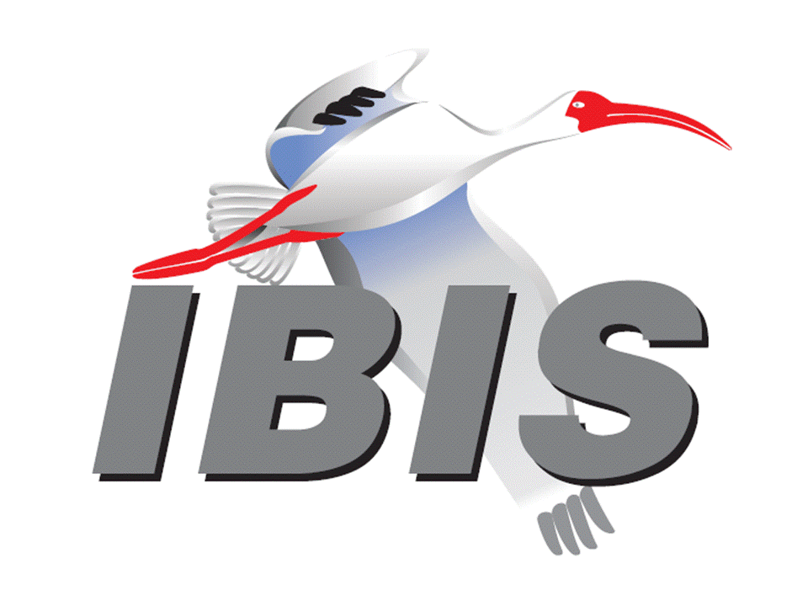

IBIS Open Forum Minutes

Meeting Date: May 10, 2017
Meeting Location: SPI-E IBIS Summit, Baveno, Italy

VOTING MEMBERS AND 2017 PARTICIPANTS
ANSYS Curtis Clark, Toru Watanabe
Applied Simulation Technology (Fred Balistreri)
Broadcom Bob Miller
Cadence Design Systems Brad Brim, Sivaram Chillarige, Debabrata Das
Ambrish Varma
Cisco Systems (Bidyut Sen)
CST Stefan Paret*, Matthias Troescher, Burkhard Doliwa*
Danilo Di Febo*, Alexander Melkozerov*
Ericsson Zilwan Mahmod*
GLOBALFOUNDRIES Steve Parker
Huawei Technologies (Jinjun Li)
IBM Luis Armenta, Adge Hawes, Greg Edlund
Infineon Technologies AG (Christian Sporrer)
Intel Corporation Michael Mirmak, Hsinho Wu, Eddie Frie
Gianni Signorini*, Barry Grquinovic
IO Methodology Lance Wang
Keysight Technologies Radek Biernacki, Pegah Alavi, Fangyi Rao
Stephen Slater, Jian Yang
Maxim Integrated Joe Engert, Don Greer, Yan Liang, Hock Seow
Mentor, A Siemens Business Arpad Muranyi, Nitin Bhagwath*, Praveen Anmula
(formerly Mentor Graphics) Fadi Deek, Raj Raghuram, Dmitry Smirnov
Bruce Yuan, Carlo Bleu*
Micron Technology Randy Wolff, Justin Butterfield
Qualcomm Tim Michalka, Kevin Roselle
Raytheon Joseph Aday
Signal Integrity Software Mike LaBonte, Walter Katz, Todd Westerhoff
Synopsys Kevin Li, Ted Mido, John Ellis, Scott Wedge
Teraspeed Labs Bob Ross
Xilinx (Raymond Anderson)
ZTE Corporation (Shunlin Zhu)
Zuken Ralf Bruening, Michael Schaeder*, Alfonso Gambuzza*

OTHER PARTICIPANTS IN 2017
Accton Raul Lozano
ASUS Nick Huang, Bin-chyi Tseng
Continental AG Stefanie Schatt*
eASIC David Banas
Extreme Networks Bob Haller
Ghent University Paolo Manfredi*
Hamburg University of Technology Torsten Revschel*, Torsen Wendt*
IdemWorks Michelangelo Bandinu*
Independent Dian Yang
John Baprawski, Inc. John Baprawski
KEI Systems Shinichi Maeda
Lattice Semiconductor Maryam Shahbazi, Dinh Tran
Leading Edge Pietro Vergine*
Politecnico di Torino Claudio Siviero*, Stefano Grivet-Talocia*, Igor Stievano*
SAE International (Logen Johnson)
Signal Metrics Ron Olisar
SPISim Wei-hsing Huang
STMicroelectronics Fabio Brina*, Olivier Bayet*
Toshiba Yasuki Torigoshi
Université Blaise Pascal Mohamed Toure*
Université de Bretagne Occidentale Mihai Telescu*

In the list above, attendees at the meeting are indicated by *. Principal members or other active members who have not attended are in parentheses. Participants who no longer are in the organization are in square brackets.

UPCOMING MEETINGS
The bridge numbers for future IBIS teleconferences are as follows:

Date Meeting Number Meeting Password
May 12, 2017 624 999 876 IBISfriday11

For teleconference dial-in information, use the password at the following website:

http://tinyurl.com/zeulerr

All teleconference meetings are 8:00 a.m. to 9:55 a.m. US Pacific Time. Meeting agendas are typically distributed seven days before each Open Forum. Minutes are typically distributed within seven days of the corresponding meeting.

NOTE: "AR" = Action Required.

-------------------------------------------------------------------------------------------------------------------------------
OFFICIAL OPENING
The IBIS Open Forum Summit was held in Baveno, Italy at the Grand Hotel Dino following the 2017 SPI conference. About 23 people representing 15 organizations were recorded in attendance.

The notes below capture some of the content and discussions. The meeting presentations and other documents are available at:

http://www.ibis.org/summits/may17/

Michael Schaeder welcomed all attendees. He presented the agenda and sincerely thanked the sponsors ANSYS, CST, Mentor, A Siemens Business, and Zuken. He also expressed gratefulness in the name of the IBIS committee to the SPI 2017 organization team, namely Manuela Trinchero, Stefano Grivet-Talocia and Igor Stievano, and all others for their support.

Following an IBIS summit tradition all attendees were pleased to give a short self-introduction and describe their relationship to IBIS and IBIS-AMI. The audience consisted of IBIS users, tool vendors, and people from universities or institutes. A few of them had no experience with IBIS models thus far.

ACCURATE MACROMODELS OF OUTPUT BUFFERS WITH PRE-/DE-EMPHASIS
Gianni Signorini*, Claudio Siviero**, Igor Simone Stievano**, Stefano Grivet-Talocia**
*Intel Corporation, Germany; **Politecnico di Torino, Italy
[Presented by Gianni Signorini, Intel Corporation, Germany]

Gianni gave a short introduction of IBIS and IBIS-AMI modeling of pseudo and true differential drivers. He explained the elements of an IBIS-AMI model, i.e. analog IBIS, AMI configuration file and EQ in the executable .dll file. Gianni showed a SERDES channel simulation with driver, channel and receiver. He pointed out possible disadvantages of current IBIS (AMI) models:
- TX EQ is assumed to be an ideal FIR filter.
- Simple R+C+Linear slope approximation without frequency dependency.
- AMI covers differential signal only, no common mode signal is included.

Gianni showed details of the Mpilog modeling framework extended to support TX models with pre-/de-emphasis. The models are parametric mathematical representations with parameter values post-processed from SPICE simulations. Output static characteristics are represented by 3D surface models. Pre-/de-emphasis effects are embedded in weighting functions. C_comp is modeled with time-domain vector fitting pole/zero models. The Mpilog model shows outstanding accuracy for both differential and common-mode signals.

An attendee asked if there is any limitation of the IBIS-AMI model at 10GHz. Gianni responded that it depends on the TX and how well the linearity assumption is fulfilled.

COMPACT MULTIVARIATE SURFACE APPROXIMATIONS FOR POWER-AWARE I/O MODELS
Claudio Siviero*, Gianni Signorini**, Stefano Grivet-Talocia*, Igor Simone Stievano*,
*Politecnico di Torino, Italy; **Intel Corporation, Germany
[Presented by Claudio Siviero, Politecnico di Torino, Italy]

Claudio introduced requirements for macromodels for signal and power integrity simulations. Open issues with IBIS power-aware models include modeling of static characteristics, rising/falling waveforms, and supply current relative to supply voltage as well as power-supply port modeling. He then discussed R&D work being done with Mpilog macromodels for SI and PI simulation. A flexible and modular approach using Mpilog can be implemented in SPICE/Verilog-A. Possible IBIS enhancements were shown to improve power-aware modeling. Validation test showed excellent accuracy in SI/PI co-simulations.

A question was asked if the consideration of ground bounce is possible (regarding slide 3). Claudio responded that in principle it is possible to consider the explicit modeling of the VSS pin as well. However, Gianni Signorini did emphasize that the meaningfulness of such an enhancement is strictly dependent on how the PDN model has been extracted. In fact, very popular extraction tools consider only the current loop between the VDD and VSS planes, so that only the voltage difference between VDD and VSS pins matters. Those are actually the typical case studies the presentation authors concentrated on. On the other hand, there are other extraction tools that account for a third reference plane and consider both the current loop VDD-reference and VSS-reference. In that case the modeling of the VSS pin voltage activity makes sense.

Another question was asked about the performance of the model. Claudio responded that the original IBIS model is only a little bit faster.

IBIS UPDATE
Mike LaBonte, Signal Integrity Software (SiSoft), USA
[Presented by Michael Schaeder, Zuken, Germany]

Michael presented the IBIS roster. Currently IBIS has 25 member companies. He also mentioned the current IBIS officers and referred to the officer's election later in May. He said that only a few people do most of the work and that this is sometimes difficult for them to bring this in line with their job duties. Michael briefly explained how the Open Forum works and the different task groups. He said the IBIS' parent organization is the SAE ITC. He explained that standard changes are requested by BIRDs.

Michael summarized the IBIS history and showed the timeline of IBIS 7.0 which is scheduled for December, 2017. He finally gave a preview of the most likely content. Most important features to come are:
- BIRD 147.6, Back-channel Support
- BIRD 158.5, AMI Ts4file Analog Buffer Models
- BIRD 189.3, Interconnect Modeling Using IBIS-ISS and Touchstone

Someone asked how many BIRDs are active today. Are open BIRDs separately listed on the web page? Michael responded that all BIRDs are listed on the web page including their statuses (open, accepted, rejected). There is no extra list for just open BIRDs (to his knowledge).

INTERCONNECT MODELING USING IBIS-ISS AND TOUCHSTONE
Michael Mirmak, Intel Corporation, USA
[Presented by Stefan Paret, CST AG, Germany]

Stefan stated that BIRD189.x was recently released by the Interconnect Task Group and is awaiting approval. The BIRD is intended for IBIS Version 7.0, and its purpose is to improve package and on-die interconnect models by supporting IBIS-ISS and Touchstone models. This includes models of both I/O and supply connections. An optional die pad interface between pins and buffers is introduced. A one-to-one path connection is assumed for I/Os. Supply rails can have multiple terminals and be merged at the various interfaces. Stefan showed some details of new keywords and subparameters as well as syntax examples.

IBIS EXTENSIONS FOR TURN-AROUND CYCLE SIMULATIONS
Nitin Bhagwath*, Arpad Muranyi*, Randy Wolff**
*Mentor, A Siemens Business, USA; **Micron Technology, USA
[presented by Nitin Bhagwath, Mentor, A Siemens Business, USA]

Nitin noted there is a need to simulate turn around cycles on memory busses because of SI effects that can negatively affect read/write or write/read transitions. Simulating bus turnaround is desirable with IBIS models. He showed what is currently missing in IBIS to correctly model transitions from 1 -> High Z , High Z -> 1, 0 -> High Z , High Z -> 0. He also mentioned that information of ODT activation behavior is needed. Nitin showed how this extra information can be fitted into IBIS, e.g. new tables for transition waveforms and a Bus_hold Submodel for smoothly turning on/off ODT. A simple change to the Bus_hold Submodel type would allow the Submodel to be triggered by a digital control signal from the EDA tool instead of from a voltage waveform crossing event.

He showed a correlation with SPICE (good agreement) and pointed out that behavioral modeling is needed for this to avoid long simulations runs (> 1 hour vs. < 1 minute). The team working on this is aiming for an IBIS BIRD to make turn-around cycle simulations possible with IBIS models. Additional modeling challenges include modeling of bus transitions between multiple on-die termination settings.

A statement from the audience was that this type of simulation is needed.

An additional comment was that this approach considers the output signal only. Should this also take power noise into account (power awareness)? Nitin responded that this is a good point. He will have to look onto this.

CONCLUDING ITEMS
Michael Schaeder again thanked the sponsors ANSYS, CST, Mentor, A Siemens Business, and Zuken, the presenters, organizers and attendees.

The meeting concluded at approximately 5:00 PM.

NEXT MEETING
The next IBIS Open Forum teleconference meeting will be held May 12, 2017. Votes on BIRD158.5 and BIRD186.3 are scheduled. Votes on conducting IBIS Summits at EDI CON and EPEPS also are scheduled.

The following IBIS Open Forum teleconference meeting is tentatively scheduled on June 2, 2017.

========================================================================
NOTES

IBIS CHAIR: Mike LaBonte
mlabonte@sisoft.com
IBIS-AMI Modeling Specialist, Signal Integrity Software
6 Clock Tower Place, Suite 250
Maynard, MA 01754

VICE CHAIR: Lance Wang (978) 633-3388
lwang@iometh.com
President/CEO, IO Methodology, Inc.
PO Box 2099
Acton, MA 01720

SECRETARY: Randy Wolff (208) 363-1764
rrwolff@micron.com
Principal Engineer, Silicon SI Group Lead, Micron Technology, Inc.
8000 S. Federal Way
P.O. Box 6, Mail Stop: 01-711
Boise, ID 83707-0006

TREASURER: Bob Ross (503) 246-8048
bob@teraspeedlabs.com
Engineer, Teraspeed Labs
10238 SW Lancaster Road
Portland, OR 97219

LIBRARIAN: Anders Ekholm (46) 10 714 27 58, Fax: (46) 8 757 23 40
ibis-librarian@ibis.org
Digital Modules Design, PDU Base Stations, Ericsson AB
BU Network
Färögatan 6
164 80 Stockholm, Sweden

WEBMASTER: Mike LaBonte
mlabonte@sisoft.com
IBIS-AMI Modeling Specialist, Signal Integrity Software
6 Clock Tower Place, Suite 250
Maynard, MA 01754

POSTMASTER: Curtis Clark
curtis.clark@ansys.com
ANSYS, Inc.
150 Baker Ave Ext
Concord, MA 01742

This meeting was conducted in accordance with ANSI guidance.

All inquiries may be sent to info@ibis.org. Examples of inquiries are:
- To obtain general information about IBIS.
- To ask specific questions for individual response.
- To subscribe to the official ibis@freelists.org and/or ibis-users@freelists.org email lists (formerly ibis@eda.org and ibis-users@eda.org).
- To subscribe to one of the task group email lists: ibis-macro@freelists.org, ibis-interconn@freelists.org, or ibis-quality@freelists.org.
- To inquire about joining the IBIS Open Forum as a voting Member.
- To purchase a license for the IBIS parser source code.
- To report bugs or request enhancements to the free software tools: ibischk6, tschk2, icmchk1, s2ibis, s2ibis2 and s2iplt.
The BUG Report Form for ibischk resides along with reported BUGs at:

http://www.ibis.org/bugs/ibischk/
http://www.ibis.org/ bugs/ibischk/bugform.txt

The BUG Report Form for tschk2 resides along with reported BUGs at:

http://www.ibis.org/bugs/tschk/
http://www.ibis.org/bugs/tschk/bugform.txt

The BUG Report Form for icmchk resides along with reported BUGs at:

http://www.ibis.org/bugs/icmchk/
http://www.ibis.org/bugs/icmchk/icm_bugform.txt

To report s2ibis, s2ibis2 and s2iplt bugs, use the Bug Report Forms which reside at:

http://www.ibis.org/bugs/s2ibis/bugs2i.txt
http://www.ibis.org/bugs/s2ibis2/bugs2i2.txt
http://www.ibis.org/bugs/s2iplt/bugsplt.txt

Information on IBIS technical contents, IBIS participants and actual IBIS models are available on the IBIS Home page:

http://www.ibis.org/

Check the IBIS file directory on ibis.org for more information on previous discussions and results:

http://www.ibis.org/directory.html

Other trademarks, brands and names are the property of their respective owners.
SAE STANDARDS BALLOT VOTING STATUS
Organization | Interest Category | Standards Ballot Voting Status | March 10, 2017 | March 31, 2017 | April 21, 2017 | May 10, 2017
ANSYS | User | Active | X | X | X | -
Applied Simulation Technology | User | Inactive | - | - | - | -
Broadcom Ltd. | Producer | Inactive | X | - | X | -
Cadence Design Systems | User | Active | X | X | X | -
Cisco Systems | User | Inactive | - | - | - | -
CST | User | Inactive | - | - | - | X
Ericsson | Producer | Inactive | - | - | - | X
GLOBALFOUNDRIES | Producer | Active | X | - | X | -
Huawei Technologies | Producer | Inactive | - | - | - | -
IBM | Producer | Active | X | X | X | -
Infineon Technologies AG | Producer | Inactive | - | - | - | -
Intel Corp. | Producer | Active | X | X | X | X
IO Methodology | User | Active | X | X | X | -
Keysight Technologies | User | Active | X | X | X | -
Maxim Integrated | Producer | Inactive | - | - | - | -
Mentor, A Siemens Business | User | Active | X | X | X | X
Micron Technology | Producer | Active | X | X | X | -
Qualcomm | Producer | Inactive | - | - | - | -
Raytheon | User | Inactive | - | - | - | -
Signal Integrity Software | User | Active | X | X | X | -
Synopsys | User | Active | X | X | X | -
Teraspeed Labs | General Interest | Active | X | X | X | -
Xilinx | Producer | Inactive | - | - | - | -
ZTE | User | Inactive | - | - | - | -
Zuken | User | Inactive | - | - | - | X

Criteria for SAE member in good standing:
- Must attend two consecutive meetings to establish voting membership
- Membership dues current
- Must not miss two consecutive meetings
Interest categories associated with SAE standards ballot voting are:
- Users - members that utilize electronic equipment to provide services to an end user.
- Producers - members that supply electronic equipment.
- General Interest - members are neither producers nor users. This category includes, but is not limited to, government, regulatory agencies (state and federal), researchers, other organizations and associations, and/or consumers.

