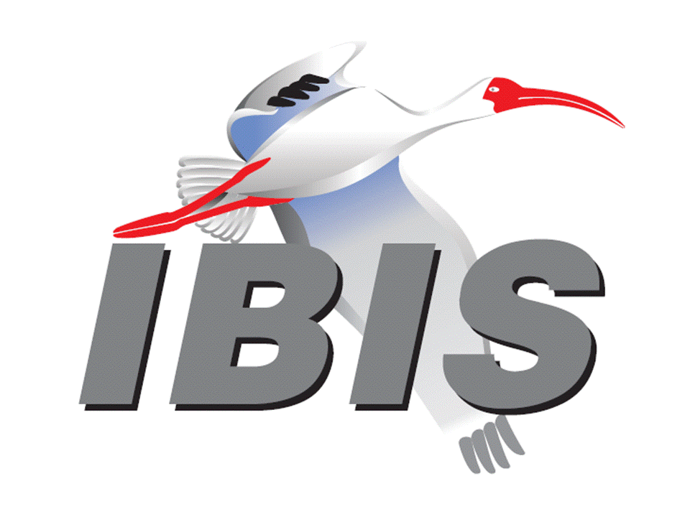
IBIS Open Forum Minutes

Meeting Date: October 24, 2014
Meeting Location: Teleconference

VOTING MEMBERS AND 2014 PARTICIPANTS
Altera David Banas*, Kundan Chand, Hsinho Wu
ANSYS (Steve Pytel)
Applied Simulation Technology Fred Balistreri, Norio Matsui
Cadence Design Systems Ambrish Varma, Brad Brim*, Joy Li, Kumar Keshavan,
Ken Willis, Yingxin Sun, Joshua Luo, John Phillips
Ericsson Anders Ekholm, Zilwan Mahmod
Huawei Technologies Jinjun Li, Xiaoqing Dong, Zanglin Yuan, Han Li
Infineon Technologies AG (Christian Sporrer)
Intel Corporation Michael Mirmak, Jon Powell, Riaz Naseer
Udy Shrivastava, Mustafa Yousuf, Jimmy Jackson
Pietro Brenner, Todd Bermensolo
IO Methodology Lance Wang*, Michelle Coombs
Keysight Technologies (Agilent) Radek Biernacki*, Nilesh Kamdar, Colin Warwick,
Graham Riley, Pegah Alavi, Fangyi Rao,
Heidi Barnes, Dimitrios Drogoudis
LSI (Avago) Xingdong Dai, Min Huang, Anaam Ansari, Brian Burdick
Venkatesh Avula
Maxim Integrated Products Hassan Rafat
Mentor Graphics Arpad Muranyi*, John Angulo, Fadi Deek, Chuck Ferry
Thomas Groebli
Micron Technology Randy Wolff*
Qualcomm Jaimeen Shah, Srinivasa Rao, Senthil Nagarathinam
Signal Integrity Software Mike LaBonte*, Walter Katz*, Todd Westerhoff,
Michael Steinberger
Synopsys Ted Mido*, Scott Wedge, Kevin Cameron, Rita Horner
Teraspeed Labs Bob Ross*, Tom Dagostino, Scott McMorrow
(Teraspeed Consulting Group)
Toshiba Hiroyuki Ikegami, Toshihiro Tsujimura, Hideo Oie
Xilinx Ravindra Gali
ZTE Corporation (Shunlin Zhu)
Zuken Michael Schaeder, Amir Wallrabenstein, Griff Derryberry
Reinhard Remmert

OTHER PARTICIPANTS IN 2014
ADVLSI Pierre Dermy, Juanna Gao
Carleton University Ramachandra Achar
Continental Automotive Catalin Negrea
CST Stefan Paret
ECL Advantage Thomas Iddings
Freescale Asher Berkovitz
Fujitsu Shogo Fujimori
Hewlett Packard Ting Zhu
Hong Kong University Lijun Jiang
IBM Adge Hawes*
Instituto de Telecomunicações Wael Dghais
KEI Systems Shinichi Maeda
Lattice Semiconductor Xu Jiang
Mediatek Alice Lin
Mellanok Technologies Piers Dawe
Microsemi Nizar Abdallah, Ann Lau
Nanium Abel Janeiro
Oracle Stephan Mueller
Pangeya Edgar Aguirre
Proficient Design Kishor Patel
Renesas Genichi Tanaka
SAE International Chris Denham*
Tabula Ben Zhou
Technische Universität Hamburg Torsten Reuschel
University of Illinois José Schutt-Ainé
Vitesse Siris Tsang

In the list above, attendees at the meeting are indicated by *. Principal members or other active members who have not attended are in parentheses. Participants who no longer are in the organization are in square brackets.

UPCOMING MEETINGS
The bridge numbers for future IBIS teleconferences are as follows:

Date Meeting Number Meeting Password
November 14, 2014 Asian IBIS Summit – Shanghai – no teleconference
November 17, 2014 Asian IBIS Summit – Taipei – no teleconference
November 20, 2014 Asian IBIS Summit – Yokohama – no teleconference
December 5, 2014 205 475 958 IBIS

For teleconference dial-in information, use the password at the following website:

https://ciscosales.webex.com/ciscosales/j.php?J=205475958

All teleconference meetings are 8:00 a.m. to 9:55 a.m. US Pacific Time. Meeting agendas are typically distributed seven days before each Open Forum. Minutes are typically distributed within seven days of the corresponding meeting. When calling into the meeting, follow the prompts to enter the meeting ID. For new, local international dial-in numbers, please reference the bridge numbers provided by Cisco Systems at the following link:

http://www.cisco.com/web/about/doing_business/conferencing/index.html

NOTE: "AR" = Action Required.

-------------------------------------------------------------------------------------------------------------------------------
INTRODUCTIONS AND MEETING QUORUM
Mike LaBonte declared that a quorum was reached and the meeting could begin. Mike ran the meeting in Michael Mirmak’s absence.

CALL FOR PATENTS
Mike LaBonte called for any patents or pending patents related to the IBIS 3.2, IBIS 4.2, IBIS 5.1, IBIS 6.0, Touchstone 2.0, IBIS-ISS 1.0 or ICM 1.1 specifications. No patents were declared.

REVIEW OF MINUTES AND ARS
Randy Wolff called for comments regarding the minutes of the October 3, 2014 IBIS Open Forum teleconference. The minutes were approved without changes.

ANNOUNCEMENTS
None.

CALL FOR ADDITIONAL AGENDA ITEMS
Bob Ross requested time to discuss the DAC Summit for 2015.

MEMBERSHIP STATUS AND TREASURER'S REPORT
Bob Ross reported no change in membership with 22 paid members. We are processing two possible parser payments and two Asian Summit payments are pending. The treasury sits at $35,184.

WEB PAGE AND MAILING LIST ADMINISTRATION
Mike LaBonte reported that he has made a little more progress adding to a document describing our server account on eda.org such as where everything is and how to manage things with scripts. This document will be useful for SAE as well as our own knowledge of our web requirements in case we need to move our IT resources at some point. He also noted that the webpage is up to date with regards to the Asian IBIS Summits.

Mike also reported that the eda.org administrators had a meeting about the IBIS reflector. We have had a serious SPAM issue. Some steps have been taken to reduce the SPAM. The administrators suggested using a web form instead of the "open" lists ibis-request@eda.org, ibis-bug@eda.org, etc., for receiving administrative requests. The ibis@eda.org and ibis-users@eda.org email lists are thus far unaffected, but there is a risk they might be impacted by server reputation problems caused by the administrative lists.

LIBRARY UPDATE
No update.

INTERNATIONAL/EXTERNAL ACTIVITIES
- Conferences
The 23rd Conference on Electrical Performance of Electronic Packaging (EPEPS) will be held October 26-29, 2014 in Portland, Oregon. There is usually some IBIS and/or signal integrity related material. Bob Ross noted that there will be some IBIS members in attendance. More information is available at:

http://epeps.org

- Press Update
None.

SUMMIT PLANNING AND STATUS
- Asian IBIS Summit Shanghai – November 14, 2014
This event will be held at the Parkyard Hotel. Bob Ross reported that approximately 10 presentations are planned. Two new sponsors are Intel and Keysight. Sponsors for Shanghai now include Huawei Technologies, ANSYS, Intel, IO Methodology, Keysight, Synopsys, Teledyne LeCroy, ZTE Corporation and others to be determined.

- Asian IBIS Summit Taipei – November 17, 2014
This event will be held at the Sherwood Hotel. Bob noted that Intel is a new sponsor. There are 7 or 8 presentations planned so far. Bob mentioned to Lance Wang that there is a presentation from Keysight and Micron that needs a presenter in Taipei if he is willing. Lance asked to continue the conversation by email. Sponsors for Taipei include ANSYS, Cadence Design Systems, Intel, IO Methodology, Synopsys and others to be determined.

- Asian IBIS Summit Yokohama – November 20, 2014
This event will be held at the Pacifico Hotel. Bob noted that this is a half day conference. About 10 presentations are planned. Sponsors for Yokohama include JEITA, IBIS Open Forum, ANSYS, Cadence Design Systems, Cybernet Systems, Mentor Graphics Corporation, MoDeCH, Zuken and others to be determined.

- DAC Summit
Bob noted that we have an invitation from DAC to hold a meeting there in 2015. We are questioning the need for a meeting given the low attendance last year of only 23. Also, we planned for a larger meeting last year due to problems with the DAC registration process for the meeting. We typically have held our officer elections at the DAC Summit, but we are considering changing to an email-based election process this year.

Mike LaBonte suggested an informal poll to see how many potential attendees there could be. Bob agreed to this. Mike asked if there were any deadlines for making a decision. Bob responded that DAC said November 15, but that seems unrealistic. Bob noted that we do get more international attendees for the DAC meeting.

Sponsorship opportunities for all upcoming IBIS summits are available, with sponsors receiving free mentions in the minutes, agenda, and other announcements. Contact the IBIS Board for further details.

QUALITY TASK GROUP
Mike LaBonte reported that the group is meeting on Tuesdays at 8:00 a.m. PT. Mike, Bob Ross and Lance Wang are working on the IBISCHK6 User Guide. They are looking at sections of the code individually. Current calculations show it would take a really long time to document all the code in detail, so they are looking at ways to reduce the effort required.

The work in progress can be reviewed at:

http://www.eda.org/ibis/ibischk6/ibischk_6.0.0_UserGuide_wip1.pdf

The Quality Task Group checklist and other documentation can be found at:

http://www.eda.org/ibis/quality_wip/

ADVANCED TECHNOLOGY MODELING TASK GROUP
Arpad Muranyi reported that the group is meeting regularly on Tuesdays at 12:00 p.m. PT. Backchannel discussions are tabled while SiSoft works on an alternate proposal. The group talked recently about improving C_comp modeling for higher speed non-AMI models. They are looking at BIRD79 as a starting point.

Task group material can be found at:

http://www.eda.org/ibis/macromodel_wip/

INTERCONNECT TASK GROUP
Walter Katz reported that group is mostly in an editorial phase on the interconnect BIRD. Hopefully we will be making continued progress. The group is meeting regularly on Wednesdays at 8:00 a.m. PT.

Task group material can be found at:

http://www.eda.org/ibis/interconnect_wip/

NEW ADMINISTRATIVE ISSUES
Bob Ross asked Adge Hawes if he was being affected by the IBM/Global Foundries deal. Adge responded that there is very tight interaction with IBM and Global Foundries. US based offices in Fishkill, Burlington and other US sites are affected. Adge was not sure if he is affected yet.

BIRD125.1: MAKE IBIS-ISS AVAILABLE FOR IBIS PACKAGE MODELING
Discussion was tabled.

BIRD128.2: ALLOW AMI_PARAMETERS_OUT TO PASS AMI_PARAMETERS_IN DATA ON CALLS TO AMI_GETWAVE
Discussion was tabled.

BIRD145.3: CASCADING IBIS I/O BUFFERS WITH [EXTERNAL CIRCUIT]S USING THE [MODEL CALL] KEYWORD
Discussion was tabled.

BIRD147: BACK-CHANNEL SUPPORT
Discussion was tabled.

BIRD157: PARAMETERIZE [DRIVER SCHEDULE]
Discussion was tabled.

BIRD158.3: AMI TOUCHSTONE ANALOG BUFFER MODELS
Discussion was tabled.

BIRD161.1: SUPPORTING INCOMPLETE AND BUFFER-ONLY [COMPONENT] DESCRIPTIONS
Discussion was tabled.

BIRD163: INSTANTIATING AND CONNECTING [EXTERNAL CIRCUIT] PACKAGE MODELS WITH [CIRCUIT CALL]
Discussion was tabled.

BIRD164: ALLOWING PACKAGE MODELS TO BE DEFINED IN [EXTERNAL CIRCUIT]
Discussion was tabled.

BIRD165: PARAMETER PASSING IMPROVEMENTS FOR [EXTERNAL CIRCUIT]S
Discussion was tabled.

BIRD166: RESOLVING PROBLEMS WITH REDRIVER INIT FLOW
Discussion was tabled.

IBISCHK6 PARSER AND BUG STATUS
Bob Ross reported that he is expecting an update soon, maybe today. This will fix several bugs. The code will need to be checked out, and if it is ok it will be distributed to parser licensees and executables will be created and posted. This will take about a week.

The source code will not fix BUG151. Bob added comments to that bug after the last meeting. BUG151 will require additional payment to a parser developer.

NEW TECHNICAL ISSUES
None.

NEXT MEETING
The Asian IBIS Summit in Shanghai will be held November 14, 2014. The Asian IBIS Summit in Taipei will be held November 17, 2014. The Asian IBIS Summit in Yokohama will be held November 20, 2014. No teleconferences will be available for the Summit meetings. The next IBIS Open Forum teleconference meeting will be held December 5, 2014.

Bob Ross moved to adjourn. David Banas seconded the motion. There were no objections.

========================================================================
NOTES

IBIS CHAIR: Michael Mirmak (916) 356-4261, Fax (916) 377-3788
michael.mirmak@intel.com
Data Center Platform Applications Engineering
Intel Corporation
FM5-239
1900 Prairie City Rd.,
Folsom, CA 95630

VICE CHAIR: Lance Wang (978) 633-3388
lwang@iometh.com
President/CEO, IO Methodology, Inc.
PO Box 2099
Acton, MA 01720

SECRETARY: Randy Wolff (208) 363-1764, Fax: (208) 368-3475
rrwolff@micron.com
Principal Engineer, Silicon SI Group Lead, Micron Technology, Inc.
8000 S. Federal Way
Mail Stop: 01-711
Boise, ID 83707-0006

LIBRARIAN: Anders Ekholm (46) 10 714 27 58, Fax: (46) 8 757 23 40
ibis-librarian@eda.org
Digital Modules Design, PDU Base Stations, Ericsson AB
BU Network
Färögatan 6
164 80 Stockholm, Sweden

WEBMASTER: Mike LaBonte
mikelabonte@eda.org
IBIS-AMI Modeling Specialist, Signal Integrity Software
6 Clock Tower Place
Maynard, MA 01754

POSTMASTER: Mike LaBonte
mikelabonte@eda.org
IBIS-AMI Modeling Specialist, Signal Integrity Software
6 Clock Tower Place
Maynard, MA 01754

This meeting was conducted in accordance with ANSI guidance.

The following e-mail addresses are used:

majordomo@eda.org
In the body, for the IBIS Open Forum Reflector:
subscribe ibis <your e-mail address>

In the body, for the IBIS Users' Group Reflector:
subscribe ibis-users <your e-mail address>

Help and other commands:
help

ibis-request@eda.org
To join, change, or drop from either or both:
IBIS Open Forum Reflector (ibis@eda.org)
IBIS Users' Group Reflector (ibis-users@eda.org)
State your request.

ibis-info@eda.org
To obtain general information about IBIS, to ask specific questions for individual response, and to inquire about joining the IBIS Open Forum as a full Member.

ibis@eda.org
To send a message to the general IBIS Open Forum Reflector. This is used mostly for IBIS Standardization business and future IBIS technical enhancements. Job posting information is not permitted.

ibis-users@eda.org
To send a message to the IBIS Users' Group Reflector. This is used mostly for IBIS clarification, current modeling issues, and general user concerns. Job posting information is not permitted.

ibis-bug@eda.org
To report ibischk parser BUGs as well as tschk2 parser BUGs. The BUG Report Form for ibischk resides along with reported BUGs at:

http://www.eda.org/ibis/bugs/ibischk/
http://www.eda.org/ibis/bugs/ibischk/bugform.txt

The BUG Report Form for tschk2 resides along with reported BUGs at:

http://www.eda.org/ibis/tschk_bugs/
http://www.eda.org/ibis/tschk_bugs/bugform.txt

icm-bug@eda.org
To report icmchk1 parser BUGs. The BUG Report Form resides along with reported
BUGs at:

http://www.eda.org/ibis/icm_bugs/
http://www.eda.org/ibis/icm_bugs/icm_bugform.txt

To report s2ibis, s2ibis2 and s2iplt bugs, use the Bug Report Forms which reside at:

http://www.eda.org/ibis/bugs/s2ibis/bugs2i.txt
http://www.eda.org/ibis/bugs/s2ibis2/bugs2i2.txt
http://www.eda.org/ibis/bugs/s2iplt/bugsplt.txt

Information on IBIS technical contents, IBIS participants and actual IBIS models are available on the IBIS Home page:

http://www.eda.org/ibis

Check the IBIS file directory on eda.org for more information on previous discussions and results:

http://www.eda.org/ibis/directory.html

Other trademarks, brands and names are the property of their respective owners.
IBIS – SAE STANDARDS BALLOT VOTING STATUS
Organization | Interest Category | Standards Ballot Voting Status | August 22, 2014 | September 12, 2014 | October 3, 2014 | October 24, 2014
Altera | Producer | Inactive | X | - | - | X
ANSYS | User | Inactive | - | - | - | -
Applied Simulation Technology | User | Inactive | - | - | - | -
Cadence Design Systems | User | Active | X | X | X | X
Ericsson | Producer | Inactive | - | - | - | -
Huawei Technologies | Producer | Inactive | - | - | - | -
Infineon Technologies AG | Producer | Inactive | - | - | - | -
Intel Corp. | Producer | Active | X | X | X | -
IO Methodology | User | Active | - | X | X | X
Keysight Technologies (Agilent) | User | Active | X | X | X | X
LSI (Avago) | Producer | Inactive | - | - | - | -
Maxim Integrated Products | Producer | Inactive | - | - | - | -
Mentor Graphics | User | Active | X | X | X | X
Micron Technology | Producer | Active | - | X | X | X
Qualcomm | Producer | Inactive | X | X | - | -
Signal Integrity Software | User | Active | X | X | X | X
Synopsys | User | Active | - | - | X | X
Teraspeed Labs | General Interest | Active | X | X | X | X
Toshiba | Producer | Active | - | X | X | -
Xilinx | Producer | Inactive | - | - | - | -
ZTE | User | Inactive | - | - | - | -
Zuken | User | Inactive | - | - | - | -

I/O Buffer Information Specification Committee (IBIS)

Criteria for Member in good standing:
- Must attend two consecutive meetings to establish voting membership
- Membership dues current
- Must not miss two consecutive Meetings
Interest categories associated with SAE ballot voting are:
- Users - Members that utilize electronic equipment to provide services to an end user.
- Producers - Members that supply electronic equipment.
- General Interest - Members are neither producers nor users. This category includes, but is not limited to, Government, regulatory agencies (state and federal), researchers, other organizations and associations, and/or consumers.

