BUFFER ISSUE RESOLUTION DOCUMENT (BIRD)

BIRD NUMBER: BIRD 145.3
ISSUE TITLE: Cascading IBIS I/O buffers with [External Circuit]s using the [Model Call] keyword
REQUESTOR: Taranjit Kukal, Ambrish Varma, Cadence Design Systems, Inc. Arpad Muranyi, Mentor Graphics.

DATE SUBMITTED: September 19, 2011
DATE REVISED: November 10, 2011; May 21, 2013
DATE ACCEPTED: Rejected July 20, 2018

STATEMENT OF THE ISSUE:

The current [External Circuit] and [Circuit Call] usage rules do not allow the direct interconnection and instantiation of existing IBIS I/O models with [External Circuit] blocks. Based on that, in order for a model developer to use an IBIS I/O model in an [External Circuit] the following steps need to
be followed:
1) Develop SPICE-like wrappers in which the corresponding typ, min, and max IBIS I/O subcircuits are instantiated
2) Develop an [External Circuit] to point to the wrapper subcircuits
3) Use the [Circuit Call] keyword to call the [External Circuit]

It is obvious that the previous usage rules are cumbersome especially when the developer could just directly call the desired IBIS I/O model without the need to develop a SPICE-like wrapper as well as an [External Circuit] section. In this BIRD, we propose the syntax to directly cascade an IBIS I/O model with an [External Circuit] using the new [Model Call] keyword.

ANALYSIS PATH/DATA THAT LED TO SPECIFICATION:

The proposed approach in this BIRD came from commercial on-die terminations (ODT) and on-die RDL parasitics modeling efforts where new functionality was needed to meet customer expectations for model functionality, accuracy and performance.
The approach and keywords in this BIRD are defined by Cadence and its semiconductor partners to make the SPICE-IBIS model development process easier.

ANY OTHER BACKGROUND INFORMATION:

BIRD 145 was originally titled:
Instantiation of IBIS I/O buffers in an [External Circuit] using the [Model Call] keyword

This BIRD is being requested by the following IBIS users and model developers, in conjunction with the authors:

IBM: Adge Hawes, Kent Dramstad

We introduce the new [Model Call] and [End Model Call] keywords to directly instantiate and connect regular IBIS buffer [Model]s with [External Circuit]s.

At the end of the [Circuit Call] section (i.e., at the end of page 121 in the IBIS 5.1 specification) add the following lines:

Keyword: [Model Call], [End Model Call]
Required: No
Description: This keyword is used to instantiate IBIS buffer [Model]s to connect their reserved ports to the ports of an [External Circuit] by connecting them to the same node declared by the [Node Declarations] keyword.
Sub-Params: Signal_pin, Diff_signal_pins, Series_pins, Port_map
Usage Rules: The [Model Call] keyword must be followed by the name of a [Model] that exists in the same [Component]. When a [Model] is called in an IBIS file, then there is NO need to associate it with an [External Circuit] section. As in this case the EDA tool should model the buffer "as usual" based on its existing I-V and V-T tables as well as its subparameters, which can be found in the called [Model].
A [Model Call] keyword should always define connections that involve one or more nodes declared by the [Node Declarations] keyword. If the involved [Circuit Call] keywords define any connections that involve one or more die pads (and consequently pins), the corresponding pins on the [Pin] list must use the reserved word "CIRCUITCALL" in the third column instead of a model name.
Multiple [Model Call] keywords may appear under a [Component] using the same [Model] name, if multiple instantiations of an IBIS buffer [Model] are needed.

Signal_pin:
Signal_pin is used when the referenced [Model] has a single analog signal port (I/O) connection to one pin through [External Circuit]. The subparameter is followed by a pin name that must match one of the pin names under the [Pin] keyword.

Diff_signal_pins:
Diff_signal_pins is used when the referenced [Model] (e.g., [External Model] inside [Model]) describes a true differential model which has two analog signal port (I/O) connections, each to a separate pin through [External Circuit]. The subparameter is followed by two pin names, each of which must match one of the pin names under the [Pin] keyword. The first and second pin names correspond to the non-inverting and inverting signals of the differential model, respectively.
The two pin names must not be identical.

Series_pins:
Series_pins is used when the referenced [Model] describes a Series or Series_switch model which has two analog signal port (I/O) connections to two pins through [External Circuit]. The subparameter is followed by two pin names, each of which must match one of the pin names under the [Pin] keyword. The first and second pin names correspond to the positive and negative ports of the Series or Series_switch model, respectively. However, the polarity order matters only when the model is polarity sensitive (as with the [Series Current] keyword). The two pin names must not be identical.

Port_map:
The Port_map subparameter is used to connect the reserved ports of an IBIS buffer [Model] to the ports of an [External Circuit] by connecting them to the same node declared by the [Node Declarations] keyword.
Every occurrence of the Port_map subparameter must begin on a new line and must be followed by two arguments, the first being a port name, and the second being a node name declared by the [Node Declarations] keyword.
The first argument of Port_map must contain a port name that matches one of the reserved port names of an IBIS [Model]. These reserved ports are defined in the table below.

Port Name Description
========= ==========================
1 D_drive Digital input to a model unit
2 D_enable Digital enable for a model unit
3 D_receive Digital receive port of a model unit
4 A_puref Voltage reference port for pullup structure
5 A_pcref Voltage reference port for power clamp structure
6 A_pdref Voltage reference port for pulldown structure
7 A_gcref Voltage reference port for ground clamp structure
8 A_signal I/O signal port for a model unit
9 A_extref External reference voltage port
10 D_switch Digital input for control of a series switch model
11 A_gnd Global reference voltage port
12 A_pos Non-inverting port for series or series switch models
13 A_neg Inverting port for series or series switch models
14 A_signal_pos Non-inverting port of a differential model
15 A_signal_neg Inverting port of a differential model

The first letter of the port name designates it as either digital ("D") or analog ("A"). Reserved ports 1 through 15 listed above are assumed or implied under the native IBIS [Model] keyword.

Under the [Model] description, power and ground reference ports are defined and connected by IBIS-compliant tools as defined by the [Power Clamp Reference], [GND Clamp Reference], [Pullup Reference], [Pulldown Reference] and/or [Voltage Range] keywords. The A_signal port is connected to an [External Circuit] node, to drive or receive an analog signal.

The pre-defined voltage reference ports (i.e., A_pcref, A_puref, A_pdref, A_gcref) of any [Model] that is called in the circuit can be either: a) manually interconnected by the model developer to the
ports of an [External Circuit] by connecting them to the same node declared by the [Node Declarations] keyword as shown in example 1 below (i.e., in this case the model developer needs to guarantee that the [External Circuit] contains the appropriate circuitry to deliver the required power to each of the voltage reference ports), or b) automatically interconnected "as usual" by the EDA tool to the corresponding voltage sources when those ports are left floating as shown in example 2 below (i.e., in this case the EDA tool should connect the reserved voltage reference ports to DC voltage sources with voltage values equal to the corresponding reference voltage values in the [Model]).

No port name may be listed more than once within a [Model Call] statement. Only those reserved port names need to be listed with the Port_map subparameter which are connected to an [External Circuit] port by connecting them to the same node declared by the [Node Declarations] keyword

The second argument of the Port_map subparameter contains the name of a node declared by the [Node Declarations] keyword. The node name may appear multiple times as Port_map subparameter arguments within the same [Model Call] statement to signify a common connection between multiple ports, such as common voltage supply.

Examples:
The following two examples demonstrate how the proposed [Model Call] keyword could be used to directly instantiate and connect regular IBIS I/O buffers with [External Circuit]s. Both examples are based on the [Pin] section in page 17 in the IBIS 5.1 specification, which is modified below to indicate that pins 5 and 9 are each referenced in a [Circuit Call] section.

|-------------------------------------------------------------------------------
[Pin] signal_name model_name R_pin L_pin C_pin
|
1 RAS0# Buffer1 200.0m 5.0nH 2.0pF
2 RAS1# Buffer2 209.0m NA 2.5pF
3 EN1# Input1 NA 6.3nH NA
4 A0 3-state
5 D0 CIRCUITCALL
6 RD# Input2 310.0m 3.0nH 2.0pF
7 WR# Input2
8 A1 I/O2
9 D1 CIRCUITCALL
10 GND GND 297.0m 6.7nH 3.4pF
11 RDY# Input2
12 GND GND 270.0m 5.3nH 4.0pF
| .
| .
| .
18 Vcc3 POWER
19 NC NC
20 Vcc5 POWER 226.0m NA 1.0pF
21 BAD1 Series_switch1 | Illegal assignment
22 BAD2 Series_selector1 | Illegal assignment

Example 1: I/O [Model] with an RDL [External Circuit]

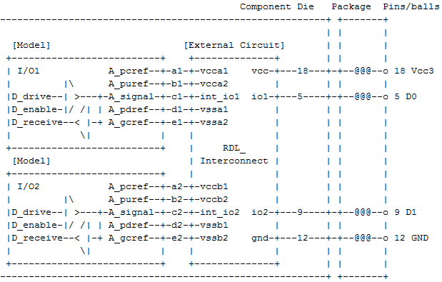

|
[Node Declarations] | Must appear before any [Circuit Call] or
| | [Model Call] keyword
|
| Die nodes:
a1 b1 c1 d1 e1 | List of die nodes
a2 b2 c2 d2 e2
|
[End Node Declarations]
|
| NOTE:
| A [Model] named "I/O1" must be present in the IBIS file in order to enable
| the tool to instantiate and connect the called model "as usual" based on
| the I-V and V-T curves as well as the subparameters under the corresponding
| [Model] section.
|
[Model Call] I/O1 | Instantiates [Model] named "I/O1"
|
Signal_pin 5
|
| mapping port node
|
Port_map A_pcref a1 | Port to internal node connection
Port_map A_puref b1 | Port to internal node connection
Port_map A_signal c1 | Port to internal node connection
Port_map A_pdref d1 | Port to internal node connection
Port_map A_gcref e1 | Port to internal node connection
|
[End Model Call]
|
| NOTE:
| A [Model] named "I/O2" must be present in the IBIS file in order to enable
| the tool to instantiate and connect the called model "as usual" based on
| the I-V and V-T curves as well as the subparameters under the corresponding
| [Model] section.
|
[Model Call] I/O2 | Instantiates [Model] named "I/O2"
|
Signal_pin 9
|
| mapping port node
|
Port_map A_pcref a2 | Port to internal node connection
Port_map A_puref b2 | Port to internal node connection
Port_map A_signal c2 | Port to internal node connection
Port_map A_pdref d2 | Port to internal node connection
Port_map A_gcref e2 | Port to internal node connection
|
[End Model Call]
|
[Circuit Call] RDL_Interconnect | Instantiates [External Circuit] named
| "RDL_Interconnect"
|
| mapping port pad/node
|
Port_map vcc 18 | Port to implicit pad connection
Port_map gnd 12 | Port to implicit pad connection
Port_map io1 5 | Port to implicit pad connection
Port_map io2 9 | Port to implicit pad connection
Port_map vcca1 a1 | Port to internal node connection
Port_map vcca2 b1 | Port to internal node connection
Port_map int_io1 c1 | Port to internal node connection
Port_map vssa1 d1 | Port to internal node connection
Port_map vssa2 e1 | Port to internal node connection
Port_map vccb1 a2 | Port to internal node connection
Port_map vccb2 b2 | Port to internal node connection
Port_map int_io2 c2 | Port to internal node connection
Port_map vssb1 d2 | Port to internal node connection
Port_map vssb2 e2 | Port to internal node connection
|
[End Circuit Call]
|

Example 2: I/O [Model] with an ODT [External Circuit]
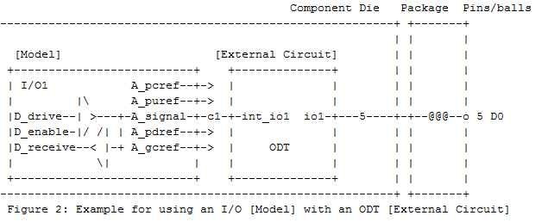
| NOTE 1:
| A [Model] named "I/O1" must be present in the IBIS file in order to enable
| the tool to instantiate and connect the called model above based on the
|* I-V and V-T curves as well as the subparameters of the corresponding [Model].
|
| NOTE 2:
| The voltage reference ports of [Model] I/O1 above are not connected in
| this circuit. Therefore, the tool has to automatically connect them to the
| corresponding voltage sources similarly to any other IBIS models.
|
[Node Declarations] | Must appear before any [Circuit Call] or
| | [Model Call] keyword
|
| Die nodes:
c1 | List of die nodes
|
[End Node Declarations]
|
[Model Call] I/O1 | Instantiates [Model] named "I/O1"
|
Signal_pin 5
|
| mapping port node
|
Port_map A_signal c1 | Port to internal node connection
|
[End Model Call]
|
[Circuit Call] ODT | Instantiates [External Circuit] named "ODT"
|
|
| mapping port pad/node
|
Port_map io1 5 | Port to implicit pad connection
Port_map int_io1 c1 | Port to internal node connection
|
[End Circuit Call]
|

