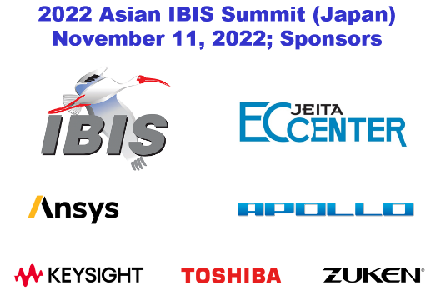
Virtual Asian IBIS Summit (Japan)
Friday, November 11, 2022

Agenda

Room: Virtual
Sponsors: IBIS Open Forum
Japan Electronics and Information Technology Industries Association (JEITA)

ANSYS, Inc.
Apollo Giken Co., Ltd.
Keysight Technologies Japan K.K.
Toshiba Corporation
Zuken Inc.
(Most presentations are in pre-recorded audio/ video format with alternative language subtitles)
(Order and times in JST subject to change)
Summit Recording (MP4)
Minutes
8:45 SIGN IN
8:55 MEETING WELCOME
Randy WOLFF (Chair, IBIS Open Forum, Micron Technology, USA)
9:00 Meeting Welcomes
Hayato OGAWA (Keysight Technologies, Japan)
Chair, JEITA EDA Model Specialty Committee
9:10 IBIS Chair's Report
Randy WOLFF (Micron Technology, USA)
9:30 IBIS Electrical Module Description (EMD) Overview
Randy WOLFF (Micron Technology, USA)
10:05 Maximum Frequency for S-parameter Model Used in Channel Simulation
Masaki KIRINAKA (FICT Limited, Japan)
10:35 BREAK (10 minutes)
10:45 SPIM (Standard PI Model) in IBIS
Kinger CAI (Intel Corp., USA)
Chi-te CHEN (Intel Corp., USA)
[Presented by Kinger CAI (Intel Corp. USA)]
11:10 [PSIJ Sensitivity] in IBIS
Kinger CAI (Intel Corp., USA)
Fern Nee TAN (Intel Corp., USA)
Chi-te CHEN (Intel Corp., USA)
[Presented by Kinger CAI (Intel Corp. USA)]
11:35 DISCUSSION AND CONCLUDING ITEMS
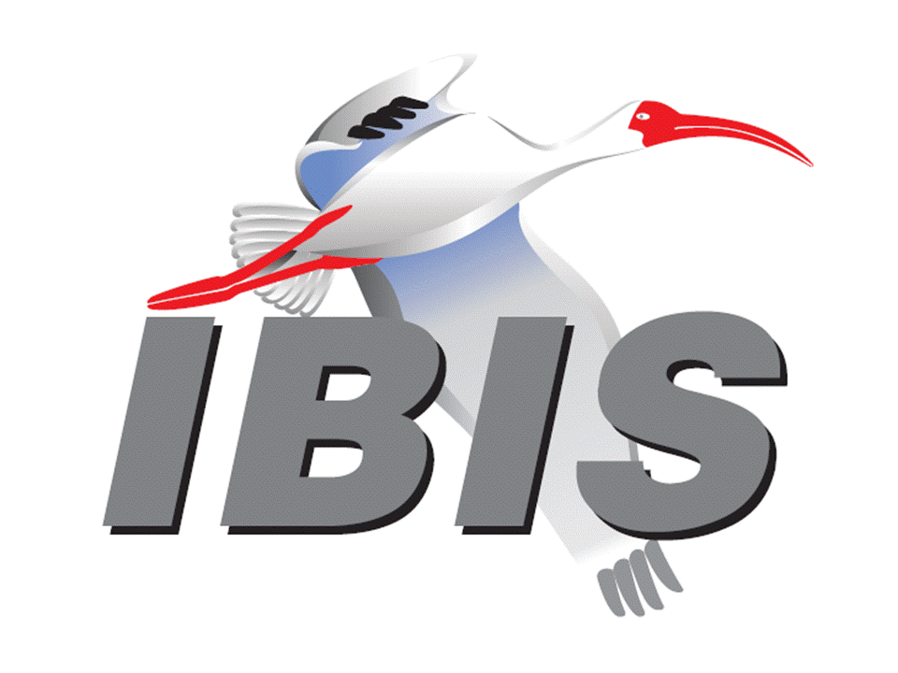
12:00 END OF IBIS SUMMIT MEETING

