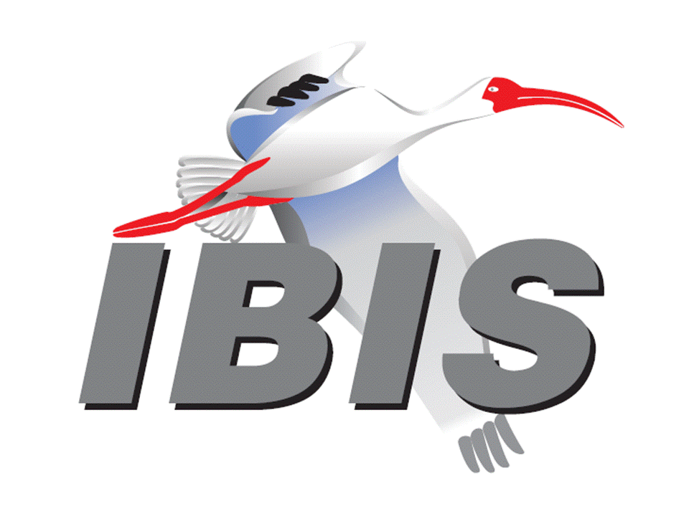

IBIS Open Forum Minutes

Meeting Date: January 11, 2019
Meeting Location: Teleconference

VOTING MEMBERS AND 2019 PARTICIPANTS
ANSYS Curtis Clark*
Applied Simulation Technology (Fred Balistreri)
Broadcom (Yunong Gan)
Cadence Design Systems Brad Brim*
Cisco Systems (Stephen Scearce)
CST (Stefan Paret)
Ericsson (Anders Ekholm)
GLOBALFOUNDRIES Steve Parker*
Huawei Technologies (Hang (Paul) Yan)
IBM Michael Cohen*
Infineon Technologies AG (Christian Sporrer)
Intel Corporation Hsinho Wu*, Michael Mirmak*
IO Methodology Lance Wang*
Keysight Technologies Radek Biernacki*
Maxim Integrated (Mahbubul Bari)
Mentor, A Siemens Business Arpad Muranyi*
Micron Technology Randy Wolff*, Justin Butterfield*
NXP (John Burnett)
Raytheon (Joseph Aday)
SiSoft Mike LaBonte*
Synopsys Ted Mido*
Teraspeed Labs Bob Ross*
Xilinx (Raymond Anderson)
ZTE Corporation (Shunlin Zhu)
Zuken (Michael Schaeder)

OTHER PARTICIPANTS IN 2019
SAE ITC (Jose Godoy)

In the list above, attendees at the meeting are indicated by *. Principal members or other active members who have not attended are in parentheses. Participants who no longer are in the organization are in square brackets.

UPCOMING MEETINGS
The bridge numbers for future IBIS teleconferences are as follows:

Date Meeting Number Meeting Password
February 1, 2019 IBIS Summit at DesignCon – no teleconference
February 22, 2019 624 227 121 IBISfriday11

For teleconference dial-in information, use the password at the following website:

http://tinyurl.com/y7yt7buz

All teleconference meetings are 8:00 a.m. to 9:55 a.m. US Pacific Time. Meeting agendas are typically distributed seven days before each Open Forum. Minutes are typically distributed within seven days of the corresponding meeting.

NOTE: "AR" = Action Required.

-------------------------------------------------------------------------------------------------------------------------------
INTRODUCTIONS AND MEETING QUORUM
Randy Wolff declared that a quorum was reached.

CALL FOR PATENTS
Mike LaBonte called for declaration of any patents or pending patents related to the IBIS 3.2, IBIS 4.2, IBIS 5.1, IBIS 6.1, Touchstone 2.0, IBIS-ISS 1.0 or ICM 1.1 specifications. No patents were declared.

REVIEW OF MINUTES AND ARS
Mike LaBonte called for comments on the minutes of the December 21, 2018 IBIS Open Forum teleconference. Radek Biernacki moved to approve all the minutes. Curtis Clark seconded the motion. There were no objections.

Mike reviewed ARs from the previous meeting.

- Michael Mirmak to confirm what LPB information he is able to share more broadly [AR].
Michael reported he discussed this with Jonathan Goldberg of IEEE. He can share feature, current status and other details, but he can’t share the documents themselves outside of the working group membership. Before final approval, all details are subject to change.
- Mike LaBonte to add Cadence as sponsor to DesignCon Summit web entry [AR].
Mike reported this as done.
- Mike LaBonte to post PDF version of IBIS 7.0 draft to web page [AR].
Mike reported this as done.
- Mike LaBonte to update IBISCHK6 web page for ibischk6 version 6.1.5 [AR].
Mike reported this as done.

Michael Cohen asked about his request for an update to the webpage to post teleconference meeting login details. Mike noted he had not done this. Curtis Clark noted he did not have Michael’s email address needed to add him to the reflector. Michael shared his email with Curtis. Michael also noted the meeting link shows a meeting every Friday, so it is not useful for adding to his calendar. Mike noted the meeting invite sent by email is the best place for up-to-date information. Michael pointed out that this is the kind of information that a new member will be looking for.

ANNOUNCEMENTS, CALL FOR ADDITIONAL AGENDA ITEMS
None.

MEMBERSHIP STATUS AND TREASURER'S REPORT
Bob Ross reported that we have 25 members. There is $19,050 in our account, with $16,800 allocated for 2018 expenses. $2,250 is allocated to 2019 expenses. We have had no accumulation for 2019 so far, either expenses or income. We expect payments for parser development of $1,000 to be made. We expect an SAE ITC participation payment to be made for 2018. Invoices for membership renewal will hopefully go out soon.

WEBSITE ADMINISTRATION
Mike LaBonte showed the web page for the IBIS 7.0 draft. The IBISCHK6 web page was updated yesterday to include Linux Ubuntu executables. The SHA1 checksums are updated on the page too. The IBISCHK6.1.5 user guide is still posted as a work in progress. The DesignCon invitation banner is also shown on the main page. Some pages have been updated with the 2019 copyright. Bob Ross noted Mike should consider making an announcement about the availability of the IBISCHK6.1.5 executables. Mike will make an announcement [AR].

Mike noted for Michael Cohen that he has plans to upgrade the IBIS webpage to a WordPress format, but this will not happen until he has more time. Michael asked about showing the 20% discount for DesignCon on the IBIS webpage. Mike will look for a banner that displays the discount or add text about the discount to update the webpage [AR].

MAILING LIST ADMINISTRATION
Curtis Clark reported nothing new to report. He will help get Michael Cohen subscribed to the mailing list.

LIBRARY UPDATE
No update.

INTERNATIONAL/EXTERNAL ACTIVITIES
- Conferences
None.

- Press Update
None.

- Related standards
IEC 63055/IEEE 2401, JEITA “LPB”
Michael Mirmak reported the next meeting will be January 23, 2019 Japan time. The group will review comments on draft 2. The comments can be logged against the document up until that time if anyone is a member to make comments. The goal is to get a final version of this document through IEEE approval by the end of the year. Mike LaBonte asked if there was any information in draft 2 about supporting new IBIS package model formats such as BIRD189. Michael noted that different descriptions of systems can be in five different formats. There is overlap with what IBIS can do, where IBIS is part of the “C”, or component, format. IBIS components interact with the board level format. S-parameters are also treated as part of the C format level. .ibs, .pkg and .ebd files are supported, and the document is being written with the expectation that IBIS 7.0 will be approved in the timeframe of LPB approval. IBIS-ISS is also part of the SPICE format supported in the document.

Mike asked if the specification will point to the [Interconnect Model] directly or to higher level keywords. Michael will look into this further. Bob Ross noted that the specification is exclusionary, for example supporting only S-parameters, but not other formats from Touchstone. He sees issues with the specification only pointing to specific parts of IBIS. Michael noted that terminals are included but may be handled differently than IBIS. Radek Biernacki asked about support for Touchstone2. Michael thought this was supported.

SUMMIT PLANNING AND STATUS
- DesignCon 2019 IBIS Summit
DesignCon will be held in Santa Clara, CA on January 29 through January 31, 2019. An IBIS Summit will be held on Friday, February 1, 2019. Mike LaBonte noted it will be in room 209 of the convention center. Let Lance Wang know if you will be attending to help with lunch planning. Bob Ross noted we can accept more presentations. There are 12 presentations penciled in. Mike stated the detailed schedule will be sent out no less than one week before the meeting. Lance reported that 39 people are registered so far. Cadence Design Systems, Keysight Technologies, Mentor, a Siemens Business, and Synopsys are sponsors.

Sponsorship opportunities for all upcoming IBIS summits are available, with sponsors receiving free mentions in the minutes, agenda, and other announcements. Contact the IBIS Board for further details.

QUALITY TASK GROUP
Mike LaBonte reported that the group is meeting on Tuesdays at 8:00 a.m. PT. The focus is about IBISCHK. There has been some activity with finalizing and releasing 6.1.5 including revising the user guide. There will be discussion upcoming on a parser for IBIS 7.0.

The Quality task group checklist and other documentation can be found at:

http://www.ibis.org/quality_wip/

ADVANCED TECHNOLOGY MODELING TASK GROUP
Arpad Muranyi reported that the group normally meets regularly on Tuesdays at 12:00 p.m. PT. The first meeting of the year was this week. Many previous meeting slots were used for Editorial task group work. The DC_Offset BIRD will be up for discussion at the next meeting.

Task group material can be found at:

http://www.ibis.org/macromodel_wip/

INTERCONNECT TASK GROUP
Michael Mirmak reported that the group usually meets at 8:00 a.m. PT on Wednesdays. The group remains suspended until IBIS 7.0 editorial activities are completed.

Task group material can be found at:

http://www.ibis.org/interconnect_wip/

EDITORIAL TASK GROUP
Michael Mirmak reported that the group has been meeting at 8:00 a.m. PT on Wednesdays and on Fridays when there is no Open Forum teleconference as well as during some ATM task group time slots. The group is meeting to review comments on the document received from Randy Wolff. About one third of the comments have been reviewed so far. Comments from others are encouraged.

Task group material can be found at:

http://www.ibis.org/editorial_wip/

NEW ADMINISTRATIVE ISSUES
None.

BIRD197.1: NEW AMI RESERVED PARAMETER DC_OFFSET
Randy Wolff noted that the BIRD197.2 draft is up for discussion at the next ATM task group meeting. Bob Ross moved to table the BIRD until a new version is submitted. Radek Biernacki seconded the motion. There were no objections.

BIRD166.4: RESOLVING PROBLEMS WITH REDRIVER INIT FLOW
Discussion was tabled.

BIRD181.1: I-V TABLE CLARIFICATIONS
Discussion was tabled.

Michael Mirmak asked if this BIRD was on the ATM task group list for discussion. Mike LaBonte noted that it is not, but that would be a good place for discussion. Arpad Muranyi noted it is mentioned as a pending BIRD waiting for discussion in the ATM task group, but it is not on the agenda. Mike added that the BIRD addresses only one part of the specification, but Bob Ross has pointed out that other parts of the specification should be updated at the same time. The BIRD may also need to be updated to reflect any changes in IBIS 7.0. Bob noted that the BIRD should be expanded to cleanup more of the specification. Michael added that he would like to see the BIRD discussed in the ATM task group meeting.

BIRD190: CLARIFICATION FOR REDRIVER FLOW
Discussion was tabled.

IBISCHK PARSER AND BUG STATUS
Bob Ross reported IBISCHK6.1.5 is finished. Source code has been sent out to all the parser owners. Parser executables have been uploaded on the IBIS web page. We still have to pay the parser developer. Mike LaBonte noted that from version 6.1.3, we began checking executables. Those checks will not run on Windows XP. Since this is not a supported operating system, there is no need to create a parser version supporting Windows XP. Lance Wang suggested to be more clear on the webpage that the 32-bit DLL is actually for a 64-bit machine. Mike suggested discussing this further in the Quality task group. The parser loads in the .dll executable in Windows or the .so in Linux. If an unsupported executable is opened, Windows normally brings up a blocking dialog. This is not useful for automated checking, so IBISCHK avoids this dialog. This is unavoidable in Windows XP.

Bob noted for IBSICHK7, they are drafting a specification. The draft contract is 19 pages, of which 12 are related to actual technical details.

NEW TECHNICAL ISSUES
None.

NEXT MEETING
The DesignCon IBIS Summit is scheduled on February 1, 2019. No teleconference will be available. The next IBIS Open Forum teleconference meeting will be held on February 22, 2019. The following teleconference meeting is tentatively scheduled for March 15, 2019.

Bob Ross noted there was discussion about holding an approval vote for IBIS 7.0 at the DesignCon IBIS Summit, but he would prefer to hold the vote at a later teleconference meeting. Mike LaBonte added he thinks we need more time to schedule the official vote. Bob also wanted to avoid a situation where unlimited time is available for discussion. Michael Cohen noted he would like more time to review the draft and share it with others at his company for review. Mike commented that so far complete read-throughs have not revealed any significant issues. A draft 2 of the document is expected and will be released for comments.

Michael Mirmak moved to adjourn. Radek Biernacki seconded the motion. The meeting adjourned.

========================================================================
NOTES

IBIS CHAIR: Mike LaBonte
mlabonte@sisoft.com
IBIS-AMI Modeling Specialist, SiSoft
6 Clock Tower Place, Suite 250
Maynard, MA 01754

VICE CHAIR: Lance Wang (978) 633-3388
lwang@iometh.com
President/CEO, IO Methodology, Inc.
PO Box 2099
Acton, MA 01720

SECRETARY: Randy Wolff (208) 363-1764
rrwolff@micron.com
Principal Engineer, Silicon SI Group Lead, Micron Technology, Inc.
8000 S. Federal Way
P.O. Box 6, Mail Stop: 01-711
Boise, ID 83707-0006

TREASURER: Bob Ross (503) 246-8048
bob@teraspeedlabs.com
Engineer, Teraspeed Labs
10238 SW Lancaster Road
Portland, OR 97219

LIBRARIAN: Anders Ekholm (46) 10 714 27 58, Fax: (46) 8 757 23 40
ibis-librarian@ibis.org
Digital Modules Design, PDU Base Stations, Ericsson AB
BU Network
Färögatan 6
164 80 Stockholm, Sweden

WEBMASTER: Mike LaBonte
mlabonte@sisoft.com
IBIS-AMI Modeling Specialist, SiSoft
6 Clock Tower Place, Suite 250
Maynard, MA 01754

POSTMASTER: Curtis Clark
curtis.clark@ansys.com
ANSYS, Inc.
150 Baker Ave Ext
Concord, MA 01742

This meeting was conducted in accordance with ANSI guidance.

All inquiries may be sent to info@ibis.org. Examples of inquiries are:
- To obtain general information about IBIS.
- To ask specific questions for individual response.
- To subscribe to the official ibis@freelists.org and/or ibis-users@freelists.org email lists (formerly ibis@eda.org and ibis-users@eda.org).
- To subscribe to one of the task group email lists: ibis-macro@freelists.org, ibis-interconn@freelists.org, or ibis-quality@freelists.org.
- To inquire about joining the IBIS Open Forum as a voting Member.
- To purchase a license for the IBIS parser source code.
- To report bugs or request enhancements to the free software tools: ibischk6, tschk2, icmchk1, s2ibis, s2ibis2 and s2iplt.
The BUG Report Form for ibischk resides along with reported BUGs at:

http://www.ibis.org/bugs/ibischk/
http://www.ibis.org/ bugs/ibischk/bugform.txt

The BUG Report Form for tschk2 resides along with reported BUGs at:

http://www.ibis.org/bugs/tschk/
http://www.ibis.org/bugs/tschk/bugform.txt

The BUG Report Form for icmchk resides along with reported BUGs at:

http://www.ibis.org/bugs/icmchk/
http://www.ibis.org/bugs/icmchk/icm_bugform.txt

To report s2ibis, s2ibis2 and s2iplt bugs, use the Bug Report Forms which reside at:

http://www.ibis.org/bugs/s2ibis/bugs2i.txt
http://www.ibis.org/bugs/s2ibis2/bugs2i2.txt
http://www.ibis.org/bugs/s2iplt/bugsplt.txt

Information on IBIS technical contents, IBIS participants and actual IBIS models are available on the IBIS Home page:

http://www.ibis.org/

Check the IBIS file directory on ibis.org for more information on previous discussions and results:

http://www.ibis.org/directory.html

Other trademarks, brands and names are the property of their respective owners.
SAE STANDARDS BALLOT VOTING STATUS
Organization | Interest Category | Standards Ballot Voting Status | November 16, 2018 | November 30, 2018 | December 21, 2018 | January 11, 2019
ANSYS | User | Active | - | - | X | X
Applied Simulation Technology | User | Inactive | - | - | - | -
Broadcom Ltd. | Producer | Inactive | - | - | - | -
Cadence Design Systems | User | Active | X | X | X | X
Cisco Systems | User | Inactive | - | - | - | -
CST | User | Inactive | - | - | - | -
Ericsson | Producer | Inactive | X | - | - | -
GLOBALFOUNDRIES | Producer | Inactive | - | X | - | X
Huawei Technologies | Producer | Inactive | - | - | - | -
IBM | Producer | Inactive | - | - | - | X
Infineon Technologies AG | Producer | Inactive | - | - | - | -
Intel Corp. | Producer | Active | X | X | X | X
IO Methodology | User | Active | - | X | X | X
Keysight Technologies | User | Active | - | X | X | X
Maxim Integrated | Producer | Inactive | - | - | - | -
Mentor, A Siemens Business | User | Active | - | X | X | X
Micron Technology | Producer | Active | - | X | X | X
NXP | Producer | Inactive | - | - | - | -
Raytheon | User | Inactive | - | - | - | -
SiSoft | User | Active | X | X | X | X
Synopsys | User | Active | - | X | - | X
Teraspeed Labs | General Interest | Active | - | X | X | X
Xilinx | Producer | Inactive | - | - | - | -
ZTE Corp. | User | Inactive | - | - | - | -
Zuken | User | Inactive | - | - | - | -

Criteria for SAE member in good standing:
- Must attend two consecutive meetings to establish voting membership
- Membership dues current
- Must not miss two consecutive meetings
Interest categories associated with SAE standards ballot voting are:
- Users - members that utilize electronic equipment to provide services to an end user.
- Producers - members that supply electronic equipment.
- General Interest - members are neither producers nor users. This category includes, but is not limited to, government, regulatory agencies (state and federal), researchers, other organizations and associations, and/or consumers.

