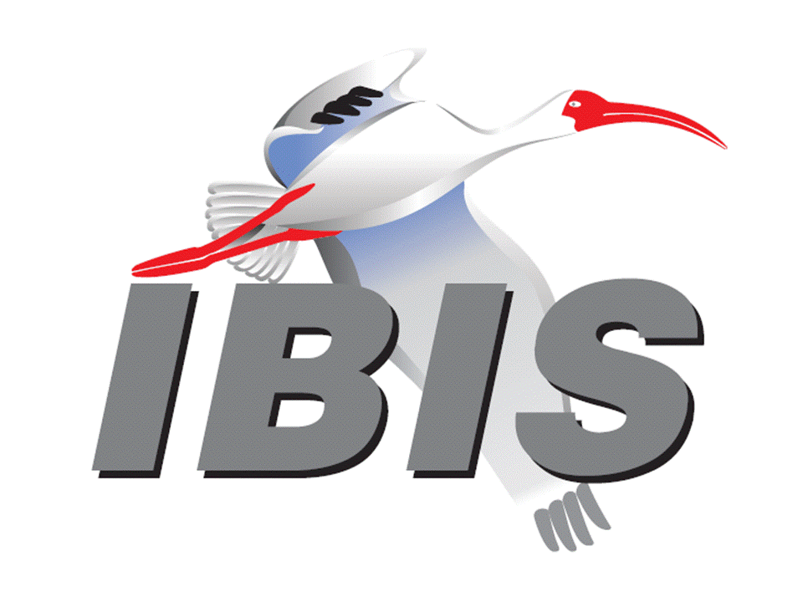

IBIS Open Forum Minutes

Meeting Date: November 2, 2018
Meeting Location: Teleconference

VOTING MEMBERS AND 2018 PARTICIPANTS
ANSYS Curtis Clark*
Applied Simulation Technology (Fred Balistreri)
Broadcom (Yunong Gan)
Cadence Design Systems Brad Brim*, Ken Willis, Ambrish Varma, Zhen Mu
Cisco Systems Stephen Scearce, Cassie Yan, Baosh Xu
CST Stefan Paret
Ericsson Anders Ekholm, Zilwan Mahmod, Guohua Wang
GLOBALFOUNDRIES Steve Parker*
Huawei Technologies (Hang (Paul) Yan)
IBM Greg Edlund, Luis Armenta, Hubert Harrer
Michael Cohen*
Infineon Technologies AG (Christian Sporrer)
Intel Corporation Hsinho Wu*, Michael Mirmak*, Nilesh Dattani
Fernando Mendoza Hernandez, Varun Gupta
Subas Bastola, Hansel Dsilva, Gianni Signorini
IO Methodology Lance Wang
Keysight Technologies Radek Biernacki*, Ming Yan, Heidi Barnes
Pegah Alavi
Maxim Integrated Joe Engert, Yan Liang
Mentor, A Siemens Business Arpad Muranyi*, Weston Beal, Raj Raghuram
Carlo Bleu, Mikael Stahlberg, Yasushi Kondou
Vladimir Dmitriev-Zdorov, Nitin Bhagwath
Micron Technology Randy Wolff*, Justin Butterfield
NXP (John Burnett)
Raytheon Joseph Aday
SiSoft Mike LaBonte*, Walter Katz*, [Todd Westerhoff]
Synopsys Ted Mido*, Adrien Auge, Scott Wedge
Teraspeed Labs Bob Ross*
Xilinx Ravindra Gali
ZTE Corporation (Shunlin Zhu)
Zuken Michael Schaeder, Takayuki Shiratori

OTHER PARTICIPANTS IN 2018
Google Zhiping Yang
Haskware David Banas
John Baprawski, Inc. John Baprawski
KEI Systems Shinichi Maeda
Lattice Semiconductor Dinh Tran, Maryam Shahbazi
OmniVision Sirius Tsang
Politecnico di Milano Flavia Grassi, Xinglong Wu
Politecnico di Torino Tommaso Bradde, Marco De Stefano, Paulo Manfredi
Riccardo Trinchero, Stefano Grivet-Talocia
Qualcomm Kevin Roselle, Tim Michalka
Ricoh Kazuki Murata
RITA Electronics Ltd. Kenichi Higashiura, Hiroyuki Motoki
SAE ITC (Jose Godoy)
Signal Metrics Ron Olisar
Socionext Megumi Ono
SPISim Wei-hsing Huang
Stanford University Tom Lee
STMicroelectronics Aurora Sanna, Olivier Bayet
Toshiba Yasuki Torigoshi, Yoshinori Fukuba
Université de Bretagne Occidentale Mihai Telescu, Charles Canaff
University of Illinois José Schutt-Aine
University of Siegen Elmar Griese
University of Technology Hamburg Torben Wendt
In the list above, attendees at the meeting are indicated by *. Principal members or other active members who have not attended are in parentheses. Participants who no longer are in the organization are in square brackets.

UPCOMING MEETINGS
The bridge numbers for future IBIS teleconferences are as follows:

Date Meeting Number Meeting Password
November 12, 2018 Asian IBIS Summit (Tokyo) – no teleconference
November 14, 2018 Asian IBIS Summit (Shanghai) – no teleconference
November 16, 2018 Asian IBIS Summit (Taipei) – no teleconference
November 30, 2018 624 227 121 IBISfriday11

For teleconference dial-in information, use the password at the following website:

http://tinyurl.com/y7yt7buz

All teleconference meetings are 8:00 a.m. to 9:55 a.m. US Pacific Time. Meeting agendas are typically distributed seven days before each Open Forum. Minutes are typically distributed within seven days of the corresponding meeting.

NOTE: "AR" = Action Required.

-------------------------------------------------------------------------------------------------------------------------------
INTRODUCTIONS AND MEETING QUORUM
Randy Wolff declared that a quorum was reached.

Michael Cohen of IBM introduced himself. He is replacing Luis Armenta as the IBM representative for IBIS. He was a representative of IBM for IBIS in the 1990’s and early 2000’s. He has worked in PCB general design support. He has rejoined IBM in the Open Power group and is working with IBIS-AMI models. Luis had suggested he become the IBM contact for IBIS.

CALL FOR PATENTS
Mike LaBonte called for declaration of any patents or pending patents related to the IBIS 3.2, IBIS 4.2, IBIS 5.1, IBIS 6.1, Touchstone 2.0, IBIS-ISS 1.0 or ICM 1.1 specifications. No patents were declared.

REVIEW OF MINUTES AND ARS
Mike LaBonte called for comments on the minutes of the October 12, 2018 IBIS Open Forum teleconference. Curtis Clark moved to approve the minutes. Bob Ross seconded the motion. There were no objections.

Mike reviewed ARs from the previous meeting.

- Mike LaBonte to check Policies and Procedures document to determine if roll call vote is required for setting dues [AR].
Mike reported the wording says that a roll call vote is required for financial matters over $500.

ANNOUNCEMENTS, CALL FOR ADDITIONAL AGENDA ITEMS
None.

MEMBERSHIP STATUS AND TREASURER'S REPORT
Bob Ross reported that we have 25 members. There is $24,897 in our account accumulated for 2018. We expect another Summit sponsorship to come in some time. We will be making payments for Summit expenses soon.

Bob moved to set the IBIS membership dues at $900 for 2019. Brad Brim seconded the motion. There were no objections.

The roll call vote tally was:

ANSYS – yes
Cadence – yes
Ericsson – yes (by email)
GLOBALFOUNDRIES – yes
IBM – yes
Intel – yes
Keysight – yes
Mentor – yes
Micron – yes
SiSoft – yes
Synopsys – yes
Teraspeed Labs – yes

The roll call vote concluded with a vote tally of Yes – 12, No – 0, Abstain – 0. The vote passed.

Bob noted that the invoicing process will begin in late December or early January. The request for setting the dues for 2019 this early was for one company requesting an invoice early. An invoice in December could be paid in 2018 or 2019. Brad Brim noted some companies will need to budget for a parser license in 2019. Bob added that the cost might increase from $2,500 to $3,000, but this is not decided yet.

WEBSITE ADMINISTRATION
Mike LaBonte reported the logo for Micron was refreshed on the website. Michael Cohen suggested adding call-in information for the teleconferences on the website to make it easier to attend. Mike suggested that Michael get added to the email reflector.

MAILING LIST ADMINISTRATION
Curtis Clark reported that everything is quiet now. He will send an email to Michael Cohen with instructions for getting added to the email reflector.

LIBRARY UPDATE
No update.

INTERNATIONAL/EXTERNAL ACTIVITIES
- Conferences
None.

- Press Update
Mike LaBonte noted a press release from SAE ITC featured on EDACafé about the Asian IBIS Summit meetings. The article is linked at:

https://www10.edacafe.com/nbc/articles/view_article.php?section=CorpNews&articleid=1621132

- Related standards
IEC 63055/IEEE 2401, JEITA “LPB”
Michael Mirmak reported that on Monday the P2401 group met. They completed their approvals of changes for the Draft 2 of the LPB specification. They expect Draft 2 approval at the December 18 meeting. A new draft and comment period will be entered after that. The group is interested in IBIS 7.0, and they would like the document to point to IBIS 7.0. Touchstone is supported in LPB, but they are only interested in supporting S-parameters and no other formats. There was discussion about a parser for LPB. It won’t be mentioned in the specification.

SUMMIT PLANNING AND STATUS
- Asian IBIS Summit (Tokyo)
An IBIS Summit will be held at the Akihabara UDX building from 12:30 p.m. to 5:00 p.m. on November 12, 2018. Bob Ross noted there is a separate JEITA event in the morning which is open but conducted in Japanese. The topic is S-parameters. There are 10 presentations. Sponsors include ANSYS, Apollo Giken Co., Cadence Design Systems, Cybernet Systems, Keysight Technologies, Ricoh, Toshiba Corporation, and Zuken.

- Asian IBIS Summit (Shanghai)
An IBIS Summit will be held at the Parkyard Hotel Shanghai from 8:30 a.m. to 5:00 p.m. on November 14, 2018. There are 7 presentations. Huawei Technologies is the primary sponsor, and IO Methodology, Mentor, a Siemens Business, Synopsys, and ZTE Corporation are additional sponsors. Bob Ross noted Teledyne-LeCroy is another potential sponsor.

- Asian IBIS Summit (Taipei)
An IBIS Summit will be held at the Sherwood Hotel from 9:00 a.m. to 4:30 p.m. on November 16, 2018. There are 5 presentations. Cadence Design Systems, KairosTech Innovation (SPISim), and Synopsys are sponsors.

- DesignCon 2019 IBIS Summit
DesignCon will be held in Santa Clara, CA on January 29 through January 31, 2019. An IBIS Summit will be held on Friday, February 1, 2019. Mike LaBonte is in barter negotiations with UBM. UBM has expressed an interest in seeing if there is more we can do on our side to promote the conference. A meeting is scheduled with him, UBM, and SAE ITC on November 7 for SAE ITC to put forth ideas on how they can promote DesignCon. SAE ITC could add a banner page on their website. UBM is interested in additional magazine articles or other promotions. Company sponsorships are welcome. Bob noted the first announcement should go out on November 30.

Sponsorship opportunities for all upcoming IBIS summits are available, with sponsors receiving free mentions in the minutes, agenda, and other announcements. Contact the IBIS Board for further details.

QUALITY TASK GROUP
Mike LaBonte reported that the group is meeting on Tuesdays at 8:00 a.m. PT. Mike will be unavailable the next two Tuesdays for meetings. The topics currently are all about IBISCHK and improving quality through IBISCHK. There are no new bugs discussed recently.

The Quality task group checklist and other documentation can be found at:

http://www.ibis.org/quality_wip/

ADVANCED TECHNOLOGY MODELING TASK GROUP
Arpad Muranyi reported that the group normally meets regularly on Tuesdays at 12:00 p.m. PT. The meeting times recently have been used by the Editorial task group to help with IBIS 7.0 development. The editorial activities are entering final stages, so hopefully the time will be used for ATM discussion soon.

Task group material can be found at:

http://www.ibis.org/macromodel_wip/

INTERCONNECT TASK GROUP
Michael Mirmak reported that the group usually meets at 8:00 a.m. PT on Wednesdays. The group remains suspended until IBIS 7.0 activities are completed.

Task group material can be found at:

http://www.ibis.org/interconnect_wip/

EDITORIAL TASK GROUP
Michael Mirmak reported that the group is meeting at 8:00 a.m. PT on Wednesdays and on Fridays when there is no Open Forum teleconference as well as during ATM task group time slots. The group is moving through the finalization stage, sweeping through for editorial changes. The Reserved Parameter summary tables for IBIS-AMI are being reviewed and will hopefully be closed in the next couple of meetings. Then the group will move onto finalization. They are trying to get the document submitted for review to the IBIS Open Forum by the end of the year.

Task group material can be found at:

http://www.ibis.org/editorial_wip/

NEW ADMINISTRATIVE ISSUES
None.

BIRD196.1: PROHIBIT PERIODS AT THE END OF FILE NAMES
Mike LaBonte reported that Arpad Muranyi requested a vote to include the BIRD in IBIS 7.0.

Radek Biernacki moved to vote on BIRD196.1 for inclusion in IBIS 7.0. Arpad Muranyi seconded the motion. There were no objections.

The roll call vote tally was:

ANSYS – yes
Cadence – yes
GLOBALFOUNDRIES – yes
IBM – abstain
Intel – yes
Keysight – yes
Mentor – yes
Micron – yes
SiSoft – yes
Teraspeed Labs – yes

The roll call vote concluded with a vote tally of Yes – 9, No – 0, Abstain – 1. The vote passed.

BIRD166.4: RESOLVING PROBLEMS WITH REDRIVER INIT FLOW
Discussion was tabled.

BIRD181.1: I-V TABLE CLARIFICATIONS
Discussion was tabled.

BIRD190: CLARIFICATION FOR REDRIVER FLOW
Discussion was tabled.

IBISCHK PARSER AND BUG STATUS
Bob Ross reported that a preliminary release of the IBISCHK 6.1.5 parser has been received, just the executables, but further review is needed. We expect a final release shortly, since the developer is doing the final release in parallel, and technically the scheduled release date is today. BUGs 190-201 are addressed. Mike LaBonte added he has his own suite of tests to run to compare with the previous version of IBISCHK for regression testing.

Bob noted there is one new bug, but if we do anything with it, it will be part of the IBIS 7.0 parser. In parallel with the IBIS 7.0 development, he has been capturing details of requirements for a parser contract for IBIS 7.0.

Mike added that the $2,500 charge for the IBISCHK source code is only associated with a major release. The 6.1.5 software executable will be freely available, and the source code will be distributed to licensees of the source code for free.

NEW TECHNICAL ISSUES
None.

NEXT MEETING
The next IBIS Open Forum teleconference meeting will be held on November 30, 2018. The following IBIS Open Forum teleconference meeting is tentatively scheduled on December 21, 2018.

The Asian IBIS Summit in Tokyo will be held November 12, 2018. The Asian IBIS Summit in Shanghai will be held November 14, 2018. The Asian IBIS Summit in Taipei will be held November 16, 2018. No teleconferences will be available for the Summit meetings.

Michael Cohen moved to adjourn. Radek Biernacki seconded the motion. The meeting adjourned.

========================================================================
NOTES

IBIS CHAIR: Mike LaBonte
mlabonte@sisoft.com
IBIS-AMI Modeling Specialist, SiSoft
6 Clock Tower Place, Suite 250
Maynard, MA 01754

VICE CHAIR: Lance Wang (978) 633-3388
lwang@iometh.com
President/CEO, IO Methodology, Inc.
PO Box 2099
Acton, MA 01720

SECRETARY: Randy Wolff (208) 363-1764
rrwolff@micron.com
Principal Engineer, Silicon SI Group Lead, Micron Technology, Inc.
8000 S. Federal Way
P.O. Box 6, Mail Stop: 01-711
Boise, ID 83707-0006

TREASURER: Bob Ross (503) 246-8048
bob@teraspeedlabs.com
Engineer, Teraspeed Labs
10238 SW Lancaster Road
Portland, OR 97219

LIBRARIAN: Anders Ekholm (46) 10 714 27 58, Fax: (46) 8 757 23 40
ibis-librarian@ibis.org
Digital Modules Design, PDU Base Stations, Ericsson AB
BU Network
Färögatan 6
164 80 Stockholm, Sweden

WEBMASTER: Mike LaBonte
mlabonte@sisoft.com
IBIS-AMI Modeling Specialist, SiSoft
6 Clock Tower Place, Suite 250
Maynard, MA 01754

POSTMASTER: Curtis Clark
curtis.clark@ansys.com
ANSYS, Inc.
150 Baker Ave Ext
Concord, MA 01742

This meeting was conducted in accordance with ANSI guidance.

All inquiries may be sent to info@ibis.org. Examples of inquiries are:
- To obtain general information about IBIS.
- To ask specific questions for individual response.
- To subscribe to the official ibis@freelists.org and/or ibis-users@freelists.org email lists (formerly ibis@eda.org and ibis-users@eda.org).
- To subscribe to one of the task group email lists: ibis-macro@freelists.org, ibis-interconn@freelists.org, or ibis-quality@freelists.org.
- To inquire about joining the IBIS Open Forum as a voting Member.
- To purchase a license for the IBIS parser source code.
- To report bugs or request enhancements to the free software tools: ibischk6, tschk2, icmchk1, s2ibis, s2ibis2 and s2iplt.
The BUG Report Form for ibischk resides along with reported BUGs at:

http://www.ibis.org/bugs/ibischk/
http://www.ibis.org/ bugs/ibischk/bugform.txt

The BUG Report Form for tschk2 resides along with reported BUGs at:

http://www.ibis.org/bugs/tschk/
http://www.ibis.org/bugs/tschk/bugform.txt

The BUG Report Form for icmchk resides along with reported BUGs at:

http://www.ibis.org/bugs/icmchk/
http://www.ibis.org/bugs/icmchk/icm_bugform.txt

To report s2ibis, s2ibis2 and s2iplt bugs, use the Bug Report Forms which reside at:

http://www.ibis.org/bugs/s2ibis/bugs2i.txt
http://www.ibis.org/bugs/s2ibis2/bugs2i2.txt
http://www.ibis.org/bugs/s2iplt/bugsplt.txt

Information on IBIS technical contents, IBIS participants and actual IBIS models are available on the IBIS Home page:

http://www.ibis.org/

Check the IBIS file directory on ibis.org for more information on previous discussions and results:

http://www.ibis.org/directory.html

Other trademarks, brands and names are the property of their respective owners.
SAE STANDARDS BALLOT VOTING STATUS
Organization | Interest Category | Standards Ballot Voting Status | August 31, 2018 | September 21, 2018 | October 12, 2018 | November 2, 2018
ANSYS | User | Active | X | X | X | X
Applied Simulation Technology | User | Inactive | - | - | - | -
Broadcom Ltd. | Producer | Inactive | - | - | - | -
Cadence Design Systems | User | Active | X | - | X | X
Cisco Systems | User | Inactive | - | - | - | -
CST | User | Inactive | - | - | - | -
Ericsson | Producer | Inactive | - | - | - | X
GLOBALFOUNDRIES | Producer | Active | X | X | X | X
Huawei Technologies | Producer | Inactive | - | - | - | -
IBM | Producer | Inactive | - | - | - | X
Infineon Technologies AG | Producer | Inactive | X | X | - | -
Intel Corp. | Producer | Active | X | X | X | X
IO Methodology | User | Active | X | X | X | -
Keysight Technologies | User | Active | X | X | X | X
Maxim Integrated | Producer | Inactive | - | - | - | -
Mentor, A Siemens Business | User | Active | X | X | X | X
Micron Technology | Producer | Active | X | X | X | X
NXP | Producer | Inactive | - | - | - | -
Raytheon | User | Inactive | - | - | - | -
SiSoft | User | Active | X | X | X | X
Synopsys | User | Active | X | - | X | X
Teraspeed Labs | General Interest | Active | X | X | X | X
Xilinx | Producer | Inactive | - | - | - | -
ZTE Corp. | User | Inactive | - | - | - | -
Zuken | User | Inactive | - | - | - | -

Criteria for SAE member in good standing:
- Must attend two consecutive meetings to establish voting membership
- Membership dues current
- Must not miss two consecutive meetings
Interest categories associated with SAE standards ballot voting are:
- Users - members that utilize electronic equipment to provide services to an end user.
- Producers - members that supply electronic equipment.
- General Interest - members are neither producers nor users. This category includes, but is not limited to, government, regulatory agencies (state and federal), researchers, other organizations and associations, and/or consumers.

