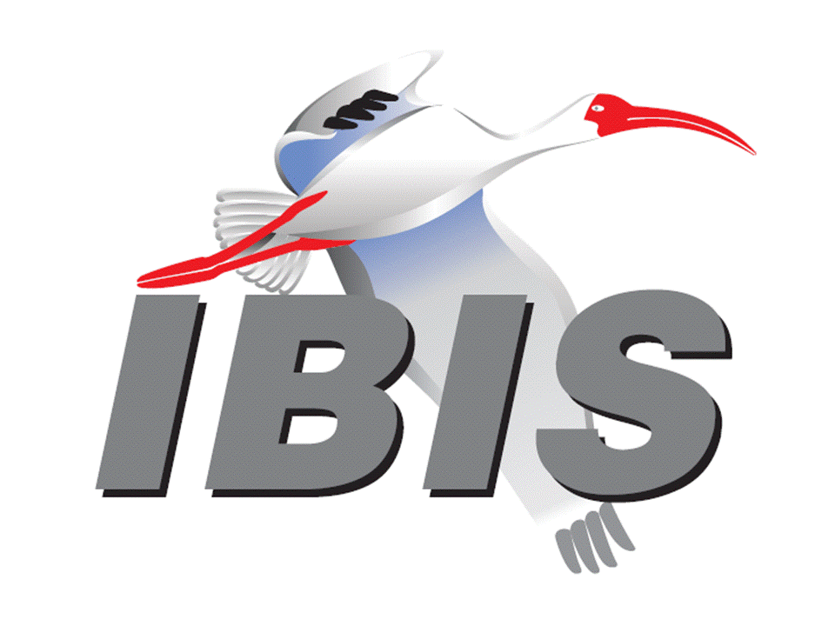

IBIS Open Forum Minutes

Meeting Date: October 12, 2018
Meeting Location: Teleconference

VOTING MEMBERS AND 2018 PARTICIPANTS
ANSYS Curtis Clark*
Applied Simulation Technology (Fred Balistreri)
Broadcom (Yunong Gan)
Cadence Design Systems Brad Brim*, Ken Willis, Ambrish Varma, Zhen Mu
Cisco Systems Stephen Scearce, Cassie Yan, Baosh Xu
CST Stefan Paret
Ericsson Anders Ekholm, Zilwan Mahmod, Guohua Wang
GLOBALFOUNDRIES Steve Parker*
Huawei Technologies (Hang (Paul) Yan)
IBM Greg Edlund, Luis Armenta, Hubert Harrer
Infineon Technologies AG (Christian Sporrer)
Intel Corporation Hsinho Wu*, Michael Mirmak, Nilesh Dattani
Fernando Mendoza Hernandez, Varun Gupta
Subas Bastola, Hansel Dsilva, Gianni Signorini
IO Methodology Lance Wang*
Keysight Technologies Radek Biernacki*, Ming Yan, Heidi Barnes
Pegah Alavi
Maxim Integrated Joe Engert, Yan Liang
Mentor, A Siemens Business Arpad Muranyi*, Weston Beal, Raj Raghuram
Carlo Bleu, Mikael Stahlberg, Yasushi Kondou
Vladimir Dmitriev-Zdorov, Nitin Bhagwath
Micron Technology Randy Wolff*, Justin Butterfield
NXP (John Burnett)
Raytheon Joseph Aday
SiSoft Mike LaBonte*, Walter Katz*, [Todd Westerhoff]
Synopsys Ted Mido*, Adrien Auge, Scott Wedge
Teraspeed Labs Bob Ross*
Xilinx Ravindra Gali
ZTE Corporation (Shunlin Zhu)
Zuken Michael Schaeder, Takayuki Shiratori

OTHER PARTICIPANTS IN 2018
Google Zhiping Yang
Haskware David Banas
John Baprawski, Inc. John Baprawski
KEI Systems Shinichi Maeda
Lattice Semiconductor Dinh Tran, Maryam Shahbazi
OmniVision Sirius Tsang
Politecnico di Milano Flavia Grassi, Xinglong Wu
Politecnico di Torino Tommaso Bradde, Marco De Stefano, Paulo Manfredi
Riccardo Trinchero, Stefano Grivet-Talocia
Qualcomm Kevin Roselle, Tim Michalka
Ricoh Kazuki Murata
RITA Electronics Ltd. Kenichi Higashiura, Hiroyuki Motoki
SAE ITC (Jose Godoy)
Signal Metrics Ron Olisar
Socionext Megumi Ono
SPISim Wei-hsing Huang
Stanford University Tom Lee
STMicroelectronics Aurora Sanna, Olivier Bayet
Toshiba Yasuki Torigoshi, Yoshinori Fukuba
Université de Bretagne Occidentale Mihai Telescu, Charles Canaff
University of Illinois José Schutt-Aine
University of Siegen Elmar Griese
University of Technology Hamburg Torben Wendt
In the list above, attendees at the meeting are indicated by *. Principal members or other active members who have not attended are in parentheses. Participants who no longer are in the organization are in square brackets.

UPCOMING MEETINGS
The bridge numbers for future IBIS teleconferences are as follows:

Date Meeting Number Meeting Password
November 2, 2018 624 227 121 IBISfriday11
November 12, 2018 Asian IBIS Summit (Tokyo) – no teleconference
November 14, 2018 Asian IBIS Summit (Shanghai) – no teleconference
November 16, 2018 Asian IBIS Summit (Taipei) – no teleconference

For teleconference dial-in information, use the password at the following website:

http://tinyurl.com/y7yt7buz

All teleconference meetings are 8:00 a.m. to 9:55 a.m. US Pacific Time. Meeting agendas are typically distributed seven days before each Open Forum. Minutes are typically distributed within seven days of the corresponding meeting.

NOTE: "AR" = Action Required.

-------------------------------------------------------------------------------------------------------------------------------
INTRODUCTIONS AND MEETING QUORUM
Randy Wolff declared that a quorum was reached and the meeting could begin.

CALL FOR PATENTS
Mike LaBonte called for declaration of any patents or pending patents related to the IBIS 3.2, IBIS 4.2, IBIS 5.1, IBIS 6.1, Touchstone 2.0, IBIS-ISS 1.0 or ICM 1.1 specifications. No patents were declared.

REVIEW OF MINUTES AND ARS
Mike LaBonte called for comments on the minutes of the September 21, 2018 IBIS Open Forum teleconference. Radek Biernacki moved to approve the minutes. Curtis Clark seconded the motion. There were no objections.

Mike reviewed ARs from the previous meeting.

- Mike LaBonte to update the IBIS events page with links to the Chinese and Japanese language Summit announcements [AR].
Mike reported this as done.

ANNOUNCEMENTS, CALL FOR ADDITIONAL AGENDA ITEMS
Bob Ross announced he had a question about membership dues to discuss.

MEMBERSHIP STATUS AND TREASURER'S REPORT
Bob Ross reported that we have 25 members. There is $23,209 in our account accumulated for 2018. There is one charge a little over $300 that has not been charged yet related to our web service.

Bob posed the question of whether we keep the membership fee the same for next year (at $900). We have had one request to know about this from a member company planning for next year’s budget. We do still need to vote on this. Mike LaBonte noted we usually have a vote at the end of the year that we schedule ahead of time.

Bob moved to schedule a vote on setting the IBIS membership dues at $900 for 2019. Brad Brim seconded the motion. There were no objections. Bob asked Mike to check the Policies and Procedures document to determine if this should be a roll call vote [AR].

WEBSITE ADMINISTRATION
Mike LaBonte reported there have been no significant changes to the website. On the SAE ITC website, they added a banner announcing the IBIS Open Forum Summit meetings in Asia. This can be viewed at:

https://www.sae-itc.com/

MAILING LIST ADMINISTRATION
Curtis Clark noted nothing unusual to report with a couple adds and a couple drops.

LIBRARY UPDATE
No update.

INTERNATIONAL/EXTERNAL ACTIVITIES
- Conferences
EPEPS – The 27th IEEE Conference on Electrical Performance of Electronic Packaging and Systems will be held in San Jose, CA on October 14-17, 2018. More information is available at:

http://www.epeps.org/

EDI CON – Electronic Design Innovation Conference & Exhibition will be held in Santa Clara, CA on October 17-18, 2018. More information is available at:

http://www.ediconusa.com

- Press Update
Mike LaBonte noted a press release from SAE about the Asian IBIS Summit meetings on the SAE website. The article is linked at:

https://www.sae.org/news/press-room

- Related standards
IEC 63055/IEEE 2401, JEITA “LPB”
No update.

SUMMIT PLANNING AND STATUS
- Asian IBIS Summit (Tokyo)
An IBIS Summit will be held at the Akihabara UDX building from 12:30 p.m. to 5:00 p.m. on November 12, 2018. Bob Ross noted there is a separate JEITA event in the morning which is open but conducted in Japanese. The topic is S-parameters. We do not yet know from JEITA who the sponsors are. We do not have room for any more presentations. Bob asked Ted Mido if he would be presenting in Japanese. Ted responded that JEITA requested he present in Japanese.

- Asian IBIS Summit (Shanghai)
An IBIS Summit will be held at the Parkyard Hotel Shanghai from 8:30 a.m. to 5:00 p.m. on November 14, 2018. Huawei Technologies is the primary sponsor, and ZTE and Synopsys are additional sponsors. Bob noted some presentations for the Summit are being reviewed. There is room for more presentations.

- Asian IBIS Summit (Taipei)
An IBIS Summit will be held at the Sherwood Hotel from 9:00 a.m. to 4:30 p.m. on November 16, 2018. Cadence Design Systems, KairosTech Innovation (SPISim), and Synopsys are sponsors. Bob noted there is room for more presentations.

- DesignCon 2019 IBIS Summit
DesignCon will be held in Santa Clara, CA on January 29 through January 31, 2019. An IBIS Summit will be held on Friday, February 1, 2019. Mike LaBonte reported we will send out the first announcement in early December. He had a phone call with a contact at UBM, the company that runs DesignCon. We have a barter agreement to secure with UBM. There will be some level of sponsorship for IBIS. UBM usually provides a room, signage, and some free passes. They may scale back on the passes this year. They are looking to get more out of our Summit, such as increased paid attendance. DesignCon’s attendance has been increasing, and they are looking to scale back on free passes, partly for fire code limit reasons. For example, not all paper authors receive free passes, only the paper presenters do. Mike noted that SAE may provide more marketing such as press releases that would make UBM happy. Bob noted this seemed contradictory, since more promotion could lead to increased attendance. Mike is doing his best to keep our arrangements the same as in years past.

Sponsorship opportunities for all upcoming IBIS summits are available, with sponsors receiving free mentions in the minutes, agenda, and other announcements. Contact the IBIS Board for further details.

QUALITY TASK GROUP
Mike LaBonte reported that the group is meeting on Tuesdays at 8:00 a.m. PT. They are discussing all matters IBISCHK including BUG202.

The Quality task group checklist and other documentation can be found at:

http://www.ibis.org/quality_wip/

ADVANCED TECHNOLOGY MODELING TASK GROUP
Arpad Muranyi reported that the group is meeting regularly on Tuesdays at 12:00 p.m. PT. The last two meeting times have been used by the Editorial task group. Arpad noted there is a draft BIRD proposal from Walter Katz to discuss (related to changes to IBIS-AMI to support single-ended signaling). Mike LaBonte noted the Editorial task group plans to use the time slot next Tuesday as well. Walter Katz was not concerned with delaying the discussion on his BIRD proposal.

Task group material can be found at:

http://www.ibis.org/macromodel_wip/

INTERCONNECT TASK GROUP
Mike LaBonte reported that the group usually meets at 8:00 a.m. PT on Wednesdays. The group remains suspended.

Task group material can be found at:

http://www.ibis.org/interconnect_wip/

EDITORIAL TASK GROUP
Mike LaBonte reported that the group is meeting at 8:00 a.m. PT on Wednesdays and on Fridays when there is no Open Forum teleconference as well as during ATM task group time slots. He reported that they have been reviewing a checklist of items that need to be accomplished. All items related to BIRDs have been reviewed. A known issues list is being reviewed. There is also a list of finalization items to work on such as figure numbering. The group also discovered an aberration related to BIRD196 to be discussed.

Task group material can be found at:

http://www.ibis.org/editorial_wip/

NEW ADMINISTRATIVE ISSUES
None.

BIRD196: PROHIBIT PERIODS AT THE END OF FILE NAMES
Arpad Muranyi introduced the BIRD. After some testing, it was determined that we cannot have a filename ending with a period and nothing else on Windows. This BIRD is written against IBIS 6.1. There are three instances where text is changed in IBIS 6.1. A fourth instance is added where a sentence was missing in IBIS 6.1. Since IBIS 6.1, BIRD186.4 made changes in the same area of the specification, but not for the same reason. BIRD186.4 cleaned up some terminology about file extensions. The logistical question is that BIRD186.4 was already approved, and BIRD196 changes IBIS 6.1, not BIRD186.4. Theoretically, changes would be made to BIRD186.4 by BIRD196. We want to make sure the chronology of the changes is captured.

Bob Ross said we should just approve BIRD196 and let the Editorial task group resolve the changes. We should make a note at the bottom of BIRD196 noting that it impacts terminology in BIRD186.4. Mike LaBonte showed an example of some text in BIRD186.4 that allows no extensions, whereas BIRD196 will make this illegal. Arpad asked if the small change required to BIRD196 will be posted as BIRD196.1. Mike confirmed this will be the case.

Bob moved to vote on BIRD196 with an added note in the Background Information section stating: “Note that the changes in this BIRD are also to be applied to the corresponding text introduced by BIRD186.4.” The modified BIRD is to be posted as BIRD196.1. Radek Biernacki seconded the motion. There were no objections.

The roll call vote tally was:

ANSYS – accept
Cadence – accept
GLOBALFOUNDIRES – accept
Intel – accept
IO Methodology – accept
Keysight – accept
Mentor – accept
Micron – accept
SiSoft – accept
Synopsys – accept
Teraspeed – accept

The roll call vote concluded with a vote tally of Accept – 11, Reject – 0, Abstain – 0. The vote passed.

BIRD166.4: RESOLVING PROBLEMS WITH REDRIVER INIT FLOW
Discussion was tabled.

BIRD181.1: I-V TABLE CLARIFICATIONS
Discussion was tabled.

BIRD190: CLARIFICATION FOR REDRIVER FLOW
Discussion was tabled.

IBISCHK PARSER AND BUG STATUS
Bob Ross reported that the IBSCHK 6.1.5 parser is still in development. The contract for the IBISCHK 7.0 parser is still in development.

Bob noted a new BUG202 is filed. It is unlikely to be fixed in the 6.1.5 release. Mike LaBonte introduced the bug. A particular model from SPISim was submitted. The parser looks for functions to exist within the AMI model. The parser crashed in Linux when checking the model. The bug notes some actions known to avoid the crash and actions that still result in a crash. Bob noted that some EDA software is not impacted due to their custom implementations of the IBISCHK code. It is unclear how to fix the bug currently.

Bob checked to see if fatal was ever listed for severity. Severe is usually used for crashes or instances where the parser does not correctly check against the specification and must be updated. Bob moved to classify BUG202 as Severe severity and Medium priority. Arpad Muranyi seconded the motion. There were no objections.

NEW TECHNICAL ISSUES
None.

NEXT MEETING
The next IBIS Open Forum teleconference meeting will be held on November 2, 2018. A vote on IBIS dues for 2019 is scheduled. The following IBIS Open Forum teleconference meeting is tentatively scheduled on November 30, 2018.

The Asian IBIS Summit in Tokyo will be held November 12, 2018. The Asian IBIS Summit in Shanghai will be held November 14, 2018. The Asian IBIS Summit in Taipei will be held November 16, 2018. No teleconferences will be available for the Summit meetings.

Curtis Clark moved to adjourn. Bob Ross seconded the motion. The meeting adjourned.

========================================================================
NOTES

IBIS CHAIR: Mike LaBonte
mlabonte@sisoft.com
IBIS-AMI Modeling Specialist, SiSoft
6 Clock Tower Place, Suite 250
Maynard, MA 01754

VICE CHAIR: Lance Wang (978) 633-3388
lwang@iometh.com
President/CEO, IO Methodology, Inc.
PO Box 2099
Acton, MA 01720

SECRETARY: Randy Wolff (208) 363-1764
rrwolff@micron.com
Principal Engineer, Silicon SI Group Lead, Micron Technology, Inc.
8000 S. Federal Way
P.O. Box 6, Mail Stop: 01-711
Boise, ID 83707-0006

TREASURER: Bob Ross (503) 246-8048
bob@teraspeedlabs.com
Engineer, Teraspeed Labs
10238 SW Lancaster Road
Portland, OR 97219

LIBRARIAN: Anders Ekholm (46) 10 714 27 58, Fax: (46) 8 757 23 40
ibis-librarian@ibis.org
Digital Modules Design, PDU Base Stations, Ericsson AB
BU Network
Färögatan 6
164 80 Stockholm, Sweden

WEBMASTER: Mike LaBonte
mlabonte@sisoft.com
IBIS-AMI Modeling Specialist, SiSoft
6 Clock Tower Place, Suite 250
Maynard, MA 01754

POSTMASTER: Curtis Clark
curtis.clark@ansys.com
ANSYS, Inc.
150 Baker Ave Ext
Concord, MA 01742

This meeting was conducted in accordance with ANSI guidance.

All inquiries may be sent to info@ibis.org. Examples of inquiries are:
- To obtain general information about IBIS.
- To ask specific questions for individual response.
- To subscribe to the official ibis@freelists.org and/or ibis-users@freelists.org email lists (formerly ibis@eda.org and ibis-users@eda.org).
- To subscribe to one of the task group email lists: ibis-macro@freelists.org, ibis-interconn@freelists.org, or ibis-quality@freelists.org.
- To inquire about joining the IBIS Open Forum as a voting Member.
- To purchase a license for the IBIS parser source code.
- To report bugs or request enhancements to the free software tools: ibischk6, tschk2, icmchk1, s2ibis, s2ibis2 and s2iplt.
The BUG Report Form for ibischk resides along with reported BUGs at:

http://www.ibis.org/bugs/ibischk/
http://www.ibis.org/ bugs/ibischk/bugform.txt

The BUG Report Form for tschk2 resides along with reported BUGs at:

http://www.ibis.org/bugs/tschk/
http://www.ibis.org/bugs/tschk/bugform.txt

The BUG Report Form for icmchk resides along with reported BUGs at:

http://www.ibis.org/bugs/icmchk/
http://www.ibis.org/bugs/icmchk/icm_bugform.txt

To report s2ibis, s2ibis2 and s2iplt bugs, use the Bug Report Forms which reside at:

http://www.ibis.org/bugs/s2ibis/bugs2i.txt
http://www.ibis.org/bugs/s2ibis2/bugs2i2.txt
http://www.ibis.org/bugs/s2iplt/bugsplt.txt

Information on IBIS technical contents, IBIS participants and actual IBIS models are available on the IBIS Home page:

http://www.ibis.org/

Check the IBIS file directory on ibis.org for more information on previous discussions and results:

http://www.ibis.org/directory.html

Other trademarks, brands and names are the property of their respective owners.
SAE STANDARDS BALLOT VOTING STATUS
Organization | Interest Category | Standards Ballot Voting Status | August 10, 2018 | August 31, 2018 | September 21, 2018 | October 12, 2018
ANSYS | User | Active | X | X | X | X
Applied Simulation Technology | User | Inactive | - | - | - | -
Broadcom Ltd. | Producer | Inactive | - | - | - | -
Cadence Design Systems | User | Active | X | X | - | X
Cisco Systems | User | Inactive | - | - | - | -
CST | User | Inactive | - | - | - | -
Ericsson | Producer | Inactive | - | - | - | -
GLOBALFOUNDRIES | Producer | Active | - | X | X | X
Huawei Technologies | Producer | Inactive | - | - | - | -
IBM | Producer | Inactive | - | - | - | -
Infineon Technologies AG | Producer | Active | - | X | X | -
Intel Corp. | Producer | Active | X | X | X | X
IO Methodology | User | Active | X | X | X | X
Keysight Technologies | User | Active | X | X | X | X
Maxim Integrated | Producer | Inactive | - | - | - | -
Mentor, A Siemens Business | User | Active | X | X | X | X
Micron Technology | Producer | Active | X | X | X | X
NXP | Producer | Inactive | - | - | - | -
Raytheon | User | Inactive | - | - | - | -
SiSoft | User | Active | X | X | X | X
Synopsys | User | Active | - | X | - | X
Teraspeed Labs | General Interest | Active | X | X | X | X
Xilinx | Producer | Inactive | - | - | - | -
ZTE Corp. | User | Inactive | - | - | - | -
Zuken | User | Inactive | - | - | - | -

Criteria for SAE member in good standing:
- Must attend two consecutive meetings to establish voting membership
- Membership dues current
- Must not miss two consecutive meetings
Interest categories associated with SAE standards ballot voting are:
- Users - members that utilize electronic equipment to provide services to an end user.
- Producers - members that supply electronic equipment.
- General Interest - members are neither producers nor users. This category includes, but is not limited to, government, regulatory agencies (state and federal), researchers, other organizations and associations, and/or consumers.

