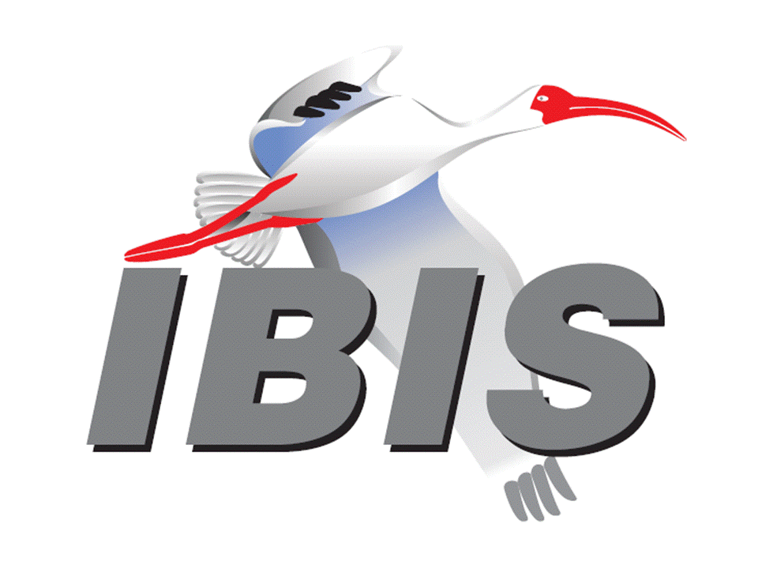

IBIS Open Forum Minutes

Meeting Date: August 31, 2018
Meeting Location: Teleconference

VOTING MEMBERS AND 2018 PARTICIPANTS
ANSYS Curtis Clark*
Applied Simulation Technology (Fred Balistreri)
Broadcom (Yunong Gan)
Cadence Design Systems Brad Brim, Ken Willis, Ambrish Varma, Zhen Mu*
Cisco Systems Stephen Scearce, Cassie Yan, Baosh Xu
CST Stefan Paret
Ericsson Anders Ekholm, Zilwan Mahmod, Guohua Wang
GLOBALFOUNDRIES Steve Parker*
Huawei Technologies (Hang (Paul) Yan)
IBM Greg Edlund, Luis Armenta, Hubert Harrer
Infineon Technologies AG (Christian Sporrer)
Intel Corporation Hsinho Wu*, Michael Mirmak*, Nilesh Dattani
Fernando Mendoza Hernandez, Varun Gupta
Subas Bastola, Hansel Dsilva, Gianni Signorini
IO Methodology Lance Wang*
Keysight Technologies Radek Biernacki*, Ming Yan, Heidi Barnes
Pegah Alavi
Maxim Integrated Joe Engert, Yan Liang
Mentor, A Siemens Business Arpad Muranyi*, Weston Beal, Raj Raghuram
Carlo Bleu, Mikael Stahlberg, Yasushi Kondou
Vladimir Dmitriev-Zdorov, Nitin Bhagwath
Micron Technology Randy Wolff, Justin Butterfield*
NXP (John Burnett)
Raytheon Joseph Aday
SiSoft Mike LaBonte*, Walter Katz*, Todd Westerhoff
Synopsys Ted Mido*, Adrien Auge, Scott Wedge
Teraspeed Labs Bob Ross*
Xilinx Ravindra Gali
ZTE Corporation (Shunlin Zhu)
Zuken Michael Schaeder, Takayuki Shiratori

OTHER PARTICIPANTS IN 2018
Google Zhiping Yang
Haskware David Banas
John Baprawski, Inc. John Baprawski
KEI Systems Shinichi Maeda
Lattice Semiconductor Dinh Tran, Maryam Shahbazi
OmniVision Sirius Tsang
Politecnico di Milano Flavia Grassi, Xinglong Wu
Politecnico di Torino Tommaso Bradde, Marco De Stefano, Paulo Manfredi
Riccardo Trinchero, Stefano Grivet-Talocia
Qualcomm Kevin Roselle, Tim Michalka
Ricoh Kazuki Murata
RITA Electronics Ltd. Kenichi Higashiura, Hiroyuki Motoki
SAE ITC (Jose Godoy)
Signal Metrics Ron Olisar
Socionext Megumi Ono
SPISim Wei-hsing Huang
Stanford University Tom Lee
STMicroelectronics Aurora Sanna, Olivier Bayet
Toshiba Yasuki Torigoshi, Yoshinori Fukuba
Université de Bretagne Occidentale Mihai Telescu, Charles Canaff
University of Illinois José Schutt-Aine
University of Siegen Elmar Griese
University of Technology Hamburg Torben Wendt
In the list above, attendees at the meeting are indicated by *. Principal members or other active members who have not attended are in parentheses. Participants who no longer are in the organization are in square brackets.

UPCOMING MEETINGS
The bridge numbers for future IBIS teleconferences are as follows:

Date Meeting Number Meeting Password
September 21, 2018 624 227 121 IBISfriday11

For teleconference dial-in information, use the password at the following website:

http://tinyurl.com/y7yt7buz

All teleconference meetings are 8:00 a.m. to 9:55 a.m. US Pacific Time. Meeting agendas are typically distributed seven days before each Open Forum. Minutes are typically distributed within seven days of the corresponding meeting.

NOTE: "AR" = Action Required.

-------------------------------------------------------------------------------------------------------------------------------
INTRODUCTIONS AND MEETING QUORUM
Mike LaBonte declared that a quorum was reached and the meeting could begin.

Justin Butterfield took meeting notes.

Zhen Mu from Cadence introduced herself. She is working on high speed digital design tools.

CALL FOR PATENTS
Mike LaBonte called for declaration of any patents or pending patents related to the IBIS 3.2, IBIS 4.2, IBIS 5.1, IBIS 6.1, Touchstone 2.0, IBIS-ISS 1.0 or ICM 1.1 specifications. No patents were declared.

REVIEW OF MINUTES AND ARS
Mike LaBonte called for comments on the minutes of the August 10, 2018 IBIS Open Forum teleconference. Radek Biernacki moved to approve the minutes. Curtis Clark seconded the motion. There were no objections.

Mike reviewed ARs from the previous meeting.

- Mike LaBonte to prepare an overview of BIRD181.1 to facilitate discussion for a future meeting [AR].
Mike reported he has prepared a summary document which highlights the changes requested in BIRD181.1. He is considering submitting a motion to un-table the BIRD, then discuss the summary document.

ANNOUNCEMENTS, CALL FOR ADDITIONAL AGENDA ITEMS
None.

MEMBERSHIP STATUS AND TREASURER'S REPORT
Bob Ross reported that we have 25 members. There is $23,209 in the treasury.

WEBSITE ADMINISTRATION
Mike LaBonte reported there was no roster page update, despite what was stated in the agenda. He mentioned Abdulrahman Rafiq has started a website development company, and he has offered to help rebuild the IBIS website. Mike has declined for now, but he wanted to mention it to the group as something to consider.

MAILING LIST ADMINISTRATION
Curtis Clark reported Arpad Muranyi had issues with some bounced emails, and he is looking into these.

LIBRARY UPDATE
As reported in the previous meeting, Anders Ekholm was making some updates to the library. Mike LaBonte reported this is now complete. If there is any feedback on the library, please let Anders know.

INTERNATIONAL/EXTERNAL ACTIVITIES
- Conferences
EPEPS – The 27th IEEE Conference on Electrical Performance of Electronic Packaging and Systems will be held in San Jose, CA on October 14-17, 2018. More information is available at:

http://www.epeps.org/

EDI CON – Electronic Design Innovation Conference & Exhibition will be held in Santa Clara, CA on October 17-18, 2018. More information is available at:

http://www.ediconusa.com

Mike LaBonte commented that they have not reached out to us, but we would probably not have been able to hold a Summit at EDI CON this year.

- Press Update
None.

- Related standards
IEC 63055/IEEE 2401, JEITA “LPB”
No update.

SUMMIT PLANNING AND STATUS
- Asian IBIS Summit (Tokyo)
An IBIS Summit will be held at the Akihabara UDX Bldg. from 12:30 p.m. to 5:00 p.m. on November 12, 2018. Bob Ross reported we have not received any updates from JEITA, but they typically schedule a Japanese IBIS session in the morning. The room for the Summit has been reserved.

- Asian IBIS Summit (Shanghai)
An IBIS Summit will be held at the Parkyard Hotel Shanghai from 8:30 a.m. to 5:00 p.m. on November 14, 2018. Huawei Technologies is the primary sponsor, and ZTE and Synopsys are additional sponsors. Bob reported he expects more sponsors.

- Asian IBIS Summit (Taipei)
An IBIS Summit will be held at the Sherwood Hotel from 9:00 a.m. to 4:30 p.m. on November 16, 2018. Bob reported that Synopsys will sponsor the event. Bob will check with Lance Wang if IO Methodology would also like to sponsor.

Bob reported the first announcement for the Tokyo Summit should go out September 10, 2018 with the other Asian Summits to follow.

- DesignCon IBIS Summit Vote
Bob moved to hold a DesignCon IBIS Summit on Friday, February 1, 2019 with costs not to exceed $9,000. Michael Mirmak seconded the motion. There were no objections.

The roll call vote tally was:

ANSYS – yes
Cadence – yes
GLOBALFOUNDRIES – yes
Infineon – yes (by email)
Intel – yes
IO Methodology – yes
Keysight – yes
Mentor – yes
Micron – yes
SiSoft – yes
Synopsys – yes
Teraspeed Labs – yes

The roll call vote concluded with a vote tally of Yes – 12, No – 0, Abstain – 0. The vote passed.

Sponsorship opportunities for all upcoming IBIS summits are available, with sponsors receiving free mentions in the minutes, agenda, and other announcements. Contact the IBIS Board for further details.

QUALITY TASK GROUP
Mike LaBonte reported that the group is meeting on Tuesdays at 8:00 a.m. PT. The focus has been on IBISCHK bugs and new parser development. Bob Ross reported there are no bugs to process today. Mike noted the group has been looking ahead to IBISCHK7 and IBISCHK6.1.5 parser definitions.

The Quality task group checklist and other documentation can be found at:

http://www.ibis.org/quality_wip/

ADVANCED TECHNOLOGY MODELING TASK GROUP
Arpad Muranyi reported that the group is meeting regularly on Tuesdays at 12:00 p.m. PT. The group is discussing upcoming IBIS-AMI features for single-ended applications such as DDR5. A strawman poll was conducted, and Vref was one of the top issues noted by the group.

Task group material can be found at:

http://www.ibis.org/macromodel_wip/

INTERCONNECT TASK GROUP
Michael Mirmak reported that the group usually meets at 8:00 a.m. PT on Wednesdays. The group remains suspended.

Task group material can be found at:

http://www.ibis.org/interconnect_wip/

EDITORIAL TASK GROUP
Michael Mirmak reported that the group is meeting at 8:00 a.m. PT on Wednesdays and on Fridays when there is no Open Forum teleconference. He reported that the group has been going through the issues and BIRDs one by one. He invited everyone to review the IBIS Version 7.0 draft on the Editorial webpage.

Task group material can be found at:

http://www.ibis.org/editorial_wip/

NEW ADMINISTRATIVE ISSUES
None.

BIRD195.1: ENABLING [RGND] AND [RPOWER] KEYWORDS FOR INPUT MODELS
Mike LaBonte asked if any discussion was needed, or if we could move to vote on BIRD195.1. Michael Mirmak stated he had not received any feedback or comments on this BIRD.

Bob Ross moved to vote on the approval of BIRD195.1. Michael seconded the motion. There were no objections.

The roll call vote tally was:

ANSYS – yes
Cadence – yes
GLOBALFOUNDRIES – yes
Intel – yes
IO Methodology – yes
Keysight – yes
Mentor – yes
Micron – yes
SiSoft – yes
Synopsys – yes
Teraspeed Labs – yes

The roll call vote concluded with a vote tally of Yes – 11, No – 0, Abstain – 0. The vote passed.

Mike will update the website to reflect BIRD195.1 as approved [AR].

BIRD166.4: RESOLVING PROBLEMS WITH REDRIVER INIT FLOW
Discussion was tabled.

BIRD181.1: I-V TABLE CLARIFICATIONS
Mike LaBonte moved to un-table BIRD181.1. Michael Mirmak seconded the motion. There were no objections.

Mike shared a summary document of the BIRD. He commented that the BIRD was a result of some editorial cleanup work. Mike asked if there was a Word document version of the BIRD. Michael reported the version posted to the website is a Word document. Mike noted his summary document highlights the changes being outlined by the BIRD. Many of the changes are clarifications including changing the term “VCC” to “Pullup_ref”. The BIRD also changes the style of the “Vtable” formulas to a Spice style syntax. The word “axis” is changed to “value”. The BIRD strikes some unnecessary text which provides recommendations for EDA tools. Examples for ECL are also added. Mike noted the summary document covers his AR, and his intent was to present the changes in a simple way.

Michael asked if the BIRD only applies to IV tables and if it makes no changes to C_comp. Mike replied that is correct.

Mike commented that Walter Katz has proposed to change pin to terminal in several places.

Mike asked Bob Ross if he had any objections related to this BIRD. Bob replied that this BIRD only addresses some of the IV tables. There are other IV tables that would need to be updated with this new Spice like syntax. He would like to see more global changes to be consistent. Michael noted the [ISSO PU]/[ISSO PD] tables are additional IV tables that would need to change. Arpad Muranyi noted that [Submodel]s would also need to change. Bob stated if we want to make this change we need to do it consistently. Arpad agreed. Bob commented he agrees with some of the changes such as those to the ECL. Michael asked if the Editorial Task Group should take up some of the components of the BIRD. Mike agreed we could take this up in Editorial, and he can do some of the work to find the other locations where changes would need to be made. But, he preferred to wait until after IBIS 7.0 is complete to start this effort.

Mike moved to table BIRD181.1. Bob seconded the motion. There were no objections.

BIRD190: CLARIFICATION FOR REDRIVER FLOW
Discussion was tabled.

IBISCHK PARSER AND BUG STATUS
Bob Ross reported there are no new bugs. Per the agreement in the last meeting, we will develop an IBISCHK6.1.5 parser update. The update would address BUG190 through BUG201. He has received a quote from the parser developer of $1,000 for this activity.

Bob moved to schedule a vote to spend $1,000 to develop an IBISCHK6.1.5 parser update to address BUG190 through BUG201. Arpad Muranyi seconded the motion. There were no objections.

Mike LaBonte asked how the timing of this would work and if this would collide with the IBISCHK7.0 parser development effort. Bob stated that we would not start on IBISCHK7.0 until the IBISCHK6.1.5 parser is complete. He commented that we will also take a few meeting cycles to vote on IBIS Version 7.0 once the editorial work is complete.

Bob reported we have a draft contract for the parser developer, but, we expect some changes per SAE.

Bob reported we are working on a contract for the parser developer for IBISCHK7.0 and that will be the basis for a quote.

NEW TECHNICAL ISSUES
None.

NEXT MEETING
The next IBIS Open Forum teleconference meeting will be held on September 21, 2018. The following IBIS Open Forum teleconference meeting is tentatively scheduled on October 12, 2018.

Michael Mirmak moved to adjourn. Arpad Muranyi seconded the motion. The meeting adjourned.

========================================================================
NOTES

IBIS CHAIR: Mike LaBonte
mlabonte@sisoft.com
IBIS-AMI Modeling Specialist, SiSoft
6 Clock Tower Place, Suite 250
Maynard, MA 01754

VICE CHAIR: Lance Wang (978) 633-3388
lwang@iometh.com
President/CEO, IO Methodology, Inc.
PO Box 2099
Acton, MA 01720

SECRETARY: Randy Wolff (208) 363-1764
rrwolff@micron.com
Principal Engineer, Silicon SI Group Lead, Micron Technology, Inc.
8000 S. Federal Way
P.O. Box 6, Mail Stop: 01-711
Boise, ID 83707-0006

TREASURER: Bob Ross (503) 246-8048
bob@teraspeedlabs.com
Engineer, Teraspeed Labs
10238 SW Lancaster Road
Portland, OR 97219

LIBRARIAN: Anders Ekholm (46) 10 714 27 58, Fax: (46) 8 757 23 40
ibis-librarian@ibis.org
Digital Modules Design, PDU Base Stations, Ericsson AB
BU Network
Färögatan 6
164 80 Stockholm, Sweden

WEBMASTER: Mike LaBonte
mlabonte@sisoft.com
IBIS-AMI Modeling Specialist, SiSoft
6 Clock Tower Place, Suite 250
Maynard, MA 01754

POSTMASTER: Curtis Clark
curtis.clark@ansys.com
ANSYS, Inc.
150 Baker Ave Ext
Concord, MA 01742

This meeting was conducted in accordance with ANSI guidance.

All inquiries may be sent to info@ibis.org. Examples of inquiries are:
- To obtain general information about IBIS.
- To ask specific questions for individual response.
- To subscribe to the official ibis@freelists.org and/or ibis-users@freelists.org email lists (formerly ibis@eda.org and ibis-users@eda.org).
- To subscribe to one of the task group email lists: ibis-macro@freelists.org, ibis-interconn@freelists.org, or ibis-quality@freelists.org.
- To inquire about joining the IBIS Open Forum as a voting Member.
- To purchase a license for the IBIS parser source code.
- To report bugs or request enhancements to the free software tools: ibischk6, tschk2, icmchk1, s2ibis, s2ibis2 and s2iplt.
The BUG Report Form for ibischk resides along with reported BUGs at:

http://www.ibis.org/bugs/ibischk/
http://www.ibis.org/ bugs/ibischk/bugform.txt

The BUG Report Form for tschk2 resides along with reported BUGs at:

http://www.ibis.org/bugs/tschk/
http://www.ibis.org/bugs/tschk/bugform.txt

The BUG Report Form for icmchk resides along with reported BUGs at:

http://www.ibis.org/bugs/icmchk/
http://www.ibis.org/bugs/icmchk/icm_bugform.txt

To report s2ibis, s2ibis2 and s2iplt bugs, use the Bug Report Forms which reside at:

http://www.ibis.org/bugs/s2ibis/bugs2i.txt
http://www.ibis.org/bugs/s2ibis2/bugs2i2.txt
http://www.ibis.org/bugs/s2iplt/bugsplt.txt

Information on IBIS technical contents, IBIS participants and actual IBIS models are available on the IBIS Home page:

http://www.ibis.org/

Check the IBIS file directory on ibis.org for more information on previous discussions and results:

http://www.ibis.org/directory.html

Other trademarks, brands and names are the property of their respective owners.
SAE STANDARDS BALLOT VOTING STATUS
Organization | Interest Category | Standards Ballot Voting Status | June 29, 2018 | July 20, 2018 | August 10, 2018 | August 31, 2018
ANSYS | User | Active | X | X | X | X
Applied Simulation Technology | User | Inactive | - | - | - | -
Broadcom Ltd. | Producer | Inactive | - | - | - | -
Cadence Design Systems | User | Active | X | X | X | X
Cisco Systems | User | Inactive | - | - | - | -
CST | User | Inactive | - | - | - | -
Ericsson | Producer | Inactive | X | - | - | -
GLOBALFOUNDRIES | Producer | Inactive | X | - | - | X
Huawei Technologies | Producer | Inactive | - | - | - | -
IBM | Producer | Inactive | - | - | - | -
Infineon Technologies AG | Producer | Active | X | X | - | X
Intel Corp. | Producer | Active | X | X | X | X
IO Methodology | User | Active | - | - | X | X
Keysight Technologies | User | Active | X | X | X | X
Maxim Integrated | Producer | Inactive | - | - | - | -
Mentor, A Siemens Business | User | Active | X | X | X | X
Micron Technology | Producer | Active | X | X | X | X
NXP | Producer | Inactive | - | - | - | -
Raytheon | User | Inactive | - | - | - | -
SiSoft | User | Active | X | X | X | X
Synopsys | User | Active | X | X | - | X
Teraspeed Labs | General Interest | Active | X | X | X | X
Xilinx | Producer | Inactive | - | - | - | -
ZTE Corp. | User | Inactive | - | - | - | -
Zuken | User | Inactive | - | - | - | -

Criteria for SAE member in good standing:
- Must attend two consecutive meetings to establish voting membership
- Membership dues current
- Must not miss two consecutive meetings
Interest categories associated with SAE standards ballot voting are:
- Users - members that utilize electronic equipment to provide services to an end user.
- Producers - members that supply electronic equipment.
- General Interest - members are neither producers nor users. This category includes, but is not limited to, government, regulatory agencies (state and federal), researchers, other organizations and associations, and/or consumers.

