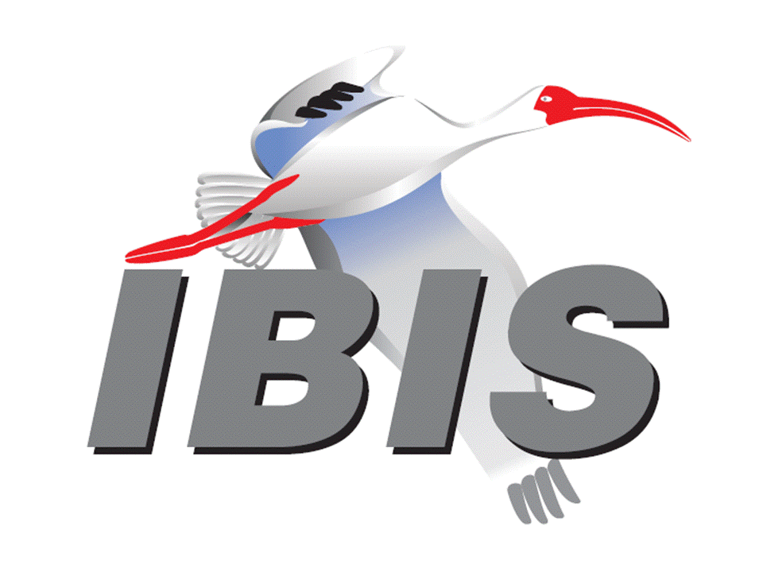

IBIS Open Forum Minutes

Meeting Date: June 8, 2018
Meeting Location: Teleconference

VOTING MEMBERS AND 2018 PARTICIPANTS
ANSYS Curtis Clark*
Applied Simulation Technology (Fred Balistreri)
Broadcom (Yunong Gan)
Cadence Design Systems Brad Brim, Ken Willis, Ambrish Varma
Cisco Systems Stephen Scearce, Cassie Yan, Baosh Xu
CST Stefan Paret
Ericsson Anders Ekholm, Zilwan Mahmod, Guohua Wang
GLOBALFOUNDRIES Steve Parker
Huawei Technologies (Hang (Paul) Yan)
IBM Greg Edlund, Luis Armenta, Hubert Harrer
Infineon Technologies AG (Christian Sporrer)
IO Methodology Lance Wang
Keysight Technologies Radek Biernacki*, Ming Yan, Heidi Barnes
Pegah Alavi
Mentor, A Siemens Business Arpad Muranyi, Weston Beal, Raj Raghuram
Carlo Bleu, Mikael Stahlberg, Yasushi Kondou
Vladimir Dmitriev-Zdorov, Nitin Bhagwath
Micron Technology Randy Wolff*, Justin Butterfield
NXP (John Burnett)
Raytheon Joseph Aday
SiSoft Mike LaBonte*, Walter Katz, Todd Westerhoff
Synopsys Ted Mido, Adrien Auge, Scott Wedge
Teraspeed Labs Bob Ross*
Xilinx Ravindra Gali
ZTE Corporation (Shunlin Zhu)
Zuken Michael Schaeder, Takayuki Shiratori

OTHER PARTICIPANTS IN 2018
Google Zhiping Yang
Haskware David Banas
Intel Corporation Hsinho Wu*, Michael Mirmak, Nilesh Dattani
Fernando Mendoza Hernandez, Varun Gupta
Subas Bastola, Hansel Dsilva, Gianni Signorini
John Baprawski, Inc. John Baprawski
KEI Systems Shinichi Maeda
Lattice Semiconductor Dinh Tran, Maryam Shahbazi
Maxim Integrated Joe Engert, Yan Liang
OmniVision Sirius Tsang
Politecnico di Milano Flavia Grassi, Xinglong Wu
Politecnico di Torino Tommaso Bradde, Marco De Stefano, Paulo Manfredi
Riccardo Trinchero, Stefano Grivet-Talocia
Qualcomm Kevin Roselle, Tim Michalka
Ricoh Kazuki Murata
RITA Electronics Ltd. Kenichi Higashiura, Hiroyuki Motoki
SAE-ITC (Jose Godoy)
Signal Metrics Ron Olisar
Socionext Megumi Ono
SPISim Wei-hsing Huang
Stanford University Tom Lee
STMicroelectronics Aurora Sanna, Olivier Bayet
Toshiba Yasuki Torigoshi, Yoshinori Fukuba
Université de Bretagne Occidentale Mihai Telescu, Charles Canaff
University of Illinois José Schutt-Aine
University of Siegen Elmar Griese
University of Technology Hamburg Torben Wendt
In the list above, attendees at the meeting are indicated by *. Principal members or other active members who have not attended are in parentheses. Participants who no longer are in the organization are in square brackets.

UPCOMING MEETINGS
The bridge numbers for future IBIS teleconferences are as follows:

Date Meeting Number Meeting Password
June 29, 2018 624 227 121 IBISfriday11

For teleconference dial-in information, use the password at the following website:

http://tinyurl.com/y7yt7buz

All teleconference meetings are 8:00 a.m. to 9:55 a.m. US Pacific Time. Meeting agendas are typically distributed seven days before each Open Forum. Minutes are typically distributed within seven days of the corresponding meeting.

NOTE: "AR" = Action Required.

-------------------------------------------------------------------------------------------------------------------------------
INTRODUCTIONS AND MEETING QUORUM
Mike LaBonte noted a quorum was not reached, so no votes could take place during the meeting.

CALL FOR PATENTS
Mike LaBonte called for declaration of any patents or pending patents related to the IBIS 3.2, IBIS 4.2, IBIS 5.1, IBIS 6.1, Touchstone 2.0, IBIS-ISS 1.0 or ICM 1.1 specifications. No patents were declared.

REVIEW OF MINUTES AND ARS
Mike LaBonte called for comments on the minutes of the May 18, 2018 IBIS Open Forum teleconference. Radek Biernacki noted he had a potential comment, but he did not think it was necessary to mention the change in the minutes.

Mike LaBonte called for comments on the minutes of the May 25, 2018 IBIS Open Forum Summit at IEEE SPI. There were no comments.

Votes to approve the minutes could not take place due to not meeting the minimum meeting quorum.

There were no ARs from the previous meeting to review.

ANNOUNCEMENTS, CALL FOR ADDITIONAL AGENDA ITEMS
None.

MEMBERSHIP STATUS AND TREASURER'S REPORT
Bob Ross reported that we have 23 members. We dropped Maxim Integrated and Qualcomm as voting members. The Intel payment is expected shortly, so Intel is temporarily in non-voting status. There is $16,787 in the treasury. We expect a payment of $522 for European IBIS Summit support from Zuken.

WEBSITE ADMINISTRATION
Mike LaBonte reported that in Europe there are new data protection regulations that are going into effect (General Data Protection Regulation or GDPR). SAE made some changes and asked us to add a link to the SAE ITC privacy policies to the main IBIS webpage. Mike added another statement that no web cookies are used by ibis.org. We were told to take down the roster page due to the contact information on the page. Mike thought he replaced the roster page, but he found during the meeting that a Perl script had restored the page. He will replace the contents of the roster page permanently with a notice about GDPR restrictions [AR]. Mike also noted that the IBIS Info and About IBIS pages are similar, and he is considering merging them together.

MAILING LIST ADMINISTRATION
Curtis Clark reported that he has been communicating with freelists about requirements for the new European privacy policy. He will send out emails to the lists once it is clear what is needed. Curtis also noted that the path for approving member joins to the lists is broken, so it is taking longer than previously. Also, some list emails are not including the original sender name and email when they are forwarded through freelists. Curtis is investigating this issue as well. Mike LaBonte added this is usually done to circumvent issues with some company’s email servers.

LIBRARY UPDATE
Mike LaBonte looked at the model library page to see if there was anything subject to the GDPR rules, and he didn’t see anything.

INTERNATIONAL/EXTERNAL ACTIVITIES
- Conferences
EPEPS – The 27th IEEE Conference on Electrical Performance of Electronic Packaging and Systems will be held in San Jose, CA on October 14-17, 2017. More information is available at:

http://www.epeps.org/

EDI CON – Electronic Design Innovation Conference & Exhibition will be held in Santa Clara, CA on October 17-18, 2018. More information is available at:

http://www.ediconusa.com

- Press Update
None.

- Related standards
IEC 63055/IEEE 2401, JEITA “LPB”
Mike LaBonte reported there was an IEEE DASC meeting yesterday, but did not attend.

SUMMIT PLANNING AND STATUS
- European IBIS Summit at SPI 2018 Review
SPI 2018 was held in Brest, France on May 22 through May 25, 2018. An IBIS Summit was held the afternoon of Friday, May 25, 2018. Bob Ross noted that a link to the minutes needs to be added to the IBIS webpage. Mike LaBonte will add a link [AR]. Mike noted that the Summit was integrated well into the program for SPI. There were interesting presentations on macro-modeling from three presenters. Another presentation was a proposal to expand [Model Selector]. Mike noted SPI 2019 will be in Chambery, France. Bob added that the sponsors for this year were Mentor, a Siemens Business, SiSoft, Teraspeed Labs, and Zuken.

- EPEPS/EDI CON Discussion
Bob wanted to make a motion to hold a Summit meeting during the week of October 14-18 at either EPEPS or EDI CON with costs not to exceed $2,000. He noted that for EPEPS, we typically do have good relationships with the academic community that is active with both EPEPS and the SPI events. This community does do IBIS work. Bob added that we do get overloaded with Summits, so that is a tradeoff. Mike asked if there is a deadline for responding to either event. Bob noted we do not have to decide immediately. Radek noted the Summit at EPEPS two years ago was well attended. Bob added that last year EPEPS put a conflicting event at the same time as the IBIS Summit, so the IBIS Summit was not as well attended. Bob would need to see if this situation could occur again this year. Mike requested Bob to find out more about the scheduling and details of proposals from each event before making an official motion for voting [AR].

- IBIS Asian Summits Discussion
Bob noted we need to make official motions to approve holding these events. We have already made reservations at hotels to hold the Tokyo Summit on November 12, 2018, the Shanghai Summit on November 14, 2018, and the Taipei Summit on November 16, 2018. No documents have been signed yet with the Shanghai and Taipei hotels. Bob proposed total costs for Shanghai not to exceed $8,000 and Taipei costs not to exceed $9,000, before sponsorships.

Bob moved to hold a Summit in Tokyo on November 12, 2018 for a cost not to exceed $1,000, a Summit in Shanghai on November 14, 2018 at a cost not to exceed $9,000, and a Summit in Taipei on November 16, 2018 at a cost not to exceed $8,000. Radek seconded the motion. The motion could not pass without a quorum, but Mike will note the anticipated official motion for soliciting votes for the next Open Forum meeting.

Sponsorship opportunities for all upcoming IBIS summits are available, with sponsors receiving free mentions in the minutes, agenda, and other announcements. Contact the IBIS Board for further details.

QUALITY TASK GROUP
Mike LaBonte reported that the group is meeting on Tuesdays at 8:00 a.m. PT. Discussion remains about IBISCHK developments including the writing of the document that will be used to develop the next parser, IBISCHK7. BIRD189 and BIRD194 have not been put in the document yet.

The IBISCHK6 user guide work in progress can be reviewed at:

http://www.ibis.org/ibischk6/ibischk_6.1.4_UserGuide_wip1.pdf

The Quality task group checklist and other documentation can be found at:

http://www.ibis.org/quality_wip/

ADVANCED TECHNOLOGY MODELING TASK GROUP
Mike LaBonte reported that the group is meeting regularly on Tuesdays at 12:00 p.m. PT. The group recently discussed a BIRD for an advanced C_comp model.

Task group material can be found at:

http://www.ibis.org/macromodel_wip/

INTERCONNECT TASK GROUP
Mike LaBonte reported that the group usually meets at 8:00 a.m. PT on Wednesdays. The group has not been meeting after the submittal of BIRD189.6 to the Open Forum for review.

Task group material can be found at:

http://www.ibis.org/interconnect_wip/

EDITORIAL TASK GROUP
Mike LaBonte reported that this group remains suspended. Should there be any official document to review such as IBIS 7.0, the task group will resume meetings on Fridays when there is no Open Forum teleconference.

Task group material can be found at:

http://www.ibis.org/editorial_wip/

NEW ADMINISTRATIVE ISSUES
- IBIS Officer Elections
Radek Biernacki reported we are in the voting period. He has received a few votes and will send a reminder at the beginning of next week. The ballot was sent out one day late, but there are still two full work weeks for voting if June 15th is kept as the last voting day. Radek proposed extending the voting until June 18th due to the delay in sending out the ballots. Mike and Bob reviewed the voting rules and felt this was appropriate. Radek will send out a reminder on Monday announcing the extended voting deadline.

BIRD189.6: INTERCONNECT MODELING USING IBIS-ISS AND TOUCHSTONE
Bob Ross noted the email should go out soon announcing the votes on BIRD189.6 and BIRD194 scheduled for the June 29, 2018 IBIS Open meeting.

BIRD194: REVISED AMI TS4FILE ANALOG BUFFER MODELS
No discussion.

BIRD125.1: MAKE IBIS-ISS AVAILABLE FOR IBIS PACKAGE MODELING
Discussion was tabled.

BIRD145.3: CASCADING IBIS I/O BUFFERS WITH [EXTERNAL CIRCUIT]S USING THE [MODEL CALL] KEYWORD
Discussion was tabled.

BIRD163: INSTANTIATING AND CONNECTING [EXTERNAL CIRCUIT] PACKAGE MODELS WITH [CIRCUIT CALL]
Discussion was tabled.

BIRD164: ALLOWING PACKAGE MODELS TO BE DEFINED IN [EXTERNAL CIRCUIT]
Discussion was tabled.

BIRD166.4: RESOLVING PROBLEMS WITH REDRIVER INIT FLOW
Discussion was tabled.

BIRD181.1: I-V TABLE CLARIFICATIONS
Discussion was tabled.

BIRD190: CLARIFICATION FOR REDRIVER FLOW
Discussion was tabled.

IBISCHK PARSER AND BUG STATUS
Bob Ross reported there are some new bugs, but he does not have them uploaded and ready to review yet.

NEW TECHNICAL ISSUES
None.

NEXT MEETING
The next IBIS Open Forum teleconference meeting will be held on June 29, 2018. A vote on the Asian IBIS Summits is planned. Votes on BIRD189.6 and BIRD194 are also scheduled for this meeting. The following IBIS Open Forum teleconference meeting is tentatively scheduled on July 20, 2018.

Radek Biernacki moved to adjourn. Bob Ross seconded the motion. The meeting adjourned.

========================================================================
NOTES

IBIS CHAIR: Mike LaBonte
mlabonte@sisoft.com
IBIS-AMI Modeling Specialist, SiSoft
6 Clock Tower Place, Suite 250
Maynard, MA 01754

VICE CHAIR: Lance Wang (978) 633-3388
lwang@iometh.com
President/CEO, IO Methodology, Inc.
PO Box 2099
Acton, MA 01720

SECRETARY: Randy Wolff (208) 363-1764
rrwolff@micron.com
Principal Engineer, Silicon SI Group Lead, Micron Technology, Inc.
8000 S. Federal Way
P.O. Box 6, Mail Stop: 01-711
Boise, ID 83707-0006

TREASURER: Bob Ross (503) 246-8048
bob@teraspeedlabs.com
Engineer, Teraspeed Labs
10238 SW Lancaster Road
Portland, OR 97219

LIBRARIAN: Anders Ekholm (46) 10 714 27 58, Fax: (46) 8 757 23 40
ibis-librarian@ibis.org
Digital Modules Design, PDU Base Stations, Ericsson AB
BU Network
Färögatan 6
164 80 Stockholm, Sweden

WEBMASTER: Mike LaBonte
mlabonte@sisoft.com
IBIS-AMI Modeling Specialist, SiSoft
6 Clock Tower Place, Suite 250
Maynard, MA 01754

POSTMASTER: Curtis Clark
curtis.clark@ansys.com
ANSYS, Inc.
150 Baker Ave Ext
Concord, MA 01742

This meeting was conducted in accordance with ANSI guidance.

All inquiries may be sent to info@ibis.org. Examples of inquiries are:
- To obtain general information about IBIS.
- To ask specific questions for individual response.
- To subscribe to the official ibis@freelists.org and/or ibis-users@freelists.org email lists (formerly ibis@eda.org and ibis-users@eda.org).
- To subscribe to one of the task group email lists: ibis-macro@freelists.org, ibis-interconn@freelists.org, or ibis-quality@freelists.org.
- To inquire about joining the IBIS Open Forum as a voting Member.
- To purchase a license for the IBIS parser source code.
- To report bugs or request enhancements to the free software tools: ibischk6, tschk2, icmchk1, s2ibis, s2ibis2 and s2iplt.
The BUG Report Form for ibischk resides along with reported BUGs at:

http://www.ibis.org/bugs/ibischk/
http://www.ibis.org/ bugs/ibischk/bugform.txt

The BUG Report Form for tschk2 resides along with reported BUGs at:

http://www.ibis.org/bugs/tschk/
http://www.ibis.org/bugs/tschk/bugform.txt

The BUG Report Form for icmchk resides along with reported BUGs at:

http://www.ibis.org/bugs/icmchk/
http://www.ibis.org/bugs/icmchk/icm_bugform.txt

To report s2ibis, s2ibis2 and s2iplt bugs, use the Bug Report Forms which reside at:

http://www.ibis.org/bugs/s2ibis/bugs2i.txt
http://www.ibis.org/bugs/s2ibis2/bugs2i2.txt
http://www.ibis.org/bugs/s2iplt/bugsplt.txt

Information on IBIS technical contents, IBIS participants and actual IBIS models are available on the IBIS Home page:

http://www.ibis.org/

Check the IBIS file directory on ibis.org for more information on previous discussions and results:

http://www.ibis.org/directory.html

Other trademarks, brands and names are the property of their respective owners.
SAE STANDARDS BALLOT VOTING STATUS
Organization | Interest Category | Standards Ballot Voting Status | May 4, 2018 | May 18, 2018 | May 25, 2018 | June 8, 2018
ANSYS | User | Active | - | X | - | X
Applied Simulation Technology | User | Inactive | - | - | - | -
Broadcom Ltd. | Producer | Inactive | - | - | - | -
Cadence Design Systems | User | Inactive | X | X | - | -
Cisco Systems | User | Inactive | - | - | - | -
CST | User | Inactive | - | - | - | -
Ericsson | Producer | Inactive | - | - | - | -
GLOBALFOUNDRIES | Producer | Inactive | X | X | - | -
Huawei Technologies | Producer | Inactive | - | - | - | -
IBM | Producer | Active | - | X | X | -
Infineon Technologies AG | Producer | Inactive | - | - | - | -
IO Methodology | User | Inactive | X | X | - | -
Keysight Technologies | User | Active | X | X | - | X
Mentor, A Siemens Business | User | Active | X | X | X | -
Micron Technology | Producer | Active | X | X | - | X
NXP | Producer | Inactive | - | - | - | -
Raytheon | User | Inactive | - | - | - | -
SiSoft | User | Active | X | X | X | X
Synopsys | User | Inactive | X | X | - | -
Teraspeed Labs | General Interest | Active | X | X | - | X
Xilinx | Producer | Inactive | - | - | - | -
ZTE Corp. | User | Inactive | - | - | - | -
Zuken | User | Inactive | - | - | X | -

Criteria for SAE member in good standing:
- Must attend two consecutive meetings to establish voting membership
- Membership dues current
- Must not miss two consecutive meetings
Interest categories associated with SAE standards ballot voting are:
- Users - members that utilize electronic equipment to provide services to an end user.
- Producers - members that supply electronic equipment.
- General Interest - members are neither producers nor users. This category includes, but is not limited to, government, regulatory agencies (state and federal), researchers, other organizations and associations, and/or consumers.

