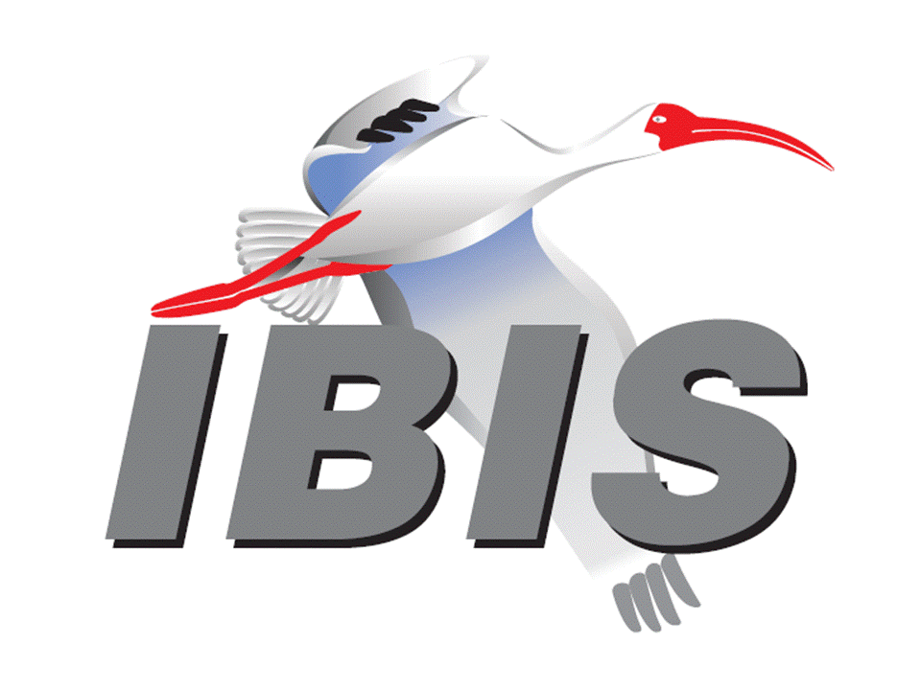

IBIS Open Forum Minutes

Meeting Date: February 16, 2018
Meeting Location: Teleconference

VOTING MEMBERS AND 2018 PARTICIPANTS
ANSYS Curtis Clark*
Applied Simulation Technology (Fred Balistreri)
Broadcom (Yunong Gan)
Cadence Design Systems Brad Brim, Ken Willis, Ambrish Varma
Cisco Systems Stephen Scearce, Cassie Yan, Baosh Xu
CST Stefan Paret
Ericsson Anders Ekholm, Zilwan Mahmod, Guohua Wang
GLOBALFOUNDRIES Steve Parker*
Huawei Technologies (Hang (Paul) Yan)
IBM Greg Edlund
Infineon Technologies AG (Christian Sporrer)
Intel Corporation Hsinho Wu*, Michael Mirmak*, Nilesh Dattani
Fernando Mendoza Hernandez, Varun Gupta
Subas Bastola, Hansel Dsilva
IO Methodology Lance Wang*
Keysight Technologies Radek Biernacki*, Ming Yan, Heidi Barnes
Pegah Alavi
Maxim Integrated Joe Engert, Yan Liang
Mentor, A Siemens Business Arpad Muranyi, Weston Beal, Raj Raghuram
Carlo Bleu, Mikael Stahlberg, Yasushi Kondou
Vladimir Dmitriev-Zdorov
Micron Technology Randy Wolff*, Justin Butterfield
NXP (John Burnett)
Qualcomm Kevin Roselle, Tim Michalka
Raytheon Joseph Aday
SiSoft Mike LaBonte*, Walter Katz*, Todd Westerhoff
Synopsys Ted Mido*, Adrien Auge, Scott Wedge
Teraspeed Labs Bob Ross*
Xilinx Ravindra Gali
ZTE Corporation (Shunlin Zhu)
Zuken Michael Schaeder, Takayuki Shiratori

OTHER PARTICIPANTS IN 2018
Google Zhiping Yang
Haskware David Banas
John Baprawski, Inc. John Baprawski
KEI Systems Shinichi Maeda
Lattice Semiconductor Dinh Tran, Maryam Shahbazi
OmniVision Sirius Tsang
Ricoh Kazuki Murata
RITA Electronics Ltd. Kenichi Higashiura, Hiroyuki Motoki
SAE-ITC (Jose Godoy)
Signal Metrics Ron Olisar
Socionext Megumi Ono
SPISim Wei-hsing Huang
Stanford University Tom Lee
Toshiba Yasuki Torigoshi, Yoshinori Fukuba

In the list above, attendees at the meeting are indicated by *. Principal members or other active members who have not attended are in parentheses. Participants who no longer are in the organization are in square brackets.

UPCOMING MEETINGS
The bridge numbers for future IBIS teleconferences are as follows:

Date Meeting Number Meeting Password
March 9, 2018 624 227 121 IBISfriday11

For teleconference dial-in information, use the password at the following website:

http://tinyurl.com/y7yt7buz

All teleconference meetings are 8:00 a.m. to 9:55 a.m. US Pacific Time. Meeting agendas are typically distributed seven days before each Open Forum. Minutes are typically distributed within seven days of the corresponding meeting.

NOTE: "AR" = Action Required.

-------------------------------------------------------------------------------------------------------------------------------
INTRODUCTIONS AND MEETING QUORUM
Mike LaBonte declared that a quorum was reached and the meeting could begin.

CALL FOR PATENTS
Mike LaBonte called for declaration of any patents or pending patents related to the IBIS 3.2, IBIS 4.2, IBIS 5.1, IBIS 6.1, Touchstone 2.0, IBIS-ISS 1.0 or ICM 1.1 specifications. No patents were declared.

REVIEW OF MINUTES AND ARS
Mike LaBonte called for comments on the minutes of the January 26, 2018 IBIS Open Forum teleconference. Radek Biernacki moved to approve the minutes. Curtis Clark seconded the motion. There were no objections.

Mike called for comments on the minutes of the February 2, 2018 DesignCon IBIS Summit. Radek moved to approve the minutes. Lance Wang seconded the motion. There were no objections.

There were no ARs to review.

ANNOUNCEMENTS, CALL FOR ADDITIONAL AGENDA ITEMS
None.

MEMBERSHIP STATUS AND TREASURER'S REPORT
Bob Ross reported that we are at 26 members carried forth from 2017. The final numbers for 2017 are in, and we have $13,086 actual cash flow and $14,836 adjusted cash flow. Due to some adjustments from SAE there is a $3,101 allocation deduction for general administrative fees which are not broken down. Eight membership payments have come in for 2018. Actual cash flow of $9,450 has been collected in 2018. There are pending expenses such as DesignCon expenses and SPI European IBIS Summit expenses coming up. We expect more membership and sponsor payments, so we are on the positive side now.

WEBSITE ADMINISTRATION
Mike LaBonte reported that he updated copyrights to 2018 on many pages. The library page has been updated. Also, we received an update to the roster page for Synopsys. Curtis Clark found a few typos on the FAQ page, including needing to point people to the support page instead of direct email links for support on that page. There was also a typo on the support page that was updated.

MAILING LIST ADMINISTRATION
Curtis Clark reported everything is going fine generally, with one subscriber email issue being worked on with freelists.

LIBRARY UPDATE
Mike LaBonte noted Anders Ekholm checked through the library page after DesignCon, and he sent updated HTML content with many fixes. The update was done today.

INTERNATIONAL/EXTERNAL ACTIVITIES
- Conferences
SPI2018 – the 22nd IEEE Workshop on Signal and Power Integrity will be held in Brest, France on May 22-25, 2018. An IBIS Summit will be held after the event. More information is available at:

https://spi2018.sciencesconf.org/

- Press Update
None.

- Related standards
Mike LaBonte noted that IEEE 2401 (JEITA LPB) is a standard that we are tracking. Michael Mirmak reported that there will be a meeting at DVCon on March 1 after the DASC meeting. It will be a chance to see if LPB is interested in further work with IBIS. Mike has emailed the DASC chair, Stan Krolikoski, about the ability for IBIS to participate in DASC and what the cost would be. Michael noted that if we want official representative, then IBIS must join as an entity.

Hsinho Wu noted that JEDEC specification JESD204C describes a high speed interface between an ADC and an ASIC or FPGA up to 32Gb/s. The standard model call JCOM is for channel compliance but also device models. There was push back about use of a proprietary model, and IBIS-AMI was suggested instead. Hsinho is pushing them to adapt IBIS-AMI for the device model. The people that did a tutorial at DesignCon on the topic may contact Mike for more information. This may just be a new way of using IBIS-AMI, so it’s possible there might be a new function needed in IBIS-AMI eventually.

SUMMIT PLANNING AND STATUS
- DesignCon 2018 Review
DesignCon was held in Santa Clara, CA on January 30 through February 1, 2018. An IBIS Summit was held on Friday, February 2, 2018 in room 209 of the Santa Clara Convention Center. Mike LaBonte noted there is now a page for it on the website with the presentations linked. Mike thanked the sponsors Cadence Design Systems, Keysight Technologies, Mentor, a Siemens Business and Synopsys. There was good attendance, and we had a keynote speech from Tom Lee of standard as well. Bob Ross noted 61 people from 32 organizations attending. Mike thanked the presenters too.

- European IBIS Summit at SPI 2018
SPI 2018 will be held in Brest, France on May 22 through May 25, 2018. An IBIS Summit will be held the afternoon of Friday, May 25, 2018. Mike noted that registrations for the meeting will open on March 1. Bob noted that we will be looking for sponsors.

Sponsorship opportunities for all upcoming IBIS summits are available, with sponsors receiving free mentions in the minutes, agenda, and other announcements. Contact the IBIS Board for further details.

QUALITY TASK GROUP
Mike LaBonte reported that the group is meeting on Tuesdays at 8:00 a.m. PT. There has been some discussion of planning for IBISCHK7.

The IBISCHK6 user guide work in progress can be reviewed at:

http://www.ibis.org/ibischk6/ibischk_6.1.4_UserGuide_wip1.pdf

The Quality task group checklist and other documentation can be found at:

http://www.ibis.org/quality_wip/

ADVANCED TECHNOLOGY MODELING TASK GROUP
Mike LaBonte reported that the group is meeting regularly on Tuesdays at 12:00 p.m. PT. In recent meetings the time has been allocated towards moving the BIRD189.5 draft forward. Michael Mirmak noted one of the new topics will be discussion of BIRD158.

Task group material can be found at:

http://www.ibis.org/macromodel_wip/

INTERCONNECT TASK GROUP
Michael Mirmak reported that the group is meeting at 8:00 a.m. PT on Wednesdays. The Friday Editorial task group time slot is also used on occasion. Draft 17 of the BIRD189.5 document was just reviewed. Good progress has been made toward releasing a document in March.

Task group material can be found at:

http://www.ibis.org/interconnect_wip/

EDITORIAL TASK GROUP
Michael Mirmak reported that this group remains suspended. Should there be any official document to review such as IBIS 7.0, the task group will resume meetings on Fridays when there is no Open Forum teleconference. Watch the editorial reflector for announcement of meetings or documents to review.

Task group material can be found at:

http://www.ibis.org/editorial_wip/

NEW ADMINISTRATIVE ISSUES
- Meetings with SAE-ITC
Mike LaBonte reported there was one meeting with SAE-ITC. Bob Ross already reported about the new administrative charges. Mike noted no changes were made in the way we operate, and our relationship stays the same. Bob said the assessment in the order of $3,000 is modest and would cover some general overhead expenses. Several expenses are classified in separate columns. A pending ibischk7 parser payment may be large enough to be capitalized and depreciated over several years for SAE-ITC IRS reporting.

BIRD193: FIGURE 29 CORRECTIONS
Bob Ross noted he thought the BIRD was ready to advance to a vote. He moved to schedule a vote on BIRD193 in the next IBIS Open Forum meeting. Michael Mirmak seconded the motion. There were no objections.

BIRD125.1: MAKE IBIS-ISS AVAILABLE FOR IBIS PACKAGE MODELING
Discussion was tabled.

BIRD145.3: CASCADING IBIS I/O BUFFERS WITH [EXTERNAL CIRCUIT]S USING THE [MODEL CALL] KEYWORD
Discussion was tabled.

BIRD163: INSTANTIATING AND CONNECTING [EXTERNAL CIRCUIT] PACKAGE MODELS WITH [CIRCUIT CALL]
Discussion was tabled.

BIRD164: ALLOWING PACKAGE MODELS TO BE DEFINED IN [EXTERNAL CIRCUIT]
Discussion was tabled.

BIRD166.4: RESOLVING PROBLEMS WITH REDRIVER INIT FLOW
Discussion was tabled.

BIRD181.1: I-V TABLE CLARIFICATIONS
Discussion was tabled.

BIRD189.4: INTERCONNECT MODELING USING IBIS-ISS AND TOUCHSTONE
Discussion was tabled.

BIRD190: CLARIFICATION FOR REDRIVER FLOW
Discussion was tabled.

IBISCHK6 PARSER AND BUG STATUS
Bob Ross reported no change. There are no new bugs processed beyond the latest ones reported, although there are several to be processed.

NEW TECHNICAL ISSUES
None.

NEXT MEETING
The next IBIS Open Forum teleconference meeting will be held March 9, 2018. The following IBIS Open Forum teleconference meeting is tentatively scheduled on March 30, 2018.

Curtis Clark moved to adjourn. Michael Mirmak seconded the motion. The meeting adjourned.

========================================================================
NOTES

IBIS CHAIR: Mike LaBonte
mlabonte@sisoft.com
IBIS-AMI Modeling Specialist, SiSoft
6 Clock Tower Place, Suite 250
Maynard, MA 01754

VICE CHAIR: Lance Wang (978) 633-3388
lwang@iometh.com
President/CEO, IO Methodology, Inc.
PO Box 2099
Acton, MA 01720

SECRETARY: Randy Wolff (208) 363-1764
rrwolff@micron.com
Principal Engineer, Silicon SI Group Lead, Micron Technology, Inc.
8000 S. Federal Way
P.O. Box 6, Mail Stop: 01-711
Boise, ID 83707-0006

TREASURER: Bob Ross (503) 246-8048
bob@teraspeedlabs.com
Engineer, Teraspeed Labs
10238 SW Lancaster Road
Portland, OR 97219

LIBRARIAN: Anders Ekholm (46) 10 714 27 58, Fax: (46) 8 757 23 40
ibis-librarian@ibis.org
Digital Modules Design, PDU Base Stations, Ericsson AB
BU Network
Färögatan 6
164 80 Stockholm, Sweden

WEBMASTER: Mike LaBonte
mlabonte@sisoft.com
IBIS-AMI Modeling Specialist, SiSoft
6 Clock Tower Place, Suite 250
Maynard, MA 01754

POSTMASTER: Curtis Clark
curtis.clark@ansys.com
ANSYS, Inc.
150 Baker Ave Ext
Concord, MA 01742

This meeting was conducted in accordance with ANSI guidance.

All inquiries may be sent to info@ibis.org. Examples of inquiries are:
- To obtain general information about IBIS.
- To ask specific questions for individual response.
- To subscribe to the official ibis@freelists.org and/or ibis-users@freelists.org email lists (formerly ibis@eda.org and ibis-users@eda.org).
- To subscribe to one of the task group email lists: ibis-macro@freelists.org, ibis-interconn@freelists.org, or ibis-quality@freelists.org.
- To inquire about joining the IBIS Open Forum as a voting Member.
- To purchase a license for the IBIS parser source code.
- To report bugs or request enhancements to the free software tools: ibischk6, tschk2, icmchk1, s2ibis, s2ibis2 and s2iplt.
The BUG Report Form for ibischk resides along with reported BUGs at:

http://www.ibis.org/bugs/ibischk/
http://www.ibis.org/ bugs/ibischk/bugform.txt

The BUG Report Form for tschk2 resides along with reported BUGs at:

http://www.ibis.org/bugs/tschk/
http://www.ibis.org/bugs/tschk/bugform.txt

The BUG Report Form for icmchk resides along with reported BUGs at:

http://www.ibis.org/bugs/icmchk/
http://www.ibis.org/bugs/icmchk/icm_bugform.txt

To report s2ibis, s2ibis2 and s2iplt bugs, use the Bug Report Forms which reside at:

http://www.ibis.org/bugs/s2ibis/bugs2i.txt
http://www.ibis.org/bugs/s2ibis2/bugs2i2.txt
http://www.ibis.org/bugs/s2iplt/bugsplt.txt

Information on IBIS technical contents, IBIS participants and actual IBIS models are available on the IBIS Home page:

http://www.ibis.org/

Check the IBIS file directory on ibis.org for more information on previous discussions and results:

http://www.ibis.org/directory.html

Other trademarks, brands and names are the property of their respective owners.
SAE STANDARDS BALLOT VOTING STATUS
Organization | Interest Category | Standards Ballot Voting Status | January 5, 2018 | January 26, 2018 | February 2, 2018 | February 16, 2018
ANSYS | User | Active | - | X | - | X
Applied Simulation Technology | User | Inactive | - | - | - | -
Broadcom Ltd. | Producer | Inactive | - | - | - | -
Cadence Design Systems | User | Active | - | X | X | -
Cisco Systems | User | Inactive | - | - | X | -
CST | User | Inactive | - | - | X | -
Ericsson | Producer | Inactive | - | - | X | -
GLOBALFOUNDRIES | Producer | Active | - | X | X | X
Huawei Technologies | Producer | Inactive | - | - | - | -
IBM | Producer | Inactive | - | - | X | -
Infineon Technologies AG | Producer | Inactive | - | - | - | -
Intel Corp. | Producer | Active | X | X | X | X
IO Methodology | User | Active | X | X | X | X
Keysight Technologies | User | Active | X | X | X | X
Maxim Integrated | Producer | Inactive | - | - | X | -
Mentor, A Siemens Business | User | Active | X | - | X | -
Micron Technology | Producer | Active | X | X | X | X
NXP | Producer | Inactive | - | - | - | -
Qualcomm | Producer | Inactive | - | - | X | -
Raytheon | User | Inactive | - | - | X | -
SiSoft | User | Active | X | X | X | X
Synopsys | User | Active | X | X | X | X
Teraspeed Labs | General Interest | Active | X | X | X | X
Xilinx | Producer | Inactive | - | - | X | -
ZTE Corp. | User | Inactive | - | - | - | -
Zuken | User | Inactive | - | - | X | -

Criteria for SAE member in good standing:
- Must attend two consecutive meetings to establish voting membership
- Membership dues current
- Must not miss two consecutive meetings
Interest categories associated with SAE standards ballot voting are:
- Users - members that utilize electronic equipment to provide services to an end user.
- Producers - members that supply electronic equipment.
- General Interest - members are neither producers nor users. This category includes, but is not limited to, government, regulatory agencies (state and federal), researchers, other organizations and associations, and/or consumers.

