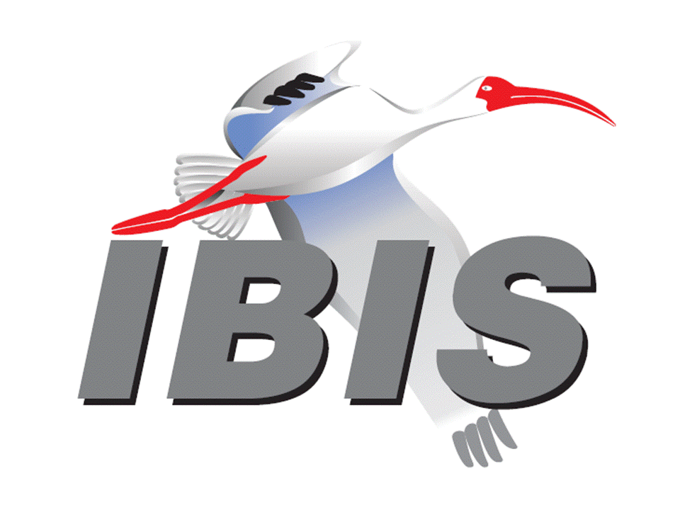
IBIS Open Forum Minutes

Meeting Date: February 5, 2016
Meeting Location: Teleconference

VOTING MEMBERS AND 2016 PARTICIPANTS
ANSYS Curtis Clark*, Toru Watanabe
Applied Simulation Technology (Fred Balistreri)
Avago Technologies Bob Miller
Cadence Design Systems Ken Willis, Brad Brim*
Cisco Systems Giuseppi Selli, Brian Baek
CST Stefan Paret
Ericsson Anders Ekholm, David Zhang, Zilwan Mahmod
Huawei Technologies (Jinjun Li)
IBM Adge Hawes*, Luis Armenta
Infineon Technologies AG (Christian Sporrer)
Intel Corporation Hsinho Wu*, Mohammad Bapi, Michael Mirmak*,
Masahi Shimanouchi, Todd Bermensolo, Zao Liu,
Gong Ouyang, Udy Shrivastava
IO Methodology Lance Wang*
Keysight Technologies Radek Biernacki*, Heidi Barnes, Jian Yang, Fangyi Rao, Stephen Slater, Pegah Alavi, Edwin Young
Maxim Integrated Products Yan Liang*, Don Greer, Thinh Nguyen, Joe Engert,
Hock Seon
Mentor Graphics Arpad Muranyi*, Vladimir Dmitriev-Zdorov, John Angulo
Micron Technology Randy Wolff*
Signal Integrity Software Mike LaBonte*, Walter Katz*, Todd Westerhoff
Synopsys Ted Mido, Kevin Li*
Teraspeed Labs Bob Ross*
Toshiba (Yasumasa Kondo)
Xilinx (Raymond Anderson)
ZTE Corporation (Shunlin Zhu)
Zuken Michael Schaeder, Amir Wallrabenstein

OTHER PARTICIPANTS IN 2016
Fujitsu Advanced Technologies Shogo Fujimori
GLOBALFOUNDRIES Steve Parker*
H3C Bin Cheng, Mao Jun
Independent Carl Gabrielson
JEITA Yosuke Kanamaru
John Baprawski, Inc. John Baprawski
KEI Systems Shinichi Maeda
Lattice Semiconductor Dinh Tran, Maryam Shahbazi
MathWorks Mike Mulligan, Corey Mathis
Northrup Grumman Alex Golian
NXP Jon Burnett
Rambus John Yan
Raytheon Joseph Aday
SAE International (Logen Johnson)
SILABTECH Biman Chattopadhyary
Signal Metrics Ron Olisar
SPISim Wei-hsing Huang

In the list above, attendees at the meeting are indicated by *. Principal members or other active members who have not attended are in parentheses. Participants who no longer are in the organization are in square brackets.

UPCOMING MEETINGS
The bridge numbers for future IBIS teleconferences are as follows:

Date Meeting Number Meeting Password
February 26, 2016 205 475 958 IBIS

For teleconference dial-in information, use the password at the following website:

https://ciscosales.webex.com/ciscosales/j.php?J=205475958

All teleconference meetings are 8:00 a.m. to 9:55 a.m. US Pacific Time. Meeting agendas are typically distributed seven days before each Open Forum. Minutes are typically distributed within seven days of the corresponding meeting. When calling into the meeting, follow the prompts to enter the meeting ID. For new, local international dial-in numbers, please reference the bridge numbers provided by Cisco Systems at the following link:

http://www.cisco.com/web/about/doing_business/conferencing/index.html

NOTE: "AR" = Action Required.

-------------------------------------------------------------------------------------------------------------------------------
INTRODUCTIONS AND MEETING QUORUM
Steve Parker introduced himself. He works for GLOBALFOUNDRIES on IBIS and AMI modeling.

Randy Wolff declared that a quorum was reached and the meeting could begin.

CALL FOR PATENTS
Mike LaBonte called for declaration of any patents or pending patents related to the IBIS 3.2, IBIS 4.2, IBIS 5.1, IBIS 6.1, Touchstone 2.0, IBIS-ISS 1.0 or ICM 1.1 specifications. No patents were declared.

REVIEW OF MINUTES AND ARS
Randy Wolff called for comments regarding the minutes of the January 8, 2016 IBIS Open Forum teleconference. Bob Ross noted that GLOBALFOUNDRIES should be listed as a voting member only after we receive a membership payment from them. So, IBM should be moved back as a voting member until June 1, 2016, unless they want to be removed. Radek Biernacki moved to approve the minutes with the noted change. Bob seconded the motion. There were no objections.

Randy reviewed ARs from the previous meeting.

- Bob Ross to update the IBISCHK parser BUGs webpage [AR].
Done.
- Mike LaBonte to get the IBISCHK6 User Guide posted on the website [AR].
Done.

Randy called for comments on the minutes of the January 22, 2016 DesignCon IBIS Summit. Radek commented that the minutes do not reflect a stronger opposition to the licensed AMI model concept presented by Ken Willis. Radek did not think a licensed model should be called an IBIS-AMI model. Radek moved to approve the minutes with the noted comments. Lance Wang seconded the motion. There were no objections.

ANNOUNCEMENTS, CALL FOR ADDITIONAL AGENDA ITEMS
None.

MEMBERSHIP STATUS AND TREASURER'S REPORT
Bob Ross reported that we are carrying over 23 members from 2015, down 1 due to the Altera/Intel merger. We have received three renewals for 2016 so far. Regarding finances, we made some payments, so our cumulative treasury balance is $54,815. Bob has reorganized the financial spreadsheet to conform to more standard business practices. It now tracks financial transactions per year, starting with a zero balance at the beginning of the year. We have not recorded some transactions yet related to the Asian IBIS summits and DesignCon. Mike LaBonte noted that this should not cause any problems by having more expenses at the beginning of the year than income. This balances out over the year. SAE accounting rules do state that we start the year with zero balance. Bob noted that SAE is tolerant of our financial practices, and overall we do show a net profit.

WEBSITE ADMINISTRATION
Mike LaBonte reported that he made some changes to better obscure email addresses. He received a logo for GLOBALFOUNDRIES and needs to update this on the webpage. He also is starting to use the address info@ibis.org for contacting IBIS members with general questions. He has gotten the filtering to work well enough that spam to this email address is minimal. Bob Ross noted that the minutes should reflect this change. Mike should also remove the Altera logo from the IBIS home page [AR].

MAILING LIST ADMINISTRATION
Curtis Clark reported that administration of freelists mailing lists is going well. The address info@ibis.org is now active. An email did come through the ibis-info@freelists.org and was seen by Curtis and Mike LaBonte. Curtis is also revamping a welcome email that goes out to new subscribers to reflect the changes.

LIBRARY UPDATE
No update.

INTERNATIONAL/EXTERNAL ACTIVITIES
- Conferences
None.

- Press Update
Mike LaBonte noted an article on the EDN website about the accuracy of AMI models. The article is: "Accurate AMI Analysis – Whose Responsibility Is It?" The article is linked at:

http://preview.tinyurl.com/j6e7nsk

Mike noted a new book by Timothy Coyle, “Backing IBIS Models for Signal Integrity Analysis”. It can be found at:

http://www.signalbytestech.com

Bob Ross noted two academic articles related to IBIS.

V.S. Deepaksubramanyan, C.Y. Roger Chan, and Adrian Nunez, "A tool to Generate Models Based on Behaviorial IBIS Models" Proceedings, 2012 IEEE 55th International Midwest Symposium on Circuits and Systems (MWSCAS) August 5-8, 2012, pp. 234-237 (held in Boise, ID, Authors from Syracuse University, Syracuse, NY).

Stepan N. Dmitriev, Alexey A. Levitskiy, "IBIS Models Based on Experimental Data" Proceedings, 2015 International Siberian Conference on Control and Communications (SIBCON) May 21-23, 2015, pp. 1-4 (held in Omsk, Russia).

- IEEE DASC
Michael Mirmak noted the approval of SystemC AMS as standard P1666.1 in late January. Michael wondered if SystemC AMS should be supported by IBIS multi-lingual modeling. Bob Ross noted that we should wait for a need. If so, we would simply have to change the text in the specification to add SystemC AMS as an option, with a minor change to the parser.

SUMMIT PLANNING AND STATUS
- DesignCon 2016 IBIS Summit Review
The IBIS Summit was held on Friday, January 22, 2016. Mike LaBonte noted that the turnout was good for having the meeting the day after DesignCon, with 62 attendees. Bob Ross noted this was almost the same number as last year. Radek Biernacki commented that we could have used more seats. Mike and Bob met the new conference director Naomi Price. They will discuss hosting the meeting next year more closely integrated with DesignCon and in a larger space. Bob noted a concern that the ceiling was low and it might have been difficult to see the screen for those in the back of the room. Radek commented that he was able to see the screen ok from multiple locations. Bob wondered if we’d get a better discount on the room costs working through UBM. The room has been free in previous years. Bob also thanked the sponsors Keysight Technologies, Mentor Graphics Corporation and Synopsys for their support.

- European IBIS Summit at SPI 2016
An IBIS Summit will be co-hosted with the IEEE Workshop on Signal and Power Integrity (SPI). The Summit will be a half day event on May 11, 2016 in Turin, Italy. Bob noted that he is waiting for confirmation on the payment to SPI. We are looking for sponsorship to offset our costs, but not conflicting with companies sponsoring SPI. Bob added that there is discussion of hosting an IBIS class on basic IBIS.

Sponsorship opportunities for all upcoming IBIS summits are available, with sponsors receiving free mentions in the minutes, agenda, and other announcements. Contact the IBIS Board for further details.

QUALITY TASK GROUP
Mike LaBonte reported that the group is meeting on Tuesdays at 8:00 a.m. PT. One new topic being discussed is checking the quality of IBIS-AMI DLLs.

The ibischk6 user guide work in progress can be reviewed at:

http://www.ibis.org/ibischk6/ibischk_6.1.1_UserGuide_wip1.pdf

The Quality Task Group checklist and other documentation can be found at:

http://www.ibis.org/quality_wip/

ADVANCED TECHNOLOGY MODELING TASK GROUP
Arpad Muranyi reported that the group is meeting regularly on Tuesdays at 12:00 p.m. PT. The group is discussing ground referencing related text in the specification. Other topics include backchannel modeling and redrivers.

Task group material can be found at:

http://www.ibis.org/macromodel_wip/

INTERCONNECT TASK GROUP
Michael Mirmak reported that the group is meeting on Wednesdays at 8:00 a.m. PT. Draft 29 of the Interconnect BIRD proposal was reviewed recently. Other changes to [Pin] and [Pin Mapping] are being discussed.

Task group material can be found at:

http://www.ibis.org/interconnect_wip/

NEW ADMINISTRATIVE ISSUES
- Second revision of IBIS Policies and Procedures
Mike LaBonte noted that the draft Policies and Procedures update is on the website for review. Bob Ross noted that he thought the document was in good shape and close to ready for a review. The document can be found at:

http://www.ibis.org/policies/

BIRD125.1: MAKE IBIS-ISS AVAILABLE FOR IBIS PACKAGE MODELING
Discussion was tabled.

BIRD128.2: ALLOW AMI_PARAMETERS_OUT TO PASS AMI_PARAMETERS_IN DATA ON CALLS TO AMI_GETWAVE
Discussion was tabled.

BIRD145.3: CASCADING IBIS I/O BUFFERS WITH [EXTERNAL CIRCUIT]S USING THE [MODEL CALL] KEYWORD
Discussion was tabled.

BIRD147: BACK-CHANNEL SUPPORT
Discussion was tabled.

BIRD158.3: AMI TOUCHSTONE ANALOG BUFFER MODELS
Discussion was tabled.

BIRD161.1: SUPPORTING INCOMPLETE AND BUFFER-ONLY [COMPONENT] DESCRIPTIONS
Discussion was tabled.

BIRD163: INSTANTIATING AND CONNECTING [EXTERNAL CIRCUIT] PACKAGE MODELS WITH [CIRCUIT CALL]
Discussion was tabled.

BIRD164: ALLOWING PACKAGE MODELS TO BE DEFINED IN [EXTERNAL CIRCUIT]
Discussion was tabled.

BIRD165: PARAMETER PASSING IMPROVEMENTS FOR [EXTERNAL CIRCUIT]S
Discussion was tabled.

BIRD166: RESOLVING PROBLEMS WITH REDRIVER INIT FLOW
Discussion was tabled.

IBISCHK6 PARSER AND BUG STATUS
Bob Ross noted that BUG172 is open. Mike LaBonte noted that IBISCHK 6.1.1 was released in mid-January.

Curtis Clark introduced BUG173. Matrix checking done for Package Models may be incorrect for Banded Matrices that wrap. Matrices that should fail may pass, but no good matrices should fail the parser. Curtis suggested classifying the bug as Moderate severity, Medium priority and Open status. There were no objections.

Bob suggested we send both bugs to the parser developer and request they be fixed. Radek Biernacki noted the fix for BUG172 is simple.

NEW TECHNICAL ISSUES
None.

NEXT MEETING
The next IBIS Open Forum teleconference meeting will be held February 26, 2016. The following IBIS Open Forum teleconference meeting will be held March 18, 2016.

Michael Mirmak moved to adjourn. Bob Ross seconded the motion.

========================================================================
NOTES

IBIS CHAIR: Mike LaBonte
mlabonte@sisoft.com
IBIS-AMI Modeling Specialist, Signal Integrity Software
6 Clock Tower Place, Suite 250
Maynard, MA 01754

VICE CHAIR: Lance Wang (978) 633-3388
lwang@iometh.com
President/CEO, IO Methodology, Inc.
PO Box 2099
Acton, MA 01720

SECRETARY: Randy Wolff (208) 363-1764
rrwolff@micron.com
Principal Engineer, Silicon SI Group Lead, Micron Technology, Inc.
8000 S. Federal Way
P.O. Box 6, Mail Stop: 01-711
Boise, ID 83707-0006

TREASURER: Bob Ross (503) 246-8048
bob@teraspeedlabs.com
Engineer, Teraspeed Labs
10238 SW Lancaster Road
Portland, OR 97219

LIBRARIAN: Anders Ekholm (46) 10 714 27 58, Fax: (46) 8 757 23 40
ibis-librarian@ibis.org
Digital Modules Design, PDU Base Stations, Ericsson AB
BU Network
Färögatan 6
164 80 Stockholm, Sweden

WEBMASTER: Mike LaBonte
mlabonte@sisoft.com
IBIS-AMI Modeling Specialist, Signal Integrity Software
6 Clock Tower Place, Suite 250
Maynard, MA 01754

POSTMASTER: Curtis Clark
curtis.clark@ansys.com
ANSYS, Inc.
150 Baker Ave Ext
Concord, MA 01742

This meeting was conducted in accordance with ANSI guidance.

All inquiries may be sent to info@ibis.org. Examples of inquiries are:
- To obtain general information about IBIS.
- To ask specific questions for individual response.
- To subscribe to the official ibis@freelists.org and/or ibis-users@freelists.org email lists (formerly ibis@eda.org and ibis-users@eda.org).
- To subscribe to one of the task group email lists: ibis-macro@freelists.org, ibis-interconn@freelists.org, or ibis-quality@freelists.org.
- To inquire about joining the IBIS Open Forum as a voting Member.
- To purchase a license for the IBIS parser source code.
- To report bugs or request enhancements to the free software tools: ibischk6, tschk2, icmchk1, s2ibis, s2ibis2 and s2iplt.
The BUG Report Form for ibischk resides along with reported BUGs at:

http://www.ibis.org/bugs/ibischk/
http://www.ibis.org/ bugs/ibischk/bugform.txt

The BUG Report Form for tschk2 resides along with reported BUGs at:

http://www.ibis.org/bugs/tschk/
http://www.ibis.org/bugs/tschk/bugform.txt

The BUG Report Form for icmchk resides along with reported BUGs at:

http://www.ibis.org/bugs/icmchk/
http://www.ibis.org/bugs/icmchk/icm_bugform.txt

To report s2ibis, s2ibis2 and s2iplt bugs, use the Bug Report Forms which reside at:

http://www.ibis.org/bugs/s2ibis/bugs2i.txt
http://www.ibis.org/bugs/s2ibis2/bugs2i2.txt
http://www.ibis.org/bugs/s2iplt/bugsplt.txt

Information on IBIS technical contents, IBIS participants and actual IBIS models are available on the IBIS Home page:

http://www.ibis.org/

Check the IBIS file directory on ibis.org for more information on previous discussions and results:

http://www.ibis.org/directory.html

Other trademarks, brands and names are the property of their respective owners.
IBIS – SAE STANDARDS BALLOT VOTING STATUS
Organization | Interest Category | Standards Ballot Voting Status | December 18, 2015 | January 8, 2016 | January 22, 2016 | February 5, 2016
ANSYS | User | Active | X | X | X | X
Applied Simulation Technology | User | Inactive | - | - | - | -
Avago Technologies | Producer | Inactive | - | - | X | -
Cadence Design Systems | User | Active | X | - | X | X
Cisco Systems | User | Inactive | - | - | - | -
CST | User | Inactive | - | - | X | -
Ericsson | Producer | Inactive | - | - | X | -
Huawei Technologies | Producer | Inactive | - | - | - | -
Infineon Technologies AG | Producer | Inactive | - | - | - | -
IBM | Producer | Active | X | X | X | X
Intel Corp. | Producer | Active | X | X | X | X
IO Methodology | User | Active | X | X | X | X
Keysight Technologies | User | Active | X | X | X | X
Maxim Integrated Products | Producer | Active | - | X | X | X
Mentor Graphics | User | Active | X | X | X | X
Micron Technology | Producer | Active | X | X | - | X
Signal Integrity Software | User | Active | X | X | X | X
Synopsys | User | Active | - | - | X | X
Teraspeed Labs | General Interest | Active | X | X | X | X
Toshiba | Producer | Inactive | - | - | - | -
Xilinx | Producer | Inactive | - | - | - | -
ZTE | User | Inactive | - | - | - | -
Zuken | User | Inactive | - | - | X | -

I/O Buffer Information Specification Committee (IBIS)

Criteria for Member in good standing:
- Must attend two consecutive meetings to establish voting membership
- Membership dues current
- Must not miss two consecutive Meetings
Interest categories associated with SAE ballot voting are:
- Users - Members that utilize electronic equipment to provide services to an end user.
- Producers - Members that supply electronic equipment.
- General Interest - Members are neither producers nor users. This category includes, but is not limited to, Government, regulatory agencies (state and federal), researchers, other organizations and associations, and/or consumers.

