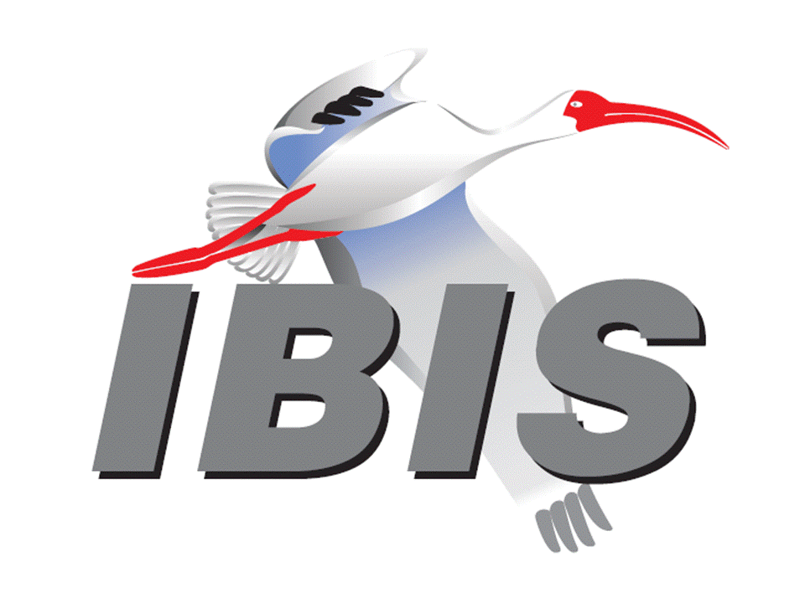
IBIS Open Forum Minutes

Meeting Date: February 6, 2015
Meeting Location: Teleconference

VOTING MEMBERS AND 2015 PARTICIPANTS
Altera David Banas
ANSYS (Steve Pytel)
Applied Simulation Technology Fred Balistreri, Norio Matsui
Cadence Design Systems Brad Brim, Joshua Luo, Ken Willis, Joy Li
Ericsson Anders Ekholm
Huawei Technologies Xiaoqing Dong
IBM Adge Hawes*, Luis Armenta
Infineon Technologies AG (Christian Sporrer)
Intel Corporation Michael Mirmak*, Todd Bermensolo, Nhan Phan
IO Methodology Lance Wang*
Keysight Technologies Radek Biernacki*, Pegah Alavi, Colin Warwick
Jian Yang, Nicholas Tzou, Heidi Barnes, Dave Larson
Kyla Thomas
Maxim Integrated Products Mahbubul Bari, Don Greer, Joe Engert
Mentor Graphics Arpad Muranyi*, Ed Bartlett, Vladimir Dmitriev-Zdorov
Micron Technology Randy Wolff*
Qualcomm Senthil Nagarathinam, Kevin Roselle
Signal Integrity Software Mike LaBonte, Walter Katz*, Todd Westerhoff
Mike Steinberger
Synopsys Ted Mido*, Rita Horner, William Lau, Scott Wedge
Michael Zieglmeier
Teraspeed Labs Bob Ross*, Tom Dagostino
Toshiba (Yasumasa Kondo)
Xilinx (Raymond Anderson)
ZTE Corporation (Min Huang)
Zuken Michael Schaeder, Markus Buecker, Griff Derryberry

OTHER PARTICIPANTS IN 2015
Avago Technologies Minh Quach, Leif Zweidinger
Bayside Design Elliot Nahas
Cisco David Siadat, Rockwell Hsu, Bidyut Sen
Continental Automotive Felix Goelden, Markus Bebendorf
CST Stefan Paret
Freescale Jon Burnett
Galbi Research Dave Galbi
Independent Tim Wang Lee
KEI Systems Shinichi Maeda
Lattice Semiconductor Xu Jiang
Raytheon Joseph Aday
SAE International Chris Denham
Simberian Yuriy Shlepnev
Vitesse Siris Tsang
ZI Consulting Iliya Zamek

In the list above, attendees at the meeting are indicated by *. Principal members or other active members who have not attended are in parentheses. Participants who no longer are in the organization are in square brackets.

UPCOMING MEETINGS
The bridge numbers for future IBIS teleconferences are as follows:

Date Meeting Number Meeting Password
February 6, 2015 205 475 958 IBIS

For teleconference dial-in information, use the password at the following website:

https://ciscosales.webex.com/ciscosales/j.php?J=205475958

All teleconference meetings are 8:00 a.m. to 9:55 a.m. US Pacific Time. Meeting agendas are typically distributed seven days before each Open Forum. Minutes are typically distributed within seven days of the corresponding meeting. When calling into the meeting, follow the prompts to enter the meeting ID. For new, local international dial-in numbers, please reference the bridge numbers provided by Cisco Systems at the following link:

http://www.cisco.com/web/about/doing_business/conferencing/index.html

NOTE: "AR" = Action Required.

-------------------------------------------------------------------------------------------------------------------------------
INTRODUCTIONS AND MEETING QUORUM
Michael Mirmak declared that a quorum was reached and the meeting could begin.

CALL FOR PATENTS
Michael Mirmak called for any patents or pending patents related to the IBIS 3.2, IBIS 4.2, IBIS 5.1, IBIS 6.0, Touchstone 2.0, IBIS-ISS 1.0 or ICM 1.1 specifications. No patents were declared.

REVIEW OF MINUTES AND ARS
Randy Wolff called for comments regarding the minutes of the January 9, 2015 IBIS Open Forum teleconference. The minutes were approved without changes.

ANNOUNCEMENTS
None.

CALL FOR ADDITIONAL AGENDA ITEMS
None.

MEMBERSHIP STATUS AND TREASURER'S REPORT
Bob Ross reported that IBM is now renewed as a voting member. Avago Technologies has dropped membership. [After the meeting we received a message that Avago Technologies is interested in retaining its membership.] Membership remains at 22 members. The treasury increased to $42,289. 6 members have renewed so far for 2015. For the DesignCon IBIS Summit, we spent $5,303 and received $1,250 in sponsorship from Keysight. One A/V bill is not recorded yet.

WEB PAGE AND MAILING LIST ADMINISTRATION
No update.

LIBRARY UPDATE
No update.

INTERNATIONAL/EXTERNAL ACTIVITIES
- Conferences
The 19th IEEE Workshop on Signal and Power Integrity (SPI 2015) will be held in Berlin, Germany, from May 10-13, 2015. An IBIS Summit meeting is usually held in conjunction with this Workshop. The paper submission deadline is January 31, 2015. More information is available at:

http://www.spi2015.org/

- Press Update
None.

ORGANIZATIONAL ACTIVITIES
Michael Mirmak noted that a new Policies and Procedures document was discussed at the DesignCon IBIS Summit. The presentation detailing it is available at:

http://www.eda.org/ibis/summits/jan15/mirmak.pdf

The document is an update to the IBIS charter, last updated in 1999. That charter is very out-of-date. The new document for review can be found at:

http://www.eda.org/ibis/policies/IBIS_policies_procedures_review_draft3.pdf

Major changes include support for electronic voting and establishing a “returning officer” method, changing the definition of quorum to 25%, adding a treasurer position, clarifying membership rules and dues, and adding “future proof” rules.

Randy Wolff mentioned that he would take the draft and format it to look more like our minutes documents. Bob Ross suggested posting the document in a different directory on the website.

Michael noted that we will be calling for comments during the next two meetings, followed by a vote after all comments are addressed. We will need 15 “yes” votes for approval, all cast at the same time. Some number of email votes may need to be accepted if we assume the language for “proxy” voting allows this.

SUMMIT PLANNING AND STATUS
- DesignCon Summary
Michael Mirmak reported that an IBIS Summit was held Friday, January 30, 2015 on the final day of DesignCon 2015. We had about 63 participants from 32 organizations. There were some major topics covered with multiple presentations including backchannel modeling and improved C_comp modeling. Bob Ross noted there were 11 presentations in total. Radek Biernacki commented that there were good presentations and discussions. Michael thanked Keysight Technologies for sponsorship as well as UBM for the room arrangements.

- EPEPS Summit Planning
Bob noted that there is interest in this meeting still, but there needs to be more discussion to determine if we have critical mass to conduct the meeting. EPEPS is taking place October 25-28, 2015 in San Jose, CA.

- SPI Summit Planning
Bob reported that there is interest in having a meeting co-located with the SPI conference in Berlin, Germany on May 13, 2015. Michael Schaeder has sent out an email gauging interest in the event from likely attendees. Bob noted that Zuken has traditionally been a sponsor, but we are open to more sponsorship.

Sponsorship opportunities for all upcoming IBIS summits are available, with sponsors receiving free mentions in the minutes, agenda, and other announcements. Contact the IBIS Board for further details.

QUALITY TASK GROUP
Bob Ross reported that the group is meeting on Tuesdays at 8:00 a.m. PT. They are continuing to work on the ibischk6 messages spreadsheet. They are occasionally working on bug reports and other parser issues as well.

The work in progress can be reviewed at:

http://www.eda.org/ibis/ibischk6/ibischk_6.0.0_UserGuide_wip1.pdf

The Quality Task Group checklist and other documentation can be found at:

http://www.eda.org/ibis/quality_wip/

ADVANCED TECHNOLOGY MODELING TASK GROUP
Arpad Muranyi reported that the group is meeting regularly on Tuesdays at 12:00 p.m. PT. They are continuing to discuss backchannel modeling, although it will be on hold as a new BIRD draft from SiSoft is being written. Some other topics such as C_comp modeling will be discussed in upcoming meetings.

Task group material can be found at:

http://www.eda.org/ibis/macromodel_wip/

INTERCONNECT TASK GROUP
Michael Mirmak reported that the group did not hold a meeting this week. Next week’s meeting may also be cancelled due to conflicts with several participants. The main discussion is still the package and on-die interconnect BIRD. Arpad Muranyi requested that Michael finish consolidating the BIRD drafts and post it before the next meeting. The group is typically meeting on Wednesdays at 8:00 a.m. PT.

Task group material can be found at:

http://www.eda.org/ibis/interconnect_wip/

NEW ADMINISTRATIVE ISSUES
None.

BIRD174.1: QUOTE CHARACTER CLARIFICATIONS
Arpad Muranyi reported that he submitted the BIRD update to address some concerns. Some questions were removed from the end of the document. Arpad tested use of the “`” character, and it caused no issues with the parser. This addressed a concern of Ted Mido. Radek Biernacki noted that we should make sure any examples in the IBIS specification conform to the quote character rules this BIRD establishes.

Arpad moved to schedule the BIRD for a vote at the next IBIS Open Forum. Radek Biernacki seconded the motion. There were no objections.

BIRD125.1: MAKE IBIS-ISS AVAILABLE FOR IBIS PACKAGE MODELING
Discussion was tabled.

BIRD128.2: ALLOW AMI_PARAMETERS_OUT TO PASS AMI_PARAMETERS_IN DATA ON CALLS TO AMI_GETWAVE
Discussion was tabled.

BIRD145.3: CASCADING IBIS I/O BUFFERS WITH [EXTERNAL CIRCUIT]S USING THE [MODEL CALL] KEYWORD
Discussion was tabled.

BIRD147: BACK-CHANNEL SUPPORT
Discussion was tabled.

BIRD157: PARAMETERIZE [DRIVER SCHEDULE]
Discussion was tabled.

BIRD158.3: AMI TOUCHSTONE ANALOG BUFFER MODELS
Discussion was tabled.

BIRD161.1: SUPPORTING INCOMPLETE AND BUFFER-ONLY [COMPONENT] DESCRIPTIONS
Discussion was tabled.

BIRD163: INSTANTIATING AND CONNECTING [EXTERNAL CIRCUIT] PACKAGE MODELS WITH [CIRCUIT CALL]
Discussion was tabled.

BIRD164: ALLOWING PACKAGE MODELS TO BE DEFINED IN [EXTERNAL CIRCUIT]
Discussion was tabled.

BIRD165: PARAMETER PASSING IMPROVEMENTS FOR [EXTERNAL CIRCUIT]S
Discussion was tabled.

BIRD166: RESOLVING PROBLEMS WITH REDRIVER INIT FLOW
Discussion was tabled.

IBISCHK6 PARSER AND BUG STATUS
Bob Ross confirmed that BUG151 will stay open until a new version of the specification is approved. He had no update on fixing BUG155.

NEW TECHNICAL ISSUES
There was some discussion on open BIRDs. Michael Mirmak noted that some BIRDs will be voted down once new BIRD proposals are approved.

Arpad Muranyi discussed BIRD157. He noted that this BIRD attempts to update some of the capabilities of [Driver Schedule] for addressing some lower speed SerDes buffers. Walter Katz commented that AMI is a much better solution for these buffers.

Arpad asked if we should release a new version of the IBIS specification now with existing approved BIRDs or wait for the package modeling improvements to be finished. Arpad noted that BIRD155.2 is a major improvement from a technical perspective. Michael noted that we are overdue for a specification update if we are trying to follow a one year development schedule. Walter commented that he hasn’t seen people asking for support of dependency tables in BIRD155.2. He thought we should spend our energy on the new BIRDs and not on dealing with a specification release. Bob Ross felt like these BIRDS only warrant a minor release and not a major release categorization. Michael asked if we think there is a large amount of work still required on the backchannel and package modeling proposals, taking up to a year of effort, where we won’t have resources to work on releasing a new specification. Walter felt that the interconnect BIRD could be completed in about a month. The backchannel BIRD is actually close to completion and will be forwarded to Cadence soon for comment. Both BIRDs might be ready before summer for vote. Arpad commented that he agreed we could probably do a major release later this year.

Michael asked if EDA tools would support a specification release soon as well as another one later this year. Arpad commented that this would allow EDA tools to begin working on support for the minor BIRDs, but they wouldn’t put out a major software release without supporting the major BIRDs. Radek Biernacki commented that he could work with either approach.

Arpad reiterated that he thought the dependency table BIRD was very important to get approved. Walter commented that he would not block any attempt to get BIRD155.2 in a specification release such as IBIS 6.1.

Michael noted that we need to make this a discussion topic for the next Open Forum teleconference. Bob took an AR to ask the parser developer about a cost estimate for a parser upgrade. Michael noted we need to discuss support for parser development costs. Arpad took an AR to send an email to the reflector to solicit comments on a new specification release.

NEXT MEETING
The next IBIS Open Forum teleconference meeting will be held February 27, 2015. A vote is scheduled on BIRD174.1. The following IBIS Open Forum teleconference meeting will be held March 20, 2015.

Radek Biernacki moved to adjourn. Arpad Muranyi seconded the motion. There were no objections.

========================================================================
NOTES

IBIS CHAIR: Michael Mirmak (916) 356-4261, Fax (916) 377-3788
michael.mirmak@intel.com
Data Center Platform Applications Engineering
Intel Corporation
FM5-239
1900 Prairie City Rd.,
Folsom, CA 95630

VICE CHAIR: Lance Wang (978) 633-3388
lwang@iometh.com
President/CEO, IO Methodology, Inc.
PO Box 2099
Acton, MA 01720

SECRETARY: Randy Wolff (208) 363-1764, Fax: (208) 368-3475
rrwolff@micron.com
Principal Engineer, Silicon SI Group Lead, Micron Technology, Inc.
8000 S. Federal Way
Mail Stop: 01-711
Boise, ID 83707-0006

LIBRARIAN: Anders Ekholm (46) 10 714 27 58, Fax: (46) 8 757 23 40
ibis-librarian@eda.org
Digital Modules Design, PDU Base Stations, Ericsson AB
BU Network
Färögatan 6
164 80 Stockholm, Sweden

WEBMASTER: Mike LaBonte
mikelabonte@eda.org
IBIS-AMI Modeling Specialist, Signal Integrity Software
6 Clock Tower Place
Maynard, MA 01754

POSTMASTER: Mike LaBonte
mikelabonte@eda.org
IBIS-AMI Modeling Specialist, Signal Integrity Software
6 Clock Tower Place
Maynard, MA 01754

This meeting was conducted in accordance with ANSI guidance.

The following e-mail addresses are used:

majordomo@eda.org
In the body, for the IBIS Open Forum Reflector:
subscribe ibis <your e-mail address>

In the body, for the IBIS Users' Group Reflector:
subscribe ibis-users <your e-mail address>

Help and other commands:
help

ibis-request@eda.org
To join, change, or drop from either or both:
IBIS Open Forum Reflector (ibis@eda.org)
IBIS Users' Group Reflector (ibis-users@eda.org)
State your request.

ibis-info@eda.org
To obtain general information about IBIS, to ask specific questions for individual response, and to inquire about joining the IBIS Open Forum as a full Member.

ibis@eda.org
To send a message to the general IBIS Open Forum Reflector. This is used mostly for IBIS Standardization business and future IBIS technical enhancements. Job posting information is not permitted.

ibis-users@eda.org
To send a message to the IBIS Users' Group Reflector. This is used mostly for IBIS clarification, current modeling issues, and general user concerns. Job posting information is not permitted.

ibis-bug@eda.org
To report ibischk parser BUGs as well as tschk2 parser BUGs. The BUG Report Form for ibischk resides along with reported BUGs at:

http://www.eda.org/ibis/bugs/ibischk/
http://www.eda.org/ibis/bugs/ibischk/bugform.txt

The BUG Report Form for tschk2 resides along with reported BUGs at:

http://www.eda.org/ibis/tschk_bugs/
http://www.eda.org/ibis/tschk_bugs/bugform.txt

icm-bug@eda.org
To report icmchk1 parser BUGs. The BUG Report Form resides along with reported
BUGs at:

http://www.eda.org/ibis/icm_bugs/
http://www.eda.org/ibis/icm_bugs/icm_bugform.txt

To report s2ibis, s2ibis2 and s2iplt bugs, use the Bug Report Forms which reside at:

http://www.eda.org/ibis/bugs/s2ibis/bugs2i.txt
http://www.eda.org/ibis/bugs/s2ibis2/bugs2i2.txt
http://www.eda.org/ibis/bugs/s2iplt/bugsplt.txt

Information on IBIS technical contents, IBIS participants and actual IBIS models are available on the IBIS Home page:

http://www.eda.org/ibis

Check the IBIS file directory on eda.org for more information on previous discussions and results:

http://www.eda.org/ibis/directory.html

Other trademarks, brands and names are the property of their respective owners.
IBIS – SAE STANDARDS BALLOT VOTING STATUS
Organization | Interest Category | Standards Ballot Voting Status | December 5, 2014 | January 9, 2015 | January 30, 2015 | February 6, 2015
Altera | Producer | Active | - | X | X | -
ANSYS | User | Inactive | X | - | - | -
Applied Simulation Technology | User | Inactive | - | - | X | -
Cadence Design Systems | User | Active | X | X | X | -
Ericsson | Producer | Inactive | - | - | X | -
Huawei Technologies | Producer | Inactive | - | - | X | -
IBM | Producer | Active | - | - | X | X
Infineon Technologies AG | Producer | Inactive | - | - | - | -
Intel Corp. | Producer | Active | X | X | X | X
IO Methodology | User | Active | X | X | X | X
Keysight Technologies | User | Active | X | X | X | X
Maxim Integrated Products | Producer | Inactive | - | - | X | -
Mentor Graphics | User | Active | X | X | X | X
Micron Technology | Producer | Active | X | X | X | X
Qualcomm | Producer | Active | - | X | X | -
Signal Integrity Software | User | Active | X | X | X | X
Synopsys | User | Active | X | X | X | X
Teraspeed Labs | General Interest | Active | X | X | X | X
Toshiba | Producer | Inactive | X | - | - | -
Xilinx | Producer | Inactive | - | - | - | -
ZTE | User | Inactive | - | - | - | -
Zuken | User | Inactive | - | - | X | -

I/O Buffer Information Specification Committee (IBIS)

Criteria for Member in good standing:
- Must attend two consecutive meetings to establish voting membership
- Membership dues current
- Must not miss two consecutive Meetings
Interest categories associated with SAE ballot voting are:
- Users - Members that utilize electronic equipment to provide services to an end user.
- Producers - Members that supply electronic equipment.
- General Interest - Members are neither producers nor users. This category includes, but is not limited to, Government, regulatory agencies (state and federal), researchers, other organizations and associations, and/or consumers.

