TOUCHSTONE ISSUE RESOLUTION DOCUMENT (TSIRD)
{See instructions starting on template page two}

TSIRD NUMBER: X_draft_04
ISSUE TITLE: Add Support for Pole Residue Data in Touchstone Files
REQUESTOR: Arpad Muranyi, Siemens EDA

DATE SUBMITTED: {for administrative use}
DATE REVISED: {for administrative use}
DATE ACCEPTED: {for administrative use}

DEFINITION OF THE ISSUE:

With the ever-incrasing complexity of package and printed circuit board designs, Touchstone files used for interconnect modeling are also increasing in size. Touchstone file sizes are often in the hundreds of Megabytes, or even Gigabytes range. This can have a negative effect on simulation performance and makes the distribution of these files very challenging. Consequently, there is a great need for finding ways to describe large interconnects with smaller files.

In addition, different EDA vendors use different (proprietary) algorithms to process the Touchstone file data in simulations, which can cause simulation results to be different from different EDA tools, even with identical Touchstone files.

A common method in the industry to reduce the size of Touchstone files - and thereby improve simulation performance - is to convert the large frequency table data to fitted pole/residue format. There are numerous advantages to this method, one of which is that EDA tools can produce identical simulation results with the same pole/residue-based models.

While pole/residue fitting has been used for decades in the industry, this data format has not been standardized yet, which makes it EDA tool dependent. The goal of this proposal is to standardize the pole/residue format so that all EDA tools could make use of the same pole/residue model files.

SOLUTION REQUIREMENTS:
The Touchstone specification must meet these requirements:
Table 1: Solution Requirements
Requirement | Notes
{enumerate each requirement in the table above, adding rows as needed}

SUMMARY OF PROPOSED CHANGES:
For review purposes, the proposed changes are summarized as follows:
Table 2: Touchstone Keywords Affected
Specification Item | New/Modified/Other | Notes
{list each affected specification item in the table above, adding rows as needed}

PROPOSED CHANGES:

Based on Vladimir’s presentation:

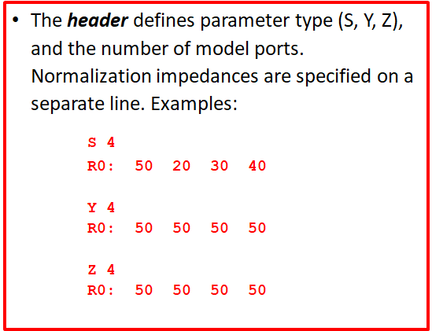

the existing option line could contain the parameter type (S/Y/Z/H/G), the existing [Number of Ports] keyword could contain the number of ports, and the existing [Reference] keyword could contain the normalization impedances.

Vladimir says that there is no need to use different units. We could agree that pole frequencies are defined in [Hz], and residues in natural units: Y in Siemens, Z in Ohms, and S is dimensionless. However, since the existing Options line includes units, we could consider applying those units to the pole/residue data also.

The original Touchstone 2.0 [Mixed Mode Order] keyword can be applied to Pole_Residue data as well.

For the Pole/Residue data, again, based on Vladimir’s presentation:

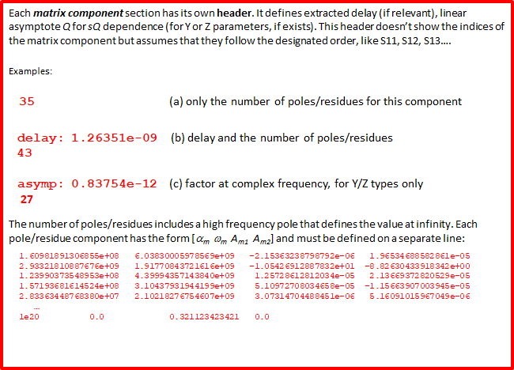

we could introduce the following new keywords and subparameters to capture the above information.

Note that if the keyword [Begin Pole/Residue Data] is present, then the [Begin Common Poles Data] and [Begin Residues Data] keywords are not permitted or vice versa. Also, if the [Begin Common Poles Data] keyword is present then the [Begin Residues Data] keyword is required or vice versa.

[Begin Pole/Residue Data] (1,1)
Delay 1.26351e-09
Asymptote 0.83754e-12
Residue_at_Infinity 0.321123423421
Number_of_Data_Lines 35
1.60981891306855e+08 6.03830005978569e+09 -2.15363238798792e-06 1.96534688582861e-05
2.93321810887676e+09 1.91770843721616e+09 -1.05426912887832e+01 -8.82630433918342e+00
1.23990373548953e+08 4.39994357143840e+09 1.25728612812034e-05 2.13669372820529e-05
1.57193681614524e+08 3.10437931944199e+09 5.10972708034658e-05 -1.15663907003945e-05
2.83363448768380e+07 2.10218276754607e+09 3.07314704488451e-06 5.16091015967049e-06
…
5.23409852743859e+06 1.34534534593845e+07 3.07314704488451e-06 5.16091015967049e-06
[End Pole/Residue Data]

The [Begin Pole/Residue Data] keyword is followed by two integers enclosed in parentheses and separated by a comma to denote indexing (i.e., to describe which matrix component the data that follows describes). Subparameters “Delay” and “Asymptote” are optional, but “Asymptote” is not permitted for S-parameters (it is only allowed for Y, Z, H and G-parameters). The “Residue_at_Infinity” and the “Number_of_Data_Lines” subparameters are required. The value of “Number_of_Data_Lines” is equal to the number of pole/residue data lines that follow. The [Begin Pole/Residue Data] / [End Pole/Residue Data] keyword pair is repeated N^2 times, where N is the number of ports. Each occurrence of this keyword pair must have unique index numbers. For example, a 4-port model would have 16 of these keyword pairs with the following integers:

[Begin Pole/Residue Data] (1,1)
[Begin Pole/Residue Data] (1,2)
[Begin Pole/Residue Data] (1,3)
[Begin Pole/Residue Data] (1,4)
[Begin Pole/Residue Data] (2,1)
…
[Begin Pole/Residue Data] (4,4)

To support common poles data, we could consider two additional keyword pairs which would be mutually exclusive with the [Begin Pole/Residue Data] / [End Pole/Residue Data] keyword pair above.

[Begin Common Poles Data]
Number_of_Data_Lines 35
1.60981891306855e+08 6.03830005978569e+09
2.93321810887676e+09 1.91770843721616e+09
1.23990373548953e+08 4.39994357143840e+09
1.57193681614524e+08 3.10437931944199e+09
2.83363448768380e+07 2.10218276754607e+09
…
5.23409852743859e+06 1.34534534593845e+07
[End Common Poles Data]

Only one [Begin Common Poles] keyword is allowed per file. Note that it does not use indexing after the keyword, and only one subparameter is allowed (and required) which is Number_of_Data_Lines. The value of Number_of_Data_Lines in the [Begin Common Poles Data] must be equal to the value of Number_of_Data_Lines in each of the [Begin Residues Data] keywords. (We might consider removing this subparameter from the [Begin Residues Data] keyword).

[Begin Residues Data] (1,1)
Asymptote 0.83754e-12
Residue_at_Infinity 0.321123423421
Number_of_Data_Lines 35
-2.15363238798792e-06 1.96534688582861e-05
-1.05426912887832e+01 -8.82630433918342e+00
1.25728612812034e-05 2.13669372820529e-05
5.10972708034658e-05 -1.15663907003945e-05
3.07314704488451e-06 5.16091015967049e-06
…
3.07314704488451e-06 5.16091015967049e-06
[End Residues Data]

The [Begin Residues Data] keyword is followed by two integers enclosed in parentheses and separated by a comma to denote indexing (i.e., to describe which matrix component the data that follows describes). The subparameter “Delay” is not allowed. The subparameter “Asymptote” is optional, but it is not permitted for S-parameters (it is only allowed for Y, Z, H and G-parameters). The “Residue_at_Infinity” and “Number_of_Data_Lines” subparameters are required. The value of “Number_of_Data_Lines” is equal to the number of residue data lines that follow. The [Begin Residues Data] / [End Residues Data] keyword pair is repeated N^2 times, where N is the number of ports. Each occurrence of this keyword pair must have unique index numbers.

Another keyword pair might be invented for reciprocal models, which could further reduce the matrix size.

SPARSE MATRIX: For missing matrix elements, we could set the Number_of_Data_Lines value to zero:

[Begin Pole/Residue Data] (1,1)
Number_of_Data_Lines 0
[End Pole/Residue Data]

[Begin Common Poles Data]
Number_of_Data_Lines 0
[End Common Poles Data]

[Begin Residues Data] (1,1)
Number_of_Data_Lines 0
[End Residues Data]

Swathing:
[Begin Pole/Residue Data] (8,8) = (1,1)

BACKGROUND INFORMATION/HISTORY:
{relevant notes regarding history, discussions, and revisions go here}

TSIRD INSTRUCTIONS (Delete before submission)
- Introduction
Changes to the Touchstone® File Format (hereinafter Touchstone) specification are proposed using Touchstone Issue Resolution Documents (TSIRDs). Each TSIRD will be assigned a number by the IBIS Open Forum Chair. Revisions to submitted TSIRDs may be submitted by the authors. Revised TSIRDs will have the revision sequence added to the TSIRD number, with a dot separator.
TSIRDs must be approved by a vote of the IBIS Open Forum members, following the rules of the IBIS Policies and Procedures. TSIRDs failing to pass a vote are considered permanently rejected unless the vote is tabled. Incorporation of approved TSIRDs into a Touchstone specification release is voted separately, as each Touchstone release is considered.
Submit TSIRDs by email to chair@ibis.org.
Submitted TSIRDs will be posted to the IBIS TSIRDs web page at https://ibis.org/tsirds/.
- Completing a TSIRD
Fill in the sections of the TSIRD as described below.
The sections of a TSIRD are considered in order, and each section must be consistent with the previous section. The Solution Requirements must enumerate all requirements to solve the Issue. The Proposed Changes must fulfill the requirements listed in the Solution Requirements section and match the Summary of Proposed Changes. The Tracking Fields, Definition of the Issue, and Solution Requirements sections must be completed upon initial submission. The Summary of Proposed Changes and Proposed Changes sections must be completed prior to final approval.
Before submitting your TSIRD you should delete the bracketed instructions in the template above, as well as these instructions.
  - Tracking Fields
The TSIRD begins with data needed to track the TSIRD. Instructions for these fields:
TSIRD NUMBER: {for administrative use only, do not change}
ISSUE TITLE: {one line description of the issue}
REQUESTOR: {your name and organization}
DATE SUBMITTED: {for administrative use only, do not change}
DATE REVISED: {for administrative use only, do not change}
DATE ACCEPTED: {for administrative use only, do not change}
The title should very briefly summarize what the TSIRD hopes to accomplish. See the TSIRDs page for examples. Separate names and organizations with commas. Consistency with other TSIRDs in the exact spelling of names and organizations will make the TSIRD index pages more usable when sorted by those fields.
  - Definition of the Issue
Describe the issue in detail. Where existing Touchstone syntax is involved give relevant Touchstone specification page numbers. Focus on what is defective or missing in Touchstone.
  - Solution Requirements
The Solution Requirements section contains a table of numbered requirements. Each requirement states something that the Touchstone specification must accomplish. Requirements should use generic language and be independent of the proposed solution. Insert new table rows as many times as needed to form the complete list of requirements.
  - Summary of Proposed Change(s)
This section contains a table listing the names of Touchstone keywords or related content that is new or will be modified. No details should appear here. This section is used for assessing the impact of a TSIRD, for reviewing competing and overlapping TSIRDs, and to assist with editorial searches to insure that proposed changes have been addressed at every relevant place within the Touchstone specification.
Each item listed in the table should be classified as follows:
- New: This would be a new keyword.
- Modified: This keyword exists in Touchstone already and a functional modification is proposed.
- Other: New content or modifications to existing content, but without functional changes. If clarifications are proposed use “Other” and note that it is a clarification. The first column may have “TEXT” if no specific keyword is affected.
  - Proposed Change(s)
The Touchstone Keywords Affected table must be filled in, listing all existing keywords that are affected as well as new keywords to be introduced. Insert “NONE” if no keywords or parameters are affected. Details of the changes should follow the table.
For changes to existing Touchstone content, where possible, copy material to be changed from the Microsoft® Word version of the Touchstone specification and paste into the Proposed Changes section of the TSIRD, keeping source document formatting. Enable change tracking and make the desired changes.
Alternatively, changes can be described by other means, such as showing before-and-after versions. This can be helpful for proposing changes to images, for example. Change tracking should be enabled after this is done.
New content should conform to Touchstone specification formatting conventions.
  - Background/History
If there is any relevant history regarding the issue, describe that here. If this TSIRD is updated, append change history information here.

