BUFFER ISSUE RESOLUTION DOCUMENT (BIRD)

BIRD NUMBER: Draft 43 – November 8, 2016
ISSUE TITLE: Interconnect Modeling Using IBIS-ISS and Touchstone
REQUESTOR: Walter Katz, Signal Integrity Software, Inc.
DATE SUBMITTED:
DATE REVISED:
DATE ACCEPTED BY IBIS OPEN FORUM:

STATEMENT OF THE ISSUE:

This BIRD enhances IBIS with interconnect modeling features to support broadband, coupled package, and on-die interconnect using IBIS-ISS and Touchstone data.

The BIRD also adds a keyword for buffer rail mapping, to link to new Terminal definitions defined for buffers.

ANALYSIS PATH/DATA THAT LED TO SPECIFICATION:

This BIRD has resulted from several years of discussion regarding the need for more flexible description of interconnects in IBIS. It was decided to avoid a keyword based approach, in favor of a circuit language approach. IBIS-ISS was developed for this purpose, and a means to instantiate IBIS-ISS models from IBIS became the logical next step.

SOLUTION REQUIREMENTS:
The IBIS specification must meet these requirements:
Table 1: Solution Requirements
Requirement | Notes
- The model maker must be able to provide interconnect models representing die and package, using a combination of IBIS-ISS and Touchstone formats. | Might replace BIRD 125.1
- Touchstone models without an IBIS-ISS wrapper circuit must be supported. | Might replace BIRD 158.1
- An interconnect model may connect buffers to pins directly or separate models may be used for the buffer to pad and pad to pin connections (die and package portions). | Die is buffer to pad. Package is pad to pin.
- An interconnect model may connect one pin or any combination of pins on one [Component]. | Coupled models are supported.
- The buffer I/O, pad, and pin terminals associated with I/O pins must be assignable to interconnect model terminals directly by pin name.
- The buffer supply, pad, and pin terminals associated with POWER and GND rail pins must be assignable to interconnect model terminals directly by pin name, or indirectly by [Pin] signal_name or [Pin Mapping] bus_label.
- The model maker must be able to provide alternative interconnect models for any given set of pins. | For example for a given pin pair it must be possible to provide both coupled and uncoupled models, high and low bandwidth models, or both IBIS-ISS and Touchstone models.
- The model maker may use new interconnect models for some pins and legacy package models for other pins.
- The model user must be able, given a pin or set of pins it must analyze, to locate all interconnect models that include the pin(s), if any. | Simulation netlisting begins with a list of pins that must be simulated.
- The model user must be able to determine all of the pins that a given interconnect model includes. | Once a model is chosen, it may add more pins to the simulation.
- The model user must be able to determine how to terminate any terminals of an interconnect model not necessary for a particular analysis. | May need to handle s-parameter and circuit models differently.
- For any pin having an interconnect model, models encompassing the full path from buffer to pin must be present and identifiable by the user.
- The model user must have useful information needed to make the choice between alternative interconnect models that differ only in characteristics other than the model format and the set of pins included. | For example: coupled/uncoupled, low/high bandwidth. This will be used to choose which alternative model set to use.
- The order of precedence for new interconnect models and legacy forms of package models must be specified. | Probably will take precedence over [Package Model], [Pin] RLC, and [Package].
- The model user must not be required to use both new interconnect and legacy package models to model any single pin or coupled set of pins of a [Component]. | For example can’t use [Pin] RLC for through path and IBIS-ISS for coupling.
- The model user must be informed which pins of an interconnect model have been modeled with coupling to other pins, sufficient for the former to represent the victim pins and the latter all of the aggressor pins in a crosstalk simulation. | Pins near one “end” of the model will be coupled to pins on one side but probably not enough pins on the other side.

BACKGROUND INFORMATION/HISTORY:

Parameter is shortened to Param (.param is legal in IBIS-ISS) to differentiate it further from Parameters in the multi-lingual syntax (Parameter has several meanings in IBIS and the Algorithmic Modeling Interface.)

File_names are not quoted, to be consistent with Corner in the multi-lingual syntax. Multiple file names for corners are not supported here, however.

Entries for strings in Param are surrounded by double quotes to be consistent with string_literal Parameters in the multi-lingual syntax (or where the AMI string_literal parameter surrounded by double quotes is passed into the multi-lingual Parameters reference). The EDA tool needs to convert string_literals into the parameter string syntax in IBIS-ISS.

Interaction of Param entries was not discussed. For example, for a transmission line, TD and Z0 could each have max and min entries, but the EDA tool could make available combinations of min/min, min/max, max/min or max/max for any corner. Due to parameter interactions, some mixing of corner combinations might not be realistic. (E.g., Z0min or Z0max might not correlate with TDmin or TDmax values, where TDmin=sqrt(LminCmin), Z0min=sqrt(Lmin/Cmax), etc.).
How corners of File_IBIS-ISS and Params are processed might be based on vendor supplied documentation. For example some, but not all, combinations are shown below:
- One file_name for all corners, one .subckt name, and all corner settings controlled by Param settings
- One file_name, three .subckts (with internal default .param settings), additional corner settings controlled by Param settings or Param is not used
- Three file_names with the same .subckt name, but with distinct default .param settings, additional settings controlled by Param settings or Param is not used
- Three file_names with three distinct .subckt name and with distinct default .param settings, additional corner settings controlled by Param settings or Param is not used
No interpretation is given for Param typ, min, and max values. It is possible to independently use typ, min, or max values for any of the Param names that have been defined (e.g., the max value of one parameter may be used with the min value of another parameter).

PROPOSED CHANGES:

The following keyword should be added to Chapter 5, COMPONENT DESCRIPTION, after the [Alternate Package Models] keyword:

Keyword: [Interconnect Model Set Selector]
Required: No
Description: Used to list [Interconnect Model Set] keywords available for the [Component].
Usage Rules: Interconnect Models are described by IBIS-ISS subcircuits or Touchstone files that connect the Pins, Die Pads, and Buffer Terminals (Supply and I/O) of a [Component].
A [Component] may have none, one, or more than one [Interconnect Model Set] keywords (defined XXX) associated with it. If any Interconnect Models exist for the Component, they shall be listed in this section. An Interconnect Model Set Selector is required even if only a single Interconnect Model is associated with the Component. [Interconnect Model Set Selector] is hierarchically within the scope of the [Component] keyword.
The section under the [Interconnect Model Set Selector] keyword shall have two entries per line, with each line defining the list of Interconnect Model Sets associated with the Component. The entries shall be separated by at least one white space. The first entry lists the Interconnect Model Set name (up to 40 characters long). The second entry is the name of the file containing the Interconnect Model Set, with the extension “.ims”. If the Interconnect Model Set is in this IBIS file, then the second entry shall be “NA”.
The files containing the Interconnect Model Sets shall be located in the same directory as the .ibs file. The file names shall follow the rules for .ibs file names given in Section 3, ’GENERAL SYNTAX RULES AND GUIDELINES’. The file names and extensions shall be lower case. An [Interconnect Model Set] with matching name shall be found in the stated location for each Interconnect Model Set named in the [Interconnect Model Set Selector].
Each Interconnect Model Set name may only appear once under the [Interconnect Model Set Selector] keyword for a given Component.
Example:
[Interconnect Model Set Selector]
QS-SMT-cer-8-pin-pkgs_iss *.ibs | In this file, a full model is present
QS-SMT-cer-8-pin-pkgs_sNp qs-smt-cer-8-pin-pkgs_s16p.ims | A separate file
|
|
A1_I/O_and_Rails NA | I/O with PU, PD rails
A1_I/O_iss NA | I/Os without Rails
A2_I/O_iss NA
A3_I/O_iss NA
|
A1_PU_PD_Rails_iss NA | PU, PD Rails separate from I/O path
I/O_PU_Rails_iss NA | One or many PU, PD buffer rails
I/O_PD_Rails_iss NA | (Assumes PC and GC rails
| are not needed)
|
A1_A5_I/Os_and_Rails_iss NA | Direct Buf_Pin and Rails for A1-A5
|
A1_A5_I/Os_Buf_Pad_iss NA | Buf-Pad for A1-A5 I/Os
A1_A5_I/Os_Pad_Pin_iss NA | Pad-Pin for A1-A5 I/Os
20_Rail_Bed_Spring_iss NA | Not all Power, Grounds Used
| or Connected for A1-A5 I/Os
| Rails can be Buf_Pin while the I/Os
| are Buf_Pad, Pad_Pin; or visa-versa
|
[End Interconnect Model Set Selector]

Keyword: [End Interconnect Model Set Selector]
Required: Yes, for each instance of the [Interconnect Model Set Selector] keyword
Description: Indicates the end of the data for one [Interconnect Model Set Selector].
Example:
[End Interconnect Model Set Selector]

The following keywords should be placed in section 5, COMPONENT DESCRIPTION, after the [Pin Mapping] keyword.

Keyword: [Bus Label]
Required: No
Description: Associates a POWER or GND signal_name with one or more bus_label names within a Component. Bus_label names can also be associated with specific Pins, Die Pads or I/O buffer rail terminals. These bus_label names can be used to define terminals of interconnect subcircuits.
Sub-Params: signal_name
Usage Rules: The first column shall contain a bus_label. The second column, signal_name, gives the data book name for the signal on that bus_label.
The signal_name shall be the signal_name used for a pin under the [Pin] keyword that uses the model_name POWER or GND.
A bus_label may not be the same as any signal_name. Duplicate bus_labels are not permitted. A bus_label may be defined also by the [Pin Mapping] keyword.
Column length limits are:
[Bus Label] 40 characters max
signal_name 40 characters max
Example:
[Bus Label] signal_name
VDD1 VDD
VDD2 VDD
VDD3 VDD
VSS1 VSS
VSS2 VSS

Keyword: [Die Supply Pads]
Required: No
Description: Associates signal_names and bus_labels to Die Pads connected to supply rails.
Sub-Params: signal_name, bus_label
Usage Rules: Only die pads with signal_names that occur on POWER or GND pins are allowed. Each line shall contain either two or three columns. The first column shall contain the supply Die Pad name. The second column, signal_name, gives the data book name for the signal. The third column is optional. If it exists, it is a bus_label. If the third column does not exist, then the bus_label shall be the signal_name.
Other Notes: The data in this section consists of a list of Die Pad node names and their corresponding signal_names or bus_labels that can be used to mate package and on-die power delivery networks.
Example:
[Die Supply Pads] signal_name bus_label
VDDQ VDDQ
VDD1 VDD VDDa
VDD2 VDD VDDa
VDD3 VDD VDDb
VSS1 VSS
VSS2 VSS
The following text should be added at the beginning of Chapter 7, PACKAGE MODELING, after the chapter head line.

Several types of package modeling formats are available in IBIS. These include:
- Lumped [Component]-level models for the entire [Component], using the [Package] keyword.
- Lumped [Component]-level modeling per-pin, using the [Pin] keyword.
- [Package Model] (including [Alternate Package Models] and [Define Package Model]).
- [Interconnect Model Set Selector] and the keywords associated with it.

The lumped formats are described in the [Package] and [Pin] keyword definitions above. Keywords for use with the [Package Model] format are described in this chapter, while keywords for use with [Interconnect Model Set Selector] are described in Chapter 12.
KEYWORDS FOR USE WITH [Package Model]

The following new Chapter 12 should be added after Chapter 11.

12 INTERCONNECT MODELING
This interconnect modeling section supports broadband interconnect models between the pins of a component and I/O buffers. These models include the ability to define accurate interconnect coupling and interconnect rail distribution. The detailed effects of on-die interconnect are now important. Interconnect models can be supplied separately for on-die interconnect and package interconnect, or can be supplied as models directly between the package pins and I/O buffers.

An [Interconnect Model] defines the connections to either an IBIS-ISS SPICE subckt or a Touchstone file. An [Interconnect Model] can be between pins of the package and I/O buffers, pins of the package and die-pads or die-pads and I/O buffers.

[Interconnect Model]s are organized into [Interconnect Model Set]s. An [Interconnect Model Set] consist of one or more [Interconnect Model]s. One [Interconnect Model Set] may contain groups of similar models, for example:
- Uncoupled I/O connections.
- Couple I/O connections.
- Rail connections.
- Uncoupled IBIS-ISS models.
- Uncoupled Tocuhstone file connections.

[Interconnect Model]s can have die-pad terminals. A die-pad describes a simulation node at the interface between the die and the package. Each I/O pin has one I/O buffer terminal and one die-pad. Because there is not one-to-one relationship between rail pins and rail die-pads, we have introduced a new section [Die Supply Pads] ([Die Rail Pads]?). The following diagram of a package and die shows graphically the potential [Interconnect Model] terminals for an I/O:

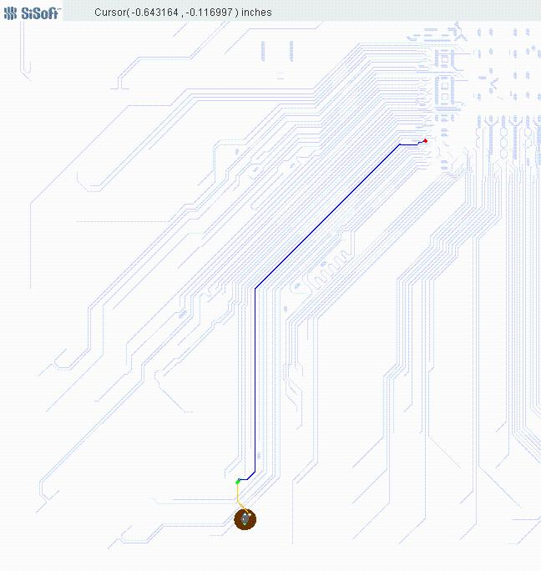

The following diagram of a package and die shows graphically the potential [Interconnect Model] terminals for a rail connection. Note that these terminals can be collapsed to a single terminal at the pin/board interface, the die package interface and the I/O buffer rail terminals. Small red dots are [Die Supply Pads], large black dots are package bump pads.

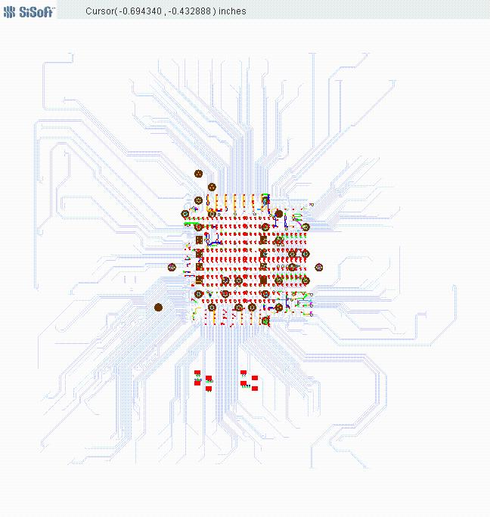
The Terminal section of an [Interconnect Model] describes how the terminals of an Interconnect Model subckt or Touchstone file instance in a SPICE deck need to be connected at a buffer terminal, die-pad interface or pin/board interface.

The description of I/O terminals is very simple. The terminal needs to describe it it as the I/O Buffer, die-pad interface or pin, qualified by the I/O pin_name.

The description of rail terminals is more complex to support models that have terminals at each pin, die-pad and and I/O Buffer rail terminals, or groups of pins, die-pads and I/O Buffer rail terminals.
- Pins
- A rail terminal can connect to a specific rail pin_name
- A rail terminal can connect to all of the pins of a rail signal_name
- A rail terminal can connect to all of the pins of a bus_label
- Die-pads
- A rail terminal can connect to a specific [Die Supply Pads]
- A rail terminal can connect to all of the [Die Supply Pads] of a rail signal_name
- A rail terminal can connect to all of the [Die Supply Pads] of a bus_label
- I/O Buffer Rail Terminal
- A rail terminal can connect to a specific I/O Buffer rail terminal
- A rail terminal can connect to all of the I/O Buffer rail terminals of a rail signal_name
- A rail terminal can connect to all of the I/O Buffer rail terminals of a signal_name

The sub-parameter Number_of_terminals tells how many SPICE nodes are required on the instance in a SPICE deck.

The terminal lines that follow this keyword describe the SPICE node each terminal should be connected to. Terminals may be at pins, die-pads or the I/O buffer
- The first column Terminal_number is a number between 1 and the Number_of_terminals that describes the ordinal (positional) number of the SPICE node in the [Interconnect Model] subckt or Touchstone file instance. The second column is Terminal_type, the third column is Terminal_type_qualifier, the fourth column is Qualifier_entry and there is an optional fifth column “Agressor”
- The second field Terminal_type determins if the terminal is at a pin, die-pad or I/O buffer.
  - For I/O connections
    - Terminal_type can be Pin_I/O, Pad_I/O and Buf_I/O
    - Terminal_type_qualifier shall be pin_name.
    - Qualifier_entry shall be the pin_name of an I/O pin.
  - For rail connections
    - Allowed Terminal_type, Terminal_type_qualifier and Qualifier_entry rules are different at pins, die-pads and I/O Buffer.
    - At pins
      - Terminal Type shall be Pin_Rail
      - Terminal_type_qualifier shall be one of the following
        - pin_name
          - Qualifier_entry shall be the pin_name of a rail pin.
        - bus_label
          - Qualifier_entry shall be a bus_label
        - sgnal_name
          - Qualifier_entry shall be a rail signal_name
    - At die-pads
      - Terminal type shall be Pad_Rail
      - Terminal_type_qualifier shall be
        - pad_name
          - Qualifier_entry shall be the pin_name of a rail pin.
        - bus_label
          - Qualifier_entry shall be a bus_label
        - signal_name
          - Qualifier_entry shall be a rail signal_name
    - At I/O Buffers
      - Terminal Type shall be one of the following
        - Buf_Rail
          - Terminal_type_qualifier shall be one of the following
            - signal_name
              - Qualifier_entry shall be a rail signal_name
            - bus_label
              - Qualifier_entry shall be a bus_label
        - Pullup_ref, Pulldown_ref, Power_clamp_ref, Gnd_clamp_ref or Ext_ref
          - Terminal_type_qualifier shall be I/O buffer pin_name
          - Qualifier_entry shall be the I/O buffer pin_name

Crosstalk simulations require Interconnect Models have connections to multiple I/O Pin_names.
- This specification also a complete interconnect model that includes all of the I/O connections.
- This specification also supports subset of the complete package model.
- An example is a model containing the coupled interconnect of DQ6, DQ7 and DQ8.
  - The following picture highlights three DQ connections DQ6, DQ7 and DQ8 in a single [Interconnect Model]. DQ7 is in the middle, DQ6 is on the left side of DQ7, and DQ8 is on the right side of DQ7.

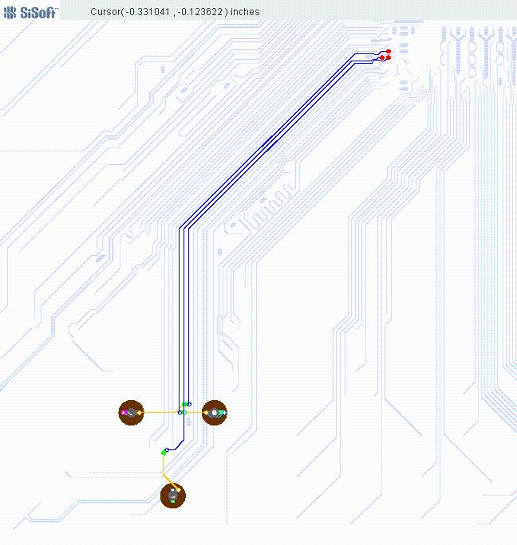

  - DQ7 has crosstalk in the package with the adjoining signals DQ6 and DQ8.
    - This model represents all of the crosstalk on DQ7 (since it includes DQ6 and DQ8).
  - This model does not include all of the crosstalk affecting DQ8 since the model does not include DQ9.
  - Similarly DQ6 does not include all of its aggressors (DQ5).
  - The model maker tells the EDA tool that connections to terminals DQ6 and DQ8 do not include all of their aggressors by adding the optional field “Aggressor” to their terminals. (Not suitable for victim: Aggressor_Only, Non_Victim)
  - In this case, simulations will include coupling on DQ6 and DQ8 from DQ7, but it will not include coupling from their aggressors (DQ5 and DQ9).
  - The DQ7 connections do not have the optional “Aggressor” field. The EDA tool may assume that DQ7 has all (or more practically most of) the coupling to its aggressor connections.
One or more Interconnect Model Sets may be included in a separate Interconnect file, with the extension “.ims”. The Interconnect file shall contain all of the required elements of a normal .ibs file, including [IBIS Ver], [File Name], [File Rev], and the [End] keywords, and at least one [Interconnect Model Set] and one [End Interconnect Model Set] keyword. Optional elements include the [Date], [Source], [Notes], [Disclaimer], [Copyright], and [Comment Char] keywords. All of the elements follow the same rules as those for a normal .ibs file. Multiple Interconnect files may be referenced by a single .ibs file.
Note that the [Component] and [Model] keywords are not allowed in the .ims file. The .ims file is for IBIS Interconnect Models only.
The specification permits .ibs files to contain the following additional list of Interconnect Modeling keywords and subparameters. Note that the actual Interconnect Models may be in a separate <filename>.ims file or may exist in a .ibs file between the [Interconnect Model Set] ... [End Interconnect Model Set] keywords for each Interconnect Model defined. For reference, these keywords and subparameters are listed in Table XX.

Table XX – Interconnect Modeling Keywords and Subparameters
Keyword or Subparameter | Notes
[Interconnect Model Set]
[Manufacturer] | (note 1)
[Description] | (note 1)
[Interconnect Model] | (note 2)
Param
File_TS | (note 3)
File_IBIS-ISS | (note 3)
Unused_port_termination | (note 4)
Number_of_terminals | (note 5)
<terminal line> | (note 6)
[End Interconnect Model] | (note 7)
[End Interconnect Model Set] | (note 8)
Note 1 [Manufacturer] and [Description] are each optional keywords within any [Interconenct Model Set]
Note 2 At least one [Interconnect Model] is required for each [Interconnect Model Set].
Note 3 One of either the File_TS or File_IBIS-ISS subparameters is required.
Note 4 This subparameter shall be followed by the “=” character and a numeric value (integers and reals are acceptable), with both optionally surrounded by whitespace.
Note 5 This subparameter shall be followed by the “=” character and an integer value, with both optionally surrounded by whitespace.
Note 6 See text below.
Note 7 Required when the [Interconnect Model] keyword is used
Note 8 Required when the [Interconnect Model Set] keyword is used

When Interconnect Model Set definitions occur within a .ibs file, their scope is “local”— they are known only within that .ibs file and no other .ibs file. In addition, within that .ibs file, they override any interconnect package models defined using the [Package], [Pin], or [Define Package Model] keywords. Interconnect Models in separate .ims files referenced by the [Interconnect Model Set Selector] keyword in a .ibs file also override any interconnect package models defined in the same .ibs file using the [Package], [Pin], or [Define Package Model] keywords.
Usage Rules for the .ims File:
Interconnect models are stored in a file whose name uses the format:
<filename>.ims.
The <filename> provided shall adhere to the rules given in Section 3, “GENERAL SYNTAX RULES AND GUIDELINES“. Use the “.ims” extension to identify files containing Interconnect Models. The .ims file shall contain the [IBIS Ver], [File Name], [File Rev], and the [End] keywords. Optional elements include the [Date], [Source], [Notes], [Disclaimer], [Copyright], and [Comment Char] keywords. All of these keywords and associated subparameters follow the same rules as those for a normal .ibs file.
Note that the [Component] and [Model] keywords are not allowed in the .ims file. The .ims file is for Interconnect Models only.

Keyword: [Interconnect Model Set]
Required: No
Description: Used to contain Interconnect Models
Usage Rules: [Interconnect Model Set] has a single argument, which is the name of the Interconnect Model Set. The length of the Interconnect Model Set name shall not exceed 40 characters in length. Blank characters are not allowed. The [Interconnect Model Set]/[End Interconnect Model Set] keyword pair is hierarchically equivalent in scope to [Component] and [Model].
The section under the [Interconnect Model Set] keyword may contain a [Manufacturer] keyword section and [Description] keyword section and shall contain one or more Interconnect Models. See the section [Interconnect Model] for a description of the content of each Interconnect Model.

Example:
[Interconnect Model Set] Signal_Integrity
[Manufacturer] Acme Packaging, Inc
[Description] This set contains one model for each I/O buffer
[Interconnect Model] DQ1
…
[End Interconnect Model]
[Interconnect Model] DQ2
…
[End Interconnect Model]
[Interconnect Model] DQS
…
[End Interconnect Model]
[End Interconnect Model Set]

Keyword: [Manufacturer]
Required: No
Description: Specifies the name of the [Interconnect Model Set] manufacturer.
Usage Rules: The length of the manufacturer’s name shall not exceed 40 characters (blank characters are allowed, e.g., Oklahoma Instruments).
Example:
[Manufacturer] NoName Corp.

Keyword: [Description]
Required: No
Description: Provides a concise yet easily human-readable description of what kind of interconnect the [Interconnect Model Set] represents.
Usage Rules: The description shall be less than 60 characters in length, shall fit on a single line, and may contain spaces.
Example:
[Description] 220-Pin Quad Ceramic Flat Pack

Keyword: [End Interconnect Model Set]
Required: Yes, for each instance of the [Interconnect Model Set] keyword
Description: Indicates the end of the Interconnect Model Set data.
Example:
[End Interconnect Model Set]

Keyword: [Interconnect Model]
Required: No
Description: Marks the beginning of an Interconnect Model description.
Sub-Params: Unused_port_termination, Param, File_TS, File_IBIS-ISS, Number_of_terminals
Usage Rules: [Interconnect Model] has a single argument, which is the name of the associated Interconnect Model. The length of the Interconnect Model name shall not exceed 40 characters in length. Blank characters are not allowed. The [Interconnect Model]/[End Interconnect Model] keyword pair is hierarchically equivalent in scope to [Component] and [Model].

The [Interconnect Model]/[End Interconnect Model] section defines both the association between a Touchstone file or IBIS-ISS subcircuit and an Interconnect Model, as well as defining the terminals and terminal usage for the Interconnect Model in the context of the given [Component].

An [Interconnect Model] shall contain one and only one of the following combinations:
- pin and buffer terminals (full package model)
- pin and die pad terminals (package only model)
- or die pad and buffer terminals (on-die interconnect model)

Other Notes: If a full package model contains an I/O pin terminal for a pin_name then it shall also contain an I/O buffer terminal for the same pin_name. If a package only model contains an I/O pin terminal for a pin_name then it shall also contain an I/O die pad terminal for the same pin_name. If an on-die interconnect model contains an I/O buffer terminal for a pin_name then it shall also contain an I/O die pad terminal for the same pin_name.
An Interconnect Model may contain only terminals to I/O buffer power rail buffer terminals.
An Interconnect Model may contain terminals to one or more than one buffer I/O terminals.
An Interconnect Model may contain terminals to both I/O buffer power rail buffer terminals and one or more than one buffer I/O terminals.

Each terminal of an Interconnect Model passes current to the simulation node it is connected to and has a “voltage”. This, as stated, is imprecise. Voltage, by definition, is a potential difference between two points. It is common to probe and plot the potential difference between simulator nodes at a terminal and the simulator ideal Node 0. This is valid for non-power aware simulations when the local ground (or return path) node is forced to Node 0 by the simulator, or for “ground referenced” power aware simulations that lump the effect of the ground interconnect into the power rails. However, this is not valid when the voltages of the ground nodes are “floating”. In this case it is important that the actual rail node that is the reference node for measurements at the I/O buffer is included as a terminal in interconnect models. If this is not done, then the interconnect model will not correctly account for all return currents, particularly from capacitive elements. If an interconnect model does not contain a reference terminal, then the user of these models should be aware that using these models in non-ground referenced power aware simulations will introduce potential errors in simulations.

The following subparameters are defined:
Unused_port_termination = <value>
Param
File_IBIS-ISS
File_TS
Number_of_terminals = <value>

In addition to these subparameters, the [Interconnect Model]/[End Interconnect Model] section may contain lines describing terminals and their connections. No specific subparameter name, token, or other string is used to identify terminal lines.

Unless noted below, no Interconnect Model subparameter requires the presence of any other subparameter.

Unused_port_termination rules:
This optional subparameter defines the termination that is to be applied by the EDA tool during simulation to the Terminals of any IBIS-ISS subcircuit or Touchstone network that is not being used in the [Interconnect Model]/[End Interconnect Model] group. The subparameter name shall be followed by a single integer argument greater than zero on the same line. The argument shall be separated from the subparameter name by the “=” character. The subparameter name, “=” character, and argument may optionally be separated by whitespace.

If this subparameter is present, the EDA tool should connect the unused Terminals to GND through a resistor with the value of resistance in ohms provided in the argument.

If this parameter is not defined and File_IBIS-ISS is present, the EDA tool may connect terminals to terminations as needed to prevent numerical instability in simulation (EDA tools are recommended to alert users when this occurs and document the termination value used). If File_TS is present, then the EDA tool should connect the unused Terminals to GND through a resistor with the Touchstone file’s reference resistance for the corresponding Terminal.

Only one Unused_port_termination subparameter may appear for a given [Interconnect Model] keyword.

Param rules:
The subparameter Param is optional and only legal with the File_IBIS-ISS subparameter documented below. Param is illegal with the File_TS subparameter documented below. Param shall be followed by three arguments: an unquoted string argument giving the name of the parameter to be passed into the IBIS-ISS subcircuit, a reserved word for the parameter format, and one numerical value or one string value (surrounded by double quotes) for the parameter value to be passed into the IBIS-ISS subcircuit.

The numerical value rules follow the scaling conventions in Section 3, “GENERAL SYNTAX RULES AND GUIDELINES”. The EDA tool is responsible for translating IBIS specified parameters into IBIS-ISS parameters. For example, 1 megaohm, would be represented as 1M in Param value according to The Section 3 rules, but would be converted by the EDA tool to case-insensitive 1meg (1X is not recommended) or 1E6 for IBIS-ISS use. Quoted string parameters in IBIS are converted to the string parameter syntax in IBIS-ISS subcircuits. For example, the Param value "typ.s2p" would be converted to str('typ.s2p') in IBIS-ISS subcircuits.

Examples:
| Param name format value
Param abc Value 2m | 2E-3 in IBIS
Param def Value 4k | 4E3 in IBIS
Param ts_file Value "typ_s2p" | file name string passed
| into IBIS-ISS

File_IBIS-ISS rules:
Either File_IBIS-ISS or File_TS is required for a [Interconnect Model]/[End Interconnect Model] group. The File_IBIS-ISS subparameter is followed by two unquoted string arguments consisting of the file_name and circuit_name (.subckt name) for an IBIS-ISS file. The referenced file under file_name shall be located in the same directory as the .ibs file.

Example:
| file_type file_name circuit_name(.subckt name)
File_IBIS-ISS net.iss netlist_typ

File_TS rules:
Either File_TS or File_IBIS-ISS is required for a [Interconnect Model]/[End Interconnect Model] group. File_TS is followed by one unquoted string argument, which is the file name for a Touchstone file. The Touchstone file under file_name shall be located in the same directory as the referencing.ibs file or .ims file.

Example:
| file_type file_name
File_TS typ.s8p

Number_of_terminals rules:
The Number_of_terminals subparameter is required and defines the number of Terminals associated with the Interconnect Model. The subparameter name shall be followed by a single integer argument greater than zero on the same line. The argument shall be separated from the subparameter name by the “=” character. The subparameter name, “=” character, and argument may optionally be separated by whitespace. Only one Number_of_terminals subparameter may appear for a given [Interconnect Model] keyword. The Number_of_terminals subparameter shall appear before any Terminal lines and after all other subparameters for a given Interconnect Model.

Terminal line rules:
Terminal lines shall appear after the Number_of_terminals subparameter and before the [End Interconnect Model] keyword. No token or reserved word identifies terminal lines.
Each Terminal line contains information on a terminal of an IBIS-ISS subcircuit (or Touchstone file).

Terminal lines are of the following form, with each identifier separated by whitespace:
<Terminal_number> <Terminal_type> <Terminal_type_qualifier> <Qualifier_entry> [Aggressor]

Terminal_number
Terminal_number is an identifier for a specific terminal. Terminal_number shall be a positive non-zero integer less than or equal to the value of the Number_of_terminals argument. This value will also match the number of terminals used in an associatedIBIS-ISS subcircuit, or the number of ports plus 1 (N+1) used in acorresponding associated Touchstone file. The same Terminal_number shall not appear more than once for a given Interconnect Model. If any Terminals are not present for a given Interconnect Model, then those Terminals are unused, and shall be terminated according to the Unused_port_termination rules.

The Terminal_number entry shall match the IBIS-ISS terminal (node) position or the Touchstone file terminal (line) position, plus an undeclared reference line. The Terminal_number entries may be listed in any order as long as there are no duplicate entries.

Terminal_type
Terminal_type is a string that identifies whether the Terminal is a supply or I/O terminal and whether the Terminal is connected at the buffer, die pad, or pin level. Further, if the Terminal is connected to a buffer supply rail, Terminal_type identifies to which specific buffer rail the Terminal is connected. Terminal_type shall be one of the following:
- Buf_I/O
- Pullup_ref
- Pulldown_ref
- Power_clamp_ref
- Gnd_clamp_ref
- Ext_ref
- Buf_Rail
- Pad_I/O
- Pad_Rail
- Pin_I/O
- Pin_Rail

Buf_I/O, Pullup_ref, Pulldown_ref, Power_clamp_ref, Gnd_clamp_ref, Ext_ref and Buf_Rail are terminals of an Interconnect Model that connect directly to I/O buffers. Pad_I/O and Pad_Rail are terminals that are at the interface between the Die Pad and the package interconnect. Pin_I/O and Pin_Rail are terminals that are at the interface between the component package and the PCB.

Terminal_type_qualifier
Terminal_type_qualifier is a string that identifies the association between a Terminal and a specific pin_name, signal_name, or bus_label. Only certain Terminal_types may be used with pad_names, pin_names, signal_names, or bus_labels respectively. The Terminal_type_qualifier for Terminal_types Buf_I/O, Pullup_ref, Pulldown_ref, Power_clamp_ref, Gnd_clamp_ref and Ext_ref shall be pin_name. The Terminal_type_qualifier for Terminal_type Buf_Rail may be signal_name or bus_label.
The Terminal_type_qualifier for Terminal_type Pad_I/O shall be pin_name.
The Terminal_type_qualifier for Terminal_type Pad_Rail shall be one of pad_name, signal_name, or bus_label.
The Terminal_type_qualifier for Terminal_type Pin_I/O shall be pin_name.
The Terminal_type_qualifier for Terminal_type Pin_Rail shall be one of pin_name, signal_name, or bus_label.

Qualifier_entry
The <Qualifier_entry> is the name permitted and to be used for the following Terminal_type_qualifiers:
pin_name <pin_name_entry>
pad_name <pad_name_entry>
signal_name <signal_name_entry>
bus_label <bus_label_entry>

Aggressor
The optional Aggressor field is allowed on all terminals. If the terminal is an I/O terminal, then the interconnect to that I/O terminal may be missing coupling to interconnections that are not included in this interconnect model. If a terminal is an I/O terminal and is not an Aggressor, then the interconnect to that I/O terminal will include coupling to all aggressor interconnections deemed necessary for coupled signal analysis.

Touchstone Files
For an Interconnect Model using File_TS with N ports, N equals the number of ports present in the data of the associated Touchstone 1.x file, or the value associated with the [Number of Ports] keyword in the associated Touchstone 2 file. The Number_of_terminals entry in the Interconnect Model shall be an integer equal to N+1. Terminal rules are described below:
- The EDA tool shall use the pin_name or signal_name specified for the associated Terminal “N+1” entry as the reference node for each of the N ports. For an Interconnect Model with N ports, the Terminals and Ports are associated as follows:
  - Terminal Port
  - 1 1
  - 2 2
  - …
  - N N
  - N+1 reference
- Terminal N+1 shall be either directly connected to a Pin with a signal_name of POWER or GND, or connected to a Pad or Buffer Terminal which is in turn connected to a Pin with a signal_name of POWER or GND.

The Terminal_types Buf_I/O, Pad_I/O and Pin_I/O are used only for any single terminal of a buffer described by the [Model] keyword and for any Model_type subparameter listed in Table XX. The Model_types Series and *_diff are used for two-terminal configurations, and their terminals are described by two separate Buf_I/O, Pad_I/O and Pin_I/O Terminal_type lines.

Table XX summarizes the rules described above.

Table XX – Allowed Terminal_type Associations¹
Terminal_type | Terminal_type_qualifier |  |  |  | aggressor
 | pin_name | signal_name | bus_label | pad_name
Buf_I/O | X |  |  |  | A
Pullup_ref | X
Pulldown_ref | X
Power_clamp_ref | X
Gnd_clamp_ref | X
Ext_ref | X
Buf_Rail |  | Y | Y
Pad_I/O | X |  |  |  | A
Pad_Rail |  | Y | Y | Z
Pin_I/O | X |  |  |  | A
Pin_Rail | Y | Y | Y

Notes
- In the table, “X” refers to I/O pin names. “Y” and “Z” are POWER and GND names. The letter “A” designates the word "Aggressor"

Connecting Pins, Pads and Terminals
Three classes of pins are defined for a Component: Signal Pins, Supply Pins and No Connect Pins. Supply Pins have a model_name of either POWER or GND. No Connect Pins have model_name NC. All other pins are classified as Signal Pins. Interconnect Models defined in this section assume that there is one Buf_I/O Terminal and one Die Pad for each Signal Pin. Pins are assumed to use the names listed under the first column of the [Pin] keyword (the pin_name column).
The model of an I/O buffer has supply terminals in addition to the Buf_I/O. These supply (or rail) terminals can be Pullup_ref, Pulldown_ref, Power_clamp_ref, Gnd_clamp_ref and/or Ext_ref. The Pullup_ref, Pulldown_ref, Power_clamp_ref, Gnd_clamp_ref and/or Ext_ref terminals of a buffer are associated either with a bus_label under the [Pin Mapping] keyword or a signal_name under the [Pin] keyword. These terminals can be connected to Interconnect Models one of two ways:
- By specifying a unique interconnect terminal for each I/O buffer Pullup_ref, Pulldown_ref, Power_clamp_ref, Gnd_clamp_ref and/or Ext_ref terminal
- By assuming that all I/O buffer supply terminals connected to a supply signal_name or bus_label are shorted together. This is done by specifying a unique terminal (of Terminal_type Buf_Rail) for all I/O buffer terminals that are connected to a specific signal_name or bus_label on at least one Supply Pin.
Pads are the location of the interface between the die and the package. Interconnect Models can either be between the Pins of a component and the I/O buffers, or they can be split into models between the Pins of a component and the Pads of the die and models between the Pads of the die and the I/O buffers. There is exactly one Pad (of Terminal_type Pad_I/O) for each Signal Pin. There can be any number of Pads (of Terminal_type Pad_Rail) for each signal_name or bus_label on Supply Pins. If Interconnect Models of supply (rail) networks are split between Pin/Pad and Pad/Buffer models, then the interface of supply connections at the die package interface can be handled in one of two ways:
- By defining a list of Die Supply Pads, and specifying terminals for some or all of the Die Supply Pads that are connected to a bus_label or signal_name on at least one Supply Pin.
- By assuming that all supply Pads connected to a supply signal_name or bus_label are shorted together. This is done by specifying a unique terminal (of Terminal_type Pad_Rail) for all Pads that are connected to a specific signal_name on at least one Supply Pin.
Pins may be terminals of the Interconnect Model that connect directly to a printed circuit board or other type of system connection to an IBIS component. Pins can be Signal Pins (Pin_I/O), or Supply Pins (Pin_Rail). An Interconnect Model can connect supply pins in one of two ways:
- By specifying terminals for some or all of the Supply Pins.
- By assuming that all supply Pins connected to a supply signal_name or bus_label are shorted together. This is done by specifying a unique terminal (of Terminal_type Pin_Rail) for all Pins that are connected to a specific signal_name on at least one Supply Pin.

The Terminals of an Interconnect Model may be located at Pins and Pads, Pins and Buffers, or Pads and Buffers. A single Interconnect Model shall not have Terminals at Pins, Pads and Buffers simultaneously.

Any one pin shall not be included in more than one Terminal of an Interconnect Model.
Any one die pad shall not be included in more than one Terminal of an Interconnect Model.
Any one buffer terminal shall not be included in more than one Terminal of an Interconnect Model.

Examples:

| All examples show a [Interconnect Model Set] under [Component] for
| complete grouping of the [Interconnect Model] descriptions
|
| Naming convention for [Interconnect Model Set] is below
| ([Interconnect Model] may show additional details)
|
| Full – Includes all IO pins
| A1 or A1_A3 – Designated pin or pins
| TS - Touchstone representation
| ISS - IBIS-ISS representation
| PDN - Includes power delivery network, can also be PU and PD
| IO - Only if modified differently than PDN below for buf_pad_pin
| buf_pad_pin – Includes models for buf_pad, pad_pin; if missing, buf_pad
| sn - Uses signal_name; if missing assumes pin_name
| bl - Uses bus_label; if missing assumes pin_name
| pn - Uses pad_name; if missing assumes pin_name
| XTALK - Cross talk analysis (coupled nets may include Aggressor)

| Examples 1 – 11 apply to the configuration below:

[Pin] signal_name model_name R_pin L_pin C_pin
A1 DQ1 DQ
A2 DQ2 DQ
A3 DQ3 DQ
D1 DQS+ DQS
D2 DQS- DQS
P1 VDD POWER
P2 VDD POWER
P3 VDD POWER
P4 VDD POWER
P5 VDD POWER
G1 VSS GND
G2 VSS GND
G3 VSS GND
G4 VSS GND

[Diff Pin] inv_pin vdiff tdelay_typ tdelay_min tdelay_max
D1 D2 NA NA NA NA

[Die Supply Pads] signal_name bus_label
VDD1 VDD
VDD2 VDD
VDD3 VDD
VSS1 VSS
VSS2 VSS

[Pin Mapping] pulldown_ref pullup_ref gnd_clamp_ref power_clamp_ref ext_ref
A1 VSS VDD NC NC NC
A2 VSS VDD NC NC NC
A3 VSS VDD NC NC NC
D1 VSS VDD NC NC NC
D2 VSS VDD NC NC NC
| ... Pins below can be deleted with [Pin Mapping] BIRD
P1 NC VDD
P2 NC VDD
P3 NC VDD
P4 NC VDD
P5 NC VDD
G1 VSS NC
G2 VSS NC
G3 VSS NC
G4 VSS NC

|******************************************************************************

| Example 1: Terminals for full IBIS-ISS component with PDN, as depicted below.

[Interconnect Model Set] Ful1_ISS_PDN_1
|-----
[Interconnect Model] Full_ISS_buf_pin_1
File_IBIS-ISS full_buf_pin_1.iss full_buf_pin_typ
Number_of_terminals = 29
1 Pin_I/O pin_name A1 | DQ1 DQ
2 Pin_I/O pin_name A2 | DQ2 DQ
3 Pin_I/O pin_name A3 | DQ3 DQ
4 Pin_I/O pin_name D1 | DQS+ DQS
5 Pin_I/O pin_name D2 | DQS- DQS
6 Pin_Rail pin_name P1 | VDD POWER
7 Pin_Rail pin_name P2 | VDD POWER
8 Pin_Rail pin_name P3 | VDD POWER
9 Pin_Rail pin_name P4 | VDD POWER
10 Pin_Rail pin_name P5 | VDD POWER
11 Pin_Rail pin_name G1 | VSS GND
12 Pin_Rail pin_name G2 | VSS GND
13 Pin_Rail pin_name G3 | VSS GND
14 Pin_Rail pin_name G4 | VSS GND
15 Buf_I/O pin_name A1 | DQ1 DQ
16 Buf_I/O pin_name A2 | DQ2 DQ
17 Buf_I/O pin_name A3 | DQ3 DQ
18 Buf_I/O pin_name D1 | DQS+ DQS
19 Buf_I/O pin_name D2 | DQS- DQS
20 Pullup_ref pin_name A1 | DQ1 DQ
21 Pullup_ref pin_name A2 | DQ2 DQ
22 Pullup_ref pin_name A3 | DQ3 DQ
23 Pullup_ref pin_name D1 | DQS+ DQS
24 Pullup_ref pin_name D2 | DQS- DQS
25 Pulldown_ref pin_name A1 | DQ1 DQ
26 Pulldown_ref pin_name A2 | DQ2 DQ
27 Pulldown_ref pin_name A3 | DQ3 DQ
28 Pulldown_ref pin_name D1 | DQS+ DQS
29 Pulldown_ref pin_name D2 | DQS+ DQS
[End Interconnect Model]
[End Interconnect Model Set]

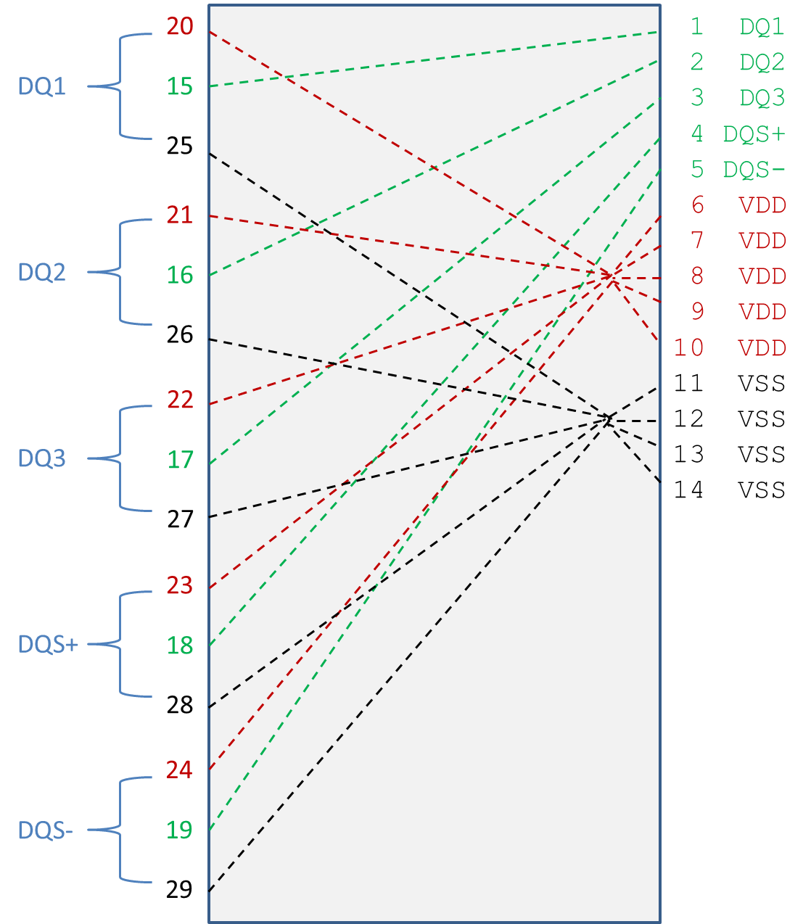

Figure 1 – Electrical Connections for Full Buffer Pin Model with Power Routing

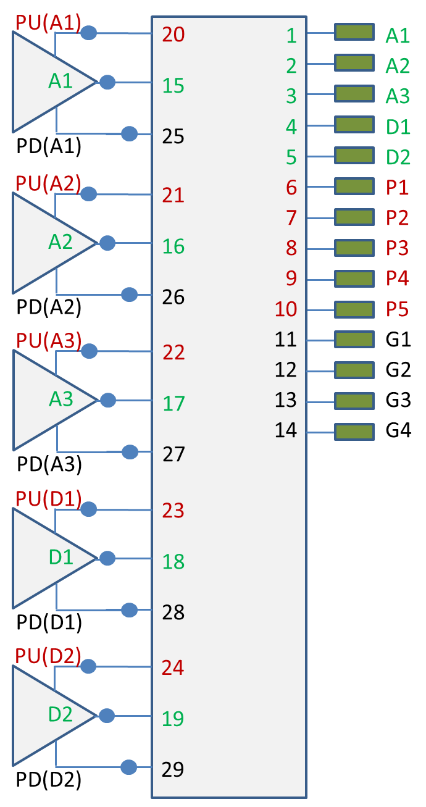
Figure 2 – Electrical Terminals for Full Buffer Pin Model with Power Routing

|******************************************************************************

| Example 2: Same as Example 1 except the PDN networks are simplified with
| signal_name qualifiers to create a pair of POWER terminals and a pair
| of GND terminals

[Interconnect Model Set] Full_ISS_PDN_sn_2
|-----
[Interconnect Model] Full_ISS_buf_pin_2
File_IBIS-ISS full_buf_pin.iss full_buf_pin_2_typ
Number_of_terminals = 14

1 Pin_I/O pin_name A1 | DQ1 DQ
2 Pin_I/O pin_name A2 | DQ2 DQ
3 Pin_I/O pin_name A3 | DQ3 DQ
4 Pin_I/O pin_name D1 | DQS+ DQS
5 Pin_I/O pin_name D2 | DQS- DQS
|
| POWER and GND terminals with signal_names
|
6 Pin_Rail signal_name VDD | VDD POWER
7 Pin_Rail signal_name VSS | VSS GND
|
8 Buf_I/O pin_name A1 | DQ1 DQ
9 Buf_I/O pin_name A2 | DQ2 DQ
10 Buf_I/O pin_name A3 | DQ3 DQ
11 Buf_I/O pin_name D1 | DQS+ DQS
12 Buf_I/O pin_name D2 | DQS- DQS
|
| POWER and GND terminals with signal_names
|
13 Buf_Rail signal_name VDD | VDD POWER
14 Buf_Rail signal_name VSS | VSS GND
|
[End Interconnect Model]
[End Interconnect Model Set]

|******************************************************************************

| Example 3: Single IO Touchstone connection with one extra terminal for the
| N+1 .s2p reference connection terminal

[Interconnect Model Set] A1_TS
|-----
[Interconnect Model] A1_TS_buf_pin
File_TS dq_ts_buf_pin.s2p
Number_of_terminals = 3
1 Pin_I/O pin_name A1
2 Buf_I/O pin_name A1
3 Pulldown_ref pin_name A1 | VSS reference for .s2p file
| Rail connections to Buf_I/O through
| [Pin Mapping] or a [Model] reference
| voltages used if no external rails
[End Interconnect Model]
[End Interconnect Model Set]

|******************************************************************************

| Example 4: Single IO pin documenting both IBIS-ISS and Touchstone files and
| showing that the Touchstone N+1 reference connection is to the VSS rail

[Interconnect Model Set] A1_IBIS_ISS_buf_pad_pin
|-----
[Interconnect Model] A1_TS_pad_pin
File_TS dq_ts_buf_pad.s2p
Number_of_terminals = 3
1 Pin_I/O pin_name A1
2 Pad_I/O pad_name A1
3 Pin_Rail signal_name VSS | VSS reference for .s2p file
| | Requires Pin_Rail VSS connection
[End Interconnect Model]

[Interconnect Model] A1_ISS_buf_pad
File_IBIS-ISS dq_iss_pad_pin.iss DQ_pad_pin_typ
Number_of_terminals = 3
1 Pad_I/O pin_name A1
2 Buf_I/O pin_name A1
3 Pulldown_ref pin_name A1 | A reference terminal for capacitor
| connection
| If missing a Node 0 might be used with
| reduced accuracy
|
| [Pin Mapping] connections used to connect external rails, or default
| internal [Model] rails used if no external rails
|
[End Interconnect Model]
[End Interconnect Model Set]

|******************************************************************************

| Example 5: Full IO IBIS-ISS configuration with PDN terminals
| under separate [Interconnect Model]s

[Interconnect Model Set] Full_ISS_PDN_3
|-----
[Interconnect Model] Full_ISS_buf_pin_IO
File_IBIS-ISS full_buf_pin.iss full_buf_pin_typ
Number_of_terminals = 11
1 Pin_I/O pin_name A1 | DQ1 DQ
2 Pin_I/O pin_name A2 | DQ2 DQ
3 Pin_I/O pin_name A3 | DQ3 DQ
4 Pin_I/O pin_name D1 | DQS+ DQS
5 Pin_I/O pin_name D2 | DQS- DQS
6 Buf_I/O pin_name A1 | DQ1 DQ
7 Buf_I/O pin_name A2 | DQ2 DQ
8 Buf_I/O pin_name A3 | DQ3 DQ
9 Buf_I/O pin_name D1 | DQS+ DQS
10 Buf_I/O pin_name D2 | DQS- DQS
11 Pin_Rail signal_name VSS | Reference at the Pin_Rail
[End Interconnect Model]

[Interconnect Model] Full_ISS_buf_pin_PDN_1
File_IBIS-ISS full_ISS_buf_pin_pdn.iss full_buf_pin_PDN_typ
Number_of_terminals = 19
1 Pin_Rail pin_name P1 | VDD POWER
2 Pin_Rail pin_name P2 | VDD POWER
3 Pin_Rail pin_name P3 | VDD POWER
4 Pin_Rail pin_name P4 | VDD POWER
5 Pin_Rail pin_name P5 | VDD POWER
6 Pullup_ref pin_name A1 | DQ1 DQ
7 Pullup_ref pin_name A2 | DQ2 DQ
8 Pullup_ref pin_name A3 | DQ3 DQ
9 Pullup_ref pin_name D1 | DQS+ DQS
10 Pullup_ref pin_name D2 | DQS- DQS
11 Pin_Rail pin_name G1 | VSS GND
12 Pin_Rail pin_name G2 | VSS GND
13 Pin_Rail pin_name G3 | VSS GND
14 Pin_Rail pin_name G4 | VSS GND
15 Pulldown_ref pin_name A1 | DQ1 DQ
16 Pulldown_ref pin_name A2 | DQ2 DQ
17 Pulldown_ref pin_name A3 | DQ3 DQ
18 Pulldown_ref pin_name D1 | DQS+ DQS
19 Pulldown_ref pin_name D2 | DQS- DQS
[End Interconnect Model]
[End Interconnect Model Set]

|******************************************************************************

| Example 6: Full IBIS-ISS IOs and separate PDNs, all with buf_pad and
| pad_pin [Interconnect Model]s

[Interconnect Model Set] Full_ISS_buf_pad_pin_PDN_4
|-----
[Interconnect Model] Full_ISS_pad_pin_IO
File_IBIS-ISS full_pad_pin_io.iss full_pad_pin_IO_typ
Number_of_terminals = 11
1 Pin_I/O pin_name A1 | DQ1 DQ
2 Pin_I/O pin_name A2 | DQ2 DQ
3 Pin_I/O pin_name A3 | DQ3 DQ
4 Pin_I/O pin_name D1 | DQS+ DQS
5 Pin_I/O pin_name D2 | DQS- DQS
|
6 Pad_I/O pin_name A1 | DQ1 DQ
7 Pad_I/O pin_name A2 | DQ2 DQ
8 Pad_I/O pin_name A3 | DQ3 DQ
9 Pad_I/O pin_name D1 | DQS+ DQS
10 Pad_I/O pin_name D2 | DQS- DQS
11 Buf_Rail signal_name VSS | Reference for I/Os
[End Interconnect Model]

[Interconnect Model] Full_ISS_buf_pad_IO
File_IBIS-ISS full_buf_pad_io.iss full_buf_pad_IO_typ
Number_of_terminals = 11
1 Pad_I/O pin_name A1 | DQ1 DQ
2 Pad_I/O pin_name A2 | DQ2 DQ
3 Pad_I/O pin_name A3 | DQ3 DQ
4 Pad_I/O pin_name D1 | DQS+ DQS
5 Pad_I/O pin_name D2 | DQS- DQS
|
6 Buf_I/O pin_name A1 | DQ1 DQ
7 Buf_I/O pin_name A2 | DQ2 DQ
8 Buf_I/O pin_name A3 | DQ3 DQ
9 Buf_I/O pin_name D1 | DQS+ DQS
10 Buf_I/O pin_name D2 | DQS- DQS
11 Pin_Rail signal_name VSS | Reference for I/Os
[End Interconnect Model]

[Interconnect Model] Full_ISS_pad_pin_PDN
File_IBIS-ISS full_iss_pad_pin_pdn.iss full_iss_pad_pin_PDN_typ
Number_of_terminals = 14
1 Pin_Rail pin_name P1 | VDD POWER
2 Pin_Rail pin_name P2 | VDD POWER
3 Pin_Rail pin_name P3 | VDD POWER
4 Pin_Rail pin_name P4 | VDD POWER
5 Pin_Rail pin_name P5 | VDD POWER
|
6 Pad_Rail pad_name VDD1 | VDD POWER
7 Pad_Rail pad_name VDD2 | VDD POWER
8 Pad_Rail pad_name VDD3 | VDD POWER
|
9 Pin_Rail pin_name G1 | VSS GND
10 Pin_Rail pin_name G2 | VSS GND
11 Pin_Rail pin_name G3 | VSS GND
12 Pin_Rail pin_name G4 | VSS GND
|
13 Pad_Rail pad_name VSS1 | VSS GND
14 Pad_Rail pad_name VSS2 | VSS GND
[End Interconnect Model]

[Interconnect Model] Full_ISS_buf_pad_PDN
File_IBIS-ISS full_iss_buf_pad_pdn.iss full_iss_buf_pad_PDN_typ
Number_of_terminals = 15
1 Pad_Rail pad_name VDD1 | VDD POWER
2 Pad_Rail pad_name VDD2 | VDD POWER
3 Pad_Rail pad_name VDD3 | VDD POWER
|
4 Pullup_ref pin_name A1 | DQ1 DQ
5 Pullup_ref pin_name A2 | DQ2 DQ
6 Pullup_ref pin_name A3 | DQ3 DQ
7 Pullup_ref pin_name D1 | DQS+ DQS
8 Pullup_ref pin_name D2 | DQS- DQS
|
9 Pad_Rail pad_name VSS1 | VSS GND
10 Pad_Rail pad_name VSS2 | VSS GND
|
11 Pulldown_ref pin_name A1 | DQ1 DQ
12 Pulldown_ref pin_name A2 | DQ2 DQ
13 Pulldown_ref pin_name A3 | DQ3 DQ
14 Pulldown_ref pin_name D1 | DQS+ DQS
15 Pulldown_ref pin_name D2 | DQS- DQS
[End Interconnect Model]
[End Interconnect Model Set]

|******************************************************************************

| Example 7: Full IBIS-ISS model with IO only [Interconnect Model] and a | separate PDN [Interconnect Model] with signal_name qualifiers

[Interconnect Model Set] Full_ISS_PDN_sn_5
|-----
[Interconnect Model] Full_ISS_buf_pin_IO
File_IBIS-ISS full_buf_pin.iss full_buf_pin_typ
Number _of_terminals = 11
1 Pin_I/O pin_name A1 | DQ1 DQ
2 Pin_I/O pin_name A2 | DQ2 DQ
3 Pin_I/O pin_name A3 | DQ3 DQ
4 Pin_I/O pin_name D1 | DQS+ DQS
5 Pin_I/O pin_name D2 | DQS- DQS
6 Buf_I/O pin_name A1 | DQ1 DQ
7 Buf_I/O pin_name A2 | DQ2 DQ
8 Buf_I/O pin_name A3 | DQ3 DQ
9 Buf_I/O pin_name D1 | DQS+ DQS
10 Buf_I/O pin_name D2 | DQS- DQS
11 Pin_Rail signal_name VSS | Reference at the Pin_Rail
[End Interconnect Model]

[Interconnect Model] Full_ISS_buf_pin_PDN_2
File_IBIS-ISS full_iss_buf_pin_pdn_2.iss full_iss_buf_pad_PDN_2
Number_of_terminals = 4
1 Pin_Rail signal_name VDD | VDD POWER
2 Buf_Rail signal_name VDD | VDD POWER
3 Pin_Rail signal_name VSS | VSS GND
4 Buf_Rail signal_name VSS | VSS GND
[End Interconnect Model]
[End Interconnect Model Set]

|******************************************************************************

| Example 8: Same full IBIS-ISS model with PDN as in Example 7, but with the
| [Interconnect Model]s describing buf_pad and pad_pin connections
| separately

[Interconnect Model Set] Full_ISS_buf_pad_pin_PDN_sn_6
|-----
[Interconnect Model] Full_ISS_pad_pin_IO
File_IBIS-ISS full_pad_pin_io.iss full_pad_pin_IO_typ
Number _of_terminals = 11
1 Pin_I/O pin_name A1 | DQ1 DQ
2 Pin_I/O pin_name A2 | DQ2 DQ
3 Pin_I/O pin_name A3 | DQ3 DQ
4 Pin_I/O pin_name D1 | DQS+ DQS
5 Pin_I/O pin_name D2 | DQS- DQS
|
6 Pad_I/O pin_name A1 | DQ1 DQ
7 Pad_I/O pin_name A2 | DQ2 DQ
8 Pad_I/O pin_name A3 | DQ3 DQ
9 Pad_I/O pin_name D1 | DQS+ DQS
10 Pad_I/O pin_name D2 | DQS- DQS
11 Buf_Rail signal_name VSS | Reference for I/Os
[End Interconnect Model]

[Interconnect Model] Full_ISS_buf_pad_IO
File_IBIS-ISS full_buf_pad_io.iss full_buf_pad_IO_typ
Number_of_terminals = 11
1 Pad_I/O pin_name A1 | DQ1 DQ
2 Pad_I/O pin_name A2 | DQ2 DQ
3 Pad_I/O pin_name A3 | DQ3 DQ
4 Pad_I/O pin_name D1 | DQS+ DQS
5 Pad_I/O pin_name D2 | DQS- DQS
|
6 Buf_I/O pin_name A1 | DQ1 DQ
7 Buf_I/O pin_name A2 | DQ2 DQ
8 Buf_I/O pin_name A3 | DQ3 DQ
9 Buf_I/O pin_name D1 | DQS+ DQS
10 Buf_I/O pin_name D2 | DQS- DQS
11 Pin_Rail signal_name VSS | Reference for I/Os
[End Interconnect Model]

[Interconnect Model] Full_ISS_pad_pin_PDN_3
File_IBIS-ISS full_iss_pad_pin_pdn_3.iss full_iss_pad_pin_pdn_3
Number_of_terminals = 4
1 Pin_Rail signal_name VDD | VDD POWER
2 Pad_Rail signal_name VDD | VDD POWER
3 Pin_Rail signal_name VSS | VSS GND
4 Pad_Rail signal_name VSS | VSS GND
[End Interconnect Model]

[Interconnect Model] Full_ISS_buf_pad_PDN_3
File_IBIS-ISS full_iss_buf_pad_pdn_3.iss full_iss_buf_pad_pdn_3
Number_of_terminals = 4
1 Buf_Rail signal_name VDD | VDD POWER
2 Pad_Rail signal_name VDD | VDD POWER
3 Buf_Rail signal_name VSS | VSS GND
4 Pad_Rail signal_name VSS | VSS GND
[End Interconnect Model]
[End Interconnect Model Set]

|******************************************************************************

| Example 9: Same full IBIS-ISS configuration with PDN as in Example 8, except
| that IO connections are direct from buf_pin while the PDN connections are
| from buf_pad and pad_pin using the signal_name qualifier – since there are | no terminal conflicts with this set, this should work

[Interconnect Model Set] Full_ISS_IO_buf_pad_pin_PDN_sn_7
|-----
[Interconnect Model] Full_ISS_buf_pin_IO
File_IBIS-ISS full_buf_pin.iss full_buf_pin_typ
Number _of_terminals = 11
1 Pin_I/O pin_name A1 | DQ1 DQ
2 Pin_I/O pin_name A2 | DQ2 DQ
3 Pin_I/O pin_name A3 | DQ3 DQ
4 Pin_I/O pin_name D1 | DQS+ DQS
5 Pin_I/O pin_name D2 | DQS- DQS
6 Buf_I/O pin_name A1 | DQ1 DQ
7 Buf_I/O pin_name A2 | DQ2 DQ
8 Buf_I/O pin_name A3 | DQ3 DQ
9 Buf_I/O pin_name D1 | DQS+ DQS
10 Buf_I/O pin_name D2 | DQS- DQS
11 Pin_Rail signal_name VSS | Reference at the Pin_Rail
[End Interconnect Model]

[Interconnect Model] Full_ISS_pad_pin_PDN_3
File_IBIS-ISS full_iss_pad_pin_pdn_3.iss full_iss_pad_pin_pdn_3
Number_of_terminals = 4
1 Pin_Rail signal_name VDD | VDD POWER
2 Pad_Rail signal_name VDD | VDD POWER
3 Pin_Rail signal_name VSS | VSS GND
4 Pad_Rail signal_name VSS | VSS GND
[End Interconnect Model]

[Interconnect Model] Full_ISS_buf_pad_PDN_3
File_IBIS-ISS full_iss_buf_pad_pdn_3 full_iss_buf_pad_pdn_3
Number_of_terminals = 4
1 Buf_Rail signal_name VDD | VDD POWER
2 Pad_Rail signal_name VDD | VDD POWER
3 Buf_Rail signal_name VSS | VSS GND
4 Pad_Rail signal_name VSS | VSS GND
[End Interconnect Model]
[End Interconnect Model Set]

|******************************************************************************

| Example 10: Terminals A1_A3 set up for and IBIS-ISS connections with coupling
| for cross-talk analysis – Aggressor terminals at the Buffer are designated

[Interconnect Model Set] A1_A3_DQ_TS_XTALK
|-----
[Interconnect Model] A1_A3_DQ_TS_buf_pin_XTALK
File_TS dq_iss_buf_pin_xtalk.s6p
Number_of_terminals = 7
1 Pin_I/O pin_name A1 Aggressor
2 Buf_I/O pin_name A1 Aggressor
3 Pin_I/O pin_name A2
4 Buf_I/O pin_name A2
5 Pin_I/O pin_name A3 Aggressor
6 Buf_I/O pin_name A3 Aggressor
7 Pulldown_ref pin_name A1 | Reference Node
[End Interconnect Model]
[End Interconnect Model Set]

|******************************************************************************

| Example 11: Same as Example 10, but with a PDN network added

[Interconnect Model Set] A1_A3_DQ_TS_XTALK_ISS_PDN
|-----
[Interconnect Model] A1_A3_DQ_TS_buf_pin_XTALK
File_TS dq_iss_buf_pin_xtalk.s6p
Number_of_terminals = 7
1 Pin_I/O pin_name A1 Aggressor
2 Buf_I/O pin_name A1 Aggressor
3 Pin_I/O pin_name A2
4 Buf_I/O pin_name A2
5 Pin_I/O pin_name A3 Aggressor
6 Buf_I/O pin_name A3 Aggressor
7 Pulldown_ref pin_name A1 | Reference Node
[End Interconnect Model]

[Interconnect Model] Full_ISS_buf_pin_PDN_2
File_IBIS-ISS full_iss_buf_pin_pdn_2.iss full_iss_buf_pad_PDN_2
Number_of_terminals = 4
1 Pin_Rail signal_name VDD | VDD POWER
2 Buf_Rail signal_name VDD | VDD POWER
3 Pin_Rail signal_name VSS | VSS GND
4 Buf_Rail signal_name VSS | VSS GND
[End Interconnect Model]
[End Interconnect Model Set]

|******************************************************************************

| Example 12 applies to the configuration below

[Pin] signal_name model_name R_pin L_pin C_pin
A1 DQ1 DQ
A2 DQ2 DQ
A3 DQ3 DQ
A4 DQ4 DQ
P1 VDD POWER
P2 VDD POWER
G1 VSS GND
G2 VSS GND

[Bus Label] signal_name
VDD1 VDD
VDD2 VDD

[Pin Mapping] pulldown_ref pullup_ref gnd_clamp_ref power_clamp_ref ext_ref
A1 VSS VDD1 NC NC NC
A2 VSS VDD1 NC NC NC
A3 VSS VDD2 NC NC NC
A4 VSS VDD2 NC NC NC
| ... Entries below can be deleted and replaced with [Bus Label] per [Pin
| Mapping] BIRD
P1 NC VDD1 NC NC NC
P2 NC VDD2 NC NC NC
G1 VSS NC NC NC NC
G2 VSS NC NC NC NC

|******************************************************************************

| Example 12: Full IBIS-ISS configuration with PDN described using both
| bus_label and signal_name qualifiers for the Rails

[Interconnect Model Set] Full_ISS_IO_PDN_bl_sn_6
|-----
[Interconnect Model] Full_ISS_buf_pin_IO_4
File_IBIS-ISS full_iss_buf_pin_io_4.iss full_iss_buf_pin_IO_4_typ
Number_of_terminals = 9
1 Pin_I/O pin_name A1 | DQ1 DQ
2 Pin_I/O pin_name A2 | DQ2 DQ
3 Pin_I/O pin_name A3 | DQ3 DQ
4 Pin_I/O pin_name A4 | DQ4 DQ
5 Buf_I/O pin_name A1 | DQ1 DQ
6 Buf_I/O pin_name A2 | DQ2 DQ
7 Buf_I/O pin_name A3 | DQ3 DQ
8 Buf_I/O pin_name A4 | DQ4 DQ
9 Pin_Rail signal_name VSS | Reference for I/Os
[End Interconnect Model]

[Interconnect Model] Full_ISS_PDN_bl_sn
File_IBIS-ISS buf_pin_pdn.iss buf_pin_PDN_typ
Number_of_terminals = 5
1 Pin_Rail signal_name VDD | VDD POWER
2 Pin_Rail signal_name VSS | VSS GND
|
3 Buf_Rail bus_label VDD1 | VDD POWER
4 Buf_Rail bus_label VDD2 | VDD POWER
5 Buf_Rail signal_name VSS | VSS GND
[End Interconnect Model]
[End Interconnect Model Set]

| The EDA tool connects the terminals and pins as follows:
|
| 1 Pins P1 and P2
| 2 Pins G1 and G2
| 3 Pullup_ref of buffers A1 and A2
| 4 Pullup_ref of buffers A3 and A4
| 5 Pulldown_ref of buffers A1, A2, A3 and A4

|******************************************************************************

Keyword: [End Interconnect Model]
Required: Yes, for each instance of the [Interconnect Model] keyword
Description: Indicates the end of the Interconnect Model data.
Other Notes: Between the [Interconnect Model] and [End Interconnect Model] keywords is the package model data itself. The data describes any number of interfaces to either IBIS-ISS models or Touchstone files.
Example:
[End Interconnect Model]

The following text should be added to the list in section 3, GENERAL SYNTAX RULES AND GUIDELINES.
15. Within this document, but aside from the actual syntax of IBIS files, the underscore (‘_’) character may be used interchangeably with a space to refer to subparameters, column headers, etc. For example, “bus_label” and “bus label” are synonymous.

The following sub-sections should be appended after 3.1, Keyword Hierarchy:

3.2 RULES OF PRECEDENCE
The sections below detail the rules of precedence to be assumed by EDA tools and model makers where multiple keywords may support similar functions.

3.2.1 PACKAGES
The order of precedence for package model data to be used by EDA tools in simulation is defined below, in ascending order. If a package data format at a numerically higher position on the list is available in an IBIS or related file, that data shall be considered by the EDA tool to be more accurate.
- [Component]/[Package]
- [Component]/[Pin]
- [Package Model] (including [Alternate Package Models] and [Define Package Model])
- [Interconnect Model Set Selector]

Note that [External Circuit] and [Interconnect Model Set Selector] shall not be present within the same [Component]. [Package Model] and [Interconnect Model Set Selector] may both be present for the same [Component] but only if they either refer to completely independent pins (terminals), or if they refer to entirely overlapping groups of pins (terminals).

