BUFFER ISSUE RESOLUTION DOCUMENT (BIRD)

BIRD NUMBER: 211
ISSUE TITLE: New Redriver Flow
REQUESTOR: Walter Katz, The MathWorks, Inc
DATE SUBMITTED: March 23, 2021
DATE REVISED:
DATE ACCEPTED:

DEFINITION OF THE ISSUE:
The current Repeater flow is known to have following issues.
- The cumulative upstream impulse response of the Redriver channel is not provided to the terminal Rx (including Retimer Rx) in AMI_Init. As a result, when the terminal Rx has DFE, the end-to-end cumulative impulse response of the Redriver channel needed in statistical simulations is not available.
- The cumulative upstream impulse response of the Redriver channel is not provided to either Tx or Rx in AMI_Init. As a result, the AMI_Init function cannot perform optimization on the upstream signal.
- The combination of Tx GetWave model and Rx Init-only model leads to deconvolution in time domain simulations.
This BIRD proposes a new repeater flow, in which certain requirements are imposed on models, to address these issues. A new reserved parameter and new data in the impulse matrix are introduced to support the proposed flow.

Existing Flow
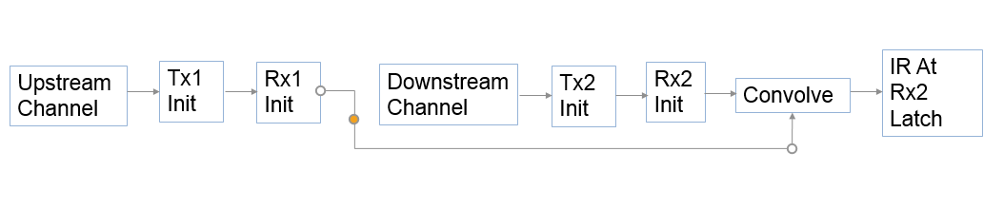
If Tx_Requires_Downstream_Channel is not in the Redriver Tx .ami file, or it is set to False, then the Redriver will now be:

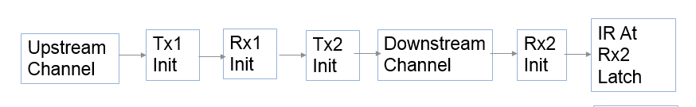

If Tx_Requires_Downstream_Channel is set to True, then the Redriver flow is:

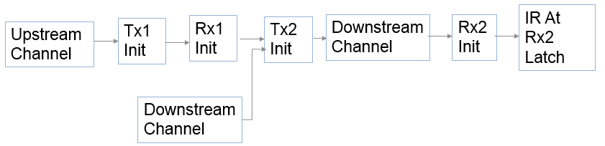

SOLUTION REQUIREMENTS:
The IBIS specification must meet these requirements:
Table 1: Solution Requirements
Requirement | Notes
- Support statistical simulations on Redriver channels whose terminal Rx (including Retimer Rx) has DFE.
- Allow Redriver Tx AMI_Init to perform optimization on the upstream signal.
- Allow Redriver Tx AMI_Init to perform optimization on the upstream signal and the downstream.
- Eliminate the need for deconvolution in simulations.

SUMMARY OF PROPOSED CHANGES:
Add one column at the end of impulse_matrix in AMI_Init.
Add new Boolean Reserved Parameter Tx_Requires_Downstream_Channel.
In the new flow only Tx redriver models are required to support parameter Tx_Requires_Downstream_Channel in the AMI_Init function.

PROPOSED CHANGES:
Add the following paragraph to Section 10.2.3.
IBIS Version 7.1 introduces modification to the Redriver simulation flow and a new simulation flow. The modification to the existing Redriver flow feeds the output of the Redriver Rx directly into the Redriver Tx. The downstream channel is combined with the Redriver Tx output and is the input to the terminal Rx. In the new flow (indicated by Tx_Requires_Downstream_Channel=True), the EDA tool is responsible to add one additional column at the end of the input impulse_matrix and to fill this additional column with the impulse response of the downstream channel from the redriver Tx to the terminal Rx algorithmic model’s input node. The Redriver Tx model’s AMI_Init function is responsible to:
- Modify the through channel column of impulse_matrix in place by applying its gain and equalization to the first column of the impulse_matrix
- Modify the crosstalk channel columns of impulse_matrix in place by applying its gain and equalization to the aggressor columns
- The model shall not modify the additional column that contains the downstream channel.
Add the following new parameter:
Parameter: Tx_Requires_Downstream_Channel
Required: No, and illegal before AMI_Version 7.1
Direction: Tx
Descriptors:
Usage: In
Type: Boolean
Format: Value
Default: <Boolean_literal>
Description: <string>
Definition: The Value must be True. The EDA tool is responsible to set the value True or False and pass it to the model in the AMI_Init function call to inform the model whether the new flow or the old flow is being executed, respectively. The EDA tool can set the value to either True or False in the AMI_Init function call.
Usage Rules: This parameter can only be used in Redriver Tx models. A model that specifies this parameter must also specify Init_Returns_Impulse=True. When Tx_Requires_Downstream_Channel is False, the model’s AMI_Init function behaves as specified in this 7.1 Specification. When Tx_Requires_Downstream_Channel is True, the model’s AMI_Init function modifies impulse_matrix as specified in Section 10.2.3. If this parameter is not present in the AMI_parameters_in string, the model assumes that Tx_Requires_Downstream_Channel=False.
Other Notes: In Repeater AMI simulations, both Repeater analog models are treated as if they are linear and time-invariant. The incoming (upstream) analog channel of the Redriver, including the upstream Tx analog model, the physical channel, and the Repeater Rx analog model, is represented by an impulse response. The outgoing (downstream) analog channel of the Repeater, including the Repeater Tx analog model, the physical channel, and the downstream Rx analog model, is represented by another impulse response.
The time domain simulation flow for a Repeater link shown in Figure 41 is defined below.

Figure 41 – Repeater Link
Repeater
Rx
Tx1
Rx1
Tx2
Rx2
channel 1
channel 2
Repeater
Repeater Tx
Incoming
(upstream)
channel
outgoing
(downstream)
channel

Here Tx1 denotes the Repeater upstream channel (channel 1) Tx AMI model (including analog and algorithmic models), Rx1 the Repeater Rx AMI model (including analog and algorithmic models), Tx2 the Repeater Tx AMI model (including analog and algorithmic models), and Rx2 the Repeater downstream channel (channel 2) Rx AMI model (including analog and algorithmic models).

Retimer Flow
Step 1. The EDA tool obtains the impulse response of the upstream analog channel, which represents the combined impulse response of Tx1’s analog model, physical channel 1, and Rx1’s analog model.
Step 2. The output of step 1 is presented to Tx1’s AMI_Init function and Tx1’s AMI_Init function is executed.
Step 3. The output of step 2 is presented to Rx1’s AMI_Init function and Rx1’s AMI_Init function is executed.
Step 4. The EDA tool obtains the impulse response of the downstream analog channel, which represents the combined impulse response of Tx2’s analog model, physical channel 2, and Rx2’s analog model.
Step 5. The output of step 4 is presented to Tx2’s AMI_Init function and Tx2’s AMI_Init function is executed.
Step 6. The output of step 5 is presented to Rx2’s AMI_Init function and Rx2’s AMI_Init function is executed.
Step 7. The EDA tool uses the impulse response returned by Rx1’s AMI_Init in step 3 to perform a statistical simulation of channel 1. The EDA tool uses the impulse response returned by Rx2’s AMI_Init in step 6 to perform a statistical simulation of channel 2.
Step 8. The EDA tool performs simulation on the upstream channel, which consists of Tx1, physical channel 1, and Rx1, according to the AMI flow defined in the specification for channels without Repeaters.
Step 9. The EDA tool samples the output waveform of Retimer Rx AMI_GetWave at ½ UI after each clock tick returned by the function, generates a digital stimulus as the input to Tx2’s algorithmic model, regardless whether Tx2’s AMI_GetWave exists or not, and performs simulation on the downstream channel, which consists of Tx2, physical channel 2, and Rx2, according to the AMI flow defined in the specification for channels without Redriver. The logic level of the digital stimulus is 1 if sampled value >= Rx1’s Rx_Receiver_Sensitivity and 0 if sampled value <= −Rx1’s Rx_Receiver_Sensitivity. If –Rx1’s Rx_Receiver_Sensitivity < sampled value < Rx1’s Rx_Receiver_Sensitivity, the logic level is unchanged from the previous bit. The digital stimulus shall have values of -½ volt for logic 0 and +½ volt for logic 1.
Step 10. The EDA tool calls the AMI_Close function of each algorithmic model in Tx1, Rx1, Tx2 and Rx2.
If just doing a statistical simulation, the flow is terminated after step 7. If doing a time domain simulation, step 7 may be skipped.
Since the Retimer output signal is driven by a digital stimulus as described above in step 9, jitter and noise parameters specified in Retimer .ami files are applied according to the specification for channels without Repeaters.

Redriver Flow

All models, including the Primary Tx, Redriver Rx, Redriver Tx, and Terminal Rx should specify Init_Returns_Impulse=True.

Step 1. The EDA tool obtains the impulse response of the upstream analog channel, which represents the combined impulse response of Tx1’s analog model, physical channel 1, and Rx1’s analog model.
Step 2. The output of step 1 is presented to Tx1’s AMI_Init function and Tx1’s AMI_Init function is executed.
Step 3. The output of step 2 is presented to Rx1’s AMI_Init function and Rx1’s AMI_Init function is executed.
Step 4. The EDA tool obtains the impulse response of the downstream analog channel, which represents the combined impulse response of Tx2’s analog model, physical channel 2, and Rx2’s analog model.
Step 5a. If Tx_Requires_Downstream_Channel is False, or not present: The output of step 3 is presented to Tx2’s AMI_Init and Tx2’s AMI_Init function is executed.
Step 5b. If Tx_Requires_Downstream_Channel is True: The output of step 3 and the output of step 4 is presented to Tx2’s AMI_Init and Tx2’s AMI_Init function is executed.
Step 6. The output of step 4 is convolved with the output of step 5.
Step 7. The output of step 6 is presented to Rx2’s AMI_Init function and Rx2’s AMI_Init function is executed.
Step 8. The EDA tool uses the impulse response returned by Rx2’s AMI_Init in step 7 to perform a statistical simulation.
Step 9. The EDA tool performs simulation on the upstream channel, which consists of Tx1, physical channel 1, and Rx1, according to the AMI flow defined in the specification for channels without Repeaters.
Step 10. The EDA tool uses the signal waveform at the output end of Rx1’s algorithmic model in step 8, regardless of whether Rx1’s AMI_GetWave exists or not, as the stimulus of Tx2’s algorithmic model, regardless of whether Tx2’s AMI_GetWave exists or not, and performs simulation on the downstream channel, which consists of Tx2, physical channel 2, and Rx2, according to the AMI flow defined in the specification for channels without Redrivers.
Step 11. The EDA tool calls the AMI_Close function of each algorithmic model in Tx1, Rx1, Tx2, and Rx2.
If just doing a statistical simulation, the flow is terminated after step 8. If doing a time domain simulation step 8 may be skipped.
Since the Redriver output signal is driven continuously by the input analog signal and does not have a sampling latch, clock times, if returned by a Redriver model, jitter parameters, and the Rx_Noise parameter specified in Redriver .ami files are ignored by the EDA tool.
Example:
(Tx_Requires_Downstream_Channel (Usage In) (Type Boolean) (Value True)
(Description "The model supports the new Redriver flow"))

