BUFFER ISSUE RESOLUTION DOCUMENT (BIRD)

BIRD NUMBER: 224
ISSUE TITLE: New AMI Reserved Parameters for Ts4file port order
REQUESTOR: Liwei Zhao, Intel Corp.; Michael Mirmak, Intel Corp.

DATE SUBMITTED: April 25, 2023
DATE REVISED:
DATE ACCEPTED: June 23, 2023

DEFINITION OF THE ISSUE:
In IBIS 7.2, the port numbering and order of the Ts4file are predefined in IEEE or even/odd format in section 10.10.1, as shown in the figures below.
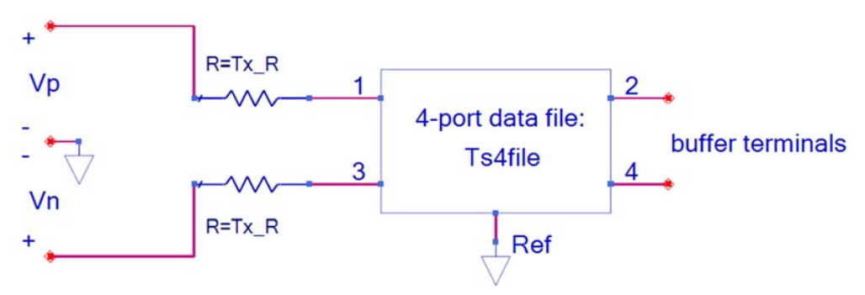
Figure 46 – Transmitter Analog Circuit
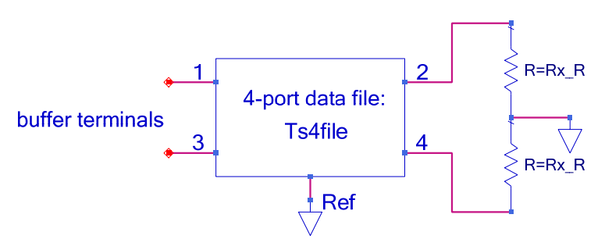
Figure 47 – Receiver Analog Circuit
Since there are two types of Touchstone file port ordering formats used in the industry, IEEE or Gonzalez, the s4p file of analog circuit data delivered by design teams may use either of these types.
In this situation, Reserved Parameters to show the port order explicitly will ensure any s4p files will work more flexibly with EDA tools.

SOLUTION REQUIREMENTS:
The IBIS specification must meet these requirements:
Table 1: Solution Requirements
Requirement | Notes
- Add new AMI parameters “Tx_Port_Order” and “Rx_Port_Order” to accept s4p files of either IEEE or Gonzalez formats | Show as “13-24” (stands for IEEE or even/odd port ordering) and “12-34” (stands for Gonzalez or sequential port ordering) to show the port order clearly

SUMMARY OF PROPOSED CHANGES:
For review purposes, the proposed changes are summarized as follows:
Table 2: IBIS Keywords, Subparameters, AMI Reserved_Parameters, and AMI functions Affected
Specification Item | New/Modified/Other | Notes
AMI Reserved Parameter Tx_Port_Order | New
AMI Reserved Parameter Rx_Port_Order | New

PROPOSED CHANGES:
Parameter: Tx_Port_Order
Required: No, and illegal before AMI_Version 7.3; illegal if the Ts4file and Tx_V parameters are not defined
Direction: Tx
Descriptors:
Usage: Info
Type: String
Format: Value
Default: <string_literal>
Description: <string>
Definition: Defines the port order for the provided Tx Ts4file parameter 4-port Touchstone file.
Usage Rules: The only input values allowed are “13-24” (stands for IEEE or even/odd port ordering) and “12-34” (stands for Gonzalez or sequential port ordering). “13-24” means that ports 1 and 3 of the Ts4file are connected to the stimulus source side non-inverting and inverting terminals respectively, and ports 2 and 4 are the transmitter analog buffer model’s non-inverting and inverting outputs respectively to the component package. “12-34” means that ports 1 and 2 of the Ts4file are connected to the stimulus source side non-inverting and inverting terminals respectively, and ports 3 and 4 are the transmitter analog buffer model’s non-inverting and inverting outputs respectively to the component package. If omitted, the default value is “13-24”. If the Ts4file Reserved Parameter uses Format List or Corner, all of its enumerated files shall use the port order defined by this parameter.
Example:
(Tx_Port_Order (Usage Info) (Type String) (Value "13-24")
(Description "This indicates the port order of the Tx s4p Ts4file")
)
The Ts4file transmitter analog circuit port orders and associated Tx_Port_Order entries are shown in the figures below:
Figure 48 – Transmitter Analog Circuit with Tx_Port_Order 13-24 (default if Tx_Port_Order is omitted)

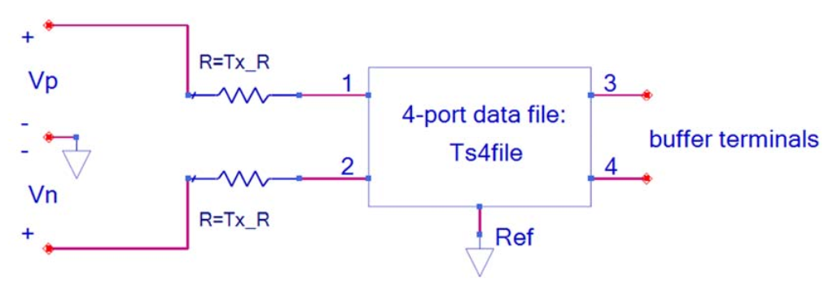
Figure 49– Transmitter Analog Circuit with Tx_Port_Order 12-34

Parameter: Rx_Port_Order
Required: No, and illegal before AMI_Version 7.3; illegal if the Ts4file parameter is not defined for the Rx direction
Direction: Rx
Descriptors:
Usage: Info
Type: String
Format: Value
Default: <string_literal>
Description: <string>
Definition: Defines the port order for the provided Rx Ts4file parameter 4-port Touchstone file.
Usage Rules: The only input values allowed are “13-24” (stands for IEEE or even/odd port ordering) and “12-34” (stands for Gonzalez or sequential port ordering). “13-24” means that ports 1 and 3 of the Ts4 file are connected to the receiver analog buffer model’s inputs, non-inverting and inverting respectively, from the component package, and the waveform at ports 2 and 4, non-inverting and inverting respectively, are the differential input to the Rx algorithmic model. “12-34” means that ports 1 and 2 of the Ts4 file are connected to the receiver analog buffer model’s inputs, non-inverting and inverting respectively, from the component package, and the waveform at ports 3 and 4, non-inverting and inverting respectively, are the differential input to the Rx algorithmic model. If omitted, the default value is “13-24”. If the Ts4file Reserved Parameter uses Format List or Corner, all of its enumerated files shall use the port order defined by this parameter.
Example:
(Rx_Port_Order (Usage Info) (Type String) (Value "13-24")
(Description "This indicates the port order of the Rx s4p Ts4file")
)
The Ts4file receiver analog circuit port orders and associated Rx_Port_Order entries are shown in the figures below:
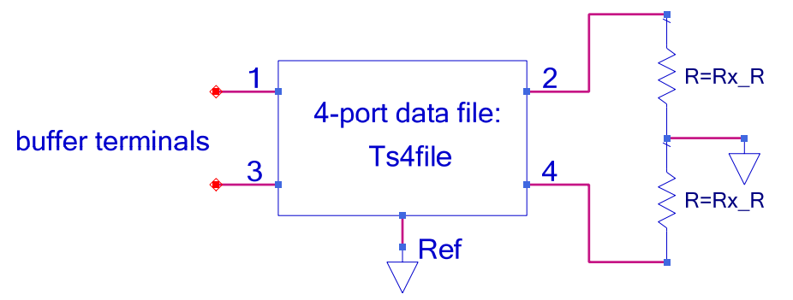Figure 50 – Receiver Analog Circuit with Rx_Port_Order 13-24 (default if Rx_Port_Order is omitted)

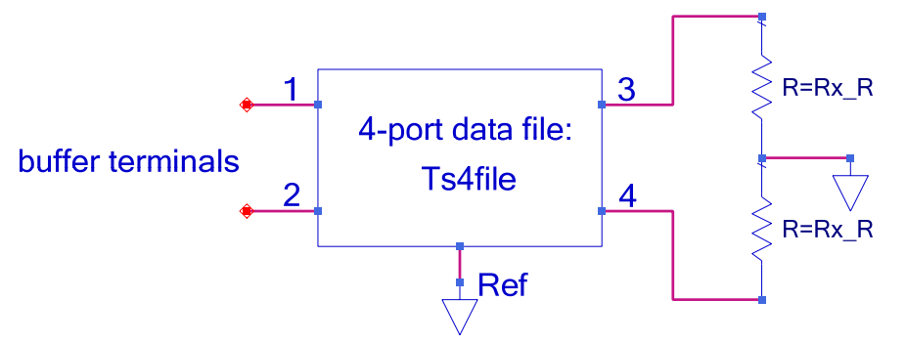Figure 51 – Receiver Analog Circuit with Rx_Port_Order 12-34

BACKGROUND INFORMATION/HISTORY:
The authors acknowledge contributions from Sai Zhou, Jingbo Li, Alaeddin Aydiner, and Kai Xiao.
The defaults for the two new parameters ensure that existing models using Ts4file will be correctly interpreted without changes to EDA tools or the models themselves.
“Gonzalez” refers to Guillermo Gonzalez, professor emeritus of the Department of Electrical Engineering at the University of Miami, and the format defined in his book, “Microwave Transistor Amplifiers: Analysis and Design”, 1996.

