**BUFFER ISSUE RESOLUTION DOCUMENT (BIRD)**

**BIRD NUMBER:** 194

**ISSUE TITLE:** *Revised AMI Ts4file Analog Buffer Models*

**REQUESTOR:**  *Walter Katz, Signal Integrity Software, Inc.*

*Todd Westerhoff, Signal Integrity Software, Inc.*

*Fangyi Rao, Keysight Technologies, Inc.*

*Radek Biernacki, Keysight Technologies, Inc.*

**DATE SUBMITTED:** May 2, 2018

**DATE ACCEPTED:** June 29, 2018

**ANALYSIS PATH/DATA THAT LED TO SPECIFICATION:**

In order to ensure proper connectivity between package interconnect models, described using the BIRD189 syntax, and the Touchstone file-based buffer models, described using the BIRD158.7 syntax, a consistent reference connection had to be defined. BIRD158.7 was somewhat vague about the meaning of the reference symbols (small triangles) used in the schematics of the Tx and Rx models. In addition, during the discussions of of this topic it seemed that the schematic drawing showing the entire channel may be inappropriate (and possibly too restrictive) in BIRD158.7 which is primarily addressing the topic of buffer modeling. The changes below reflect the conversations and decisions made in several IBIS Advanced Modeling Task Group meetings during the month of March, 2018.

**ANY OTHER BACKGROUND INFORMATION:**

The purpose of this BIRD is to make a few modifications on BIRD158.7. However, since BIRD158.7 has been approved already at the time these changes became necessary, this new BIRD had to be submitted with the goal to supersede BIRD158.7. For that reason, this BIRD includes the entire content of BIRD158.7 indicating the changes that need to be applied to it.

The following text is to be added as a new sub-section 10.x within the section “10 ALGORITHMIC MODELING”, superseding the similar changes made in BIRD158.7:

**10.x ALTERNATIVE AMI ANALOG BUFFER MODELING**

This section discusses an alternative analog buffer modeling technique, specifically designed for AMI applications. The approach uses 4-port analog circuit data provided in a Touchstone file specified by the AMI parameter named Ts4file. (Note: Ts4file implies a restricted Touchstone format, where the number of ports is four and the port numbering is predefined.)

**TRANSMITTER ANALOG CIRCUIT**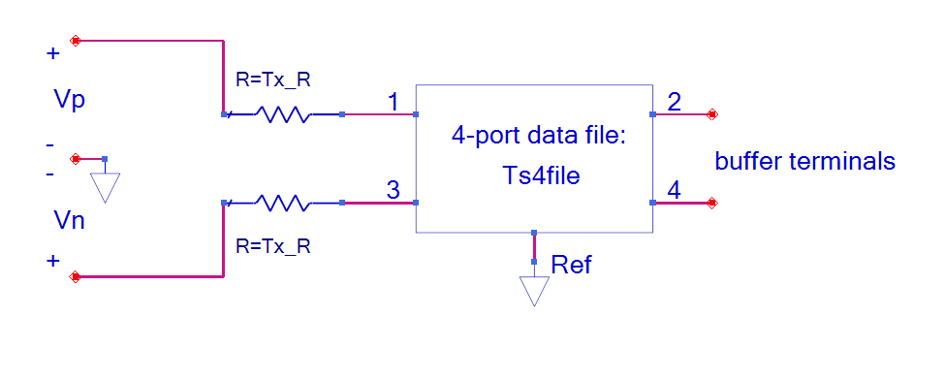

Fig xxx Transmitter Analog Circuit

For logic level 1 Vp=Tx_V / 2 and Vn=-Tx_V / 2 where Tx_V is a reserved parameter (defined below). For logic level 0 Vp=-Tx_V / 2 and Vn=Tx_V / 2. The ideal step stimulus is a differential voltage waveform Vp - Vn when the logic level is switched from 0 to 1. This may be used to determine the impulse response needed for the AMI flow. For Tx models that have the reserved parameter Ts4file, the reserved parameter Tx_V is required and the reserved parameter Tx_R is optional (default is 0.0 Ohms). For a Tx buffer, the transmitter circuit defines the analog buffer model between the zero-impedance stimulus input voltage source and the buffer terminals.

Ports 1, 2, 3 and 4 of the 4-port network are between the nodes 1, 2, 3 and 4 and the common reference node Ref, respectively. Ports 1 and 3 are at the stimulus source side, and ports 2 and 4 are the transmitter analog buffer model’s output. Furthermore, ports 1 and 2 correspond to the non-inverting signal path and ports 3 and 4 to the inverting signal path. The reference node, represented by the triangle reference symbol in the above figure is the reference node A_gnd as defined in this specification.

# Receiver Analog Circuit



Fig xxx Receiver Analog Circuit

Ports 1, 2, 3 and 4 of the 4-port network are between the nodes 1, 2, 3 and 4 and the common reference node Ref, respectively. Ports 1 and 3 are the receiver analog buffer model’s input, and the waveforms at ports 2 and 4 are the differential input of the Rx algorithmic model. Furthermore, ports 1 and 2 correspond to the non-inverting signal path and ports 3 and 4 to the inverting signal path. The reference node, represented by the triangle reference symbol in the above figure is the reference node A_gnd as defined in this specification. For Rx models that have the reserved parameter Ts4file, the reserved parameter Rx_R is optional (default is open circuit). For an Rx buffer, the receiver circuit defines the analog buffer model between the buffer terminals and the high impedance input of the Rx Algorithmic model.

By definition, the placement of the Ts4file information within .ami files makes the Ts4file data exclusively limited to AMI applications. If the same electrical behavior is desired for non-AMI applications of the same IBIS model (the one referencing the Algorithmic Model) the model maker can optionally provide an equivalent description using the [External Model] keyword. However, the latter is not needed if the model is intended for AMI applications only.

## Reserved Parameter DEFINITIONs

*Parameter:* **Ts4file**

*Required:* No

*Direction:* Tx, Rx

*Descriptors*:

Usage: Info, Dep

Type: String

Format: Value, List, Corner

Default: <string literal>

Description:<string>

*Definition:* This parameter provides the file reference for a 4-port Touchstone file to be used in the Analog Circuit. See the Analog Circuit definitions above for the port order associated with the Touchstone file data.

*Example:*

(Ts4file (Usage Info)(Type String)(Corner “typ.s4p” “min.s4p” “max.s4p”))

*Parameter:* **Tx_V**

*Required:* Yes, if the .ami file is defined for the Tx direction and **Ts4file** parameter is defined. Illegal otherwise.

*Direction:* Tx

*Descriptors*:

Usage: Info, Dep

Type: Float

Format: Value, List, Corner, Range, Increment, Steps

Default: <numeric_literal>

Description:<string>

*Definition:* This parameter defines the voltage swing of the stimulus input to the transmitter circuit.

*Example:*

(Tx_V (Usage Info)(Type Float)(Range 1.0 0.5 1.0))

*Parameter:* **Tx_R**

*Required:* No, illegal if parameter **Ts4file** is not defined.

*Direction:* Tx

*Descriptors*:

Usage: Info, Dep

Type: Float

Format: Value, List, Corner, Range, Increment, Steps

Default: <numeric_literal>

Description:<string>

*Definition:* This parameter is optional and defines the value Tx_R in ohms of the series resistors shown in the Fig. XX. It can only be present if the .ami file is defined for the Tx direction. If this parameter is not present in the .ami file, the value of Tx_R defaults to zero.

*Example:*

(Tx_R (Usage Info)(Type Float)(Value 0.0))

*Parameter:* **Rx_R**

*Required:* No, illegal if parameter **Ts4file** is not defined.

*Direction:* Rx

*Descriptors*:

Usage: Info, Dep

Type: Float

Format: Value, List, Corner, Range, Increment, Steps

Default: <numeric_literal>

Description:<string>

*Definition:* This parameter is optional and defines the value of Rx_R in ohms of the resistors shown in Fig. XX. It can only be present if the .ami file is defined for the Rx direction. If this parameter is not present in the .ami file, the value of Rx_R defaults to infinity, or a reasonable approximation thereof.

*Example:*

(Rx_R (Usage Info)(Type Float)(Value 1.0e6))

The following three tables need to be added and renumbered appropriately.

Table – General Rules and Allowable Usage for General Reserved Parameters

| **Reserved Parameter** | **General Rules** | | **Allowable Usage** | | | | |
| --- | --- | --- | --- | --- | --- | --- | --- |
| **Required** | **Default** | **Info** | **In** | **Out** | **Dep1** | **InOut** |
| Ts4file | No | -- | X |  |  | X |  |
| Tx_V | Yes/No | -- | X |  |  | X |  |
| Tx_R | No | 0 | X |  |  | X |  |
| Rx_R | No | Infinity | X |  |  | X |  |

Table – Allowable Data Types for General Reserved Parameters

| **Reserved Parameter** | **Data Type** | | | | |
| --- | --- | --- | --- | --- | --- |
| **Float** | **UI** | **Integer** | **String** | **Boolean** |
| Ts4file |  |  |  | X |  |
| Tx_V | X |  |  |  |  |
| Tx_R | X |  |  |  |  |
| Rx_R | X |  |  |  |  |

Table – Allowable Data Formats for General Reserved Parameters

| **Reserved Parameter** | **Data Format** | | | | | | | | | |
| --- | --- | --- | --- | --- | --- | --- | --- | --- | --- | --- |
| **Value** | **Range** | **Corner** | **List** | **Increment** | **Steps** | **Gaussian** | **Dual-Dirac** | **DjRj** | **Table** |
| Ts4file | X |  | X | X |  |  |  |  |  |  |
| Tx_V | X |  |  |  |  |  |  |  |  |  |
| Tx_R | X |  |  |  |  |  |  |  |  |  |
| Rx_R | X |  |  |  |  |  |  |  |  |  |